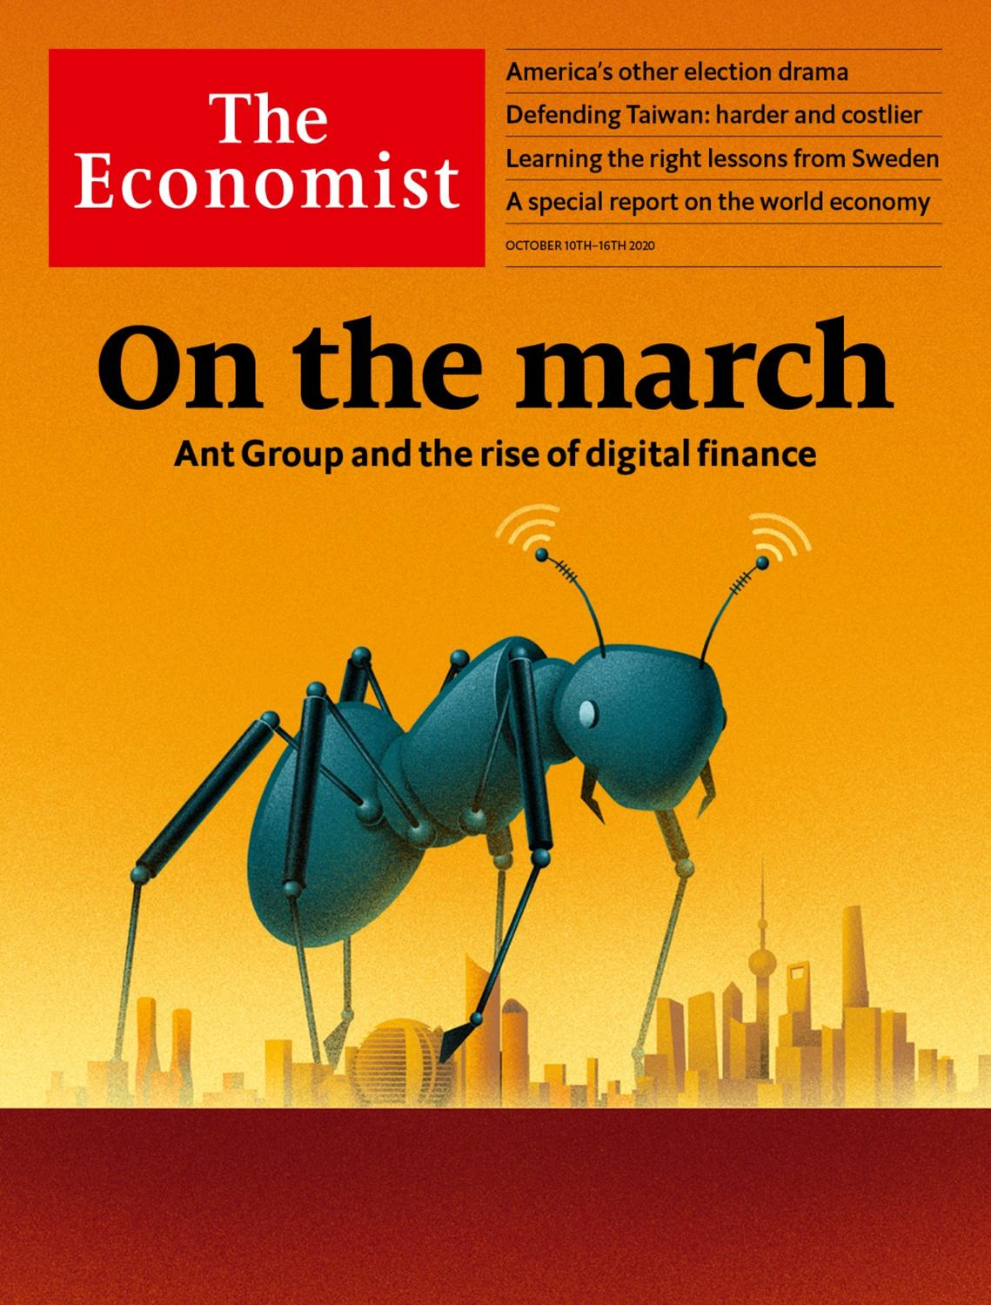

# Table of Contents

The world this week

Politics this week

Business this week

KAL’s cartoon

Leaders

The economy after covid-19: Winners and losers

Nagorno-Karabakh: No one in charge

American democracy: Don’t rob them, count them

Sweden and covid-19: Land of the mask-free

China’s fintech champion: On the march

Letters

Letters to the editor: On Mexico, “Cuties”, democracy, Milton Friedman, the Supreme Court, Harold Evans, tanks

Briefing

Ant’s jumbo IPO: Queen of the colony

Asia

War over Taiwan: Strait shooting

Kyrgyzstan: Take three

Elections in Tajikistan: Ballot-ticking exercise

Polio in Pakistan and Afghanistan: Deliverance delayed

A big K-pop IPO: Woke blokes

Banyan: Modi the multi-tasker

China

Law in Hong Kong: Slow strangulation

The Dongba script: Rune revival

United States

Covid-19 in the White House: A sick body politic

The vice-presidential debate: Rumble of the understudies

Voter suppression: A battleground in Texas

Neck-and-neck in Ohio: Swinging again

Jobs (i): Entrepreneurship: Startup nation

Jobs (ii): Lay-offs: A second wave

Lexington: The battle in miniature

The Americas

Cuba: Welcome to Queueba

Argentina: Alberto of the Antarctic

Bello: Sliding down the pandemic snake

Middle East & Africa

Iran and China: Friends without benefits

Israel: Sickly leadership

Egypt: A rage for roads

Ivory Coast’s election: Old men spell danger

Nigeria’s economy: Fuel me once

Money talk: Where calling is a calling

Europe

War in the Caucasus: Heavy metal

Greece: Selling Salamis

France’s Greens: The cancelled Christmas tree

The media in Poland: The Hungarian model

Coronavirus in Sweden: The odd one out

Charlemagne: The princess, the pea and foreign policy

Britain

Rishi Sunak: Easy riser

Dirty money: Please explain

Vaccine programme: Ready, steady, jab

Brexit talks: Deadline diplomacy

Mortgage market: Fixing it

Green energy: Straws in the wind

International

Funeral culture: Deathly silence

Special report

The world economy: The peril and the promise

International trade: Changing places

Labour markets: Zoom and gloom

Competition: Survival of the fittest

Interest rates: The eternal zero

Emerging markets: Prognosis uncertain

The role of government: The right kind of recovery

Business

The global shipping industry: It’s an ill wind that blows no one any good

Canada’s oil industry: Crude crutch

Cinemas: Curtains

Regulating big tech: Ex-antics

Bartleby: Free the workers

Japanese telecoms: Dialling down

Schumpeter: Battle for the iron throne

Finance & economics

The future of finance: The digital surge

Labour markets in Europe: Pain relief

America’s presidential election: Braced for impact

International trade: Working to rule

Buttonwood: Feel the burn

Free exchange: Beggars banquet

Science & technology

The 2020 Nobel science prizes: They walked in looking like dynamite

Living with El Niño: One man’s bane is another’s bounty

New materials: Joint approach

Conservation: How to prepare poached eggs

Books & arts

Money and morals: The way of the world

The history of science: Sleeping giants

Classical music: Phoning it in

Pets and poetry: Dead cat bounce

Theaster Gates: Feats of clay

Economic & financial indicators

Economic data, commodities and markets

Graphic detail

Obituary

Swami Agnivesh: Of human bondage



### Friday, October 9, 2020

|  |  |
| --- | --- |
| The world this week | 3 |
| Leaders | 5 |
| Letters | 1 |
| Briefing | 1 |
| Asia | 6 |
| China | 2 |
| United States | 7 |
| The Americas | 3 |
| Middle East & Africa | 6 |
| Europe | 6 |
| Britain | 6 |
| International | 1 |
| Special report | 7 |
| Business | 7 |
| Finance & economics | 6 |
| Science & technology | 4 |
| Books & arts | 5 |
| Economic & financial indicators | 1 |
| Graphic detail | 1 |
| Obituary | 1 |

|  |  |  |
| --- | --- | --- |
|  | Sections | Leaders |

The world this week

Politics this week

.

Business this week

.

KAL’s cartoon

.

|  |  |  |
| --- | --- | --- |
|  | Sections | Leaders |

|  |  |  |  |
| --- | --- | --- | --- |
|  | Articles | Sections | Next |

# Politics this week

Oct 8th 2020 |

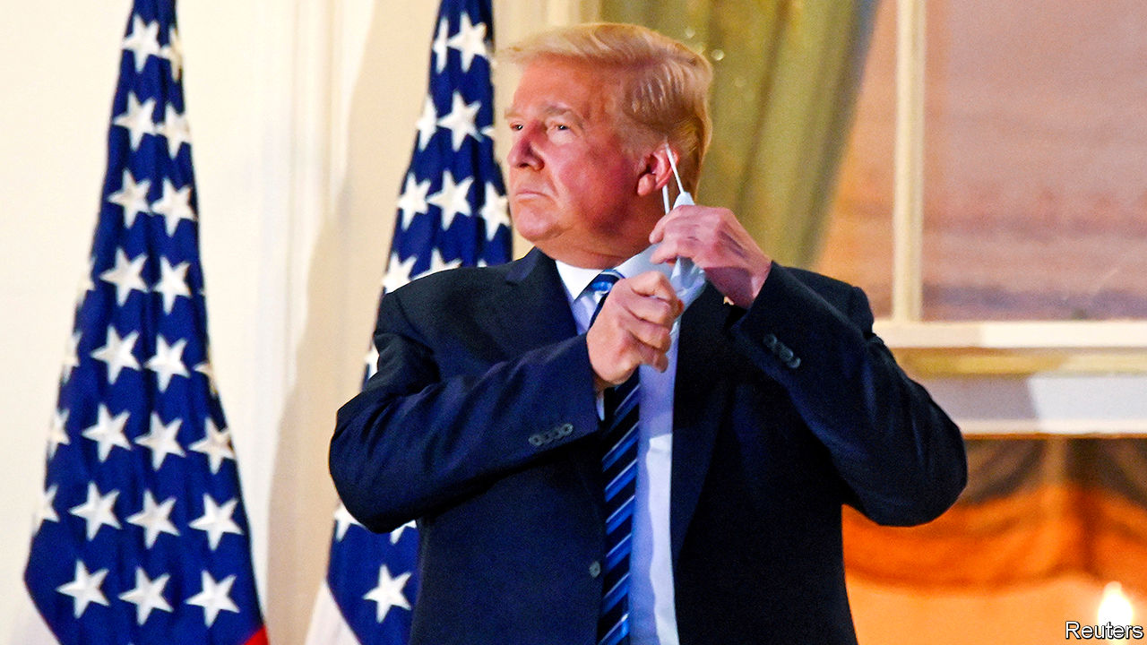

Donald Trump’s doctors were keeping a close eye on their patient, after the 74-year-old president checked out of hospital just three days after being admitted for treatment for covid-19. Around 20 other people in Mr Trump’s circle have also tested positive, including his wife, Melania, Stephen Miller, an adviser, and Chris Christie, a former governor who helped Mr Trump prepare for his first debate. The president described catching the virus as a “blessing from God”. The Commission on Presidential Debates said that the next debate between Mr Trump and Joe Biden should be held virtually. See [article](https://www.economist.com/node/21792696).

Covid-19 featured large in the vice-presidential debate between Kamala Harris and Mike Pence, a more orderly affair compared with the fireworks of the Biden-Trump encounter a week earlier. See article.

The Department of Homeland Security said that white supremacists are “the most persistent and lethal” terrorist threat to America, as foreign groups are “constrained” in their ability to conduct attacks. Since 2018 white racists have carried out more lethal assaults in the United States than any other extremist group, targeting racial and religious minorities, gay people and fans of globalisation.

Thirty-nine countries called on China to respect human rights in Xinjiang. A similar statement last year gained the backing of only 23. However, 45 countries said China’s policies towards Uighurs were just fine. Human Rights Watch called the pro-China group a “Who’s Who of leading rights abusers”.

Parties backing the president appeared to have swept elections in Kyrgyzstan. Protesters said the voting was crooked, and freed a former president from jail. The government offered to hold a new vote and the prime minister resigned. See article.

Indonesia’s parliament approved a law to cut red tape and stimulate investment. The measure had been championed by the president, Joko Widodo. Left-wing activists fret that it will weaken protections for workers and the environment.

Authorities in Vietnam arrested Pham Doan Trang, a prominent democracy activist, for “anti-state activities”. Her arrest came hours after America and Vietnam concluded a “human-rights dialogue”.

A British appeals court ruled in favour of Nicolás Maduro’s regime in Venezuela in a dispute over who controls nearly $2bn-worth of gold stored at the Bank of England. The court overturned a decision by the High Court, which said that because Britain recognises the leader of the opposition, Juan Guaidó, as the country’s interim president, he is in charge of the gold. The appeals court said that Britain’s recognition of Mr Guaidó is ambiguous and sent the case back to the High Court for a clearer ruling on which man is Venezuela’s president in the eyes of British law.

Guatemalan security forces stopped 3,500 Hondurans from heading towards America. Guatemala’s president, Alejandro Giammattei, said they might spread covid-19. The group was the first big migrant caravan to form since the pandemic began.

Tanzania barred Tundu Lissu, the opposition leader, from campaigning for president for seven days, claiming that his speeches criticising the government were “unethical”. Elections are on October 28th. Opposition offices have been firebombed.

West Africa’s regional bloc, ECOWAS, blinked in its stand-off with the leaders of a coup in Mali and lifted sanctions on the country. It had previously insisted that power be handed to a civilian government and that it would not accept the appointment as president of Bah Ndaw, a former defence minister.

Prince Bandar bin Sultan, a senior member of the royal family of Saudi Arabia, accused Palestinian leaders of betraying their people, in an interview on Saudi-owned television. The comments were seen as a signal of declining Saudi support for the Palestinians and a possible first step towards closer relations between Israel and the kingdom.

Fighting intensified in and around the disputed enclave of Nagorno-Karabakh. At least 200 people have been killed. Azerbaijan is trying to wrest back territory seized from it by neighbouring Armenia after the collapse of the Soviet Union. Turkey has armed Azerbaijan and encouraged it to break a fragile peace that has mostly held since 1994. See [article](https://www.economist.com/node/21792678).

The leaders of Golden Dawn, a neo-fascist Greek political party, were convicted in Athens of running a criminal organisation, after a party member murdered a rapper in 2013. The party itself has not been banned, but lengthy prison terms are now expected for those who incited violence.

If the British government was wondering what the next clanger in its handling of covid-19 would be, then outdated software provided the answer. Public Health England’s developers chose to use an old version of Microsoft’s Excel program to collate testing results, missing some 16,000 over several days. The version of software used by PHE was superseded over a decade ago and is not used in any serious data-gathering exercise. Meanwhile, with infections up sharply, further restrictions in England were being mooted.

## Coronavirus briefs

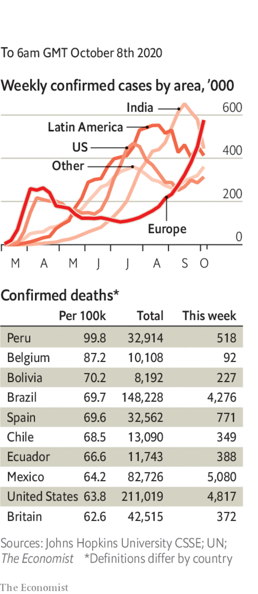

The governor of New York state, Andrew Cuomo, refused a request from the mayor of New York City, Bill de Blasio, to close non-essential businesses in parts of Brooklyn and Queens that have become virus hotspots, but imposed his own new restrictions.

Bars and cafés in Paris were ordered to close again, this time for two weeks.

The Irish government rejected a plea from senior scientific advisers to place the country in a strict lockdown, saying that the risk to jobs of closing the economy was too great. Some restrictions were reimposed; people were again told to work remotely.

October 16th was set as the date for a travel bubble between Australia and New Zealand to begin. It will be limited to New Zealanders at first; New Zealand recently declared itself free of coronavirus, for the second time.

This article was downloaded by calibre from <https://www.economist.com/the-world-this-week/2020/10/08/politics-this-week>

|  |  |  |  |
| --- | --- | --- | --- |
|  | Articles | Sections | Next |

|  |  |  |  |
| --- | --- | --- | --- |
| Previous | Articles | Sections | Next |

# Business this week

Oct 10th 2020 |

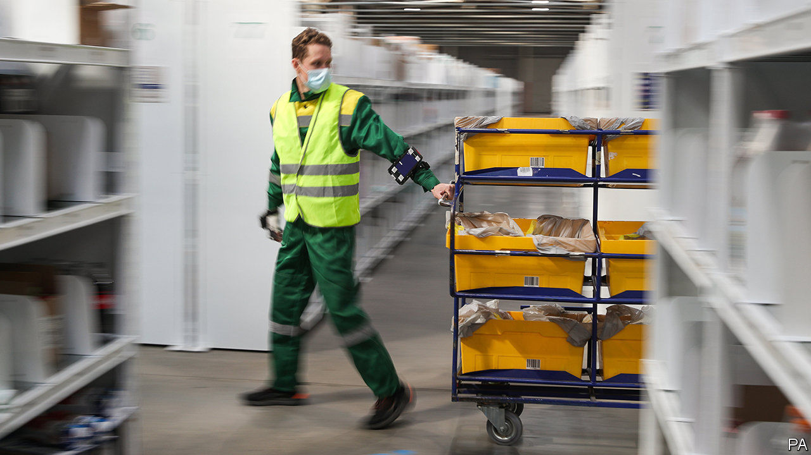

The IMF urged governments in rich countries to step up spending on investment, pointing out that, even before covid-19, public-investment-to-GDP ratios were declining. The rates of return from spending on adaptation to climate change in particular are often greater than 100%, it said. Meanwhile, Kristalina Georgieva, the IMF’s managing director, described the path to economic recovery after the pandemic as “the long ascent—a difficult climb that will be long, uneven and uncertain. And prone to setbacks.”

## The covid economy

Jerome Powell, the chairman of the Federal Reserve, once again called for more fiscal stimulus measures. He described the policy risks of supporting the American economy as asymmetric: providing too little help will be worse than providing too much. Donald Trump said he would not agree to a stimulus package until after the election. Employers created 661,000 jobs in September, a much smaller number than in each of the previous four months, when firms rehired as lockdowns eased. See article.

OurCrowd, an investment platform based in Jerusalem, struck a partnership with a business-development company backed by Al Naboodah Investments of Dubai. It is the first big alliance between investment firms in Israel and the United Arab Emirates after the recent normalisation of relations between the two countries.

There was more consolidation in the payments industry with the announcement that Nexi, Italy’s biggest provider of digital payments, would buy SIA, a smaller rival that is owned by the Italian government. Through a development bank, the government will retain a 25% stake.

Companies aiming to increase staff diversity may be drawing more legal scrutiny from the American government. Microsoft and Wells Fargo, who have both promised to double their number of black executives, were both contacted by the Department of Labour recently to inquire whether their plans comply with laws that forbid hiring practices based on race.

America’s Supreme Court heard arguments from Google and Oracle in a closely watched case concerning how copyright law should apply to computer code. Oracle argues that Google unlawfully reused parts of Java, a programming language, in its Android smartphones. Google retorts that such reuse has been common industry practice for decades, and is vital for interoperability between software. A lower court’s ruling in Oracle’s favour in 2018 alarmed the rest of the tech industry, which mostly takes Google’s side.

A committee in America’s House of Representatives accused Amazon, Apple, Facebook and Google of exploiting their monopoly power, comparing them to oil and railway tycoons in the 19th century, and recommended sweeping reforms to antitrust laws. That could spell trouble for the tech giants if the Democrats win both chambers of Congress next month. See [article](https://www.economist.com/business/2020/10/07/how-best-to-regulate-big-tech).

Boeing’s annual outlook for the overall aerospace industry forecast an 11% drop in demand for commercial planes over the next decade, compared with last year’s forecast. Over the next 20 years, it predicts passenger-traffic growth will return to pre-pandemic levels of 4% a year.

Walmart at last found a buyer for Asda, a British supermarket chain that it bought in 1999 and has been trying to sell for more than two years. The new owner in the £6.8bn ($8.7bn) deal is a consortium led by Zuber and Mohsin Issa. The brothers run EG Group, which operates petrol stations and food concessions across ten countries, and owns many Kentucky Fried Chicken franchises in Britain.

Bristol-Myers Squibb made another big acquisition, agreeing to pay $13.1bn for MyoKardia, a clinical-stage biopharmaceutical company specialising in treatments for heart disease. Last year Bristol-Myers Squibb bought Celgene for $90bn, one of the largest-ever deals in the drug industry.

Facebook said it had started to remove all pages across all its platforms that are linked to QAnon, a far-right conspiracy theory that thinks Donald Trump is battling a cabal of Satan-worshipping paedophiles. The company had been criticised for not doing enough to counter the surge in fake news from QAnon adherents.

## Bond is back (well, next year)



Cineworld decided to close all its cinemas in America and Britain until next year, after the release date of “No Time To Die”, the next James Bond film, was again postponed, until April. Already struggling as social-distancing keeps the crowds away from its venues, Cineworld was banking on what would have been this year’s biggest box-office draw. Other films have been delayed, some have gone straight to streaming. Many in the industry believe lavish blockbusters need to be seen in cinemas first in order to create the all-important buzz. See article.

This article was downloaded by calibre from <https://www.economist.com/the-world-this-week/2020/10/10/business-this-week>

|  |  |  |  |
| --- | --- | --- | --- |
| Previous | Articles | Sections | Next |

|  |  |  |  |
| --- | --- | --- | --- |
| Previous | Articles | Sections | Next |

# KAL’s cartoon

Oct 8th 2020 |

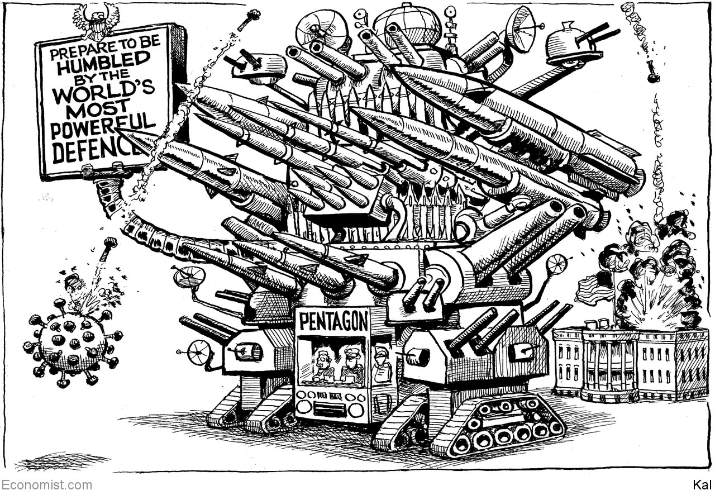

This article was downloaded by calibre from <https://www.economist.com/the-world-this-week/2020/10/08/kals-cartoon>

|  |  |  |  |
| --- | --- | --- | --- |
| Previous | Articles | Sections | Next |

|  |  |  |
| --- | --- | --- |
| The world this week | Sections | Letters |

Leaders

The economy after covid-19: Winners and losers

.

Nagorno-Karabakh: No one in charge

.

American democracy: Don’t rob them, count them

.

Sweden and covid-19: Land of the mask-free

.

China’s fintech champion: On the march

.

|  |  |  |
| --- | --- | --- |
| The world this week | Sections | Letters |

|  |  |  |  |
| --- | --- | --- | --- |
|  | Articles | Sections | Next |

#### Winners and losers

# The pandemic has caused the world’s economies to diverge

But its long-term impact will be even more far-reaching

Oct 8th 2020 |

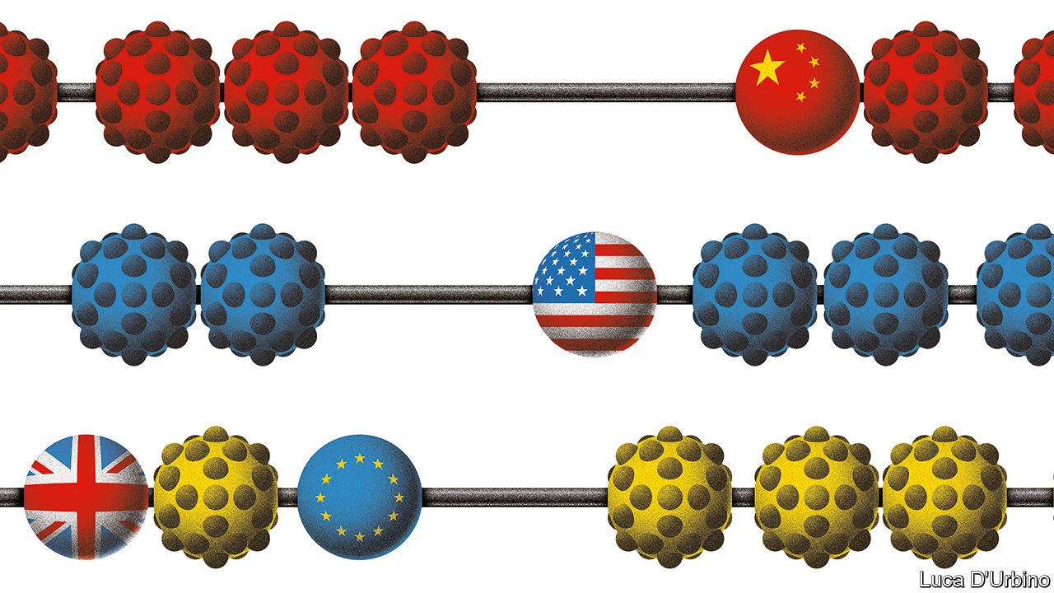

Editor’s note: Some of our covid-19 coverage is free for readers of The Economist Today, our daily [newsletter](https://my.economist.com/user#newsletter). For more stories and our pandemic tracker, see our [hub](https://www.economist.com/news/2020/03/11/the-economists-coverage-of-the-coronavirus)

IN FEBRUARY THE coronavirus pandemic struck the world economy with the biggest shock since the second world war. Lockdowns and a slump in consumer spending led to a labour-market implosion in which the equivalent of nearly 500m full-time jobs disappeared almost overnight. World trade shuddered as factories shut down and countries closed their borders. An even deeper economic catastrophe was avoided thanks only to unprecedented interventions in financial markets by central banks, government aid to workers and failing firms, and the expansion of budget deficits to near-wartime levels.

The crash was synchronised. As a recovery takes place, however, huge gaps between the performance of countries are opening up—which could yet recast the world’s economic order. By the end of next year, according to forecasts by the OECD, America’s economy will be the same size as it was in 2019 but China’s will be 10% larger. Europe will still languish beneath its pre-pandemic level of output and could do so for several years—a fate it may share with Japan, which is suffering a demographic squeeze. It is not just the biggest economic blocs that are growing at different speeds. In the second quarter of this year, according to UBS, a bank, the distribution of growth rates across 50 economies was at its widest for at least 40 years.

The variation is the result of differences between countries. Most important is the spread of the disease. China has all but stopped it while Europe, and perhaps soon America, is battling a costly second wave. Over the past week Paris has closed its bars and Madrid has gone into partial lockdown. In China, meanwhile, you can now down sambuca shots in nightclubs. Another difference is the pre-existing structure of economies. It is far easier to operate factories under social distancing than it is to run service-sector businesses that rely on face-to-face contact. Manufacturing makes up a bigger share of the economy in China than in any other big country. A third factor is the policy response. This is partly about size: America has injected more stimulus than Europe, including spending worth 12% of GDP and a 1.5 percentage point cut in short-term interest rates. But policy also includes how governments respond to the structural changes and creative destruction the pandemic is causing.

As our special report this week explains, these adjustments will be immense. The pandemic will leave economies less globalised, more digitised and less equal. As they cut risks in their supply chains and harness automation, manufacturers will bring production closer to home. As office workers continue to work in their kitchens and bedrooms for at least part of the week, lower-paid workers who previously toiled as waiters, cleaners and sales assistants will need to find new jobs in the suburbs. Until they do, they could face long spells of unemployment. In America permanent job losses are mounting even as the headline unemployment rate falls (see article).

As more activity moves online, business will become more dominated by firms with the most advanced intellectual property and the biggest repositories of data; this year’s boom in technology stocks gives a sense of what is coming, as does the digital surge in the banking industry (see our leader on Ant Group). And low real interest rates will keep asset prices high even if economies remain weak. This will widen the gulf between Wall Street and Main Street that emerged after the global financial crisis and which has worsened this year. The challenge for democratic governments will be to adapt to all these changes while maintaining popular consent for their policies and for free markets.

That is not a concern for China, which so far seems to be emerging from the pandemic strongest—at least in the short run. Its economy has bounced back quickly. Later this month its leaders will agree on a new five-year plan which emphasises Xi Jinping’s model of high-tech state capitalism and increasing self-sufficiency. Yet the virus has exposed longer-term flaws in China’s economic apparatus. It has no safety-net worth the name and this year had to focus its stimulus on firms and infrastructure investment rather than shoring up household incomes. And in the long run its system of surveillance and state control, which made brutal lockdowns possible, is likely to impede the diffuse decision-making and free movement of people and ideas that sustain innovation and raise living standards.

Europe is the laggard. Its response to the pandemic risks ossifying economies there, rather than letting them adjust. In its five biggest economies, 5% of the labour force remains on short-work schemes in which the government pays them to await the return of jobs or hours that may never come back (see article). In Britain the proportion is twice as high. Across the continent, suspended bankruptcy rules, tacit forbearance by banks and a flood of discretionary state aid risk prolonging the life of zombie firms that should be allowed to fail. This is all the more worrying given that, before the crisis, France and Germany were already embracing an industrial policy that promoted national champions. If Europe sees the pandemic as a further reason to nurture a cosy relationship between government and incumbent businesses, its long-term relative decline could accelerate.

The question-mark is America. For much of the year it got the policy balance roughly right. It provided a more generous safety-net for the jobless and a larger stimulus than might have been expected in the home of capitalism. Wisely, it also allowed the labour market to adjust and has shown less inclination than Europe to bail out firms that are in danger of becoming obsolete as the economy adjusts. Partly as a result, unlike Europe, America is already seeing the creation of many new jobs.

Instead America’s weakness is toxic and divided politics. This week President Donald Trump seemed to ditch talks over renewing its stimulus, meaning that the economy could fall over a fiscal cliff. Critical reforms, whether to redesign the safety-net for a tech-driven economy or to put deficits on a sustainable course, are all but impossible while two warring tribes define compromise as weakness. Covid-19 is imposing a new economic reality. Every country will be called on to adapt, but America faces a daunting task. If it is to lead the post-pandemic world, it will have to reset its politics. ■

This article was downloaded by calibre from <https://www.economist.com/leaders/2020/10/08/the-pandemic-has-caused-the-worlds-economies-to-diverge>

|  |  |  |  |
| --- | --- | --- | --- |
|  | Articles | Sections | Next |

|  |  |  |  |
| --- | --- | --- | --- |
| Previous | Articles | Sections | Next |

#### Lessons of Nagorno-Karabakh

# Why “America First” makes wars in other places more likely

A vacuum of global leadership lets local conflicts expand

Oct 10th 2020 |

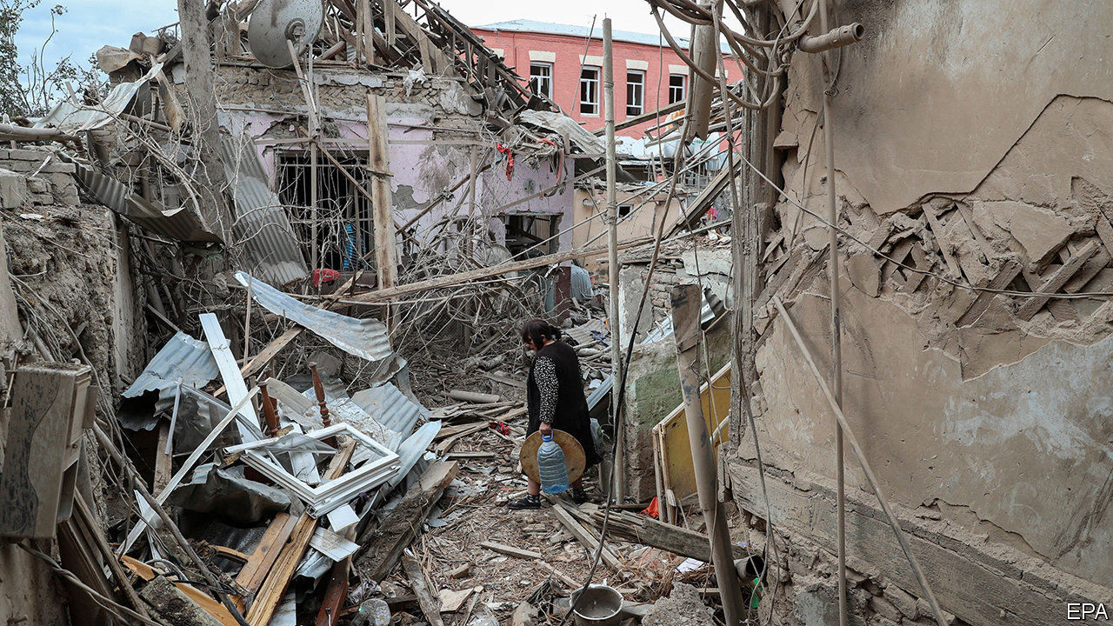

MORE THAN 200 people, mostly soldiers, have been killed in the past ten days. Shells are falling on towns in and around Nagorno-Karabakh. Turkish-made drones are loitering in the sky before blasting targets on the ground—and filming the destruction, to be posted on YouTube (see [article](https://www.economist.com/node/21792682)). This is not just a small war in a far-off place. It already involves bigger powers, and it could get much bloodier and nastier.

Nagorno-Karabakh is a disputed enclave populated largely by (Christian) Armenians. It broke away from (Muslim) Azerbaijan as the Soviet Union collapsed. Armenia supported it, and seized a huge chunk of Azerbaijani territory to connect with it, during a war that killed tens of thousands of people and displaced perhaps 1m more. A ceasefire was reached in 1994, but there have been repeated flare-ups since then—and this one is easily the worst. The Azerbaijanis are again trying to take their land back by force. Russia has a collective-security agreement with Armenia. Turkey backs Azerbaijan, whose people are ethnically and culturally close to Turks. Turkey’s president, Recep Tayyip Erdogan, sees the conflict as a chance to assert himself as a regional hegemon and Muslim champion, as he is already doing in Syria and Libya. Russia has so far acquiesced, but that may not last. Iran borders both countries and has a large Azeri minority; it could easily be sucked in. Pipelines carrying gas from the Caspian Sea run near the front lines.

The outlines of a solution have been promoted by outsiders for over a decade. Nagorno-Karabakh must have a legally guaranteed autonomous status, pending a final determination based on something like a plebiscite. In return, Armenia will have to hand back the Azerbaijani districts it grabbed in the early 1990s, retaining only a narrow corridor linking Armenia to Nagorno-Karabakh. Both governments once broadly accepted these principles. Now, however, neither is willing to compromise.

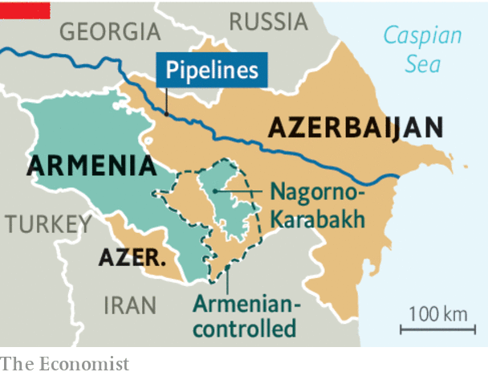

The tragedy for everyone is that the mechanisms for fixing this sort of crisis seem to have broken down. One obstacle is the coronavirus. In the past, the ground would have been thick with negotiators from an alphabet soup of peacemaking outfits and concerned nations, all trying to build local and regional confidence. The pandemic makes that sort of diplomacy much harder in conflict zones all around the world.

The bigger problem, though, is the absence of global leadership. America and Russia helped bring about the ceasefire in 1994, and in the past the two powers have kept a lid on things. America started to turn inward under Barack Obama. During the presidency of Donald Trump it has brokered improvements in relations between Arab rulers and Israel, which go down well at home. But it almost entirely abandoned the long, thankless slog of routine peace-maintenance. Turkey is an ally in NATO, which might in the past have been a useful forum to urge Mr Erdogan to stop meddling, and to press the combatants to lay down their weapons. But Mr Trump has little time for NATO, which without America is rudderless. Past American presidents might have put time, brainpower and muscle into preventing war in the Caucasus, but Mr Trump showed no interest even before he fell sick with covid-19. In the past Russia, too, might have reined in Mr Erdogan; but Vladimir Putin, like Mr Trump, is preoccupied with his own domestic troubles, and sees little harm in allowing the strongman in Ankara to make mischief, within limits. Pretty much anything that drives a wedge between Turkey and the rest of NATO suits the Kremlin.

There are many “frozen conflicts” around the world: places where war may not be raging, but where the underlying tensions have not been resolved and historical or territorial grievances run deep. The trouble with frozen conflicts is that they can turn hot at any moment. In a world where the democratic superpower is resentful, consumed and distracted, averting wars is far harder than it was—or should be. ■

This article was downloaded by calibre from <https://www.economist.com/leaders/2020/10/10/why-america-first-makes-wars-in-other-places-more-likely>

|  |  |  |  |
| --- | --- | --- | --- |
| Previous | Articles | Sections | Next |

|  |  |  |  |
| --- | --- | --- | --- |
| Previous | Articles | Sections | Next |

#### American democracy

# The spreading scourge of voter suppression

Don’t rob people of votes, count them

Oct 10th 2020 |

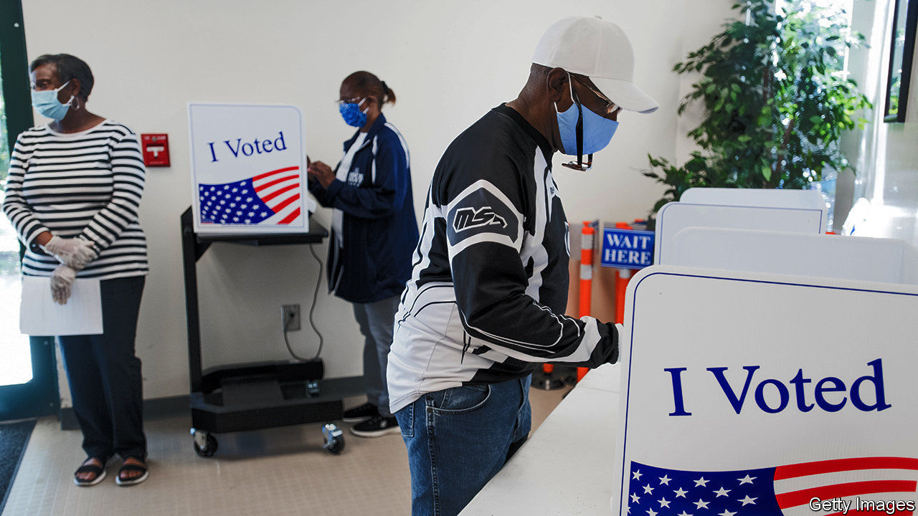

A PRESIDENT IN hospital, virus in the White House, a fight over the Supreme Court, leaked presidential tax returns: it is enough to make you reel. Amid the tumult of the campaign, it is easy to miss a less frenzied turn of events that has no less profound implications for America’s democracy. It concerns suppressing the vote. “Elections belong to the people,” said the Republican Party’s greatest president. What, then, would Abraham Lincoln make of his partymen’s efforts—in Florida, North and South Carolina, Texas, Wisconsin and other contested states—to limit the number of people the coming election belongs to?

Allegations of minority-voter suppression are hardly new. They are also often overheated and hard to prove. Yet Greg Abbott’s action in Texas stands out (see article). On October 1st the Republican governor restricted the number of drop boxes for completed ballots to just one per county. For the 4.7m residents of Harris County, 70% of whom are non-white and liable to vote Democratic, that is a travesty.

Echoing President Donald Trump, Mr Abbott said this was necessary to prevent voter fraud. Wisconsin’s Republican legislature said the same to justify restricting early voting in the state, as did their counterparts in the Carolinas when insisting on the need for a witness counter-signature on mail-in ballots. Preventing fraud is a sound principle. Some Republican measures, including in Texas, involve tightening up covid-19 provisions for early voting that those same lawmakers had introduced. In practice, however, concerns about electoral fraud, which Republican lawmakers have cited in 25 states over the past decade, are almost always unfounded. This makes their arguments against the special covid-19 provisions hard to sustain.

The only major instance of voter fraud in recent times was perpetrated by a rogue Republican activist in North Carolina. There is no evidence of the mass Democratic electoral fraud many Republicans claim to detect. Mr Trump, who alleged that 5m votes were cast illegally for Hillary Clinton in 2016, launched a commission to find some. It returned empty-handed. Meanwhile, examples of new Republican restrictions have piled up.

In Georgia, Ohio and Texas at least 160,000 people, disproportionately non-white, were wrongly removed or marked for removal from the electoral roll in 2018-19. And though the effect of recent measures is unclear, Florida hints at what may be to come. The state voted in 2018 to enfranchise felons who had met all their obligations, an estimated 1.4m people—including a fifth of black Floridians. The Republican legislature passed a law enacting this plebiscite that interpreted those obligations in the most onerous way possible by demanding they first settle all outstanding fines. Former felons were always likely to be low-propensity voters, but this erected a formidable bureaucratic hurdle even to those able to pay. As Florida’s registration deadline passed this week, perhaps one in six had registered to vote.

Mr Trump’s threat that he will refuse to accept the election results has raised fears of a constitutional crisis. They need to be taken seriously. More likely, however, these practised instances of vote suppression will turn out to be the election’s real lasting democratic damage. It is perverse for one party in a democracy to shape its politics around suppressing the vote. Adopting this as a political tool is especially foul in a country where African-Americans were denied the vote in living memory.

The tactic is the apogee of Republican short-termism. True, Georgia’s governor may owe his job to suppressing black votes. But the party will sooner or later be unable to win national elections if it cannot woo non-whites. With every cycle of electoral abuse, the party of Lincoln is handing them fresh grievances.■

Dig deeper:  
Read the [best of our 2020 campaign coverage](https://www.economist.com/us-election-2020) and explore our [election forecasts](https://projects.economist.com/us-2020-forecast/president), then sign up for Checks and Balance, our [weekly newsletter](https://www.economist.com/checksandbalance/) and [podcast](https://play.acast.com/podcasts/2020/01/24/checks-and-balance-our-new-weekly-podcast-on-american-politics) on American politics.

This article was downloaded by calibre from <https://www.economist.com/leaders/2020/10/10/the-spreading-scourge-of-voter-suppression>

|  |  |  |  |
| --- | --- | --- | --- |
| Previous | Articles | Sections | Next |

|  |  |  |  |
| --- | --- | --- | --- |
| Previous | Articles | Sections | Next |

#### Land of the mask-free

# The real lessons from Sweden’s approach to covid-19

Sweden is held up as a champion of liberty. In fact it is the home of pragmatism

Oct 10th 2020 |



Editor’s note: Some of our covid-19 coverage is free for readers of The Economist Today, our daily [newsletter](https://my.economist.com/user#newsletter). For more stories and our pandemic tracker, see our [hub](https://www.economist.com/news/2020/03/11/the-economists-coverage-of-the-coronavirus)

THE GREAT thing about using a small country to support your argument is that your opponents are unlikely to know what is really going on there. Perhaps that is why Sweden, with 10.3m people, has become a much-cited example in the debate about how to deal with covid-19. Liberty-loving Swedes are supposedly pursuing a mask-free, lockdown-light strategy that will create herd immunity without bankrupting the economy. Sweden’s success, it is said, is a standing rebuke to the left-wing killjoys who love bossing folk around and shutting everything down.

Sweden does indeed hold lessons—but they are less about freedom than about using trade-offs to generate lasting social cohesion. The country makes an odd paragon for fans of small government. The last time it pursued individualism red in tooth and claw, social policy was in the hairy hands of men who went to work in longboats. Today Sweden is a progressive beacon, lying seventh in the OECD’s ranking of social spending—ahead even of Germany.

Fans of Sweden are right to point out that, in the first phase of the disease, the government had a light touch. Although it banned large groups and issued plenty of health advice, it rejected blanket lockdowns. But that was not a particularly successful approach. Sweden has a fatality rate of around 60 per 100,000, ten times that of Finland and Norway, which did lock themselves down. Swedes’ freedom did not spare the economy, even though many deaths were among elderly people no longer working. Output in the second quarter alone shrank by 8.3%—also worse than the other Nordic countries. A high caseload is bad for the economy.

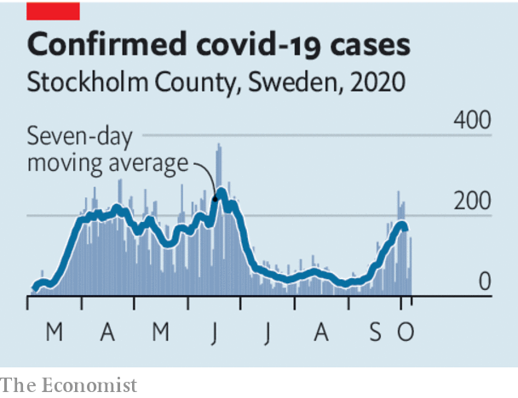

One rejoinder is that, unlike Britain, France and Spain, Sweden has not seen a second wave. However, even if you leave aside the fact that cases in Stockholm County roughly quadrupled in September (in absolute terms, they are still low), Sweden’s new strategy for the second phase converges with Germany’s. Contrary to some claims, this is not dependent on herd immunity—Sweden still has a large population of susceptible people. Rather, it entails rapid large-scale testing and contact-tracing so as to identify and suppress outbreaks early. This is accompanied by a clear, consistent message that is sustainable because it gives people autonomy (see article). Those are the building blocks of successful anti-covid-19 strategies everywhere.

The lesson from the new Swedish policy is not that it is libertarian, but that the government weighs up the trade-offs of each restriction. For instance, when someone tests positive, their entire household must go into quarantine, but schoolchildren are exempt—because, the government reckons, the gains from shutting them away are overwhelmed by the lasting harm to their education. Likewise, the quarantine lasts five to seven days, compared with two weeks elsewhere. The risk of spreading covid-19 in that second week is small and shrinking, but the harm to mental health of extended isolation is growing.

Sweden is a high-trust society, where people follow the rules. And yet its approach is based on the idea that, as covid-19 is here for a long time, asking too much of people will lower compliance and thus spread the disease. Low-trust societies may need a different balance between coercion and self-policing but they, too, need sustainable rules.

And what of masks? Sweden’s fans seize on mask-free crowds in Stockholm as proof of its liberty. But that is not the basis for its policy. Government experts argue that the evidence that masks help is weak, and that their other measures work fine. In this, Sweden is out of step with other countries. If the disease charges back there, that is likely to change. After all, its policy is based on evidence and pragmatism, not blind principle. ■

This article was downloaded by calibre from <https://www.economist.com/leaders/2020/10/10/the-real-lessons-from-swedens-approach-to-covid-19>

|  |  |  |  |
| --- | --- | --- | --- |
| Previous | Articles | Sections | Next |

|  |  |  |  |
| --- | --- | --- | --- |
| Previous | Articles | Sections | Next |

#### Digital money

# Ant Group and fintech come of age

A blockbuster listing shows how fintech is revolutionising finance

Oct 8th 2020 |



IN 1300 OR so Marco Polo, a Venetian merchant, introduced Europeans to a monetary marvel witnessed in China. The emperor, he wrote, “causes the bark of trees, made into something like paper, to pass for money all over his country”. Eventually the West also adopted paper money, some six centuries after China invented it. More recent foreign travellers to China have come back agog at the next big step for money: the total disappearance of paper, replaced by pixels on phone screens.

China’s pre-eminence in digital money is likely to be on display in the next few weeks with the monster listing of Ant Group, its largest fintech firm, in Hong Kong and Shanghai. Measured by cash raised, it will probably be the biggest initial public offering in history, beating Saudi Aramco’s last year. Once listed, Ant, which was formed in 2004, could have a similar value to JPMorgan Chase, the world’s biggest bank, which traces its roots to 1799. Ant’s rise worries hawks in the White House and enthralls global investors. It portends a bigger transformation of how the financial system works—not just in China but around the world.

Jamie Dimon, JPMorgan’s boss, and others have kept a wary and admiring eye on Ant for years. Spun off from Alibaba, an e-commerce firm, it has over 1bn users, mostly in China, and its payments network carried $16trn of transactions last year, connecting 80m merchants (see Briefing). Payments are just the appetiser. Users can borrow money, choose from 6,000 investment products, and buy health insurance. Imagine if main-street banks, Wall Street’s brokers, Boston’s asset managers and Connecticut’s insurers were all shrunk to fit into a single app designed in Silicon Valley that almost everyone used. Other Chinese firms, notably Tencent, which owns the WeChat app, also operate cutting-edge fintech arms.

China is not alone. The pandemic has supercharged activity elsewhere (see article). Alongside the surge in global e-commerce and remote working there has been an accompanying boom in digital payments, which have jumped by 52% at Venmo, an American network, compared with last year, and by 142% at Mercado Pago, a Latin American fintech. Parisian farmers’ markets, pizza firms and Singaporean hawkers have upgraded their systems so they can be paid instantly without physical contact or cash. Investors sense a tectonic shift, like the one that shook retailing. Conventional banks now account for only 72% of the stockmarket value of the global banking and payments industry, down from 96% in 2010.

If the surge in digital finance is universal, the business models behind it are not. In Latin America look out for digital banks and e-commerce pioneers such as Nubank and MercadoLibre, owner of Mercado Pago. In South-East Asia Grab and Gojek, two ride-hailing services, are becoming “super-apps” with financial arms. Fintech firms now provide the majority of consumer loans in Sweden. In America credit-card firms such as Visa (the world’s most valuable financial firm), digital-finance giants such as PayPal (the sixth) and the big banks both co-operate and compete. Tech giants such as Apple and Alphabet are dipping their toes in, tempted by the financial industry’s $1.5trn global pool of profits.

There is much to be excited about. At its best, fintech offers big gains in efficiency. If the world’s listed banks cut expenses by a third, the saving would be worth $80 a year for every person on Earth. Ant makes razor-thin margins on payments and takes minutes to grant a loan. Gone are the days of getting gouged by money-changers in airports. Firms such as TransferWise and Airwallex offer exchange services that are cheaper and faster.

Digitisation also promises to broaden the spread of finance. Reaching customers will be easier and data will make loan underwriting more accurate. Firms like Square and Stripe help small businesses connect to the digital economy. In India and Africa digital finance can free people from dodgy moneylenders and decrepit banks. By creating their own digital currencies, governments may be able to bypass the conventional banking system and tax, take deposits from, and make payments to citizens at the touch of a button. Compare that with the palaver of Uncle Sam posting stimulus cheques this year.

Yet the fintech conquest also brings two risks. The first is that it could destabilise the financial system. Fintech firms swarm to the most profitable parts of the industry, often leaving less profit and most of the risk with traditional lenders. Fully 98% of loans issued through Ant in China ultimately sit on the books of banks, which pay it a fee. Ant is eventually expected to capture a tenth or more of Chinese banking’s profits. Lumbering lenders in the rich world are already crushed by low interest rates, legacy IT systems and huge compliance costs. If they are destabilised it could spell trouble, because banks still perform crucial economic functions, including holding people’s deposits and transforming these short-term liabilities into long-term loans for others.

The second danger is that the state and fintech “platform” firms could grab more power from individuals. Network effects are integral to the fintech model—the more people use a platform the more useful it is and likely that others feel drawn to it. So the industry is prone towards monopoly. And if fintech gives even more data to governments and platforms, the potential for surveillance, manipulation and cyber-hacks will rise. In China Ant is a cog in the Communist Party’s apparatus of control—one reason it is often unwelcome abroad. When Facebook, a firm not known for its ethical conduct, launched a digital currency, Libra, last year, it caused a global backlash.

As the fintech surge continues, governments should take a holistic view of financial risk that includes banks and fintech firms—Chinese regulators rightly snuffed out Ant’s booming business in loan securitisation, which had echoes of the subprime fiasco. Governments should also lower barriers to entry so as to boost competition. Singapore and India have cheap, open, bank-to-bank payment systems which America could learn from. Europe has flexible banking that lets customers switch accounts easily. Last, the rise of fintech must be tied to a renewed effort to protect people’s privacy from giant companies and the state. So long as fintech can be made safer, open and respectful of individual rights, then a monetary innovation led by China will once again change the world for the better.■

This article was downloaded by calibre from <https://www.economist.com/leaders/2020/10/08/ant-group-and-fintech-come-of-age>

|  |  |  |  |
| --- | --- | --- | --- |
| Previous | Articles | Sections | Next |

|  |  |  |
| --- | --- | --- |
| Leaders | Sections | Briefing |

Letters

Letters to the editor: On Mexico, “Cuties”, democracy, Milton Friedman, the Supreme Court, Harold Evans, tanks

.

|  |  |  |
| --- | --- | --- |
| Leaders | Sections | Briefing |

|  |  |  |  |
| --- | --- | --- | --- |
|  | Articles | Sections | Next |

#### On Mexico, “Cuties”, democracy, Milton Friedman, the Supreme Court, Harold Evans, tanks

# Letters to the editor

A selection of correspondence

Oct 10th 2020 |

Letters are welcome via e-mail to letters@economist.com

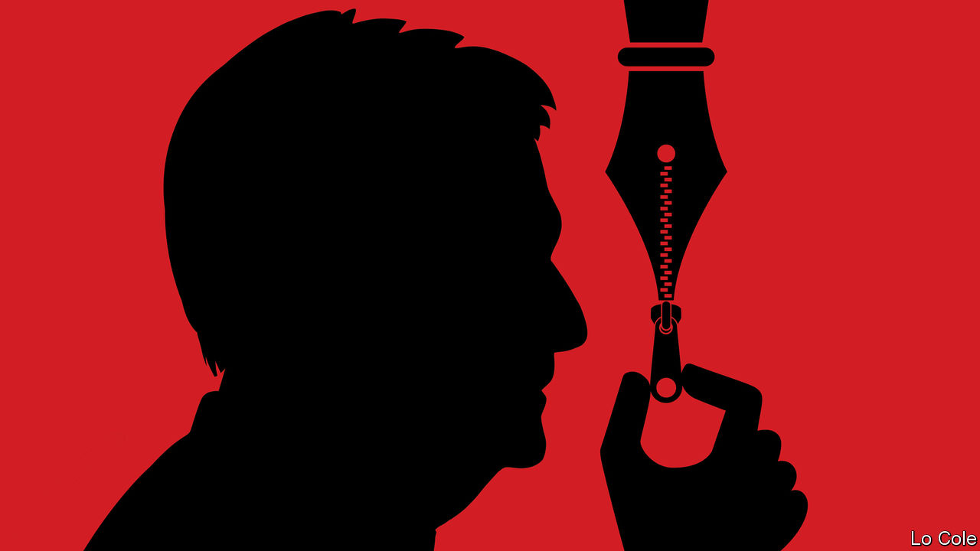

## Mexico’s president

The idea that Andrés Manuel López Obrador might be afraid of two magazines and their editors, who are sharp critics of the Mexican president, would be hilarious, were it not so misleading (Bello, [September 26th](https://www.economist.com/the-americas/2020/09/24/amlos-war-against-the-intelligentsia)). The president thrives in debate and his administration encourages a degree of freedom of the media not seen in Mexico since 1913. He is the only head of state, as far as I know, who holds a daily press conference.

I have known the past seven presidents of Mexico and can testify that Mr López Obrador is the most intellectually inclined among them. He is a voracious reader, particularly of the history and literature of his country, and was a protégé of Carlos Pellicer, a great poet. He is married to a university professor with a PhD in literature. I even expect that, at the end of his term, he will devote his time to academic pursuits.

From your writing I suspect that The Economist is mostly in touch with the upper echelons of Mexican society, the business and financial communities, who feel threatened by change and the new priorities of the government, such as its fight against corruption and inequality. Perhaps you ought to get closer to other parts of society, including underprivileged Mexicans, in order to gain a more balanced view of Mexico these days.

SENATOR HÉCTOR VASCONCELOS  
Chairman of the Foreign Relations Committee in the Mexican Senate  
Mexico City



## A contentious movie

I read your review of “Cuties”, a controversial French film on the hyper-sexualisation of pre-teens (“The dancer and the dance”, [September 19th](https://www.economist.com/books-and-arts/2020/09/19/a-bold-french-film-stirs-controversy-in-america)). You did recognise that the film contains uncomfortable scenes and that its subject matter is “a troubling phenomenon”, but you ultimately called it a “strong debut feature”, ignoring whether the film is legitimate at all.

In the film actresses aged 11 to 13 dance in an extremely sexual manner for long scenes. They are depicted in stages of undress. The Economist, like so many other publications, fell into the trap of defending this work when it deserves censure. Perhaps the fact that right-wing American politicians have condemned the film caused you to laud it. Perhaps because the director is a woman of colour, reflecting her own experience, you thought it was valid commentary. Or perhaps French-language films are just above reproach.

Whatever the reasons, defenders of this film should be ashamed. It is a mechanism for and depiction of the sexual exploitation of minors. It is another sad example of the film industry becoming inured to the images of sexualised underage actors to the point where it doesn’t blink an eye.

LAURA STANTON HAAK  
Washington, DC

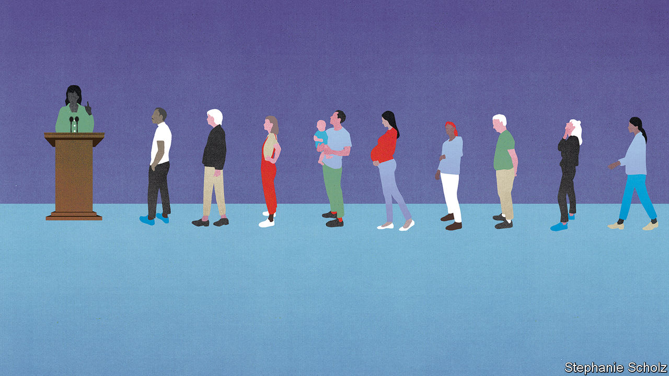

## Deliberative democracy

Your article on the increasing popularity of citizens’ assemblies did not have much to say about the Middle East (“Some assembly required”, [September 19th](https://www.economist.com/international/2020/09/19/citizens-assemblies-are-increasingly-popular)). Steps are being taken in a handful of Arab countries to establish, with Western support, economic and social councils. Although more formal and not as randomly selected than the assemblies you mentioned, these councils have representatives from unions, business, universities and other parts of society and provide advice to the government. Jordan’s council just produced a series of evidence-based studies on the effects of covid-19 on the country.

As your article highlighted, some legitimacy and empowerment would go a long way into making citizens’ assemblies relevant and effective. They could be the secret ingredient to renewing the social contract that the Arab spring failed to achieve.

NADIM KHOURIWashington, DC

* Not all countries are dissatisfied with their democratic institutions. In a study this year researchers at Cambridge University found that the seven countries with the highest political satisfaction all have proportional representation. In countries where the parliament reflects society in terms of age, gender, ethnicity, and so on, there is less need to create a representative citizens’ assembly. The coalition governments in these countries are often better equipped at reaching a cross-party consensus on thorny subjects.  
  
Only three countries in Europe use a “winner-takes-all” system (Belarus, Britain and France). All the others use some form of proportional representation.

KATHRINE SANTOS  
London

* Your advocacy for deliberative democracy brought to mind my own long study of Thomas Jefferson’s promotion of what he called “ward republics”, local citizen assemblies deliberating over the particular concerns of the local community. These assemblies were central to his understanding of the nature of republicanism since early Rome. In a letter written well after leaving the presidency, he stated: “The further the departure from the direct and constant control by the citizens, the less has the government of the ingredient of republicanism.”   
  
To recapture popular sovereignty and empower currently disaffected citizens of America, the more deliberative democracy and local republicanism should be restored.

GARY HART  
Kittredge, Colorado

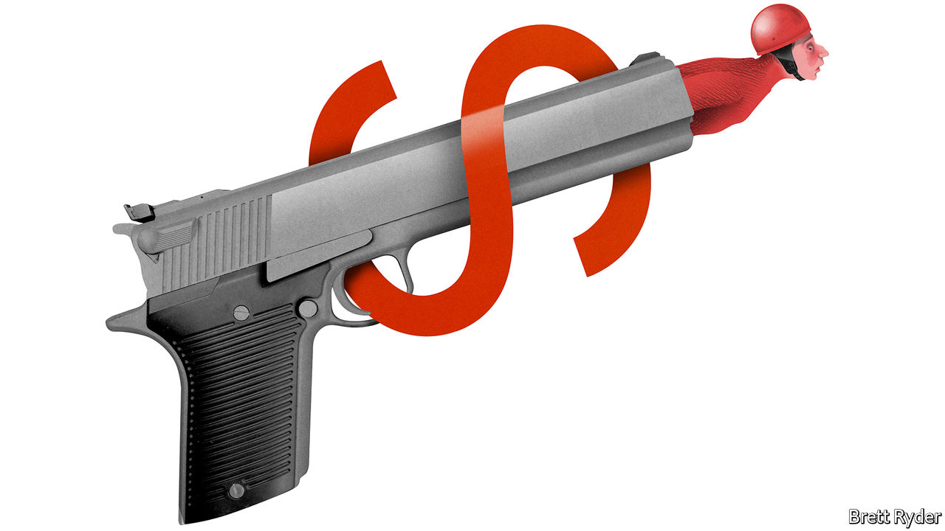

## Friedman on stakeholders

The complexities of stakeholder capitalism were pointed out clearly by Schumpeter ([September 19th](https://www.economist.com/business/2020/09/19/what-is-stakeholder-capitalism)). But although Milton Friedman would perhaps turn in his grave about Walmart’s new corporate strategy embracing “green energy and gay rights”, it would not be a complete 180-degree turn.

Yes, in his famous article from 1970 Friedman declared that those who promote desirable social ends for companies are “preaching pure and unadulterated socialism”. Those opening paragraphs are punchy, but many people stop reading the essay too soon. Because a little further down in the same article Friedman says the following:

“It may well be in the long-run interest of a corporation that is a major employer in a small community to devote resources to providing amenities to that community or to improving its government. That may make it easier to attract desirable employees, it may reduce the wage bill or lessen losses from pilferage and sabotage or have other worthwhile effects.”

Stakeholder capitalism is gaining ground because there is a business case as well as a moral case for it. I think Friedman would have approved.

DANIEL MALAN  
Assistant professor in business ethics  
Trinity College Dublin

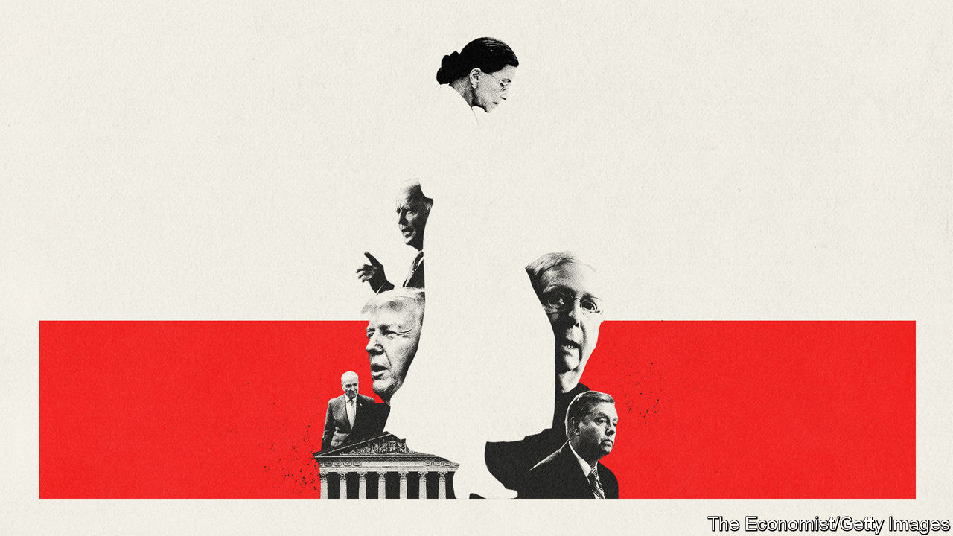

## Renominating John Jay

The chart in “Courting trouble” ([September 26th](https://www.economist.com/united-states/2020/09/26/the-knife-fight-over-ruth-bader-ginsburgs-replacement)) of Supreme Court nominations during a presidential election year had a slight error in it. John Jay’s second nomination was in fact confirmed by the Senate in 1800. However, Jay declined the position. John Adams then nominated John Marshall, his secretary of state, to the court, who went on to become one of its most highly regarded justices. Marshall was nominated by a lame-duck president and confirmed by a lame-duck Senate. Try imagining what would happen if Donald Trump tried to appoint Mike Pompeo to the Supreme Court after losing this election.

BARRY SWEET  
Professor of political science  
Clarion University of Pennsylvania

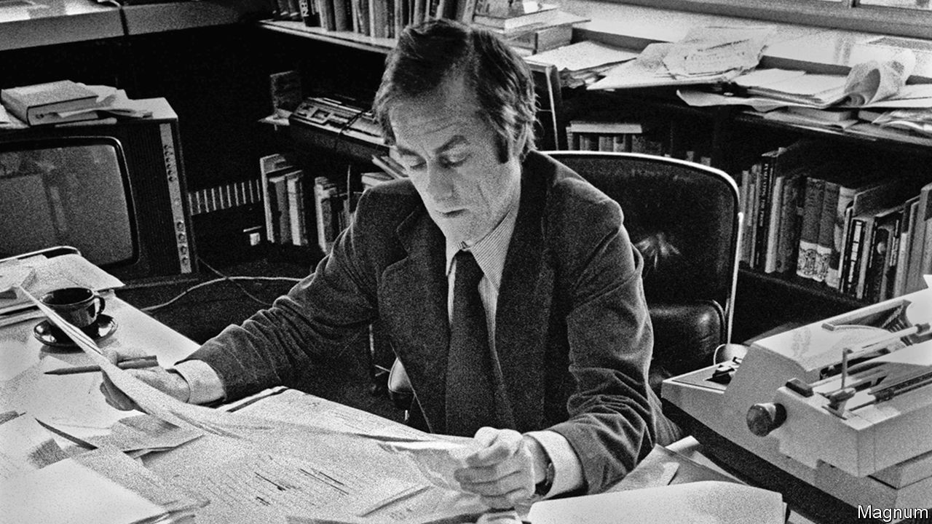

## Read all about it

You rightly praised Harold Evans in your obituary ([October 3rd](https://www.economist.com/obituary/2020/10/03/harold-evans-died-on-september-23rd)) as an outstanding post-war editor. But in lauding his achievement as editor of the Sunday Times you did a disservice to the paper he inherited. The colour section was not Harry’s invention but that of Denis Hamilton who had introduced it five years before, along with founding the Insight team and a separate business section. Far from being a “staid, class-bound broadsheet”, it was a rapidly growing title with a worldwide reputation and a circulation of 1.5m. Hamilton, like Harry, was from the north of England, had left school at 17 to work as a junior reporter on the local Middlesborough paper and as editor of the Sunday Times recruited a range of talent from many backgrounds.

He brought Harold Evans to the paper in 1966 and made him editor a year later. Hamilton continued as editor-in-chief and adviser to Harry.

ADRIAN HAMILTON  
Shepton Mallet, Somerset

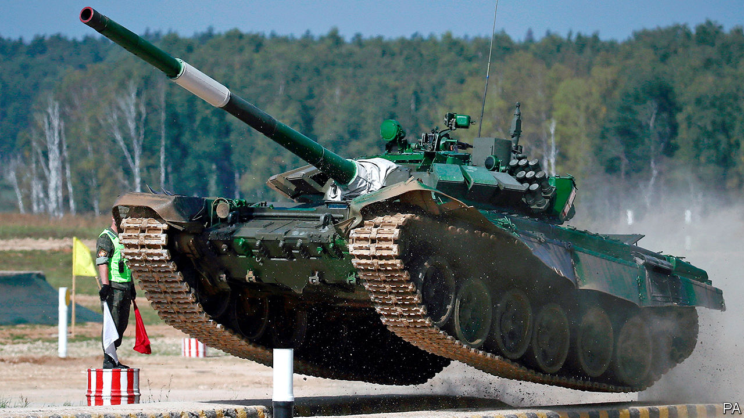

## Tanks for the memories

“Army surplus?” ([September 12th](https://www.economist.com/science-and-technology/2020/09/12/tanks-have-rarely-been-more-vulnerable)) reported that the army’s peak-tank period is probably behind us. However, I think that post-peak-tank the continued existence of the armoured vehicle will serve a purpose of providing the think-tanks referred to in the article with a reason for continuing to think about tanks.

JIM LEWIS  
Basel, Switzerland

* Letters appear online only

This article was downloaded by calibre from <https://www.economist.com/letters/2020/10/10/letters-to-the-editor>

|  |  |  |  |
| --- | --- | --- | --- |
|  | Articles | Sections | Next |

|  |  |  |
| --- | --- | --- |
| Letters | Sections | Asia |

Briefing

Ant’s jumbo IPO: Queen of the colony

.

|  |  |  |
| --- | --- | --- |
| Letters | Sections | Asia |

|  |  |  |  |
| --- | --- | --- | --- |
|  | Articles | Sections | Next |

#### Queen of the colony

# What Ant Group’s IPO says about the future of finance

The giant Chinese fintech upstart is expected to raise more than $30bn, eclipsing Saudi Aramco’s debut last year

Oct 10th 2020 | SHANGHAI

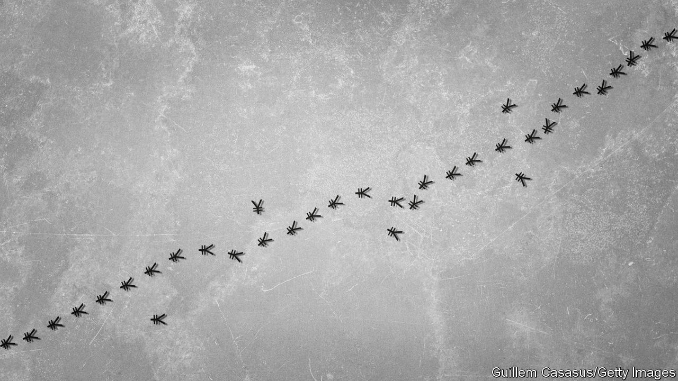

IN THE STAID world of Chinese banking, it is rare for executives to voice public criticism. So Jack Ma, the founder of e-commerce giant Alibaba, made headlines in 2008 when he bemoaned how hard it was for small businesses to get loans: “If the banks don’t change, we’ll change the banks.” He has not repeated his warning since then. He has not needed to.

Through Ant Group, which began life as a payments service on Alibaba, Mr Ma’s impact on the Chinese financial system has been profound. Ant has helped establish China as the world leader in digital transactions, given entrepreneurs and consumers far greater access to loans, and changed the way that people manage their money. It is now a giant in its own right. Over the past year it counted more than 1bn active users. Last year it handled 110trn yuan ($16trn) in payments, nearly 25 times more than PayPal, the biggest online payments platform outside China (see chart 1).

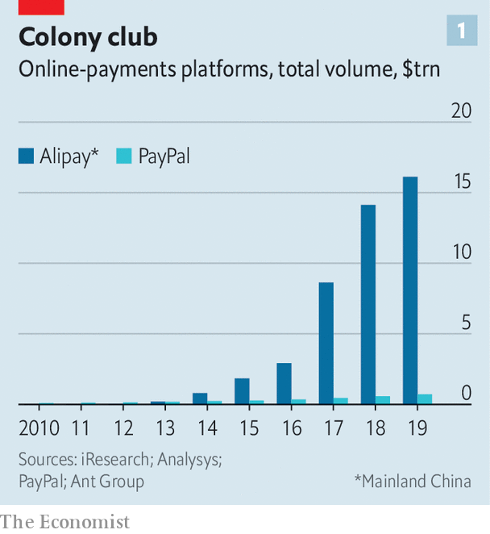

An initial public offering (IPO) in the coming weeks will bear testimony to Ant’s growth. It is expected to raise more than $30bn, eclipsing Saudi Aramco’s debut last year as the biggest IPO—a symbol of the world’s transition from a century in which oil was the most valuable resource to an era that prizes data. With a forward price-to-earnings multiple of 40, in line with big global payments companies, Ant could fetch a market capitalisation in excess of $300bn, more than any bank in the world.

## A four-legged insect

More important than its size is what Ant represents. It matters globally in a way that no other Chinese financial institution does. China’s banks are huge but inefficient, burdened by state ownership. By contrast foreign financiers look at Ant with curiosity, envy and anxiety. Some hawks in the White House reportedly want to rein in the company or hobble its IPO. Ant is the most integrated fintech platform in the world: think of it as a combination of Apple Pay for offline pay, PayPal for online pay, Venmo for transfers, Mastercard for credit cards, JPMorgan Chase for consumer financing and iShares for investing, with an insurance brokerage thrown in for good measure, all in one mobile app.

Given the abundance of consumer data in China and the relatively lax safeguards around its use, Ant has more to work with than fintech peers elsewhere. More than 3,000 variables have gone into its credit-risk models, and its automated systems decide whether to grant loans within three minutes—a claim that may seem far-fetched but for Alibaba’s proven ability to handle 544,000 orders per second. Ant is, in short, the world’s purest example of the tremendous potential of digital finance. But as it advances further, it may also be an early warning of its limitations.

Start with a deceptively simple question: what is Ant? In its decade as an independent company it has changed names three times—from Alibaba E-Commerce to Ant Small and Micro Financial Services to Ant Group. The company once called itself a fintech leader. Then Mr Ma inverted the term to techfin, in order better to capture its priorities. Such are its efforts to distinguish itself from a purely financial firm that it has asked some brokerages to assign tech analysts to cover it. (Of course, it does not hurt that the valuations for tech stocks are much plumper than for bank stocks.)

Yet there is no doubt that Ant, at its heart, is about finance. The clearest way of understanding its business model is to look at the four sections into which it divides its revenues. The first is payments—how it started and still the foundation of the company. Ant began in 2004 as a solution to a problem. Shoppers and merchants were flocking to Alibaba but lacked a trusted payment option. Alipay was created as an escrow account, transferring money to sellers after buyers had received their products. With the launch of a mobile Alipay app, it moved into the offline world, super-charging its growth in 2011 with the introduction of QR codes for payments. A shop owner needed to show only a QR code print-out to accept money, a big advance for a country previously reliant on cash.

For China as a whole, digital transactions reached 201trn yuan in 2019, up from less than 1trn in 2010. Alipay’s market share has been whittled down by Tencent, which added a payments function to WeChat, China’s dominant messaging app. Both companies earn as little as 0.1% per transaction, less than banks do from debit-card swipes. Given the sheer volume, this still adds up to a lot. Ant generated nearly 52bn yuan of revenues from its payments business last year. But growth is slowing, dropping from 55% of Ant’s revenue in 2017 to 36% in the first half of this year. Instead, the crucial point is that payments are a gateway: how Ant attracts users, understands them and ultimately monitors them.

The biggest beneficiary of all this data is Ant’s lending arm, the second part of the company (which Ant, never one to shy away from jargon, calls CreditTech). Ant began consumer lending as recently as 2014, with the launch of Huabei, a revolving unsecured credit line for purchases—basically a virtual credit card. Alipay users can tap into Huabei to defer payments by a month or to break them into instalments. Credit cards had never taken off in China, so Huabei was lapped up. That led to Jiebei, an Alipay feature which allows users to borrow larger sums. Ant also offers loans, with a focus on very small businesses. Annualised interest rates hover between 7% and 14%, lower than the alternatives from small-loan companies.

Like many Ant clients, Zhu Yifan, owner of Rabbits Go Home, a convenience store in Dongyang, an eastern city, started small. Four years ago she and her husband wanted to open their store. With no property as collateral, they could not get a bank loan. Instead, they pulled together money from friends and relatives, and, on a whim, borrowed 10,000 yuan from Ant, the most they could obtain then. By repaying that initial loan and getting customers to use Alipay—giving Ant a look at her cash flow—Ms Zhu’s credit score improved. Now, she has a 100,000 yuan credit line from Ant, which lets her stock up before busy holidays.

In barely half a decade Ant has reached 1.7trn yuan in outstanding consumer loans, or roughly a 15% share of China’s consumer-lending market. Its loans to small businesses total about 400bn yuan, about 5% of the micro-enterprise loan market. From a financial perspective, Ant’s biggest innovation is the way that it funds the credit. Initially, it made the loans and then packaged them as securities, sold to other financial institutions. But regulators feared parallels with the securitisation boom that preceded the financial crisis of 2007-09. They required that the originators of securities hold capital much like any bank—a rule that cut into Ant’s margins.

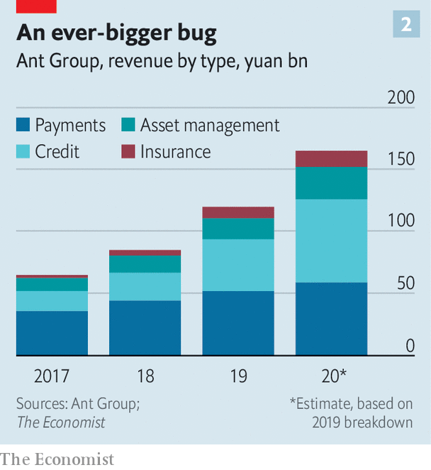

So Ant devised a new approach. It now identifies and assesses borrowers, but passes them on to banks which extend the loans. Ant collects a “technology service fee”. For borrowers it is seamless. With a few taps on their smartphones, their credit requests are approved or rejected. Ant ends up with a cash-rich, asset-light lending model. Fully 98% of the loans are held as assets by other firms. Credit has become Ant’s biggest single business segment, accounting for 39% of its revenues in the first half of this year (see chart 2).

The strength of Ant’s platform is what enables its third and fourth business segments: asset management and insurance (InvestmentTech and InsureTech, to use Ant’s nomenclature). Ant got started on asset management in 2013 with the launch of Yu’ebao, or “leftover treasure”. The idea was that merchants or shoppers with cash in Alipay could get a small return by parking it in a money-market fund. That attracted people interested in Yu’ebao purely for storing cash, since its yields (now roughly 1.7%) were higher than those available on current accounts at banks. By 2017 Yu’ebao had given rise to the world’s biggest money-market fund by size.

Ant broadened its offerings to become one of China’s most powerful distribution channels for investments. Today 170 companies sell more than 6,000 products such as stock and bond funds on Ant. Altogether these firms have roughly 4.1trn yuan in assets under management enabled by the app. As with its lending business, Ant screens prospective clients and directs them to products. It then collects a service fee. “Our growth on Ant has been faster than on any other digital platform,” says Li Li, deputy CEO of Invesco Great Wall Fund Management. Her group’s two money-market funds soared from 665m yuan in assets under management in early 2018, when it started selling them on Ant, to 114bn yuan in June.

Ant’s push into insurance happened more recently. For a decade it offered shipping insurance for purchases on Alibaba, letting dissatisfied customers return goods for no charge. But it is only in the past two years that it has applied its asset-management template to insurance. In partnership with big insurance firms, it has unveiled life, car and medical insurance—again collecting fees as a distribution platform. Asset management and insurance now make up nearly a quarter of revenues.

## All the ants are marching

Simply looking at the numbers, Ant can appear unstoppable. It has chalked up dizzying growth rates in every market that it has targeted. It benefits from the network effects so familiar in the tech world: the more people use it, the stronger its attraction for yet more borrowers, lenders and investors. It is a virtuous cycle, especially for Ant’s shareholders. Nevertheless, there exist three kinds of risks that could slow it down: regulatory, competitive and those that are intrinsic to its own model.

The regulatory landscape in China is treacherous. Officials endlessly tweak rules for banks and investors, patching up holes as they emerge in the fast-growing but debt-laden economy. Many have long assumed that the government will give Ant, a private-sector firm, only so much leeway in the state-controlled system.

Indeed, regulators have already put numerous hurdles in Ant’s path. Its first attempt at launching a virtual credit card was blocked. The securitisation crackdown upended its lending model. A government plan to standardise QR codes could weaken it in payments, potentially reducing Ant’s market dominance. Another new rule, taking effect in November, will force Ant to hold more capital.

But if all these hurdles were meant to stop Ant, they have not succeeded. So there exists an alternative explanation. Regulators, wary of the pitfalls in financial innovation, continue to erect guardrails around Ant. In general, though, they like it. Not only has it steered credit towards small consumers and businesses, it has also given the government more information about money flows. Duncan Clark, author of a biography of Jack Ma, notes that regulators have long struggled to monitor all corners of China, referencing the old saying that the mountains are high and the emperor far away. “Ant has basically let Beijing tunnel through the mountains and fly drones over their summits,” he says.

Another threat to Ant is its competitors. Until 2013 mobile pay was, more or less, Ant’s exclusive domain. But Tencent has used its ubiquitous WeChat app to muscle in, taking nearly a 40% market share. Other firms also have financial ambitions. Meituan, an app known for food delivery, now also offers credit. The financial arm of JD.com, an e-commerce firm, and Lufax, an online wealth-management platform, are on track for IPOs this year.

So far these competitors have a much smaller financial footprint than Ant’s. Partly this is because they do not have the same breadth. Shawn Yang of Blue Lotus, a boutique Chinese investment bank, says that Tencent, for instance, has high-frequency but low-value consumption data, less rich than the trove that Ant has thanks to Alibaba, which accounts for more than half of Chinese online retail sales.

But it is also a matter of business culture. The most controversial episode in Ant’s history came in 2011 when Mr Ma spun it out from Alibaba, without notifying SoftBank and Yahoo, which together held about 70% of Alibaba’s shares back then. Mr Ma explained that Chinese regulations forbade foreigners from owning domestic payments firms, though there may have been work-arounds. Some suspected that he wanted to bring in powerful investors closer to home. Ant’s earliest rounds of fundraising as an independent firm did indeed attract major state-owned enterprises. A stake was also sold to a private equity firm managed by the grandson of Jiang Zemin, China’s paramount leader during Alibaba’s early years.

Yet in retrospect the spin-off has a clear strategic rationale. As a standalone company Ant has had the motivation to explore distant corners of the banking system and act aggressively. An executive with another e-commerce company says that its financial unit worries about making mistakes that might taint the group’s core retail business. Ant, by contrast, has diversified, with less than 10% of its revenues now from Alibaba. For China’s other e-commerce dynamos, its success offers a template. They may be several years behind but the fintech race is far from over.

The final danger for Ant has the most global resonance: the nature of its model. Unsecured lending to small borrowers is risky, whichever way it is done. Indeed the coronavirus pandemic has offered a sharp test for Ant. Delinquent loans (more than 30 days past due) issued via its app nearly doubled from 1.5% of its outstanding total in 2019 to 2.9% in July. Yet that is better than most other banks in China. Is that because of Ant’s prowess? Some critics say that it reflects its market power. Given the centrality of Alipay and Alibaba to their operations, few dare to default on Ant loans, worried that a downgraded credit rating may damage other parts of their business.

Still, many bankers are persuaded that Ant truly does have an advantage in its analytics. “They don’t need quarterly statements. They see your daily flow of funds. They know who your customer is. They know who your customer’s customer is,” says one. Based on the address for e-commerce deliveries, Ant has more up-to-date information about where someone lives and works than a bank. Based on what that person buys, Ant can work out their income bracket and their habits, preferences and way of life.

But according to Hui Chen, a finance professor at Massachusetts Institute of Technology who has worked on research projects with Ant, individual and systemic risks are different. The machine learning that underpins Ant’s algorithms observes individual behaviour again and again, and is then able to detect patterns and anomalies. But if risks do not appear in the historical data—say, a big economic shock—the same machine learning may stumble.

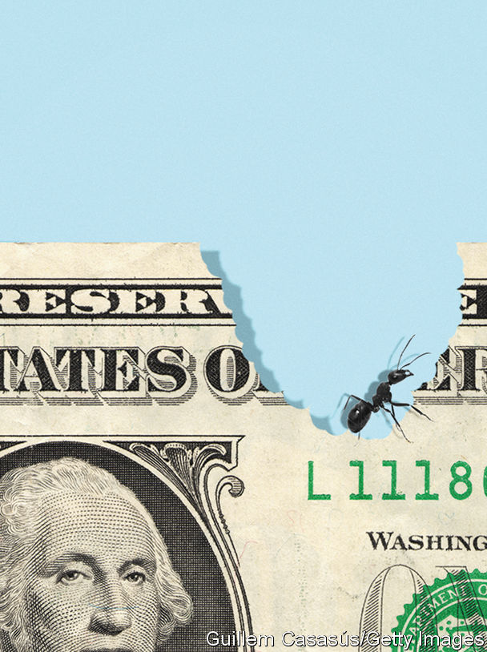

There are also some limitations hard-wired into Ant’s strategy. By design, it aims for high-volume, small-scale borrowers and investors. “Their analytical advantage is most significant with this mass market, where traditional banking models are most inaccessible,” says Mr Chen. Most corporate lending—about 60% of all credit in China—will remain off limits. Ant also has an awkward relationship with banks. It relies on them to fund the loans on its platform, but as it grows it may become a competitor in their eyes. For now that is not much of a concern, given that it focuses on borrowers ignored by banks. But it means that Ant must befriend the very institutions that it once set out to disrupt.

Doubts exist about its investment and insurance platforms, too. Ant has excelled in selling money-market funds to a plethora of retail investors. Moving up the value chain could be harder. “They are great at selling penny products. But that’s not where you make the money in insurance,” says Sam Radwan of Enhance, a consultancy. To close a deal on a valuable, complex policy like a variable annuity, brokers typically speak with consumers several times. “No ordinary customer is going to trust an online broker for something that complicated,” says Mr Radwan.

## Doing the jitterbug

Ant’s global ambitions are also running into problems beyond its control. It has stakes in around ten different fintech companies in Asia, such as Paytm in India. Boosters once imagined a world connected by Ant, its credit-to-investment architecture straddling borders. The first blow to that vision came in 2018 when America blocked Ant’s acquisition of MoneyGram, a money-transfer firm, which would have established Ant as a force in global remittances. Security concerns over Ant have increased as China’s foreign policy has become more aggressive. Little wonder that Ant plans to devote just a tenth of its IPO proceeds to cross-border expansion.

Despite all these limitations, one lesson from Ant’s decade in existence is that future possibilities remain vast. Ms Li of Invesco gushes about her fund-management firm’s mini-site within the Alipay app, one of the tens of thousands of separate sections that constitute the Ant ecosystem. In September Invesco hosted a live-stream on the mini-site to discuss its market outlook. More than 700,000 tuned in—just one example of how Ant has become the main doorway into the financial system for tens of millions of people. And for all those who have walked through it, many more have not. Ant will soon know where they live, how much they earn and what they want. It is coming for them. ■

This article was downloaded by calibre from <https://www.economist.com/briefing/2020/10/10/what-ant-groups-ipo-says-about-the-future-of-finance>

|  |  |  |  |
| --- | --- | --- | --- |
|  | Articles | Sections | Next |

|  |  |  |
| --- | --- | --- |
| Briefing | Sections | China |

Asia

War over Taiwan: Strait shooting

.

Kyrgyzstan: Take three

.

Elections in Tajikistan: Ballot-ticking exercise

.

Polio in Pakistan and Afghanistan: Deliverance delayed

.

A big K-pop IPO: Woke blokes

.

Banyan: Modi the multi-tasker

.

|  |  |  |
| --- | --- | --- |
| Briefing | Sections | China |

|  |  |  |  |
| --- | --- | --- | --- |
|  | Articles | Sections | Next |

#### Strait shooting

# Defending Taiwan is growing costlier and deadlier

Would America have the stomach for such a fight?

Oct 10th 2020 | ZHUWEI

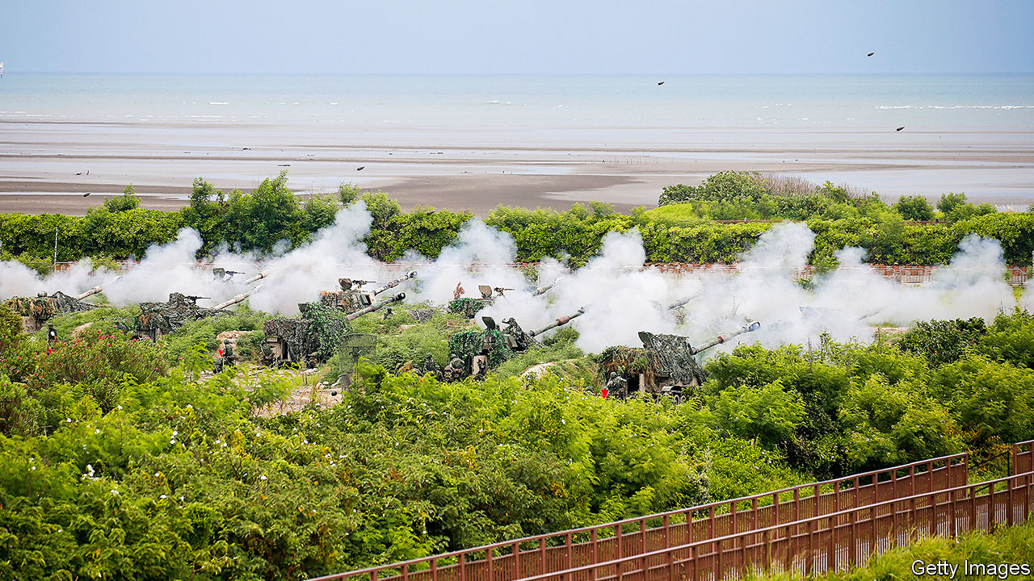

ROUSING MUSIC accompanies the H-6K, a hulking Chinese bomber, as it sweeps up into a pink sky. Moments later, its pilot presses a red button, with the panache and fortitude that only a People’s Liberation Army (PLA) officer could muster, and a missile streaks towards the island of Guam. The ground ripples and a fiery explosion consumes America’s Andersen air force base. Never mind that the PLA propaganda film released in September pinches footage from Hollywood blockbusters; the message is that this is what America can expect if it is foolhardy enough to intervene on behalf of Taiwan in a regional war.

China’s Communist Party claims Taiwan, a democratic and prosperous country of 24m people, although the island has not been ruled from the mainland since 1949. A tense peace is maintained as long as Taiwan continues to say that it is part of China, even if not part of the People’s Republic. China once hoped that reunification could be achieved bloodlessly through growing economic and cultural ties. But two-thirds of Taiwanese no longer identify as Chinese, and 60% have an unfavourable view of China. In January Tsai Ing-wen of the Democratic Progressive Party was resoundingly re-elected as president over a China-friendly rival.

Last year Xi Jinping, China’s leader, declared unification to be an “inevitable requirement for the historical rejuvenation of the Chinese nation”. The PLA has stepped up pressure on Taiwan in recent months, sending warplanes across the “median line” that long served as an unofficial maritime boundary and holding large naval drills off several parts of Taiwan’s coast.

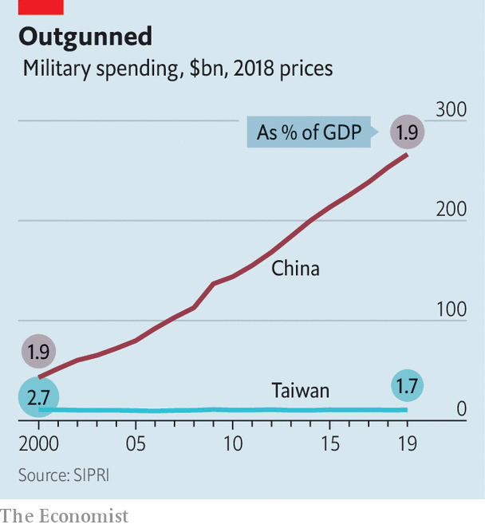

Defending Taiwan is growing ever harder. A decade ago China had four times as many warships as Taiwan. Today it has six times as many. It has six times the number of warplanes and eight times as many tanks. China’s defence budget, merely double Taiwan’s at the end of the 1990s, is now 25 times greater (see chart).

American intelligence officials do not think that China is about to unleash this firepower. The PLA’s amphibious fleet has grown slowly in recent years. China has never held even a single exercise on the scale that would be required for a D-Day-type campaign. Indeed, no country has assaulted a well-defended shore since America did so in Korea—with good reason.

Although China could wipe out Taiwan’s navy and air force, says William Murray of the US Naval War College, the island would still be able to fire anti-ship missiles at an invading armada, picking out targets with mobile radar units hidden in the mountainous interior. That could make mincemeat of big ships crossing a narrow strait (see map). “The PLA can’t use precision weapons to attack small, mobile things,” says Ethan Lee, who as chief of general staff at Taiwan’s defence ministry in 2017-19 developed a strategy for asymmetrical warfare.

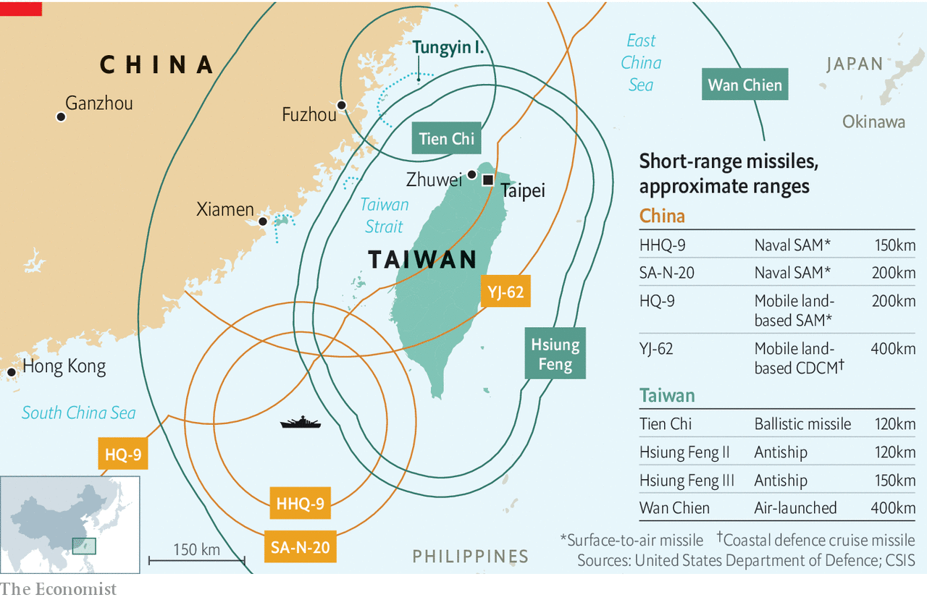

Nor can China put all its forces to use. “Only a fraction of the PLA could be deployed,” says Dennis Blasko, a former American army attaché in Beijing, “because its overwhelming numbers can’t all fit into the Taiwan front or in the airspace surrounding Taiwan at one time”. Satellite reconnaissance would give Taiwan weeks of warning to harden defences and mobilise reserves. Mr Blasko thinks a nimbler air assault, using helicopters and special forces, is more likely than an amphibious attack. Even then, he says, the island is “very defensible, if it is properly prepared and the people have the will to defend it”.

Alas, Taiwan’s preparedness and its will to fight both look shaky. “The sad truth is that Taiwan’s army has trouble with training across the board,” says Tanner Greer, an analyst who spent nine months studying the island’s defences last year. “I have met artillery observers who have never seen their own mortars fired.” Despite long-standing efforts to make the island indigestible, Taiwan’s armed forces are still overinvested in warplanes and tanks. Many insiders are accordingly pessimistic about its ability to hold out. Mr Greer says that of two dozen conscripts he interviewed, “only one was more confident in Taiwan’s ability to resist China after going through the conscript system.” Less than half of Taiwanese polled in August evinced a willingness to fight if war came.

A vital question is therefore whether Americans would do so, for the sake of a distant country whose defence spending has fallen steadily as a share of GDP over two decades. America does not have a formal alliance with Taiwan. But it sells the island weapons—$13bn-worth over the past four years—and has long implied that it would help repel an invasion if Taiwan had not provoked one. Yet the same trend that imperils Taiwan in the first place—China’s growing military power—also raises the price of American involvement.

In wargames set five or more years in the future, “the United States starts losing people and hardware in the theatre very quickly,” says David Ochmanek of the RAND Corporation, a think-tank. “Surface combatants tend to stay far from the fight, forward air bases get heavily attacked and we’re unable to project power sufficiently into the battlespace to defeat the invasion.” America is disadvantaged by geography, with its air force reliant on a handful of Asian bases well within range of Chinese missiles. American bombers can swoop in from the safety of American soil, but there is a shortage of missiles to arm them. Nor is it clear how America’s technology-dependent armed forces would fare against an inevitable physical and electronic barrage on their satellites and computer networks.

In another wargame conducted earlier this year, the Centre for a New American Security (CNAS), another think-tank, assumed that Taiwan would fight tenaciously and that America would have access to weapons still under development. Under those rosier circumstances, the island survives—at least after ten notional days of combat—but even then only at huge cost. The seas around Taiwan would look “like no-man’s-land at the Somme”, notes Christopher Dougherty of CNAS.

The question is whether America has the stomach for this. The conquest of Taiwan would not just dent American prestige but also expose the outlying islands of Japan, an ally America is pledged to defend. The Trump administration has sent several high-level officials to Taipei to show its support—one reason for the recent Chinese bluster. In Congress support for Taiwan is at “new highs”, says Bonnie Glaser of the Centre for Strategic and International Studies (CSIS), another think-tank.

Polls by CSIS show that Americans broadly support coming to Taiwan’s aid, roughly as much as they support helping South Korea, Japan or Australia. Such enthusiasm may wane, however, if American ships start getting sunk in large numbers. American losses in the CNAS wargame amount to a hundred or so aircraft, dozens of ships and perhaps a couple of carriers. “An aircraft-carrier has 5,000 people on it,” says Mr Murray. “That’s 100 voters in every state of our union. That’s a lot of funerals.”

Fear of such losses might deter an American president from entering the fray. But incurring them might stiffen American resolve. America and its partners can use this dynamic to their advantage, says Elbridge Colby, a former Pentagon official. If American troops were to disperse in allied countries like Japan and draw on allied support to repel a Chinese attack, China would have to choose between striking a wide range of targets beyond Taiwan, and outraging American and Asian public opinion, or sacrificing military advantage.

Escalation might go even further. The fact that Chinese nuclear missiles can now reach any American city raises the stakes dramatically. “When the bullets really start flying,” says Michael Hunzeker of George Mason University, “the American people, most of whom can’t find Taiwan on a map, will be hard-pressed to say, ‘No, I’m really willing to trade Los Angeles for Taipei.’”

Taiwanese officials acknowledge these grim trends. Even if America is willing to come to Taiwan’s aid, that is no use if it is not capable of doing so, Su Chi, a former secretary-general of Taiwan’s National Security Council, has argued. But the logical response, transforming Taiwan’s own defences, is hard when only a fifth of people think war will come. In the sleepy fishing village of Zhuwei, on the north-west coast, an area thought to be a prime landing site for the PLA, tourists eat stir-fried seafood in restaurants as multicoloured fishing vessels bob in the harbour. “The Chinese won’t invade,” says Lin Fu-fun, an airport safety inspector who has come to watch the waves splash on a jagged breakwater. “Our language and culture are the same.” ■

This article was downloaded by calibre from <https://www.economist.com/asia/2020/10/10/defending-taiwan-is-growing-costlier-and-deadlier>

|  |  |  |  |
| --- | --- | --- | --- |
|  | Articles | Sections | Next |

|  |  |  |  |
| --- | --- | --- | --- |
| Previous | Articles | Sections | Next |

#### Take three

# Angry Kyrgyz rebel against a tainted election—for the third time

The president has offered to annul the results, but protesters want him to step down

Oct 7th 2020 | ALMATY

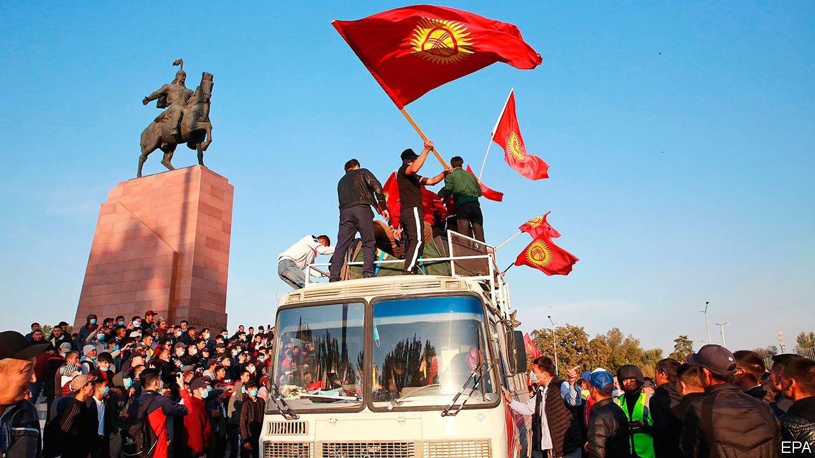

ONE THING is clear: the people of Kyrgyzstan are not keen on tainted elections. This week, for the third time in 15 years, they rose up in rebellion following a vote widely seen as crooked. Adakhan Madumarov, an opposition leader, describes the parliamentary poll on October 4th as the dirtiest in Kyrgyzstan’s turbulent three decades of independence. On October 5th thousands poured onto the main square of Bishkek, the capital, in protest. That night demonstrators battled riot police before storming the building housing the president’s office and parliament. They were shouting a revolutionary slogan popularised in previous uprisings but now directed at the current president, Sooronbay Jeyenbekov: “Ketsin!” (“Go!”)

Mr Jeyenbekov insists he remains in control, but his whereabouts are unknown. He has dismissed complaints about the elections as a “pretext” to attempt his overthrow. Yet he has also acquiesced to at least one of the protesters’ demands: electoral officials have annulled the results of the election and promised a re-run. It is not clear that this will satisfy the angry mob in Bishkek, however, which has freed several politicians who had landed in jail in recent years, including Almazbek Atambayev, Mr Jeyenbekov’s predecessor. Some outgoing MPs are trying to impeach Mr Jeyenbekov and the prime minister, Kubatbek Boronov, has resigned.

Kyrgyzstan has held several competitive elections—an oddity in Central Asia, where crushing landslides for autocratic rulers are the norm (see article). As he cast his ballot this week, Mr Jeyenbekov doggedly insisted the election was “open and fair”. Videos circulating on social media, however, showed voters being brought by minibus to polling places, where they handed photos of the ballots they had cast to men with clipboards. At the very least, there was rampant vote-buying ($25 was the going rate). The preliminary results announced on October 5th would have left only five of the 16 parties participating with any seats in parliament. Two parties loyal to the president won a big majority: Birimdik (Unity), which Mr Jeyenbekov tacitly backed, and Mekenim Kyrgyzstan (My Homeland Kyrgyzstan), which has ties to Raimbek Matraimov, a wealthy former customs official. Last year corruption-busting journalists accused Mr Matraimov of complicity in a multibillion-dollar smuggling ring. The main source behind the exposé was murdered in a gangland-style killing. Mr Matraimov has denied the allegations and was not charged with any crimes.

The opposition parties are already failing to find common cause, with bickering between rival factions sometimes descending into fisticuffs. The threat of violence hangs in the air, as politicians sprung from jail and other influential figures (including some with rumoured connections to organised crime) jostle to fill the vacuum. A comeback by Mr Atambayev, who presided over flourishing corruption and a degradation of democracy that has continued under Mr Jeyenbekov, would prove unpopular in many quarters.

Two rivals are already laying claim to the job of prime minister: Tilek Toktogaziyev, a youthful entrepreneur, and Sadyr Japarov, a rabble-rousing nationalist ex-MP released by the protesters from jail, where he had been sent for kidnapping an official during a previous bout of political turmoil. China, which is alarmed at reports that the protesters are targeting Chinese-owned gold mines, has expressed concern. So has Russia, which has a military base in Kyrgyzstan and is hostile to popular uprisings in what it still sees as its backyard, particularly given the sustained protests against authoritarian rule in Belarus.

The confusion may help Mr Jeyenbekov hang on, though his hopes of securing a pliant parliament in his remaining three years in office have been scotched. Whatever happens, however, Kyrgyzstan’s democracy is a victim. The succession from Mr Jeyenbekov to Mr Atambayev was hailed as Central Asia’s first peaceful and democratic transfer of power. A one-term limit had been imposed on the presidency, to impede future power grabs. In retrospect, the cheerleaders were too optimistic. ■

This article was downloaded by calibre from <https://www.economist.com/asia/2020/10/07/angry-kyrgyz-rebel-against-a-tainted-election-for-the-third-time>

|  |  |  |  |
| --- | --- | --- | --- |
| Previous | Articles | Sections | Next |

|  |  |  |  |
| --- | --- | --- | --- |
| Previous | Articles | Sections | Next |

#### Ballot-ticking exercise

# Why Tajikistan’s president will win a fifth term

Emomali Rahmon has arrested or chased away any better candidates

Oct 10th 2020 | ALMATY

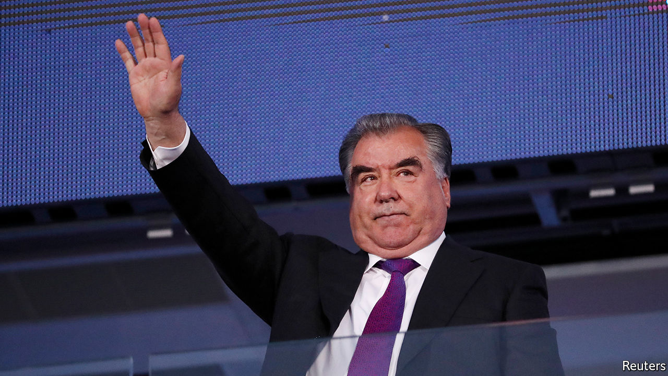

ELECTIONS IN TAJIKISTAN are a staid affair compared with Kyrgyzstan’s. When voters go to the polls to elect a president on October 11th, the ballot paper will offer them a false choice: either tick the box next to the name of Emomali Rahmon, the strongman who has ruled for 28 years, or choose one of four stooges also on the ballot and watch Mr Rahmon storm to victory anyway. The only question is how big a landslide Mr Rahmon will award himself: it would be poor form if he did not better the 84% he won in 2013.

The Founder of Peace and National Unity, Leader of the Nation—to give Mr Rahmon his official title—faces no genuine opposition because he has rooted it out with zeal. In 2015 a court banned the moderate Islamic Renaissance Party of Tajikistan, his main challenger, branding it a terrorist group. Its leader, Muhiddin Kabiri, fled abroad. Other senior members were put in jail, where some have died in mysterious circumstances (officially, in a “prison riot”). Umarali Quvvatov, the leader of a reformist movement called Group 24, which is also outlawed in Tajikistan, was gunned down in Istanbul in 2015.

More recently the government has turned its sights on the National Alliance of Tajikistan, a coalition of dissidents living in Europe. Last year, a court—predictably—found the group guilty of terrorism and banned it. The alliance has called for a boycott of this election, as has the Social Democratic Party of Tajikistan, the last legal opposition movement left inside the country. It did take part in a rigged parliamentary election in March, winning a meagre 0.3% of the vote and no seats.

There had been speculation that the 68-year-old Mr Rahmon, the longest-serving leader in the former Soviet Union, was thinking of stepping down. He came to power in 1992 during a civil war which he eventually ended by negotiating a power-sharing deal. To many older voters, therefore, he embodies peace and stability (even though he later reneged on the pact).

Still, he appears to be looking to the future. He has been grooming his son, Rustam Emomali, as his successor. In April Mr Emomali, already mayor of the capital, Dushanbe, became speaker of the Senate, too. That means he would become acting president if the incumbent were to step down—not that Mr Rahmon seems inclined to do so very soon. ■

This article was downloaded by calibre from <https://www.economist.com/asia/2020/10/10/why-tajikistans-president-will-win-a-fifth-term>

|  |  |  |  |
| --- | --- | --- | --- |
| Previous | Articles | Sections | Next |

|  |  |  |  |
| --- | --- | --- | --- |
| Previous | Articles | Sections | Next |

#### Deliverance delayed

# Pakistan and Afghanistan are the last countries fighting polio

Covid-19 has contributed to a resurgence in the poliovirus

Oct 10th 2020 | LAHORE

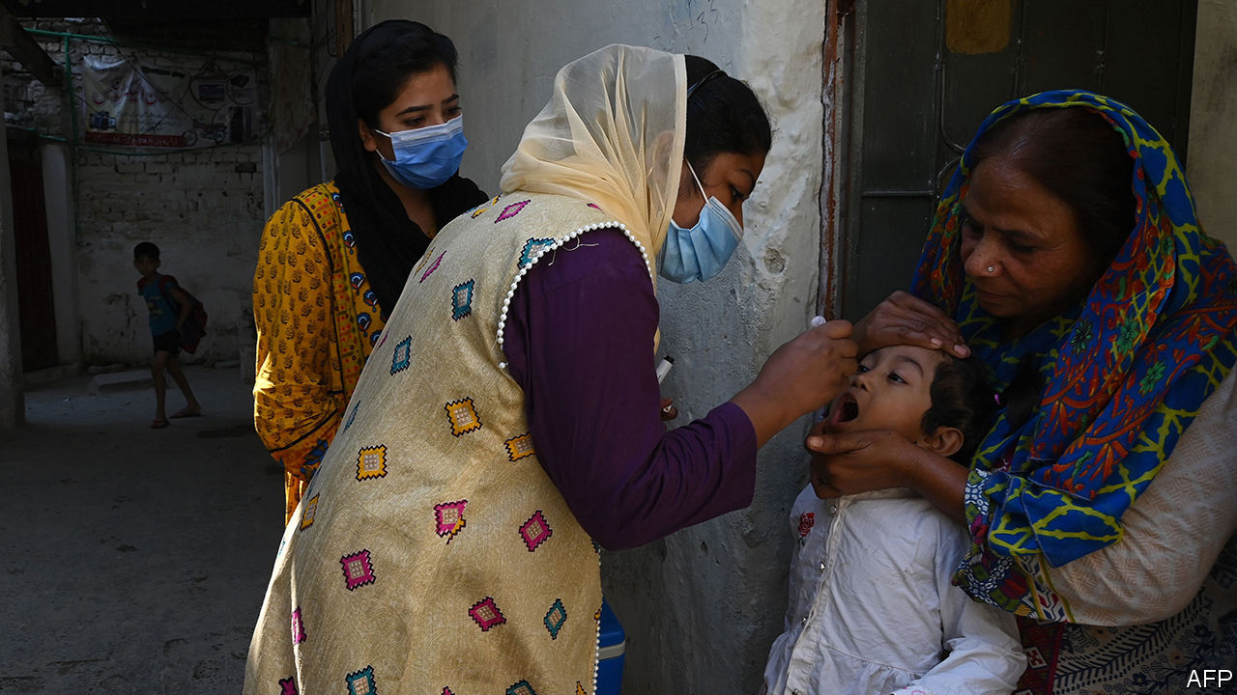

CLIPBOARD IN ONE hand and polio drops in the other, Afshaan Shaukat walks her neighbourhood methodically. The dense lanes of houses, workshops and kiosks close to Lahore’s splendid Badshahi mosque are her beat. She knows which family lives behind each gate, how many children they have and often their names, too. Undaunted by the frazzling heat, she spends hours knocking at house after house. Her task is simple, yet exacting: she must administer drops to every young child in the neighbourhood, making sure no one demurs or goes undetected.

Pakistan’s polio-vaccination drive involves a remarkable mass-mobilisation of workers like Ms Shaukat. She and her brother, Humza, make up one of 4,000 door-to-door teams in Lahore alone. Another 1,000 teams hang around waiting to vaccinate children in bazaars and bus stations. Nationwide there are 260,000 vaccinators at work, chasing 40m children.

Despite the pandemic gloom, the world reached a welcome public-health milestone in August when Africa was declared free of wild poliovirus (cases derived from mutations of the weakened version of the virus used in the oral vaccine still crop up in some countries). Thirty years ago some 350,000 people around the world were afflicted by the crippling virus each year; now it survives only in Afghanistan and Pakistan. Yet in those two countries, despite the efforts of Ms Shaukat, the news is far from good.

An international monitoring board of public-health specialists has declared the programme to stamp out polio in the two countries to be in “dire straits”. The number of cases in Pakistan has risen after a “jaw-dropping slump of performance”. Nationwide cases had fallen to 12 in 2018, only to jump to 147 last year. Across the border in Afghanistan the insurgents of the Taliban have prohibited door-to-door teams in areas they control, leaving many children unvaccinated. On top of that, covid-19 halted vaccination campaigns in both countries for four months. A polio-free world now seems “a distant pinpoint of light”, say the monitors.

The coronavirus has meant that Ms Shaukat has added a face mask and bottle of hand-sanitiser to her kit, but things in Lahore were already on the slide. Pakistan’s cultural capital recorded five cases last year, having been polio-free since 2011. Another two have appeared so far this year. Sewage samples once showed no trace of the virus; now they now detect it everywhere. Complacency had set in, officials admit, letting polio creep back from its strongholds in the cities of Karachi and Quetta and along the border with Afghanistan. What is more, disinformation and conspiracy theories, including the claim that the vaccinators are in fact administering a drug to sterilise children as part of a Western plot to weaken Islam, have spread like wildfire on social media. Last year a health worker and two police guards were killed in a series of attacks on vaccinators around the country and panicked parents rushed thousands of children to hospital for fear the vaccine was poisoning them.

The campaign has six months to sort itself out. Otherwise, the monitors reckon, “the wheels will come off the Pakistan bus.” Dr Rana Muhammad Safdar says an overhaul is already under way. As national polio co-ordinator from 2015 to 2019, he steered the campaign within touching distance of eliminating the bug and has returned to prevent further regression. Politicians, unusually, have united behind the campaign and harmful rumours are being rebutted, says the doctor. While he acknowledges that covid-19 has slowed momentum as medical staff switch their focus, he says he is confident the ground can be made up. Indeed, some officials say the fight against coronavirus has sharpened the public-health service.

India’s example shows that progress can be fast, says Dr Hamid Jafari, the World Health Organisation’s polio-eradication director in the region. That country went from 741 cases in 2009 to 42 the next year and registered its last in 2011. That breakthrough, he says, brings to mind a saying of Nelson Mandela: “It always seems impossible until it’s done.” ■

This article was downloaded by calibre from <https://www.economist.com/asia/2020/10/10/pakistan-and-afghanistan-are-the-last-countries-fighting-polio>

|  |  |  |  |
| --- | --- | --- | --- |
| Previous | Articles | Sections | Next |

|  |  |  |  |
| --- | --- | --- | --- |
| Previous | Articles | Sections | Next |

#### Woke blokes

# The company behind BTS, K-pop’s biggest act, is going public

The boy band has found success by defying oafish stereotypes

Oct 10th 2020 | SEOUL



FOR THE past couple of years, the biggest news in the world of K-pop has been decidedly unpleasant. A scandal centred on “Burning Sun”, a glitzy nightclub in Seoul, South Korea’s capital, saw several male K-pop stars and industry executives accused last year of sexual abuse, procuring sex for business partners, drug-peddling and bribery. Later in the year two female idols committed suicide in the space of a few weeks. Both had been subject to misogynistic abuse for years.

But the industry’s biggest stars seem untouched by its seedy side. BTS, the world’s most successful K-pop group and the biggest boy band on the planet, has found global success by selling something close to the opposite of the machismo and aloofness that are usually required from K-pop idols. The seven 20-something men present themselves as down-to-earth, frank about the pressures and downsides of fame, socially engaged and aware of their own shortcomings. When fans got upset about a set of sexist lyrics a few years ago, the member who wrote them apologised for his ignorance and vowed to “study more” to avoid such lapses in future (he has since been spotted reading a feminist novel). And when American fans asked the group to support the Black Lives Matter protests this year, they promptly did.

Such behaviour resonates with fans in South Korea and beyond. “The message they send is so different from other boy bands,” says Lim Hyun-jee, a 26-year-old from Seoul. “They talk about growth, mental health, bullying and anything that we can all relate to,” she gushes. “And they get along so well, it’s very appealing.”

Hong Seok-kyeong of Seoul National University believes that BTS’s success stems partly from the hope they offer a generation of fans worn down by the pressure to compete and conform in their education and careers. “Both in their songs and in their interactions with fans they show that they can relate to these pressures,” she says. “Their whole story suggests that it’s OK to be different and that you can still be successful even if you don’t really fit in.” She thinks that young women, in particular, like their softer, emotionally vulnerable brand of masculinity as an alternative to South Korean machismo. Being pretty helps, of course. “The way they make themselves beautiful is very much about providing visual pleasure to a female audience.”

Some Korean feminists speculate that the band’s woman-friendly image is too good to be true, given the sexist norms of the industry in which they work. Others take it at face value. At the very least, BTS’s success has shown that niceness is a marketable quality, which may encourage others to give it a try. The numbers speak for themselves. After teetering on the brink of bankruptcy a decade ago, Bang Si-hyuk, who founded BTS’s production company, Big Hit Entertainment, is now a squillionaire. The company’s planned listing on the Korean stock exchange on October 15th looks set to make him and BTS even richer. Massively oversubscribed by both institutional investors and hardened fans, it is expected to value Big Hit at $4bn or so. ■

This article was downloaded by calibre from <https://www.economist.com/asia/2020/10/10/the-company-behind-bts-k-pops-biggest-act-is-going-public>

|  |  |  |  |
| --- | --- | --- | --- |
| Previous | Articles | Sections | Next |

|  |  |  |  |
| --- | --- | --- | --- |
| Previous | Articles | Sections | Next |

#### Banyan

# For good and ill, India’s prime minister is hard at work

Narendra Modi is ramming through reforms with little consultation

Oct 10th 2020 |

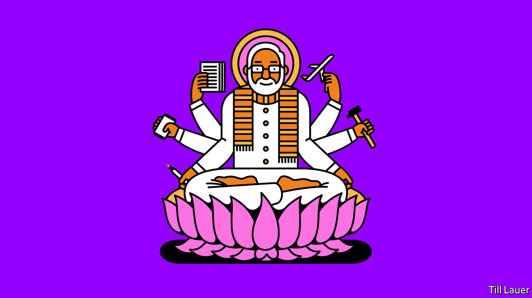

LAST YEAR Pratap Bhanu Mehta, the most Olympian of India’s public intellectuals, infuriated many of his compatriots. Instead of lauding the audacity of a government that had just imposed direct rule on Jammu and Kashmir, India’s most troubled state and its sole Muslim-majority one, Mr Mehta issued a warning. We should not cheer the “Indianisation” of Kashmir, he said, but rather fear a creeping “Kashmirisation” of India. The focus should not be on what Narendra Modi, the prime minister, wanted Indians to see: an assertion of national (read Hindu majoritarian) will and an end to decades of flaccid ambiguity over the territory, which is claimed by Pakistan. Rather, argued Mr Mehta, it should be on what was meant to remain unseen in Kashmir: the failure of the world’s biggest democracy to respect its most basic constitutional responsibility, to seek the consent of the governed.

In his first term, before his thumping re-election last year, Mr Modi often reflected such dualities. He could speak of unity while practising the politics of division, or talk of freeing markets while entrenching the power of the state, or publicly champion the little man while privately pandering to mighty plutocrats. Now well into his second term, the prime minister seems not only to have kept his Janus face, but to have sprouted the extra arms of a Hindu deity.

In a few short weeks his government has pushed through an impressive stack of laws. Tackling issues that have for decades been cobwebbed by political point-scoring, it has among other things taken bold steps to free farming from state control, untangle stifling labour rules, revise public education and reform the bureaucracy. The new regulations on labour, for instance, collapse 44 laws into four simplified national codes.

The moves are understandably controversial. They take a sledgehammer to chunks of the patriarchal socialist state, erected in the early decades of India’s independence, that had escaped earlier bouts of liberalisation. Mr Modi’s numerous and noisy acolytes are proclaiming a great moment of transition. Even critics of his government concede that, whether or not the specific laws are well-considered, Mr Modi has at least shaken trees that needed shaking and at last shown the mettle to do what he had promised, but failed to deliver, in his first term.

Yet all this welcome vigour in the foreground cannot completely disguise what happens in the background. Just as with one arm Mr Modi unshackles India’s economy, with another he is quashing hard-won freedoms. His government used not only its bigger numbers, but petty rules, a highly dubious voice-vote and an opposition walk-out to ram more than two dozen laws through parliament in a single week.

Away from parliament, too, the Modi government’s disdain for due process grows ever more striking. To a degree unprecedented even in India’s murky politics, it has turned ostensibly impartial agencies of the state, such as the police, into blunt instruments of executive power. And in their zeal to promote a glowing narrative, the prime minister’s supporters go to bizarre lengths to mute or discredit contrary views. This is not just a matter of critics facing bogus lawsuits or tax demands. During one recent media frenzy, an army of sycophantic television anchors and online trolls screamed murder after a Bollywood actor’s tragic suicide, just to besmirch a political party that opposes Mr Modi’s.

Behind all the noise, what such antics reveal is an increasingly pronounced aspect of the Modi era that residents of Kashmir, in particular, are all too familiar with: hypocrisy. Consider foreign funding. Citing national security and the need for accountability, the Modi government has selectively throttled donations to groups it does not like. Over six years some 15,000 NGOs have been forced to shut, the latest being the Indian office of Amnesty International, a human-rights defender. Yet with another hand, Mr Modi pulls a veil over political funding, as well as over the personal “emergency” fund for the prime minister that was set up during the pandemic.

Whatever he is doing with all his other hands, Mr Modi is always sure to keep one free for waving at crowds. In “liberated” Kashmir last year, cameras caught him on a ship on Lake Dal, standing erect like an admiral of the fleet. More recently he was pictured at the opening of a road tunnel high in the Himalayas, standing aboard a jeep, again waving. But a closer view of both scenes revealed something else. There were no crowds, only security men.

This article was downloaded by calibre from <https://www.economist.com/asia/2020/10/10/for-good-and-ill-indias-prime-minister-is-hard-at-work>

|  |  |  |  |
| --- | --- | --- | --- |
| Previous | Articles | Sections | Next |

|  |  |  |
| --- | --- | --- |
| Asia | Sections | United States |

China

Law in Hong Kong: Slow strangulation

.

The Dongba script: Rune revival

.

|  |  |  |
| --- | --- | --- |
| Asia | Sections | United States |

|  |  |  |  |
| --- | --- | --- | --- |
|  | Articles | Sections | Next |

#### Slow strangulation

# Hong Kong’s new security law is being applied sparingly, so far

Pro-democracy campaigners should not feel relieved

Oct 8th 2020 | HONG KONG

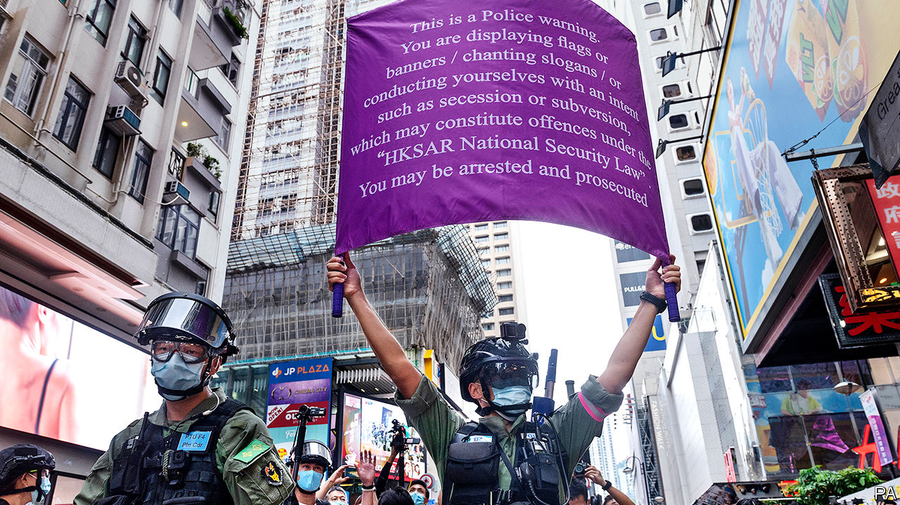

REMINDERS OF HONG KONG’s draconian new security law are everywhere. It is advertised on billboards and giant hoardings (“Restore stability,” they enjoin). During scattered protests on October 1st, China’s national day, Hong Kong’s police raised purple banners warning demonstrators that their slogans or flags may incur charges of secession or subversion under the act. Fear of it is everywhere, too. On the same day a year ago, hundreds of thousands of people joined unauthorised demonstrations calling for full democracy. Now only the very brave are prepared to protest without police approval.

Many of the activists involved in the unrest that swept Hong Kong for months last year are keeping their heads down. Some have been organising workshops to teach like-minded citizens how the mainland’s secret police work—the new law allows its state-security officers to operate in Hong Kong. Those attending include people working in NGOs that are likely to face scrutiny under the act (the law calls for strengthened “management” of foreign groups). They learn how to evade surveillance by using encrypted apps and VPNs and how to respond to questions by police—tactics that are second nature to dissidents on the mainland, but unfamiliar to many in once carefree Hong Kong.

Among those who were at the forefront of last year’s protests, alarm has risen since August 23rd, when Hong Kong’s police confirmed that their mainland counterparts had seized 12 people trying to flee the territory by boat. They had been intercepted in mainland waters, apparently on their way to Taiwan. At least one of them had been accused in Hong Kong of violating the security law (though he had not been formally charged). They are being held across the border in Shenzhen, where their treatment has been a chilling reminder of how mainland justice works. Officials have called them “separatists”. They are being denied family visits. They may use only state-appointed lawyers. “I don’t think anyone else will try to flee by boat now,” says a Hong Konger with several friends who have already escaped to Taiwan. “Our thinking now is that we would rather spend ten years in a Hong Kong jail than disappear into the mainland system.”

So far, however, the law has been sparingly applied. Hundreds of people have been arrested for protest-related offences since the central government in Beijing imposed the act on June 30th. They include Joshua Wong, one of Hong Kong’s most prominent activists. But the police have accused them of violating other statutes, not the security law. Mr Wong’s alleged crimes are joining an illegal gathering last year and ignoring a (pre-covid) ban on mask-wearing by protesters.

Only about 30 people have been arrested under the new law. Among them is Jimmy Lai, a media tycoon and outspoken champion of pro-democracy causes. He has been accused of collusion with foreign forces. But he has not (yet) been formally charged with that offence and is out on bail.

The only person who has been prosecuted is Tong Ying-kit. He has been charged with terrorism for allegedly ramming his motorcycle into three police officers, and with incitement to secession for flying a flag on the back of the bike with the words “Liberate Hong Kong, revolution of our times”—a slogan often used during last year’s protests. Mr Tong’s case is being argued in an open court “in a way that would be unimaginable under the mainland legal system”, says Danny Gittings, a legal scholar. There have been no reports of the new law being used against foreign firms.

But anti-government activists are right to be afraid. On September 30th Luo Huining, the mainland’s top official in Hong Kong, said the security law had ended what he called “savage” unrest. But were protests to flare up as they did last year, with demonstrators surrounding mainland-government offices and throwing stones and petrol bombs, the central government would surely urge more sweeping use of the new act. Under it, Mr Luo has been appointed as a national-security “adviser” to Hong Kong’s government. In effect, that means he calls the shots on such matters.

It is clear already that mainland officials are frustrated with the way some of Hong Kong’s prosecutors and judges have been handling cases involving protesters. Since the unrest began in June 2019, more than 10,000 people have been arrested in connection with it. But only around 20% of them have been formally charged (Hong Kong’s post-colonial constitution, the Basic Law, says that decisions on whether to prosecute must be “free from any interference”). Communist Party-controlled newspapers in Hong Kong frequently complain about charges being dropped or sentences being too light. They blame “yellow” influence in the legal apparatus, referring to the symbolic colour of the protest movement.

To ensure that protesters charged under the old laws are dealt with as harshly as possible, pro-Communist politicians have been demanding “legal reform”. They want the government to set up a sentencing committee, which would set clearer guidelines for how specific crimes should be punished. They also want a “special court” set up to handle cases involving rioting and to guarantee they are fast-tracked.

The national-security law may have shattered the notion of Hong Kong being run according to a framework of “one country, two systems”. But it is not yet the case that every wish of mainland officials is immediately acted on in the territory. On September 23rd Hong Kong’s chief justice, Geoffrey Ma, issued a lengthy statement in defence of the territory’s legal system. “There must not be a politicisation of the judiciary and its functions,” he wrote. Pro-Communist media and politicians grumbled that he had dodged their demands.

Worryingly, debate has flared up over how independent the judiciary should be. In August it emerged that new editions of school textbooks would not refer to a “separation of powers” between the judiciary, executive and legislature in Hong Kong. The territory’s chief executive, Carrie Lam, defended this, insisting that Hong Kong was “executive-led”—even though Mr Ma himself had said in 2014 that the Basic Law “sets out clearly the principle” that there should be such a separation.

Public anxiety was fuelled last month by the resignation of an Australian judge, James Spigelman, from Hong Kong’s Court of Final Appeal. Mr Spigelman, one of 14 foreign judges who sit on the territory’s highest court, said his decision was “related to the content of the national-security legislation”. He has not elaborated.

As a bellwether of how robust Hong Kong’s judiciary remains, all eyes will be on the case of Mr Lai, the media entrepreneur currently on bail. Mr Lai has been a thorn in the side of the Communist Party since it massacred protesters in Beijing in 1989. His newspaper, Apple Daily, is one of Hong Kong’s biggest-selling and among the most critical of the party. “I’m not sure what is going to happen,” says Mr Lai. But he has no doubt that the party “will decide how to treat me based on what is most politically expedient for them”. Few in Hong Kong are in much doubt of that either. ■

This article was downloaded by calibre from <https://www.economist.com/china/2020/10/08/hong-kongs-new-security-law-is-being-applied-sparingly-so-far>

|  |  |  |  |
| --- | --- | --- | --- |
|  | Articles | Sections | Next |

|  |  |  |  |
| --- | --- | --- | --- |
| Previous | Articles | Sections | Next |

#### Rune revival

# Pictographs survive in a Chinese tourist town

But locals are reminded that being “civilised” requires use of standard Chinese

Oct 10th 2020 | LIJIANG



DURING THE “golden week” national holiday that began on October 1st, hundreds of thousands of sightseers flocked to Lijiang, a picturesque historic town in the south-western province of Yunnan. Among its attractions are the symbols printed beneath the Chinese characters on road signs and shop fronts (Starbucks included). They are Dongba pictographs, an ancient form of writing that originated among the Naxi, a local ethnic group. It was almost defunct until about a decade ago, when local officials cottoned on to its touristic value and plastered the town with the script.

Dongba was never widely used by the Naxi, of whom there are about 300,000 living in the Himalayan foothills near Lijiang, as well as in adjacent Tibet and Sichuan province. Their elite spoke Chinese and used it for written communications (a few Chinese characters are pictographic, but Dongba is mainly so). The pictographs, which evolved as early as the seventh century, were developed by shamans of the Dongba faith, which has roots in Tibet. When called upon, the wizards would don a five-lobed crown and pray for divine favours. The roughly 2,000 pictographs would help them to recall the chants. As in ancient Egypt, the glyphs were also used as rebuses (ie, for their sounds alone) to form new words.

Over 20,000 of these religious records survive. They provide rich insight into how Naxi people thought about warfare, geography, astronomy and agriculture. But they are devilishly hard to read. Linguists are helped by the area’s Dongba priests. There are about 600, most of them very old, including Yang Guoxing who ran a school from 2010 to 2015 to teach Dongba to children living in the mountains. When Mr Yang was growing up, “everyone was too busy farming” to learn it. Now they are all busy soaking up China’s dominant Han pop culture, he says, shuffling outdoors to offer rites for safe travel to a gaggle of tourists.

Signs at bus stations in rural Yunnan urge locals to use written and spoken Chinese if they “want to be civilised”. But the Naxi get off lightly compared with ethnic minorities in Tibet, Xinjiang and Inner Mongolia, where officials have been stepping up efforts to purge regional languages from schools. Primary schools in Lijiang teach the Dongba script twice a week, as well as Naxi nursery rhymes. Li Dejing, the head of the Dongba Culture Research Institute, says this is not just about keeping alive the pictographs, but letting children grasp “the very spirit of their own culture”. And, as the government would see it, helping tourism to thrive in Lijiang.

This article was downloaded by calibre from <https://www.economist.com/china/2020/10/10/pictographs-survive-in-a-chinese-tourist-town>

|  |  |  |  |
| --- | --- | --- | --- |
| Previous | Articles | Sections | Next |

|  |  |  |
| --- | --- | --- |
| China | Sections | The Americas |

United States

Covid-19 in the White House: A sick body politic

.

The vice-presidential debate: Rumble of the understudies

.

Voter suppression: A battleground in Texas

.

Neck-and-neck in Ohio: Swinging again

.

Jobs (i): Entrepreneurship: Startup nation

.

Jobs (ii): Lay-offs: A second wave

.

Lexington: The battle in miniature

.

|  |  |  |
| --- | --- | --- |
| China | Sections | The Americas |

|  |  |  |  |
| --- | --- | --- | --- |
|  | Articles | Sections | Next |

#### Covid-19 in the White House

# The virus has hit President Donald Trump and his re-election hopes

The president’s covid-defiance is putting off plenty of voters, including some Republicans

Oct 10th 2020 |

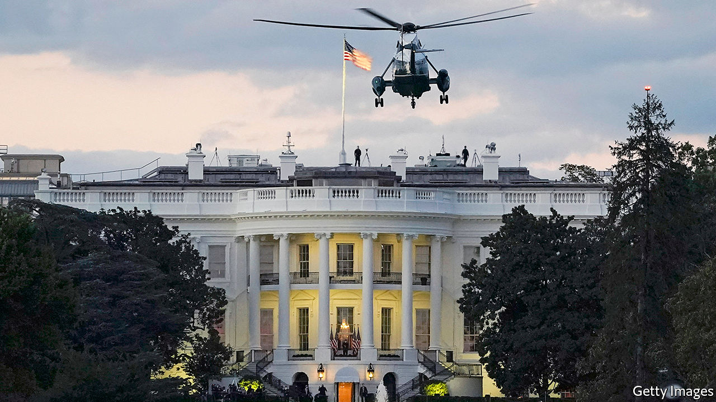

PRESIDENTIAL HISTORY is replete with lies and evasions concerning the state of the commander-in-chief’s health. Grover Cleveland underwent secret cancer surgery, in the dead of night, aboard a yacht anchored in Long Island Sound. An ailing Franklin D. Roosevelt won the election in 1944 while claiming to be in the pink—and died three months into his new term. Rumours persist that Ronald Reagan began showing signs of dementia while in office. That the current administration has been less than straightforward about when Donald Trump contracted covid-19, what his subsequent movements were and how sick he remains might have been the most normal drama of his entire presidency.

Yet, as always, he writes his own script. Whereas Roosevelt sought to underplay his sickness, Mr Trump has gone overboard in claiming to have not merely survived the coronavirus, but vanquished it. After three nights in Walter Reed Medical Centre, following his tweeted announcement of a positive covid-19 test on October 2nd, Mr Trump declared that he had not felt better in 20 years, had “learned a lot” about the virus, then got himself discharged.

Back at the White House, he ascended to the Truman balcony, turned to face the cameras and slowly peeled off his face-mask. In subsequent video messages, he called on Americans not to let the virus “dominate your life” and suggested he might be immune to a virus that, according to his doctors, had caused his blood-oxygen level to plummet three days earlier.

The criticism of his actions has been immense—including from parts of the conservative media. More than 210,000 Americans have died of the virus, which Mr Trump downplayed long before he claimed to have conquered it. Five days before his first positive test he presided over a largely maskless gathering at the White House in honour of his latest Supreme Court nominee, Amy Coney Barrett. Two days before it he mocked Joe Biden, in the first presidential debate, for the Democrat’s punctilious mask-wearing. So many of the attendees at the White House event have since come down with the virus, in addition to Mr Trump and his wife Melania, that the media are calling it a superspreader event. And still Mr Trump is trying to find an angle in anti-facemaskism.

Stricken attendees at the White House gathering include Kellyanne Conway, a senior Trump adviser; Chris Christie, a former governor of New Jersey; and, in Mike Lee and Thom Tillis, two Republican senators whose votes will be required to vote Mrs Barrett onto the Supreme Court bench.

Inside the rabbit-hutch offices of the West Wing, the infection rate is higher. The president’s speechwriter, Stephen Miller, another senior aide, Hope Hicks, the press secretary, Kayleigh McEnany, and four of her colleagues are among the afflicted. So are two periodic White House visitors, Bill Stepien, the president’s campaign manager, and Ronna McDaniel, chair of the Republican National Committee. The minority of White House employees showing up to work, according to a memo leaked to the New York Times, have been told to wear surgical masks and gowns during any close encounter with the president. This might not seem like a good moment to trumpet masklessness.

Mr Trump was never likely to adopt the covid-contrite demeanour some conservative commentators have recommended. It is not in his nature. Squint hard, however, and there is a sort of rationale for his covid-defiance. Contrition, at this point, might look like an admission of responsibility for a public-health calamity that most Democrats and independents already blame him for. To stop that rot spreading to his own supporters, his defiance is in essence an effort to use his personal hold on them to try to change the subject.

There are two problems with this—the first of which represents the central flaw in Mr Trump’s political calculus from the moment he bagged the presidency. Having begun his term as the most unpopular incumbent on record, he needed to reach beyond his base to be sure of re-election. Instead he has revved up his supporters furiously, with hyper-partisan rhetoric and a diet of cultural grievance. His laughter-in-the-face-of-covid strategy is the latest example. This has had predictable results. Polls conducted in the wake of his boorish attack on Mr Biden in the debate suggest almost everyone outside MAGA world is mobilising against him.

A CNN survey puts Mr Biden 16 points ahead—the worst poll for an incumbent this close to an election—even though it showed Mr Trump’s support, at 41%, to be little changed. The average of polls shows a similar trend, though with a nine-point margin. Surveys of the battleground states, which have been consistently better for the president than his overall ratings, bring worse news. He is trailing Mr Biden in Pennsylvania, the state considered likeliest to give Mr Biden an electoral-college majority, by seven points.

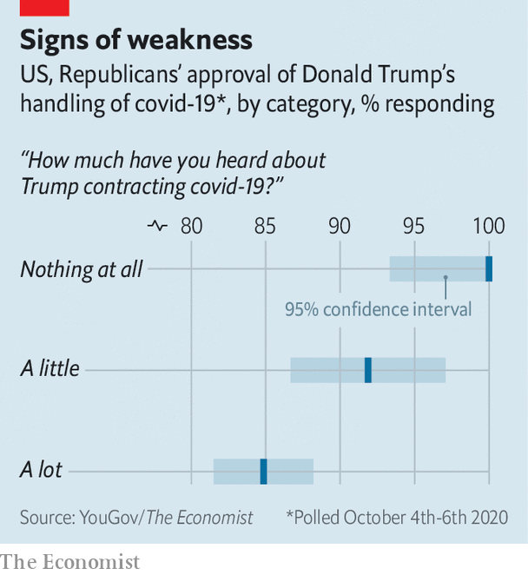

The second problem is that Mr Trump’s covid messaging may be starting to turn off Republicans. YouGov polling for The Economist suggests that the more Republican voters hear of his illness, the more harshly they are liable to judge him on his management of the pandemic (see chart). One reason for this may be that the conservative media bubble, into which bad news about Mr Trump rarely percolates, has little choice but to propagate the fact that he and many in his White House have come down with covid.

Another, more intriguing, possibility is that this small slippage points to a nascent reconsideration of the president by his most tenuous supporters, a group of traditional pro-business conservatives, sometimes referred to as “reluctant Trumpers”. A late addition to the Trump train, members of this group, which represents perhaps 10% of the president’s base overall, are especially likely to prize the economy and competence. If Mr Trump lost them, he would be on track for an electoral wipeout.

It is too soon to predict that. Though weakened, he could still be only a lucky break or two from returning to serious contention. Yet, with time running out, he now faces three conspicuous obstacles in the way of that possible recovery.

## Hurdles on the road to victory

One is his own health. Though Mr Trump is said to be showing no symptoms, obese 74-year-old men tend not to recover from covid-19 as rapidly as that would imply. A second is the health of his aides, fellow Republicans and the White House attendants who have also been laid low. They will be receiving less elaborate medical care than the president; Mr Christie is morbidly obese. Mr Trump needs them all to recover without major upset if he is to move the media’s attention elsewhere.

The third hurdle is the economy, which is both Mr Trump’s strongest issue, and spluttering. Labour-market figures for September point to a pronounced slowdown in job creation. That is why the mooted fresh dose of stimulus spending that Steve Mnuchin, the Treasury secretary, and House Democrats had been arduously negotiating also looked so important to Mr Trump’s re-election prospects. And yet on October 6th, in another show of strength-in-weakness, the president abruptly called off those negotiations. It was as unfathomable an action as holding an unmasked gathering during a pandemic.■

Dig deeper:  
Read the [best of our 2020 campaign coverage](https://www.economist.com/us-election-2020) and explore our [election forecasts](https://projects.economist.com/us-2020-forecast/president), then sign up for Checks and Balance, our [weekly newsletter](https://www.economist.com/checksandbalance/) and [podcast](https://play.acast.com/podcasts/2020/01/24/checks-and-balance-our-new-weekly-podcast-on-american-politics) on American politics.

This article was downloaded by calibre from <https://www.economist.com/united-states/2020/10/10/the-virus-has-hit-president-donald-trump-and-his-re-election-hopes>

|  |  |  |  |
| --- | --- | --- | --- |
|  | Articles | Sections | Next |

|  |  |  |  |
| --- | --- | --- | --- |
| Previous | Articles | Sections | Next |

#### The Veep debate

# Mike Pence v Kamala Harris ends in a normal sort of a draw

The battle of the understudies casts them as plausible presidential successors

Oct 8th 2020 | WASHINGTON, DC

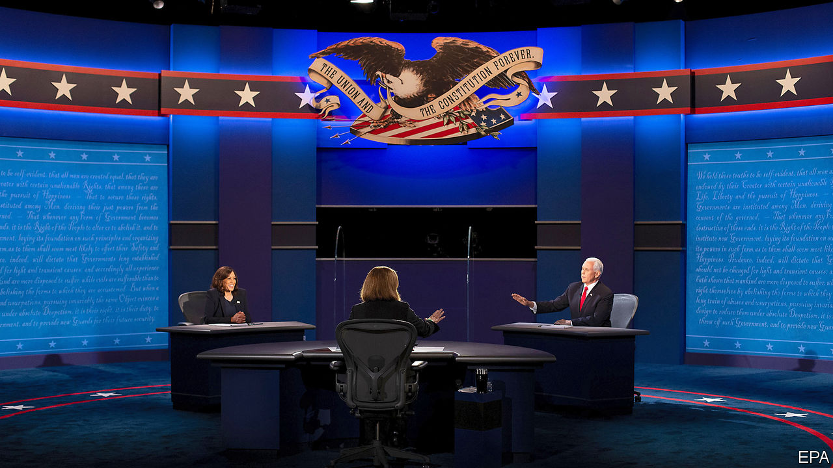

THE TELEVISED debate between Mike Pence and Kamala Harris on October 7th had been ballyhooed even before the president’s covid-19 diagnosis underlined the mortality of the election’s top billing. Donald Trump and Joe Biden are both vying to be the oldest newly elected president. Mr Trump is 74 and obese; Mr Biden is 77 and can seem older. It follows that the winner’s deputy, Mr Pence or Ms Harris, will assume the role of presidential understudy with an unusually good chance of being suddenly promoted to the top job.

From that narrow perspective, the vice-president and the senator from California both cleared the bar. Over the course of a 90-minute debate that was mostly pro-forma, occasionally illuminating and fundamentally normal compared with the ill-tempered shouting match that was last week’s presidential encounter, both projected professionalism and competence. Mr Pence, a skilful performer, who comes across as far more mainstream than a reputation for religious zealotry might suggest, would be a more than acceptable stand-in for Mr Trump. Ms Harris, a charismatic figure with solid government experience, appears equally up to the job of first reserve.

No “Veep” face-off has ever had a significant electoral impact. Even so, Mr Pence and Ms Harris will both feel they had modest success in shoring up their ticket’s weaknesses. The Democrat’s task was easier. She has no record to defend and Mr Trump’s handling of the coronavirus—“the greatest failure of any presidential administration in the history of our country”, she called it—was an unmissable target. One of the Trump campaign’s scare stories, that she is the radical pulling Mr Biden’s strings, was always likely to dissolve in contact with her pragmatism.

Ms Harris appears far more comfortable relaying Mr Biden’s centrist message, of a helping hand to the working guy and nothing too crazy, than pushing the leftist platform that she ill-advisedly compiled for her own presidential run. She also boasted of Mr Biden having assembled “one of broadest coalitions of folks you’ve ever seen in a presidential race”, including “seven members of George W. Bush’s cabinet”. That is not something a true leftie would want to advertise.

Yet nobody makes a better fist of selling Mr Trump’s record than his polished deputy. On the coronavirus disaster, Mr Pence scored points merely by sounding sympathetic to those who have suffered. He also made a better case against Mr Biden and his party by restricting his criticisms to the bounds of reality. Mr Trump has failed to paint Mr Biden as a deranged socialist. Mr Pence’s pressing of Ms Harris on the implications of his vow to scrap the Trump tax cuts for its middle-class beneficiaries seemed likelier to impress swing voters.

Yet as this proceeded, it began to feel no more relevant than the usual constrained, forgettable “Veep” debate. An inevitable sense that both debaters are mainly trying to avoid messing up is unexciting. It reflects the central truth that the importance of the vice-president has not risen remotely in step with the ever-swelling powers and mystique of the presidency. If anything, it has come to seem more nondescript by comparison—as brilliantly satirised in the eponymous HBO show that spanned Mr Biden’s second term in the job and most of Mr Pence’s. The peculiar dynamics of this year’s election have also to some degree accentuated this effect.

Some Democrats feared Ms Harris’s charisma might put Mr Biden in the shade. Yet his party chose him precisely because his blandness felt appropriately low-risk for the big push against Mr Trump. There is no demand for pizzazz on the left currently.

Similarly, if Mr Pence’s policy smarts and cogency might impress some of the tiny number of undecided voters that remain, they also underline how little demand there is for those qualities in the president’s party currently. Their day will come again. And when it does it will be interesting to see what survives of Mr Pence’s odd patchwork of small-government verities and America First sabre-rattling. For the meantime, however, it was all too easy to become distracted from the vice-president’s claimed convictions by a fly that settled, for more than two minutes, atop his snow-white head.■

Dig deeper:  
Read the [best of our 2020 campaign coverage](https://www.economist.com/us-election-2020) and explore our [election forecasts](https://projects.economist.com/us-2020-forecast/president), then sign up for Checks and Balance, our [weekly newsletter](https://www.economist.com/checksandbalance/) and [podcast](https://www.economist.com/podcasts/2020/01/24/checks-and-balance-our-new-weekly-podcast-on-american-politics) on American politics.

This article was downloaded by calibre from <https://www.economist.com/united-states/2020/10/08/mike-pence-v-kamala-harris-ends-in-a-normal-sort-of-a-draw>

|  |  |  |  |
| --- | --- | --- | --- |
| Previous | Articles | Sections | Next |

|  |  |  |  |
| --- | --- | --- | --- |
| Previous | Articles | Sections | Next |

#### Voter suppression

# At risk of losing Texas, Republicans scheme to limit Democratic votes

The state is becoming younger and less white. It is not outlandish to imagine that Republicans would try to keep turnout low

Oct 10th 2020 | WASHINGTON, DC

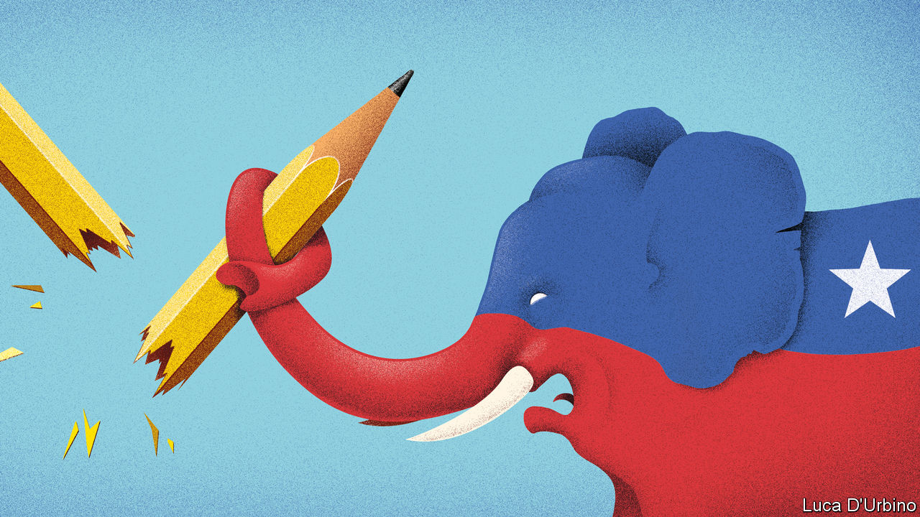

ON THE SURFACE, the decision made almost no sense, but on deeper inspection its insidious intent seems clear. Last week Greg Abbott, the Republican governor of Texas, ordered counties to close extra drop-off sites for absentee votes until they have only one each. The move means that the 4.7m residents of Harris County, which surrounds Houston, will all have to converge on the same drop-box if they wish to cast an absentee vote in person. Such restrictions might make sense for Loving County (population 169), but the decision could deter many of Harris’s majority non-white and urban folk from voting. The story is similar in the state’s other cities.

Mr Abbott has cited voter fraud as a justification for his decision. According to the governor, absentee voting (which is not common in Texas, as the state restricts the practice mainly to disabled, sick or elderly residents) gives fraudsters a chance to influence the election. Yet there is no evidence that such fraud takes place often enough to be a real concern.

Instead, Mr Abbott’s critics allege that his move is meant to decrease turnout to keep his party in power. Jeremy Smith, the CEO of Civitech, a company that works to get Democrats elected, argues that Texas’s history of voter suppression has helped politicians like Mr Abbott stay in office by decreasing turnout for non-whites and the young. That, says Mr Smith, has made the government reflect an unrepresentative electorate of whiter, older Texans.

Texas is undergoing a rapid shift in demography that promises to alter its politics fundamentally. As Hispanics have become a bigger force, the share of white voters in the state has fallen from 56% to roughly 50% over the past decade. Texas has become younger, too. According to Mr Smith’s data, Texans under 30 now constitute nearly 20% of all registered voters, up from 18% four years ago.

Faced with these shifts, it is not outlandish to imagine that Republicans would try to step up efforts to keep voter turnout low. This is not the first time that Texas has adopted a policy that would disproportionately decrease turnout for Democrats. Mr Smith highlights other aspects of the state’s voting-and-registration system that benefit Republicans.

One is its requirement that anyone wanting to be a voter-registrar must be trained by a local county official. Texas is the last state to stipulate that groups taking part in a registration drive should undergo such training. Mr Smith says this hurts Democratic groups, whose successes rely on registering new voters. Such laws reduce the pool of people who can help other voters get registered, leading (in Texas at least) to the electorate being whiter and older than it should be.

Second, Texas has no online voter-registration system. Everything must be done by mail or in person. That makes it one of only ten states that have not caught up with online procedures, although a federal judge recently ruled that it must establish such a system for people who register for a driving licence.

According to The Economist’s modelling, 66% of Texans who actually voted in 2016 were white, compared with 53% among the population of eligible voters. And 17% of voters were under 30, as against 24% who were eligible. If every eligible person in the state cast a ballot, according to our analysis of polling and census data, Texas would probably be a Democratic state.

In Texas the Republican Party has for years faced a puzzle: how do you win elections when only a minority of potential voters supports you? Mr Abbott’s answer has been to try his darndest to prevent opponents from voting. ■

Dig deeper:  
Read the [best of our 2020 campaign coverage](https://www.economist.com/us-election-2020) and explore our [election forecasts](https://projects.economist.com/us-2020-forecast/president), then sign up for Checks and Balance, our [weekly newsletter](https://www.economist.com/checksandbalance/) and [podcast](https://play.acast.com/podcasts/2020/01/24/checks-and-balance-our-new-weekly-podcast-on-american-politics) on American politics.

This article was downloaded by calibre from <https://www.economist.com/united-states/2020/10/10/at-risk-of-losing-texas-republicans-scheme-to-limit-democratic-votes>

|  |  |  |  |
| --- | --- | --- | --- |
| Previous | Articles | Sections | Next |

|  |  |  |  |
| --- | --- | --- | --- |
| Previous | Articles | Sections | Next |

#### Ohio, bellwether again

# A close race in Ohio is bad news for Donald Trump

The more he must focus on winning there, the less he can concentrate on other vital Midwestern races

Oct 10th 2020 | DELAWARE COUNTY AND LORDSTOWN, OHIO

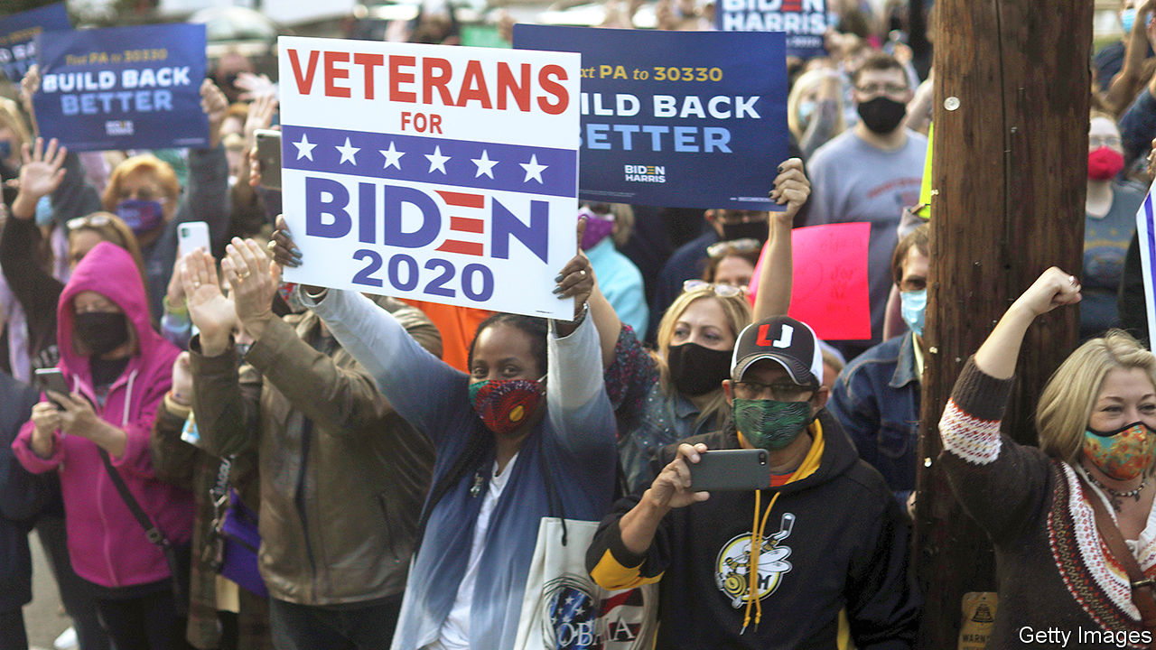

FROM THE car park of a desultory Dollar General shop in Lordstown, a declining corner of north-east Ohio, not much suggests a presidential campaign at full blast. A few plastic Halloween decorations flap in the breeze. Passing customers say they pay little heed to politics. Shane Edwards, in a green mask, admits he forgot to cast a ballot in 2016. He had planned to vote for Donald Trump, who took Ohio by eight points in any case. Grey-haired Rose says she always voted Democratic, then switched when Mr Trump showed up. She has “no idea” what to do this time, but will probably ask her husband.

Places such as Lordstown are mostly home to blue-collar workers who, like Rose, have shed their old loyalty to Democrats but are wary of committing themselves again to Mr Trump. Rose’s doubts are mostly over the pandemic. She does not think the president has handled it well. She worries, too, about her disability payments and care for veterans. Her county, Trumbull, saw a huge swing to Mr Trump in 2016, when voters took against Hillary Clinton. Yet Democrats won back much support in mid-term elections two years ago. And Joe Biden, who makes much of his working-class roots in Scranton, Pennsylvania, is again making it a closer race.

Mr Biden’s fortunes in Ohio have soared in recent weeks. A Republican strategist talks of colleagues startled by internal polls that point, after months of Mr Trump being ahead, to an almost tied race. Some recent public ones have even put Mr Biden just in front. Our own forecast still gives Mr Trump a slightly better chance of winning, but his prospects have dipped sharply. Mr Biden, meanwhile, is buying more television advertising in the state (just as Mr Trump is buying fewer) and paid a brief visit there, by train, last week.

For much of the past year Mr Trump had banked on Ohio, where rural voters, non-college ones, Catholics and the former coal-mining areas of Appalachia were solidly behind him, and a strong local operation reliably gets out the vote. The state is big, with 18 electoral-college seats, and more Republican-leaning than most of the Midwest. That makes it indispensable. No Republican has ever become president without it. Its record as a bellwether is unmatched. In 29 of the past 31 elections, whoever won Ohio won the White House.

The trouble for Mr Trump is that the most populous and fastest-growing parts of the state increasingly favour his rival. Mr Biden does not need to win back all the lost support in places like Lordstown if he can pile up votes in cities and suburbs, especially in big counties around the “three Cs”: Columbus, Cincinnati and Cleveland.

The activity of Abby Wimbiscus Black, a music teacher in Delaware County, a former Republican stronghold in central Ohio, north of Columbus, is emblematic of this. A party strategist calls her area the “frontier” of the election battle. Her tiny garden is crammed with eight signs for Mr Biden and other Democrats; a colourful knitted scarf is draped round a tree, with a message urging all to vote. Biden and BLM signs have sprouted on nearby lawns. Each night Mrs Wimbiscus Black writes 30 postcards to would-be voters across Ohio. She also texts, phones and posts online. She moved there a year ago from Columbus, part of an exodus of liberal-minded, young, urban folk (notably college-educated women) spilling out to suburbs and smaller cities as bigger ones get more costly.

Paul Beck at Ohio State University calls Mrs Clinton’s rotten showing in 2016 an “anomaly”. Democrats have been quietly gaining, he says, for example in state-legislative elections in suburbs near Columbus. The re-election of a Democratic senator, Sherrod Brown, two years ago points to wider strength. He cites a poll from late September, by Fox, showing Mr Biden with a ten-point lead in Ohio’s suburbs.

What explains the recent surge? Some moderates may be swayed by a former governor, John Kasich, who has endorsed Joe Biden. Older voters, like Rose, are dismayed by the coronavirus. Many women despise Mr Trump’s personal style. A party strategist says the president did so disastrously in the first debate he can’t recover. Spending on ads by Mr Biden, and the scarcity of Trump ones, could be making a difference. And local Republicans’ notably swampy behaviour does not help: Larry Householder, the Republican speaker of Ohio’s House, was arrested and indicted for racketeering in July.

Kyle Kondik, who wrote a book on Ohio’s influence on presidential elections, says Ohio is more competitive again. Yet he doesn’t think it matters, for the national contest, whether Mr Biden pulls off a victory there—a close race would be good enough for him. A Republican strategist agrees, calling Ohio the “head and neck” of the Midwest: as long as Mr Trump must scramble to avoid losing there, his prospects of crucial victories elsewhere in the region, in Michigan, Pennsylvania or Wisconsin, look vanishingly small. Mr Biden, in contrast, could triumph even if Ohio remains tantalisingly just out of reach. ■

Dig deeper:  
Read the [best of our 2020 campaign coverage](https://www.economist.com/us-election-2020) and explore our [election forecasts](https://projects.economist.com/us-2020-forecast/president), then sign up for Checks and Balance, our [weekly newsletter](https://www.economist.com/checksandbalance/) and [podcast](https://play.acast.com/podcasts/2020/01/24/checks-and-balance-our-new-weekly-podcast-on-american-politics) on American politics.

This article was downloaded by calibre from <https://www.economist.com/united-states/2020/10/10/a-close-race-in-ohio-is-bad-news-for-donald-trump>

|  |  |  |  |
| --- | --- | --- | --- |
| Previous | Articles | Sections | Next |

|  |  |  |  |
| --- | --- | --- | --- |
| Previous | Articles | Sections | Next |

#### Entrepreneurship

# The number of new businesses in America is booming

No other rich-world country is experiencing the same rise in entrepreneurship

Oct 10th 2020 |

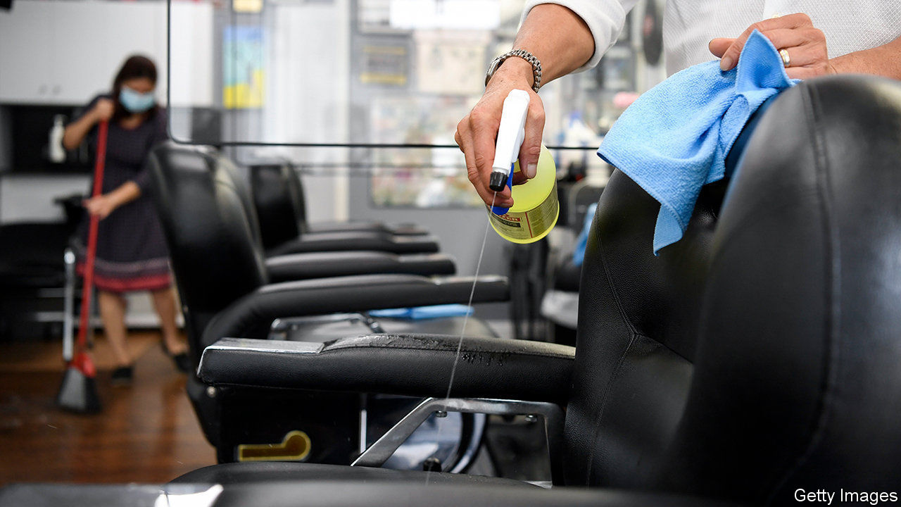

THE PANDEMIC has had all sorts of unexpected consequences, from a boom in sourdough-bread baking to more people listening to nostalgic music on Spotify. Less noticed is a once-in-a-generation surge in startups. The government regularly releases figures on new-business formation, derived from applications for tax registrations. And “high-propensity” business applications—those displaying characteristics typically associated with firm-creation and the employment of staff—recently reached their highest quarterly level on record (see chart).

Some of these may represent people trying to claim stimulus funds, and a backlog of unprocessed applications had probably built up in March and April. Nonetheless they reflect a genuine rise in American entrepreneurship. Based on a different survey Goldman Sachs, a bank, finds that the share of respondents starting a new business in the past three months has also risen sharply. Other evidence shows that about as many Americans now work for themselves as before the pandemic, even as overall joblessness remains high.

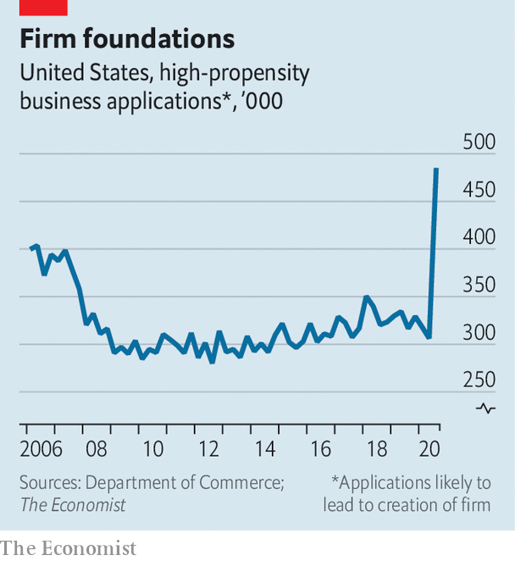

All this has surprised economists. In the last recession the number of “high-propensity” business applications sharply declined. And over the past four decades the rate of new-business creation had been drifting downwards (researchers pointed to declining population growth as one cause, as well as the growing power of large firms, which may have dissuaded new ones from entering the market). The fact that America has suddenly recovered its entrepreneurial mojo is particularly intriguing, since nothing comparable seems to be happening elsewhere in the rich world.

The surge in startups cannot make up for all the damage wreaked by lockdowns and social distancing. The overall number of firms employing workers almost certainly remains lower than it was before the pandemic, since so many have gone bust, says John Haltiwanger of the University of Maryland. Many of America’s largest firms continue to shed staff (see article). The jobs report for September showed the unemployment rate at a still-high 7.9%.

But the entrepreneurship boom bodes well for the future. A recovery with lots of startups tends to be more jobs-rich than one without, since young firms typically seek to expand, hiring new staff. Talk to the owners of new enterprises, and it is hard not to feel optimistic about America’s economic prospects. “People in general are tired of staying indoors, so if they feel safe at an establishment, they’re gonna come out,” says Matt, who with his wife Thao has just opened Smokin Beauty, a Vietnamese-inspired BBQ joint in Austin which boasts plenty of outdoor seating. Buzzer, a platform which allows people to see clips of sports events, proudly describes itself as “a company born during a global pandemic that has paused all live sports”.

Economists do not yet know what has provoked America’s entrepreneurship boom. But the economic-rescue package passed by Congress in March may play the biggest role. It did relatively little to preserve jobs, instead focusing on protecting people’s incomes with stimulus cheques worth up to $1,200 and bumped-up unemployment-insurance (UI) payments. This gave people both the need (losing their job) and the means (greater financial security) to take on the risk of founding a business.

Some evidence backs up that theory. Official data suggest that 90% of the net rise in the number of sole traders is being driven by people with a gross household income of less than $35,000, a group that was especially likely to lose their jobs when the pandemic struck, and who would have seen a particularly large income boost from the stimulus measures. America’s new crop of entrepreneurs is moving away from dying sectors and towards up-and-coming ones. In most industries the number of sole traders is in decline, yet in the past year the number working in the information sector, comprising jobs such as data-processing, web-search portals and publishing, has risen by 50%.

The more-generous UI benefits expired in July. More people may now prefer to look for a steady job rather than take a risk on a new business. Yet as the economy changes, new opportunities will continue to emerge. America’s startup boom may last for some time yet.■

Editor’s note: Some of our covid-19 coverage is free for readers of The Economist Today, our daily [newsletter](https://my.economist.com/user#newsletter). For more stories and our pandemic tracker, see our [hub](https://www.economist.com/news/2020/03/11/the-economists-coverage-of-the-coronavirus)

This article was downloaded by calibre from <https://www.economist.com/united-states/2020/10/10/the-number-of-new-businesses-in-america-is-booming>

|  |  |  |  |
| --- | --- | --- | --- |
| Previous | Articles | Sections | Next |

|  |  |  |  |
| --- | --- | --- | --- |
| Previous | Articles | Sections | Next |

#### Unemployment

# The reasons behind America’s new wave of lay-offs

Now the pandemic, next automation and simplification

Oct 8th 2020 | NEW YORK

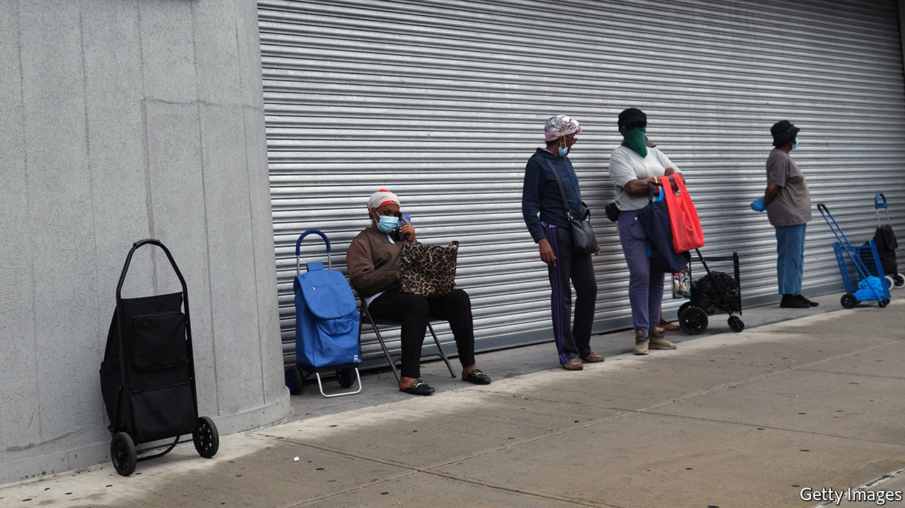

ON OCTOBER 6TH Jerome Powell, the chairman of the Federal Reserve, made a plea for immediate extra stimulus, arguing that “too little support would lead to a weak recovery, creating unnecessary hardship for households and businesses”. Hours later President Donald Trump shocked USA Inc by declaring he wants no new stimulus until after the election in November (he later backtracked a bit). But do some company bosses see an opportunity in the prolonged pain of the pandemic?

The sudden shutdown of big parts of the economy in spring forced over 20m people out of their jobs. As the economy rebounded during the summer, many went back to work and the rate of new lay-offs slowed. Yet the nature of the sackings is evolving, with a sharp rise in permanent unemployment (see chart). Now a new wave of lay-offs suggests firms are getting ready to make deeper cuts. In recent days leading airlines have said they will cut over 30,000 workers. Disney, an entertainment giant, plans to shed 28,000. Regal Cinemas, the country’s second-biggest chain of theatres, is shutting all 500-plus venues in America (see article). Even LinkedIn, a social network used by professionals to find work, plans to lose nearly 1,000 employees in America and beyond.

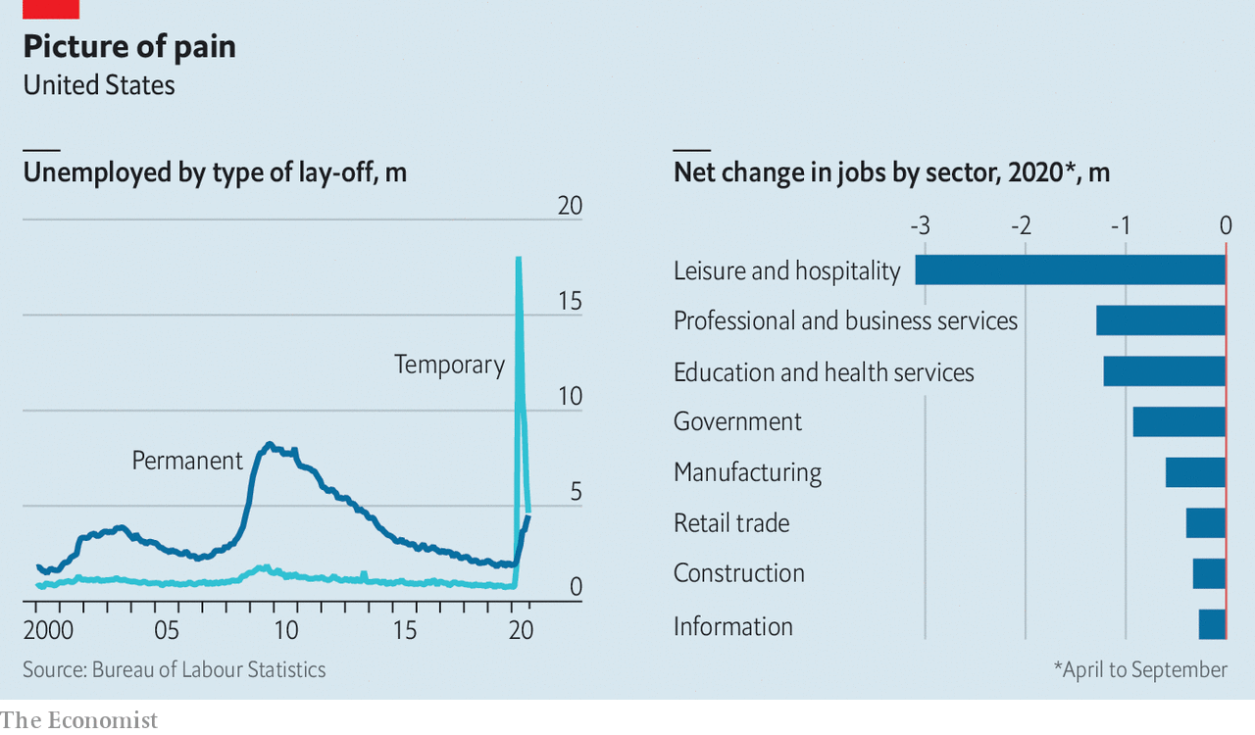

The disruption caused by the pandemic is one obvious explanation for deeper cuts in payroll. But David Garfield of AlixPartners, an advisory firm, reckons if companies must make do with only 70-90% of historical sales, as may happen with an anaemic recovery, they cannot survive without “major restructuring”. Mr Garfield believes firms must reduce complexity if they want to build resilience into supply and distribution networks. A recent study found that big grocery stores today offer 80% more varieties of products than the average store did three decades ago. Mondelez, a big consumer-products firm, plans to slash the number of stock-keeping units it offers by a quarter. Coca-Cola and Procter & Gamble have made similar noises.

Bain, another consultancy, sees American companies “retooling for the new normal” by ploughing $5trn-10trn over the next decade into automation. This may kill old-fashioned jobs in the short term, but create new, tech-savvy ones over time.

The jobs picture is likely to get worse before it gets better. The pandemic is the proximate cause, but the deeper driver is bosses preparing for a new economy. “This is your moment to strike as chief executive if you want a dramatic change in market share,” says Hernan Saenz of Bain. “Recessions are an amazing opportunity.” ■

This article was downloaded by calibre from <https://www.economist.com/united-states/2020/10/08/the-reasons-behind-americas-new-wave-of-lay-offs>

|  |  |  |  |
| --- | --- | --- | --- |
| Previous | Articles | Sections | Next |

|  |  |  |  |
| --- | --- | --- | --- |
| Previous | Articles | Sections | Next |

#### Lexington

# The battle in miniature

A small town in Pennsylvania depicts a microcosm of the election—and how Americans are handling it

Oct 10th 2020 |

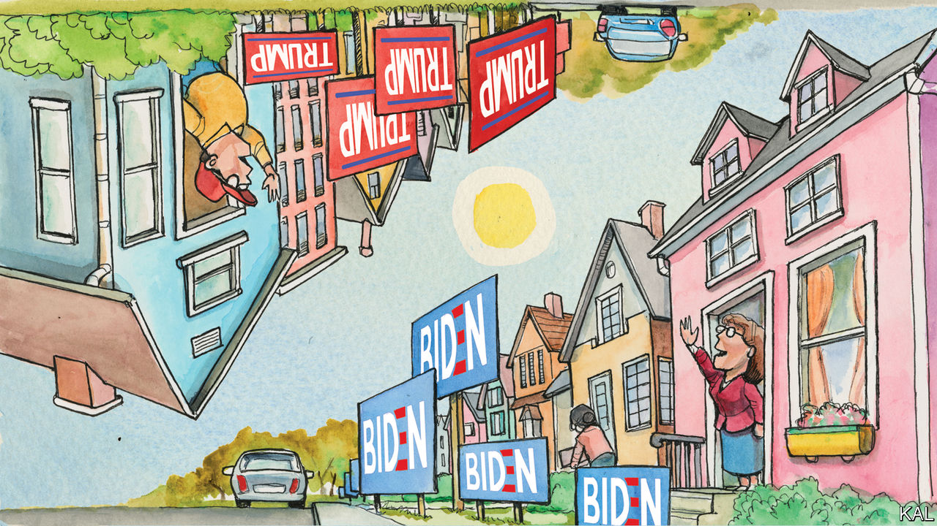

A MODERN-DAY Alexis de Tocqueville might find talk of America’s painful divisions baffling at first blush. Up close, as Bill Bishop wrote in “The Big Sort”, the country has never looked more cohesive. The leafy suburbs of America’s fast-growing, diverse cities are so uniformly Democratic it can be hard to find two people in serious disagreement. Republicans, an older, less mobile group, live equally clustered, farther out. The country is less fractured than ghettoised—as is especially apparent at election time.

In Lexington’s suburb of the national capital (where Donald Trump won 4% of the vote in 2016), local opinion is expressed in a phalanx of Joe Biden yard-signs. Drive 20 minutes into the Maryland countryside and, as if some partisan border had been crossed, “Donald J. Trump” signs are everywhere. Yet there are still places along the frontier where rivals co-exist. One is Easton, an unshowy town in eastern Pennsylvania, where your columnist went to see some weekend canvassing for the president.

A former transport hub, at the confluence of the Lehigh and Delaware rivers, the town once thrived on its strategic site—and still relies on it. It is 70 miles from both New York and Philadelphia, a just-about-commutable distance, which has brought new families to the town, attracted by its house prices, and visitors to its main attraction, a theme-park for Crayola crayons. By no means rich yet not struggling, hardly dynamic yet replenished by incomers: the town sits between socioeconomic categories and political cultures. This has helped make it one of the most contested corners of one of the most competitive states in the country.

Northampton County, of which it is the capital, was one of three in Pennsylvania that flipped to the Republicans in 2016, giving Mr Trump the state by a whisker. True to form, the quadrant of four streets around which Lexington accompanied Karen Frey, an amiable Republican foot-soldier wearing a red “Deplorables Club” sweatshirt (and not wearing the Trump 2020 face-mask that dangled, alongside a stun-gun, “rape alarm” and mace spray, from her wrist), displayed Trump and Biden signs in similar measure.

They otherwise offered no clue to the occupants’ affiliation. Outside the 40-odd houses Mrs Frey called on, a Virgin Mary statue or “We support our police” flag was no likelier to denote a Republican than a Democratic household. At a corner of Hickory Lane, the occupant displayed signs supporting the police, teachers and Mr Biden. “We’re not Trump here, keep walking,” he yelled at Mrs Frey through his car window. The suburb is a throwback to pre-sort America, but bristling with post-sort partisanship. The result is a rare microcosmic view of what partisanship is doing to America.

Very few who answered the door claimed to be undecided—and most were probably, as Mrs Frey conceded, being kind. Only one voter expressed weak feelings about her choice. “I vote for the party, not the candidate,” said Lisa, a lifelong Republican staunchly against abortion. Everyone else appeared fiercely decided.

Given that just over half were planning to vote Democratic (“This year more than ever,” several said), this gave rise to awkward scenes. “I’m sorry, I’m sure you’re a nice person, but I’m 92 years old, I’ve voted for Republicans and Democrats, and I cannot understand how you can like him,” a man on Hickory Lane told Mrs Frey.

He then launched a fact-filled evisceration of Mr Trump’s record, before ending, fighting back tears, on a personal note. “My father came from Italy. Trump hates migrants. My five dead brothers fought for this country. The son-of-a-bitch calls them suckers.” When Mrs Frey, visibly shaken, said this was untrue, the man quoted the president’s slander of John McCain. Mrs Frey countered with a fake-news story—that the late Republican senator killed scores of sailors in a fire. “God bless you,” said the old man.

“It multiplies,” said Mrs Frey enigmatically, as she walked away. Though she knocked on “over 3,000 doors” in 2016, she did not seem used to such pushback. Modern campaigns aim canvassers almost exclusively at likely voters for their own side; she had kindly decided to knock on every door mainly as a favour to Lexington. It was also apparent from her assertions, which tended to be untrue, that Mrs Frey inhabited a deep realm of the Trump bubble.

Considering much of Fox News “too liberal”, she got her news from the far-right One America News Network and Epoch Times, a pro-Trump newspaper produced by the Falun Gong sect that has spread the anti-Semitic QAnon conspiracy. When she encountered a like-minded voter, her relief was palpable. On their doorsteps she referred to Joe Biden as a “communist” and any self-professed Christians who voted Democratic as “Satan-worshippers”.

Lee Drutman, a political scientist, attributes the mutual loathing of America’s political tribes to three things: cultural sorting (including media bubbles); the slim margins of national elections, which makes them seem existential to both sides; and the nationalisation of politics, which has bulldozed local concerns that once girded communities. All are evident in Easton—though its much-provoked voters live cheek-by-jowl. What lessons does that offer?

One is that politics exaggerates reality. While several voters expressed unease about their neighbours’ allegiances, your columnist saw nothing to suggest a community anything like as divided as the political views its members expressed. On a sunny Saturday morning, Trumpers and anti-Trumps mowed lawns and walked dogs together. Outside elections, most of them probably give politics little thought. Given the state of things, that is consoling.

## A question of legitimacy

Yet this election will prove harder to recover from—because Republicans, taking their cues from the president, are already trying to invalidate it. Almost Mrs Frey’s first words to your columnist were: “We’re trying to win without stuffing ballots, we’re the Republican Party.” She repeatedly assured voters that mail-in voting was fraudulent. This promises a new order of conflict for a society whose forbearance cannot be counted on indefinitely.■

Dig deeper:  
Read the [best of our 2020 campaign coverage](https://www.economist.com/us-election-2020) and explore our [election forecasts](https://projects.economist.com/us-2020-forecast/president), then sign up for Checks and Balance, our [weekly newsletter](https://www.economist.com/checksandbalance/) and [podcast](https://play.acast.com/podcasts/2020/01/24/checks-and-balance-our-new-weekly-podcast-on-american-politics) on American politics.

This article was downloaded by calibre from <https://www.economist.com/united-states/2020/10/10/the-battle-in-miniature>

|  |  |  |  |
| --- | --- | --- | --- |
| Previous | Articles | Sections | Next |

|  |  |  |
| --- | --- | --- |
| United States | Sections | Middle East & Africa |

The Americas

Cuba: Welcome to Queueba

.

Argentina: Alberto of the Antarctic

.

Bello: Sliding down the pandemic snake

.

|  |  |  |
| --- | --- | --- |
| United States | Sections | Middle East & Africa |

|  |  |  |  |
| --- | --- | --- | --- |
|  | Articles | Sections | Next |

#### Welcome to Queueba

# With shop shelves bare, Cuba mulls economic reforms

The government hints it may scrap its dotty dual-currency system

Oct 10th 2020 |

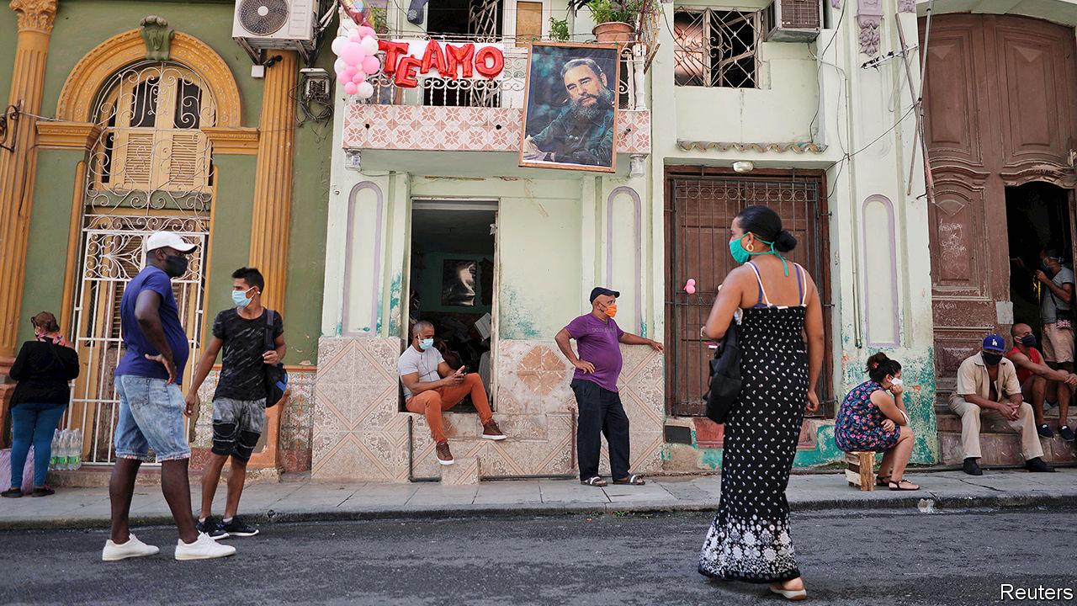

LONG QUEUES and empty shelves are old news in Cuba. Recently, though, the queues have become longer and the shelves emptier. Food is scarcer than it has been since the collapse in 1991 of the Soviet Union, which supported the island’s communist regime. Now shoppers queue twice: once for a number that gives them a time slot (often on the next day). They line up again to enter the store.

Once inside, they may find little worth buying. Basic goods are rationed (for sardines, the limit is four tins per customer). Shops use Portero (Doorman), an app created by the government, to scan customers’ identity cards. This ensures that they do not shop in one outlet too often. Eileen Sosin recently tried but failed to buy shampoo and hot dogs at a grocery store near her home in Havana. She was told that she could not return for a week.

Queues at grocery stores are short compared with those outside banks. They are a sign that, under pressure from food shortages and the pandemic, the government is moving closer towards enacting a reform that it has been contemplating for nearly two decades: the abolition of one of its two currencies. In July state media began telling Cubans that change was imminent. Cubans are eager to convert CUC, a convertible currency pegged to the American dollar, into pesos, which are expected to be the surviving currency. If they do not make the switch now, Cubans fear, they will get far fewer than 24 pesos per CUC, the official exchange rate for households and the self employed.

Cuba introduced the CUC in 1994, when it was reeling from the abrupt end of Soviet subsidies. The government hoped that it would curb a flight into dollars from pesos, whose worth plunged as prices rose.

The system created distortions that have become deeply entrenched. The two currencies are linked by a bewildering variety of exchange rates. Importers of essential goods, which are all state-owned, benefit from a rate of one peso per CUC. That lets them mask their own inefficiencies and obtain scarce dollars on favourable terms. This keeps imports cheap, when they are available at all. But it also discourages the production of domestic alternatives. Foreign-owned earners of hard currency, such as hotels, do not profit from the artificial gap between revenues and costs. That is because instead of paying workers directly they must give the money to a state employment agency, which in turn pays the employees one peso for every CUC (or dollar). The rule is, in effect, a massive tax on labour and on exports.

The dual-currency regime is an obstacle to local production of food, which already faces many. Farmers must sell the bulk of their output to the Acopio (purchasing agency) at prices set by the state. It gives them seeds, fertiliser and tools, but generally not enough to produce as much as their land will yield.

A farmer from Matanzas, east of Havana, recently complained on social media that the Acopio, which required him to provide 15,000lbs (6,800kg) of pineapples, neither transported them all the way to its processing facility nor paid him. Instead, they were left to rot. When the Acopio does manage to provide lorries, it often fails to deliver boxes in which to pack farmers’ produce. They can sell their surplus to the market, but it is rarely enough to provide a decent income. No wonder Cuba imports two-thirds of its food.

It is becoming more urgent to free the economy from such burdens. Although Cuba has done a good job of controlling covid-19, the pandemic has crushed tourism, a vital source of foreign exchange. The Trump administration, which imposes sanctions on Cuba in the hope that they will force the Communist Party out of power (and, perhaps more important, that they will please Cuban-American voters in Florida), recently tightened them. In September the State Department published a “Cuba prohibited accommodations list”, which blacklists 433 hotels controlled by the regime or “well-connected insiders”. Venezuela, Cuba’s ally, has cut back shipments of subsidised oil. The economy is expected to shrink by around 8% this year.

As it often does when times are tough, Cuba is improvising. To hoover up dollars from its citizens, since last year the government has opened many more convertible-currency shops. As these usually have the best selection of goods, demand for dollars has rocketed. Banks have none left. Cubans either get them from remittances, sent by relatives abroad, or on the black market, where the price can be double the official rate of one per CUC.

The government is now sending signals that it wants to scrap the economy-warping dual-currency regime. “We have to learn to live with fewer imports and more exports, promoting national production,” said the president, Miguel Díaz-Canel, in July.

But it has signalled before that such a reform was imminent only to decide against it. That is because the change, when it comes, will be painful. Importers with artificial profits may lay off workers en masse. If they have to pay more for their dollars, imports will become more expensive, sparking a rise in inflation. Pavel Vidal, a Cuban economist at the Pontifical Xavierian University in Cali, Colombia, expects the value of Cubans’ savings to drop by 40%. The government has said that it will raise salaries and pensions after a currency reform, but it has little cash to spare. This year’s budget deficit is expected to be close to 10% of GDP. That could rise when the government is forced to recognise costs now hidden by the twin-currency system.

The government may yet wait until it has built up bigger reserves of foreign exchange to help it cushion the shock. It may hope that Joe Biden will win the White House and reverse some of the sanctions imposed by the Trump administration. That would boost foreign earnings.

The economic crisis makes other reforms more necessary. Under Raúl Castro, who stepped down as president in 2018 (but still heads the Communist Party), a vibrant private sector started up. It has gained more freedoms, but at a slow pace.

The government has recently promised faster action. It said it would replace lists of the activities open to cuentapropistas, as Cuba’s entrepreneurs are called, with negative lists, which specify in which sectors they cannot operate. The new rules have yet to be published. The government recently let cuentapropistas import supplies through state agencies, but prices are prohibitive. In July it opened a wholesale market, where payment is in hard currencies. Firms that use it no longer have to buy from the same bare shops as ordinary citizens.

Cuentapropistas have been lobbying since 2017 for the right to incorporate, which would enable them to sign contracts and deal normally with banks, and to import inputs directly rather than through state agencies. The government has yet to allow this. Until it frees up enterprise, Cubans will go on forming long queues outside shops with empty shelves. ■

This article was downloaded by calibre from <https://www.economist.com/the-americas/2020/10/10/with-shop-shelves-bare-cuba-mulls-economic-reforms>

|  |  |  |  |
| --- | --- | --- | --- |
|  | Articles | Sections | Next |

|  |  |  |  |
| --- | --- | --- | --- |
| Previous | Articles | Sections | Next |

#### Alberto of the Antarctic

# Argentina doubles in size, or so it claims

The government takes advantage of a UN ruling to extend the country’s territorial waters

Oct 10th 2020 | BUENOS AIRES

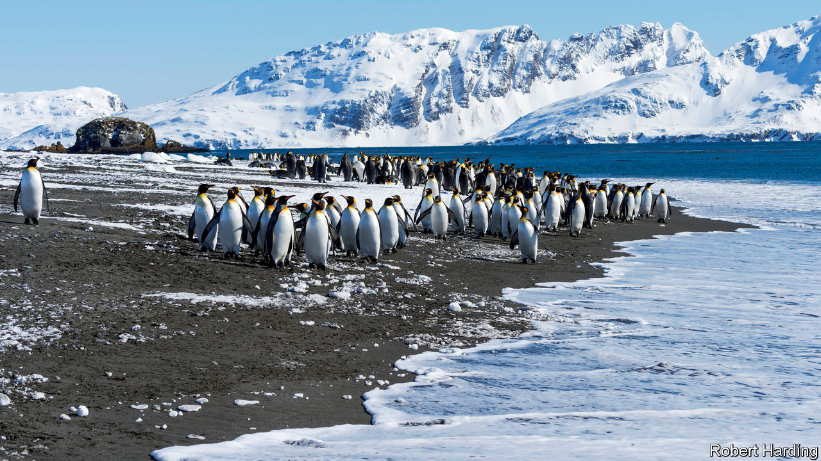

ARGENTINA’S PRESIDENT, Alberto Fernández, has plenty to worry about: a soaring covid-19 caseload and a depressed economy. So it must have been delightful for the government to change the subject on September 21st by issuing a map showing that the country’s territory is nearly double its former size. It illustrates the effect of a law Mr Fernández signed in August, which expands Argentina by 1.7m square km (650,000 square miles), an area three times the size of metropolitan France. Argentina now bestrides South America and Antarctica, from the Tropic of Capricorn to the South Pole. Its territory includes some of the world’s richest fishing grounds and possibly oil and gas. The Falkland islands, which Argentines call the Malvinas, lie within it.

This is not entirely based on fantasy. In 2016 the UN’s Commission on the Limits of the Continental Shelf (CLCS) issued a ruling, based on the UN Convention on the Law of the Sea, that fixes the edge of the vast shelf that juts out from Argentina’s coast. There the seabed is shallow enough—less than 2,500 metres deep—to count as an extension of Argentina’s mainland. The effect of the ruling is to extend Argentina’s territorial waters beyond the normal 200 nautical miles (370km).

Mauricio Macri, Argentina’s then-president, a conservative, celebrated the ruling in 2016 as a diplomatic victory but did not write it into law. His priority was friendly relations with the rest of the world, including Britain. In 1982 Britain fought a war to expel Argentina’s armed forces, which had invaded the Falklands that year.

Mr Fernández, a left-leaning Peronist, is more assertive. The law he signed in August, and the borders on his map, take in far more than the area to which CLCS said Argentina was entitled. In sending the territorial-expansion bill to Congress this year, Mr Fernández insisted on “Argentina’s claim to the Malvinas”, which has long been part of its law and is endorsed by nearly all Argentines.

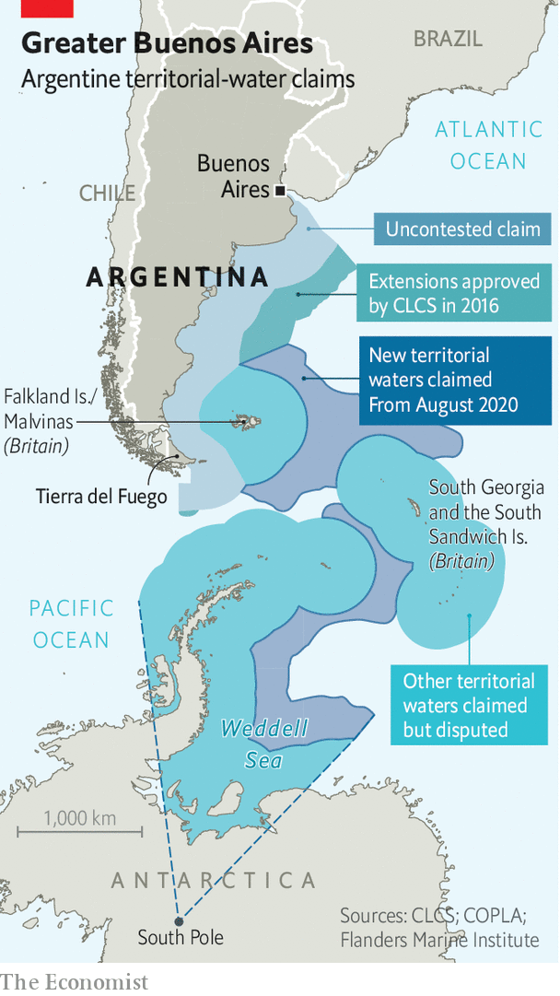

The new official map shows South Georgia and the South Sandwich islands (also British), as part of Argentina, too, and adds areas that had it not claimed in law before. The British are mainly interested in the water’s riches, Argentina’s government thinks. That explains the “stubbornness of British colonialism”, suggested Daniel Filmus, the government’s secretary for the Malvinas, Antarctica and South Atlantic. The map asserts Argentine sovereignty over the Antarctic peninsula, an ice-cream cone poking into the Weddell sea, which is also claimed by Chile and Britain. In fact, the UN commission avoided taking a position “in a case where a land or maritime dispute exists”. The areas it awarded Argentina are a fraction of the country’s claim.

Argentina does not plan to try to reconquer the islands, but it does hope to use its interpretation of the commission’s ruling to press Britain to negotiate. “The UN is saying that the Malvinas is a matter of dispute,” contends an adviser to the president. “The British always try to say there is no dispute over the islands.” Argentina’s foreign ministry put out a video calling for “dialogue” under UN auspices. Britain is unlikely to agree.

So Mr Fernández may have to be content with smaller satisfactions. Argentine oceanographers are now in demand from other countries. They are being consulted by specialists from Brazil, Germany, Denmark and even Chile, despite the peninsular dispute. Schoolchildren will be taught that Tierra del Fuego, Argentina’s southernmost province, is now the country’s centre. The country’s population of emperor penguins and leopard seals has greatly expanded. In tough times, that may cheer Argentines up a bit.■

This article was downloaded by calibre from <https://www.economist.com/the-americas/2020/10/10/argentina-doubles-in-size-or-so-it-claims>

|  |  |  |  |
| --- | --- | --- | --- |
| Previous | Articles | Sections | Next |

|  |  |  |  |
| --- | --- | --- | --- |
| Previous | Articles | Sections | Next |

#### Bello

# Latin America’s new poor

The pandemic is reversing years of progress on poverty and inequality

Oct 10th 2020 |

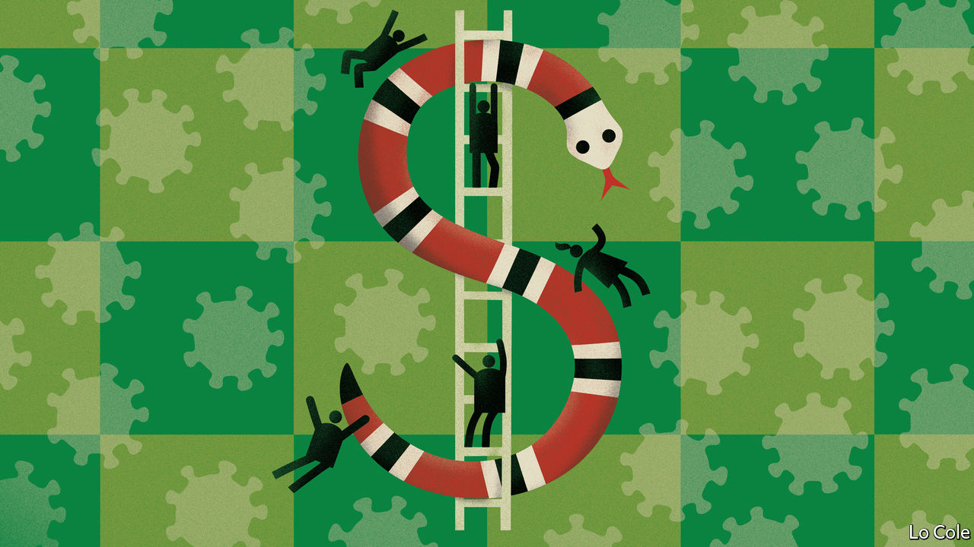

WHEN THE pandemic struck Piura, a city in northern Peru, Daniel Zapata had a part-time job with a market-research firm. The 250 soles ($70) he earned each month paid his fees for a three-year course in business administration. The covid-19 recession put paid to all that. The firm closed, and Mr Zapata, who is 20 and lives with his parents and a sister, has dropped out of his course. The family received 760 soles in emergency aid from Peru’s government. With the lockdown over, they must now rely on his sister’s income as a teacher and his father’s pension from his years working in a textile factory. Having lived in the lower tier of the middle class, Mr Zapata is staring into the abyss of poverty. He expects little from a general election next April. The politicians “just squabble instead of working”, he says.

The covid-19 recession is wiping out years of progress in Latin America in reducing poverty and inequality. Economists are starting to map just how big the social impact of the pandemic is. Many governments imposed long lockdowns. These hit the half of Latin Americans who work in the informal economy especially hard. Many countries, like Peru, offset part of the lost income by expanding aid programmes for the poor. That has helped, but not enough, and the effort may not be sustainable.

The region’s economy is set to contract by 9.1% this year, according to the UN Economic Commission for Latin America and the Caribbean. It says this means that 45m people will fall back into poverty (taking the total to 37% of the population). The unemployment rate has risen by 2.2 percentage points to 11% in nine countries for which data are available, reports the International Labour Organisation. Income from wages in Latin America has fallen by 19.3%, compared with a global average of 10.7%.

These estimates assume that everyone loses a similar percentage of their income. Nora Lustig, an Argentine economist, and her team at Tulane University in New Orleans have used household surveys to figure out which groups lost most income and received most from the government in Brazil, Mexico, Colombia and urban areas of Argentina, which together account for two-thirds of Latin America’s total population. They think that the biggest losers will be among the region’s lower-middle classes, because social-assistance programmes provide an income floor for many of the poor. Although women, people of African descent and indigenous people are more likely to lose income, they get more help from the government.

Ms Lustig thinks the year may end with up to 21m new poor in those four countries. The impact is much bigger in Mexico than in Brazil, because of contrasting government policies. Mexico’s president, Andrés Manuel López Obrador, claims to be of the left and his campaign slogan was “First, the poor”. Yet he has done little to help the poorest. Brazil’s president, Jair Bolsonaro, is of the hard right. But his government has made an emergency payment of $107 per month for five months, from which 53m people have benefited. The payment has been extended, though at a lower amount. Poverty could even decline slightly in Brazil, while in Mexico there will be at least 10m new poor.

The damage will last. Even though the pandemic is at last starting to wane in the region, at least for now, and many economies have opened up again, demand will remain depressed because firms and workers are poorer. Researchers at the Inter-American Development Bank have found that in past recessions when GDP contracted by 5% or more unemployment took an average of nine years to return to its previous level.

If the pandemic-induced recession is like previous ones it will reverse much of Latin America’s recent progress in reducing inequality. The causes of that progress included the spread of education and more demand for unskilled workers in service businesses. The hard-up are much less likely to be able to work remotely. The many low-skilled workers whose jobs require personal contact—waiters, hairdressers, etc—may see their wages fall.

Even before the pandemic Latin America was highly unequal. Frustration at slow economic growth, lack of opportunity and a discredited political class showed in the election of populist presidents and in street protests in several countries. The tens of millions of new poor have reasons for resentment. They may not accept their fate quietly. That is likely to shape the region’s politics for years to come.

This article was downloaded by calibre from <https://www.economist.com/the-americas/2020/10/10/latin-americas-new-poor>

|  |  |  |  |
| --- | --- | --- | --- |
| Previous | Articles | Sections | Next |

|  |  |  |
| --- | --- | --- |
| The Americas | Sections | Europe |

Middle East & Africa

Iran and China: Friends without benefits

.

Israel: Sickly leadership

.

Egypt: A rage for roads

.

Ivory Coast’s election: Old men spell danger

.

Nigeria’s economy: Fuel me once

.

Money talk: Where calling is a calling

.

|  |  |  |
| --- | --- | --- |
| The Americas | Sections | Europe |

|  |  |  |  |
| --- | --- | --- | --- |
|  | Articles | Sections | Next |

#### Friends with few benefits

# Iran wants a “strategic partnership” with China

For China, Iran is just one piece on a large chessboard

Oct 10th 2020 | BEIRUT

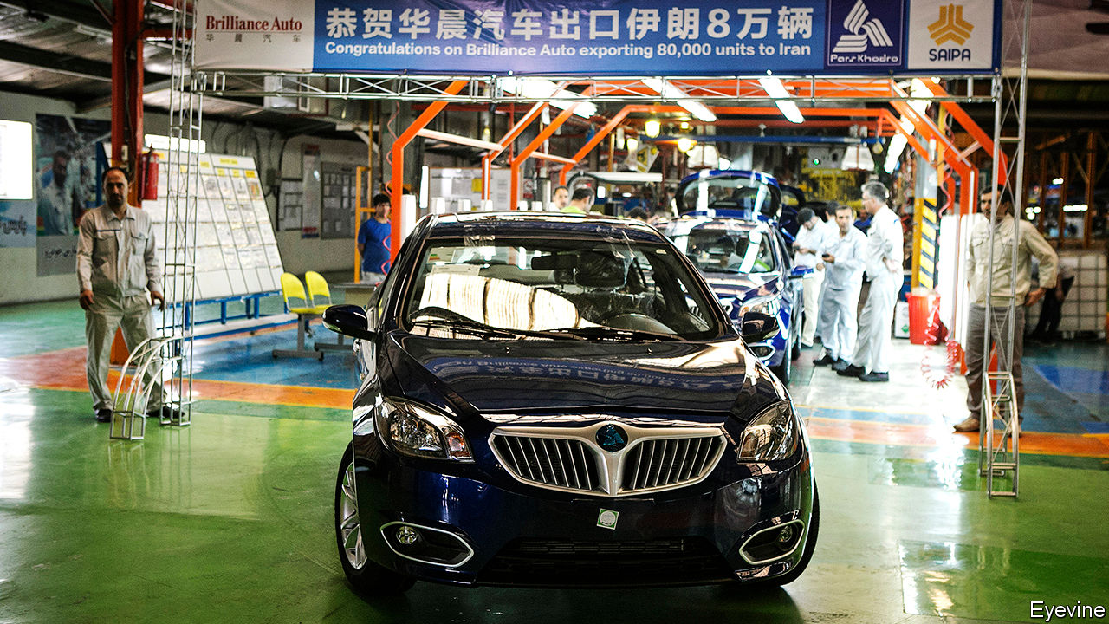

CHINA COMMANDS a certain mystique in the Middle East. For politicians in Lebanon, broke and on the brink of hyperinflation, it is an ATM waiting to dispense billions if they can only find the passcode. For the regime of Bashir al-Assad in Syria it is a deus ex machina to rebuild a shattered country. Often caricatured, the Middle East is prone to draw caricatures of its own.

On October 1st Hassan Rouhani, the Iranian president, declared a “major step” in Iran’s relations with China. For months the two have been discussing plans for a 25-year “strategic partnership”. But the details remain vague.

Leaked drafts call for big Chinese investment in everything from roads and ports to telecoms and nuclear energy. The agreement would probably give China a stake in Iran’s oil industry, guaranteeing a market for its crude and refined products. Infrastructure projects would stitch Iran into the Belt and Road Initiative as a transit point between Asia, Europe and the Middle East. Rumours flew in Iran’s media that it might even cede control of Kish, an island that is a free-trade zone in the Persian Gulf. The government says this is bunk. The draft makes no mention of it.

China’s new friendship has caused a measure of alarm in Washington. Mike Pompeo, America’s secretary of state, warned that it would “destabilise the Middle East”. Like much Chinese diplomacy in the Middle East, however, its proposed partnership with Iran is long on ambition but short on detail. Rather than a comprehensive road map, the proposal is more a sign of both Iran’s desperation and the limits of China’s ambition.

Even without covid-19 battering the world economy, Iran would be in dire straits. Sanctions reimposed by America in 2018 have pushed Iran’s oil production to its lowest levels since the 1980s. In July it pumped an estimated 1.9m barrels per day (b/d), about half of what it was pulling from the ground in 2018. Most of its output is being used for domestic consumption or diverted to storage. Exports, depressed by sanctions and the pandemic, were probably well below 500,000b/d.

The sanctions failed in their stated goal of compelling Iran to agree to more restrictions on its nuclear programme and to roll back its meddling in the region. But they have crippled its economy, which shrank by 7.6% last year after a 5.4% contraction in 2018. Its currency, the rial, traded at 3,800 to the dollar when Donald Trump took office in 2017. Now a dollar costs more than 29,500 rials. In May parliament approved a plan to lop four zeroes off banknotes. The original nuclear deal brought the promise of investment and trade from Western countries. Mr Trump’s Iran policy has dashed such hope.

To judge by the rhetoric in Tehran and Beijing, China should be rushing to fill the void. During the previous round of sanctions, which culminated in the nuclear deal in 2015, it emerged as the buyer of last resort for Iranian oil. But the resulting barter system was often derided as “trash for oil”. Consumers got cheap stuff, but some of it was junk: in 2011 Iran banned the import of scores of shoddy Chinese products.

It has not been a saviour this time either. Last year bilateral trade between Iran and China fell by about one-third. In the first eight months of this year China’s imports from Iran decreased by 62%, from $10.1bn to $3.9bn. Exports have held up better, dropping by just 7%: Iran still relies on Chinese-made goods, even if China does not need so much of Iran’s oil.

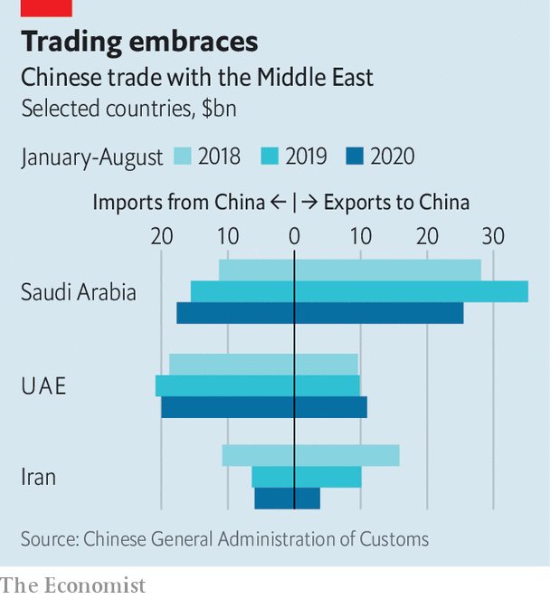

The circumstances have been unusual, of course. Oil demand in China has fallen because of covid-19. But trade with other oil-producers has not been so affected (see chart). Imports from Saudi Arabia, mostly oil and petrochemicals, are down by a less awful 28%. Those from the United Arab Emirates are up by 11%.

Unlike America, China is happy to cultivate ties with all sides in the Middle East. But some of those relationships have limits. Talk of partnerships aside, China cares more about America than about Iran. It backed out of a $5bn deal to develop Iran’s South Pars gasfield rather than fall foul of American sanctions. Common sense plays a role, too. As Lebanon tips into economic crisis, and with its Arab and Western partners reluctant to help, some Lebanese politicians are keen to “look east” and court Chinese aid. To date, though, there has been no major Chinese investment in their country, and its endemic corruption will probably keep China away. “Maybe they’ll build a power station or a highway. But they’re not going to park $10bn in the central bank,” says a diplomat in Beirut.

China’s most valued relationships are with the rich, well-run Gulf states. They in turn are willing to tolerate China’s diplomatic ties with Iran. In June, for example, China voted against a resolution at the International Atomic Energy Agency, the UN’s watchdog, that urged Iran to let inspectors into two nuclear facilities. The vote passed smoothly. A Chinese military base across the Persian Gulf would, however, be another matter. So would big Chinese arms sales to Iran, which are possible if a UN embargo is not renewed this month.

China and Iran will probably conclude an agreement within months. For Iran, it will seem a vital lifeline—particularly if Mr Trump wins a second term. For China, though, Iran will remain just one piece on a much larger chessboard. ■

This article was downloaded by calibre from <https://www.economist.com/middle-east-and-africa/2020/10/10/iran-wants-a-strategic-partnership-with-china>

|  |  |  |  |
| --- | --- | --- | --- |
|  | Articles | Sections | Next |

|  |  |  |  |
| --- | --- | --- | --- |
| Previous | Articles | Sections | Next |

#### Pandemic politics

# Binyamin Netanyahu is losing support

The Israeli prime minister’s botched response to covid-19 is costing lives and public trust

Oct 10th 2020 | JERUSALEM

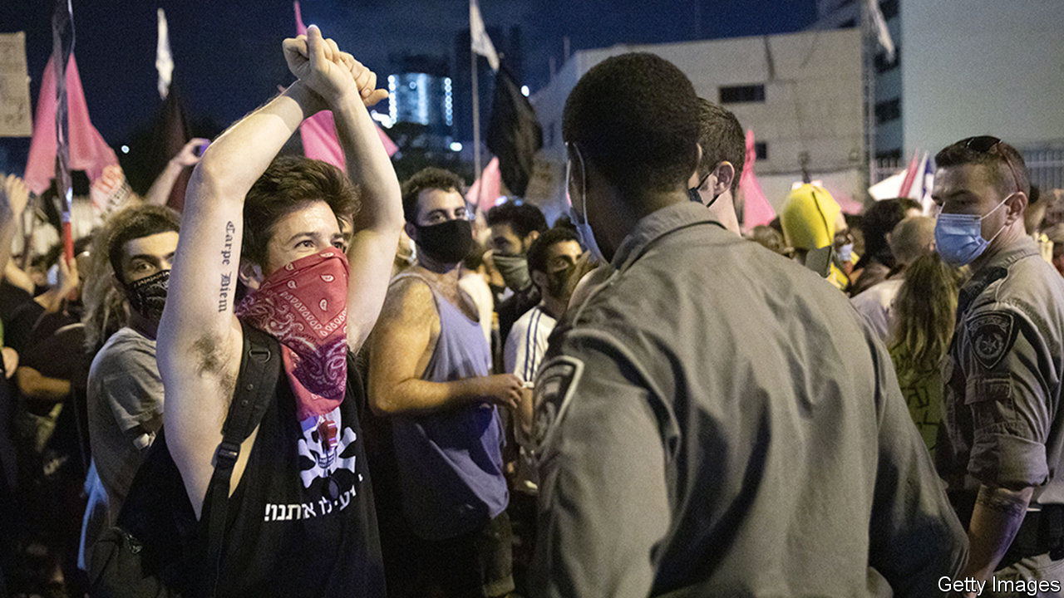

WITH ISRAEL in indefinite nationwide lockdown against covid-19, Binyamin Netanyahu, the prime minister, tried on October 5th to put a positive spin on the situation. “We were the first to go into lockdown” in the second wave, he said. This was therefore an achievement, rather than the result of the highest recorded daily infection rate in the world and one of its highest recorded death rates.

Few Israelis believe him. Polls suggest that if an election were held now, Mr Netanyahu’s Likud party would lose more than a quarter of the seats it took in March. Many would go to another right-wing party led by Naftali Bennett, his former aide.

The swing is not about ideology or policy. Both men hold similar views on many issues. It is a kick in the teeth for the prime minister. In April 58% of Israelis approved of his handling of the pandemic. Now just 27% do (see chart).

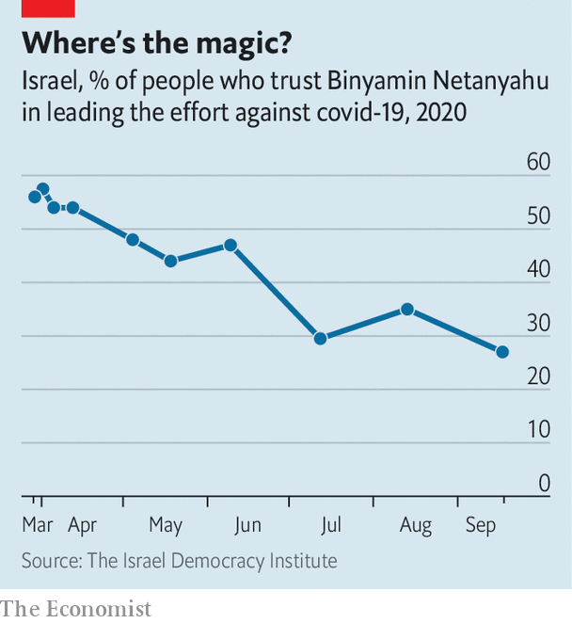

Israel’s longest-serving prime minister should have been at the peak of his powers. After calling three elections, each ending in a stalemate, he managed in May to split the opposition against him and cajole his main challenger, Benny Gantz, leader of the centrist Blue and White party, to join him in a coalition government. Under his leadership Israel seemed to have dealt well with the pandemic’s first wave. He could also boast of a summer of diplomatic triumphs, with the United Arab Emirates and Bahrain agreeing to establish full relations.

But more recently his poorly organised reopening of schools and the economy has led to another surge of infections and a breakdown of public trust in him. Mr Netanyahu’s coddling of his ultra-Orthodox allies, who have been openly flouting medical guidelines, has made matters worse.

Left-wingers who have protested for months outside his residence, calling for his resignation, have been a particular irritation. Papers friendly to him have branded them as “anarchists” and “disease-spreaders”. The latest lockdown rules seemed aimed as much to target them as to suppress the virus. “Whenever the protesters come up in cabinet meetings,” says one minister, “Netanyahu simply loses it.”

Yet the lockdown is failing on both counts. The protesters can no longer gather in thousands outside Mr Netanyahu’s house. But they have dispersed into hundreds of smaller demonstrations, gaining new followers. Some even take place in Jewish settlements on the West Bank.

Defying the new rules, Israelis now seem less inclined to stay at home. Mobile-phone data show that they moved around 75% less than normal in the first lockdown. Now they are moving just 60% less than usual. “The public is much less disciplined,” says Eran Segal of the Weizmann Institute. As a result, the infection rate will probably fall slowly, adding to Mr Netanyahu’s woes. “Covid has tainted him,” says a former aide who has seen him come back from polling slumps before. “Netanyahu can’t rebuild his image after this.” ■

This article was downloaded by calibre from <https://www.economist.com/middle-east-and-africa/2020/10/10/binyamin-netanyahu-is-losing-support>

|  |  |  |  |
| --- | --- | --- | --- |
| Previous | Articles | Sections | Next |

|  |  |  |  |
| --- | --- | --- | --- |
| Previous | Articles | Sections | Next |

#### A rage for roads

# Egypt is busily building expressways

But locals would prefer a more carfree Cairo

Oct 8th 2020 | CAIRO

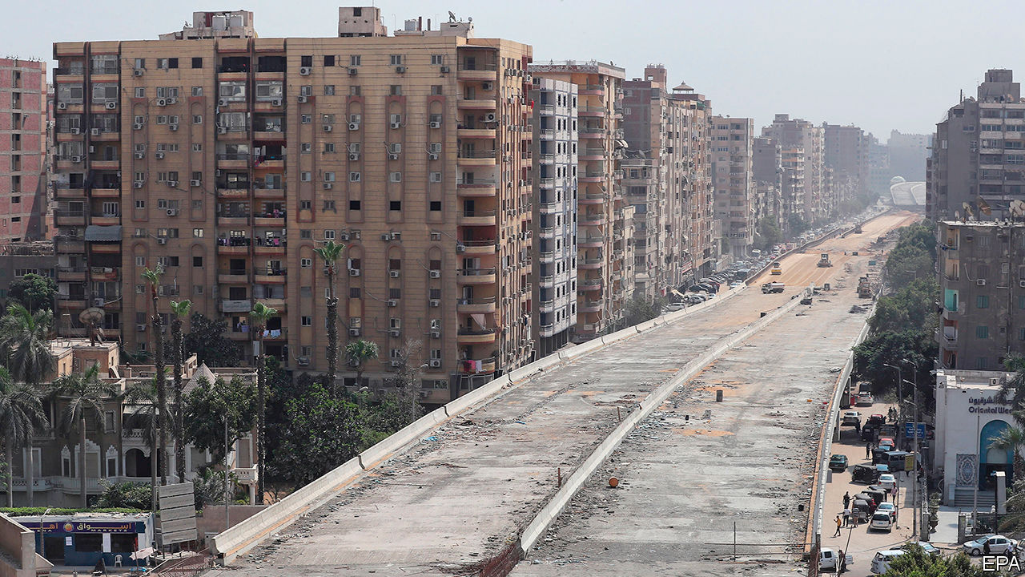

THE NEW flyover in Giza, near Cairo, is something to behold. The road runs so close to the adjacent apartment buildings that some residents can reach out of their windows and touch it (see picture). One jokingly told a local newspaper that he would invite passing motorists in for tea on his balcony. But the road is more than just an object of ridicule. To many Egyptians, it is a symbol of their government’s ineptitude, as it pursues an ambitious national development plan.

The scale of construction, which includes highways linking new and planned cities, is vast. In August the transport minister, Kamel al-Wazir, said 130bn Egyptian pounds ($8.3bn) had been allocated to complete 1,000 bridges and tunnels by 2024 (about 600 are already done). The goal is to double Egypt’s urban space over the next 30 years. President Abdel-Fattah al-Sisi, a former general, wants the work done quickly. Roughly a fifth of Egypt’s 100m citizens live in Cairo, the timeworn capital.

Many Egyptians support the effort. Cairo’s roads are notoriously clogged. Part of the plan is to reorient the flow of traffic towards a shimmering new capital, 45km east of the current one. With new highways taking shape, commutes into central Cairo from the periphery have never been so brisk. The roads are a rare but tangible way in which the quality of life for many Egyptians has improved under Mr Sisi.

But much of the construction appears poorly planned. The new concrete bridges and flyovers are eyesores. Residents of Heliopolis, a relatively posh neighbourhood in the capital, mourn the loss of hundreds of trees. Public parks and squares have been paved over and roads have gobbled up pavements to make way for cars. Dozens of pedestrians were struck on one expanded stretch of road in the weeks after it reopened earlier this year. The carnage forced the government to station soldiers there to help people cross.

The construction also threatens Egypt’s heritage. One planned expressway would slice through the City of the Dead, an ancient necropolis listed by UNESCO as a world heritage site. Bulldozers have already begun rolling through a section of its more contemporary graves. Elsewhere a pair of highways is being carved through the Giza plateau, near the Great Pyramids. Egyptologists worry that archaeological treasures may be lost under concrete. (An earlier version of the Giza highway plan was scrapped in the 1990s after an outcry.)

Locals complain that the government has not consulted them (they are not allowed to protest). Urban planners say the development is misguided. They point to cities elsewhere, from Paris to Seoul, which have recently become more green and walkable. Norman Foster, an architect, put it plainly at a forum in Cairo: “One has to question why one part of the world is building huge roadwork when elsewhere...the lessons have been already learned.” ■

This article was downloaded by calibre from <https://www.economist.com/middle-east-and-africa/2020/10/08/egypt-is-busily-building-expressways>

|  |  |  |  |
| --- | --- | --- | --- |
| Previous | Articles | Sections | Next |

|  |  |  |  |
| --- | --- | --- | --- |
| Previous | Articles | Sections | Next |

#### The vengeance of old men

# A dangerous election looms in Ivory Coast

Geriatric rivals argue over the rules, as fears of another bloody election grow

Oct 10th 2020 |

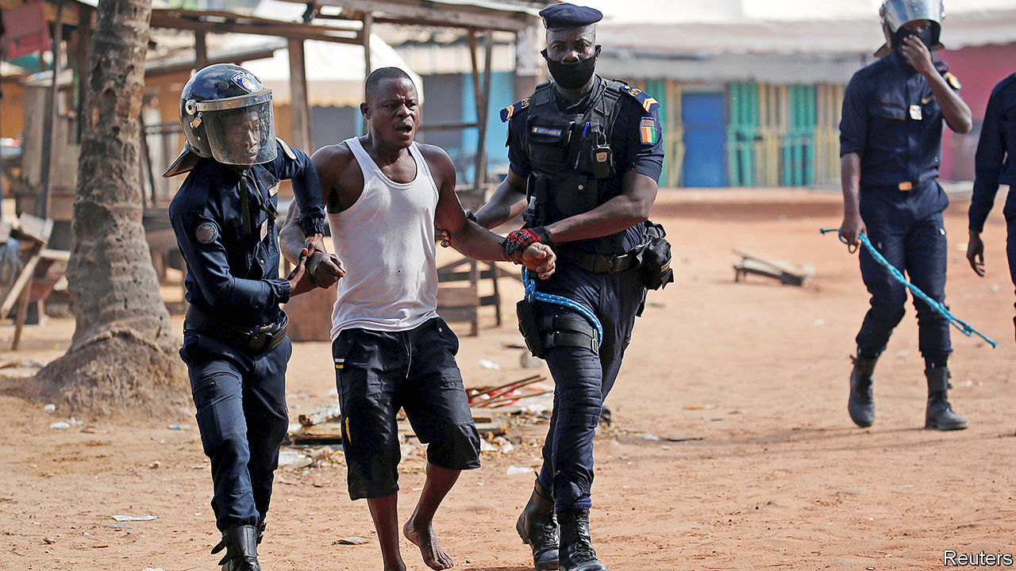

THE LAST time Ivory Coast had a close election, 3,000 people were killed. So when a policeman in Abidjan, its commercial capital, recently saw men with machetes pouring out of vans, chatting amicably with his police chief and then attacking nearby unarmed protesters while the police looked on, he complained to Amnesty International, a human-rights watchdog. “Their presence was not coincidental,” he said. “This reminds me of the two past crises when militias were sowing terror among the people.”

Ivory Coast, Francophone west Africa’s biggest economy and a regional business hub, is on edge before the first round of a presidential election, due on October 31st. President Alassane Ouattara, aged 78, made matters worse by deciding to run for a third term, seemingly in breach of the constitution, after his chosen successor died in July. Rivalries within the same cast of ancient politicians who have fought over the country for 30 years once again threaten chaos. At least 14 people have been killed in political punch-ups since mid-August. Ivorians fear that worse is to come.

In 2010 the then president, Laurent Gbagbo, refused to accept that he had lost the election and had to be prised from his bunker by forces loyal to the winner, Mr Ouattara, who was backed by French troops and helicopters. Mr Gbagbo was carted off to face trial at the International Criminal Court (ICC) in The Hague. The economy bounced back under Mr Ouattara, averaging 8% growth a year since 2011, though many Ivorians are still poor.

Since then, efforts at reconciliation have failed. The election’s rules and the choice of who should oversee the vote are disputed. On September 14th the constitutional council waved through Mr Ouattara’s controversial candidacy, after he claimed that a constitutional change during his time in office meant that his two-term limit could be reset. Idayat Hassan of the Centre for Democracy and Development, a think-tank in Abuja, Nigeria’s capital, calls it a “constitutional coup”.

The council was less lenient towards most would-be candidates, blocking 40 of the 44 who applied to run. This included Guillaume Soro, a former rebel leader and prime minister under Mr Ouattara, and Mr Gbagbo himself, who was acquitted by the ICC last year of charges of crimes against humanity. Mr Gbagbo is, however, more or less stuck in Belgium pending an appeal against the verdict by the prosecutor. The Ivorian constitutional council, banning both men, cited criminal convictions secured against them in absentia: Mr Gbagbo for allegedly looting the central bank, Mr Soro for alleged embezzlement. Despite Mr Gbagbo’s grim record, he still has a big following. Mr Soro calls Mr Ouattara’s bid for a third term a “mad venture”.

The candidates who have been allowed to run are hardly any happier. They say the election should not go ahead unless Mr Ouattara withdraws and the constitutional council and electoral commission are dissolved. Pascal Affi N’Guessan, another candidate, says the government is a “dictatorship”. The leading opposition figure, Henri Konan Bédié, another former president, has called for civil disobedience. The opposition hopes to fill a stadium with 50,000 supporters on October 10th. Its overall aim, suggests Séverin Kouamé of the University of Bouaké, is to alarm foreign governments so much that they feel obliged to intervene, as they have before.

Mr Ouattara is ignoring the opposition’s demands and has banned street protests. “I warn anyone who wants to make trouble, if that is what they want, they will have to face me,” he says. Meanwhile, he has sought to please the quarter of the population who depend on growing cocoa by announcing a 21% increase in its price.

France’s president, Emmanuel Macron, the most influential of the Western leaders involved, is said to have urged Mr Ouattara to delay the poll. The International Crisis Group, a Brussels-based conflict-prevention outfit, says the same. But after 30 years of rancorous rivalry the main protagonists are in no mood for dialogue. Whereas the median age in Ivory Coast is 19, Mr Bédié is 86. Mr Gbagbo is 75, only three years younger than Mr Ouattara. The two opposition candidates have a history of stirring up ethnic strife for their own ends.

A delay seems unlikely. Were Mr Ouattara to win, the opposition would surely reject the result. Violence, which many fear would take on an ethnic hue, could well erupt. Mr Soro has a following in the army, increasing the risks of bloodshed. “The people are scared,” says Mr Kouamé.

With luck, Ivorians—fed up with the bad blood among politicians—may prove reluctant to take to the streets. There are fewer armed groups now than in 2010. And although Mr Gbagbo has a history of rallying supporters to the streets, he is in Belgium. From such a distance, he may be less able to stir up trouble.

If by hook or by crook Mr Ouattara wins, as seems probable, swathes of the electorate will view him as illegitimate. Even if violence is avoided, Ivory Coast will face a post-election crisis, says William Assanvo of the Institute for Security Studies. ■

This article was downloaded by calibre from <https://www.economist.com/middle-east-and-africa/2020/10/10/a-dangerous-election-looms-in-ivory-coast>

|  |  |  |  |
| --- | --- | --- | --- |
| Previous | Articles | Sections | Next |

|  |  |  |  |
| --- | --- | --- | --- |
| Previous | Articles | Sections | Next |

#### Fuel me once

# Nigeria’s President Buhari is doing away with petrol subsidies

The reform is long overdue

Oct 10th 2020 | ABUJA

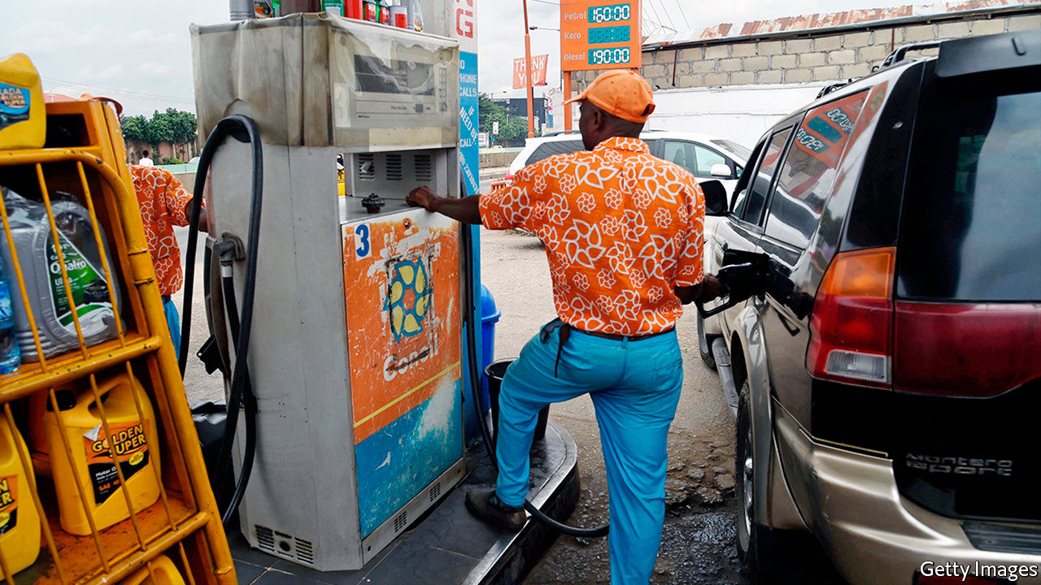

TIME IN NIGERIA sometimes seems to follow its own rhythm. When the government introduced petrol subsidies they were meant to last just six months. Some four decades later, they endure.

Africa’s biggest oil producer sometimes has the continent’s longest queues outside filling stations. Not one of its four refineries has produced a drop of petrol in more than a year. The reason is that the government forces oil companies to sell petrol at the pump for less than it is worth on international markets (with the state, belatedly, paying the difference). The subsidies have been a huge drain on the treasury: when oil prices were higher in 2011 they equalled almost 5% of GDP. The subsidies are often stolen. And when they are not, they encourage overconsumption of a planet-cooking fossil fuel.

Muhammadu Buhari, now in his second term as Nigeria’s president, has long promised to repair state-owned refineries to reduce the fuel-import bill. But he has also balked at letting them sell petrol at prices high enough to make refining profitable. Until now. Over the past few months the government has steadily lifted the retail price of fuel after announcing in June that it would phase out the subsidies. A litre now sells for 162 naira ($0.42), up from 121 naira in June.

These reforms have irked opposition parties and trade unions. Labour bosses threatened strikes, as they did when a previous government tried to end petrol subsidies in 2012. Then, after ten days of protests and 12 deaths (mostly from police bullets), the government backed down and reduced subsidies instead of eliminating them.

This time the government has little choice but to hold firm. The World Bank reckons Nigeria’s economy will shrink by 3.2% this year, its worst recession in four decades. Government revenues are slumping, leaving little cash to support the more than 40% of Nigerians who are extremely poor, let alone provide subsidised petrol to middle-class motorists.

The economic crisis also seems to have dampened the unions’ fighting spirit. Low oil prices mean that the loss of the subsidies is not being felt as keenly as in 2012. They called off a nationwide strike scheduled for September 28th after talks with the government. They did not leave empty-handed: the government put on hold planned increases in electricity prices, which are needed to make it profitable for companies to generate the stuff. The unions, it seems, would rather have cheap imaginary power than slightly dearer juice that actually comes out of the socket. ■

This article was downloaded by calibre from <https://www.economist.com/middle-east-and-africa/2020/10/10/nigerias-president-buhari-is-doing-away-with-petrol-subsidies>

|  |  |  |  |
| --- | --- | --- | --- |
| Previous | Articles | Sections | Next |

|  |  |  |  |
| --- | --- | --- | --- |
| Previous | Articles | Sections | Next |

#### When calling is a calling

# For some Ugandans, phoning the radio is a way of life

Those who praise politicians can land plum jobs

Oct 10th 2020 | KAMPALA

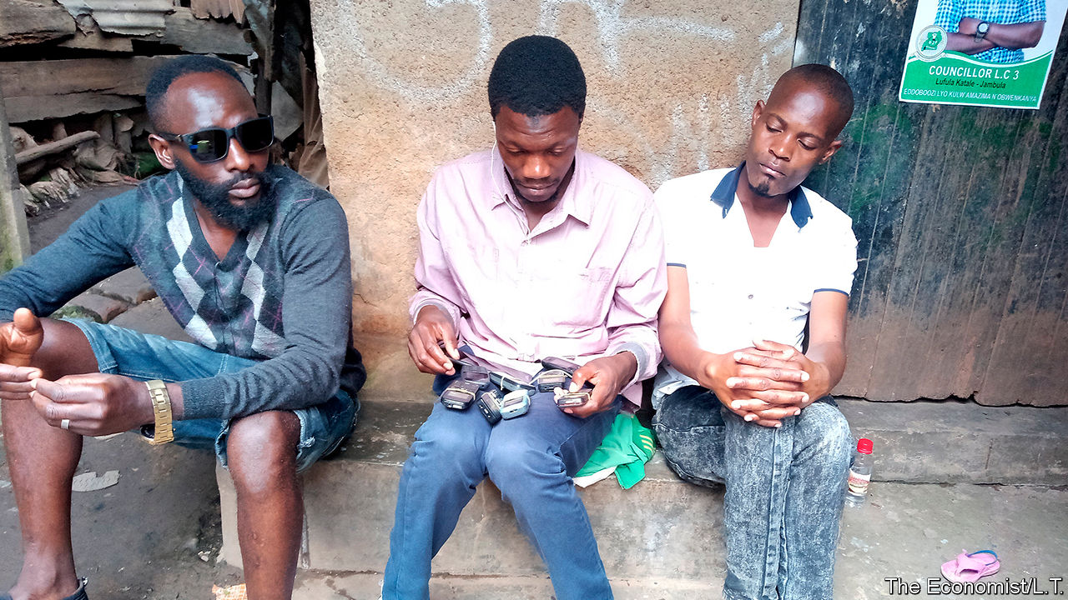

THE TRICK to getting on Ugandan radio is to call early and often, says Rajabu Bukenya (pictured). A phone is tucked in his shirt pocket, its radio receiver tuned to a popular talk show. Eight others are balanced on his thighs, all dialling the station’s number. Soon one connects and he gives his trademark introduction. “This is Rasta Man in Bwaise who eats once a day!” Hunched on a step, beside a wall scrawled with graffiti, he has all of Kampala as his audience.

Mr Bukenya says he phones “from morning up to evening”, expounding on crooked politics, bad roads, or the floods that sweep through Bwaise, a poor quarter of the Ugandan capital. He considers himself a “freedom fighter”. But not everyone concurs. Adam Kungu, who hosts a political talk show on Top Radio, says that eight in ten calls come from regulars like Mr Bukenya, stopping ordinary listeners from getting through. “Repetitive callers are a menace,” complains Abby Mukiibi, a programmer at CBS, another station. “To them it is a way of living now, it’s employment.”

The business model is murky. Some callers have clubbed together into trade associations. A member says they meet to discuss issues and do not take money from politicians. But most listeners suspect otherwise. Mr Mukiibi says he knows one caller who used his earnings to buy a chicken farm and another who got a job in the intelligence service. When he tries to block repeat callers he gets messages from state security saying “Let those people do it.”

The most dedicated diallers can do well. Linos Ngompek used to drive taxis to pay his college fees. After graduating he started phoning radio stations to praise the ruling party, and soon joined other “media activists” in government-run training sessions. “Sometimes you find that a ministry is being bashed on air, so these ministers would call us to give us facts,” he says. He denies receiving cash, but says calling helped him in other ways: in 2014 he was appointed a local security chief by the president, and he is now running for parliament.

The men who phone in—very few are women—insist they are not driven by a desire for fame or money. The role of a caller is to fill “a vacuum” that exists between government and the people, says Nicholas Musinguzi, a spokesman for “Kangabaije”, a pressure group which phones in daily to stations in Hoima town. It takes its name from a drum traditionally beaten to alert the community in a crisis. In Bwaise, Mr Bukenya canvasses opinion with market vendors and motorbike-taxi drivers. He still lives in “the ghetto”, but now even big politicians take his calls. “My aim is for my voice to reach where I cannot,” he says.

This article was downloaded by calibre from <https://www.economist.com/middle-east-and-africa/2020/10/10/for-some-ugandans-phoning-the-radio-is-a-way-of-life>

|  |  |  |  |
| --- | --- | --- | --- |
| Previous | Articles | Sections | Next |

|  |  |  |
| --- | --- | --- |
| Middle East & Africa | Sections | Britain |

Europe

War in the Caucasus: Heavy metal

.

Greece: Selling Salamis

.

France’s Greens: The cancelled Christmas tree

.

The media in Poland: The Hungarian model

.

Coronavirus in Sweden: The odd one out

.

Charlemagne: The princess, the pea and foreign policy

.

|  |  |  |
| --- | --- | --- |
| Middle East & Africa | Sections | Britain |

|  |  |  |  |
| --- | --- | --- | --- |
|  | Articles | Sections | Next |

#### Heavy metal

# The Azerbaijan-Armenia conflict hints at the future of war

A fleet of cheap Turkish drones is slicing through Armenian defences

Oct 10th 2020 | ISTANBUL AND LONDON

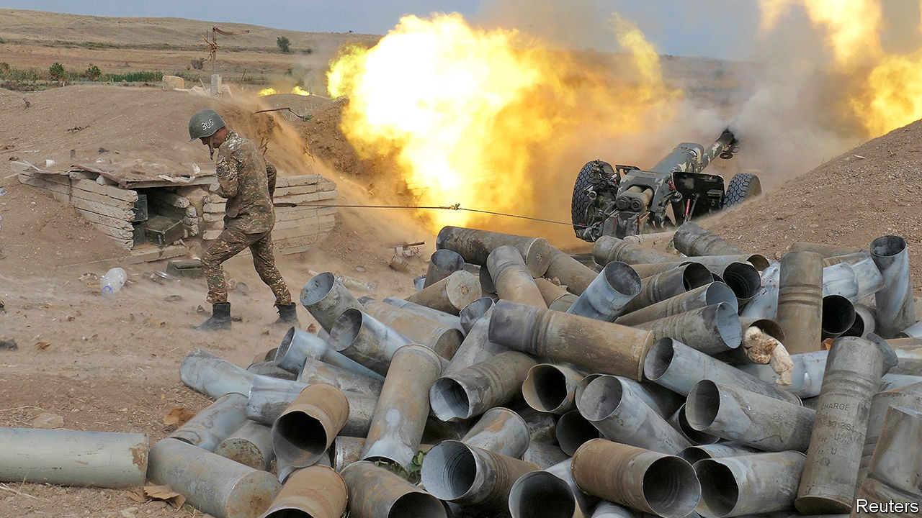

AZERBAIJAN’S ARMED forces may be busy waging war over Nagorno-Karabakh, a disputed enclave run by Armenia. That did not stop them from setting aside scarce helicopters and tanks to star in a music video, complete with khaki-clad singers, guitarists and a drummer. The bellicose heavy-metal tune, accompanied by a montage of bombing raids, would not be out of place in the Eurovision song contest, and is part of a crude attempt by Azerbaijan’s corrupt and autocratic government to rally people round the flag.

The real war, which began on September 27th, has been less telegenic. Hundreds of people, most of them soldiers, are already believed dead. The fighting is the worst since 1994, when ethnic Armenian forces seized Nagorno-Karabakh and surrounding Azerbaijani districts after a conflict that saw tens of thousands killed and a million people displaced. Azerbaijan claims to have taken a dozen villages in the Jabrayil district, one of seven that ring Nagorno-Karabakh and were occupied by Armenian forces. Azerbaijani cluster munitions have struck Stepanakert, the capital of the breakaway province. Armenian forces have shelled Ganja, Azerbaijan’s second-biggest city. Both sides seem to have used ballistic missiles, and a few stray rockets have landed in next-door Iran.

Ceasefire calls by America, the European Union and Russia—which has a defence treaty with Armenia and a base there, but sells weapons to both sides—have fallen on deaf ears. Turkey, meanwhile, has exhorted Azerbaijan to continue its offensive and offered its ally unconditional support. “We say again to our Azerbaijani brothers,” Turkey’s president, Recep Tayyip Erdogan, said on October 5th, “that we stand by them in their holy struggle until victory.”

The support has been more than rhetorical. Evidence is mounting that Turkey has sent hundreds of Syrian mercenaries to fight for Azerbaijan. Videos of Syrians on the front lines are circulating on social media. The Syrian Observatory for Human Rights, a monitoring group, says that 72 of them have already died in combat. The use of mercenaries indicates the difficulty in mobilising Azerbaijan’s youth to fight for a small, mountainous region populated by ethnic Armenians that it lost 30 years ago.

In Armenia, by contrast, men of all ages, even with no military background, have been enlisting for action. As Thomas de Waal, an expert on Nagorno-Karabakh, says, “Armenia’s statehood and its independence are inseparable from Nagorno-Karabakh. It is Armenia’s Jerusalem.” For Azerbaijan, the loss of Nagorno-Karabakh was traumatic. Its government is now trying to regain its national pride with military action, Mr de Waal adds.

Militiamen, artillery duels and rocket attacks hark back to an older way of war. But Azerbaijan’s success against more professional Armenian forces stems from an oil-fuelled arms-buying spree that has yielded high-tech weapons from Russia, Turkey and Israel. “Even though the overall count of Armenian and Azerbaijani heavy weapons is now more or less equal,” notes Pavel Felgenhauer, a Russian defence analyst, “Azerbaijan’s military boasts a definite qualitative technological edge.”

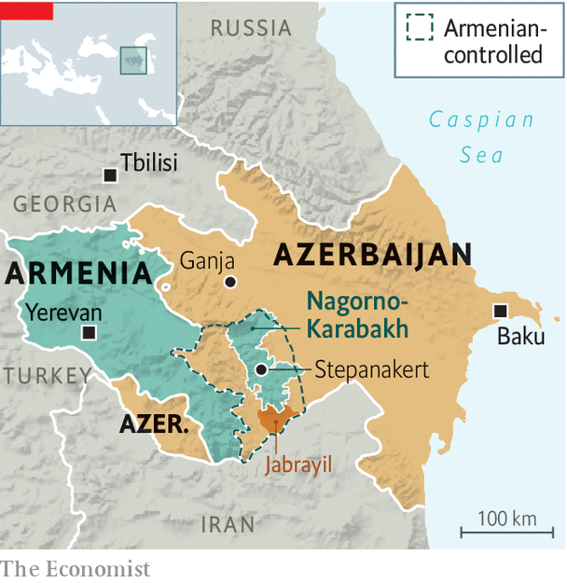

Evidence of that can be seen in four large launchers visible behind the band in Azerbaijan’s tub-thumping video. They contain the Harop, an Israeli-made “loitering munition”—essentially, a kamikaze drone—capable of cruising independently for hours before smashing into a radar, or returning home to land. In 2016 the Harop struck a bus full of Armenian reinforcements. Video footage from the current fighting suggests it is in use again.

That in itself is surprising. “The general understanding among experts used to be that drones wouldn’t play a big role in inter-state wars, as they are vulnerable to anti-aircraft fire,” says Ulrike Franke of the European Council on Foreign Relations, a think-tank. That is probably true in wars involving big powers like America, China and Russia. It has proved mistaken in lesser conflicts. When Turkey launched an offensive in northern Syria in February, it used its TB2 drones to destroy hundreds of Syrian armoured vehicles. That carnage is repeating itself in the Caucasus. Azerbaijan has methodically knocked out a hefty proportion of Armenian air defence, artillery and armour using its own fleet of TB2s.

Turkish and Azerbaijani tactics point to a new, more affordable type of air power. Drones make an especially big difference for countries with small air forces, points out Ms Franke. Warplanes are expensive to buy, maintain and operate; that is why Armenia and Azerbaijan have just 52 between them. The TB2, costing a few million dollars and lacking a pilot, is expendable. In Syria and Libya, several of Turkey’s TB2s were shot down by the Russian-made Pantsir S1, a short-range air-defence system. But the drones destroyed several of those systems, in turn. The trade-off is worth it, says Rob Lee of King’s College London, “like trading a pawn for a knight” (assuming that a country has a suitably large pool of drones). “The TB2 should drive home to European armed forces what such systems can do to ground forces that lack adequate air defences,” says Franz-Stefan Gady of the International Institute for Strategic Studies, a think-tank in London.

The value of drones is not just their destructive potential, but also their ability to document their kills. Both sides in the conflict have released dramatic footage of drones and soldiers destroying enemy tanks. They have learnt from Turkey, which flaunted its aerial exploits in Syria and Libya. “Turks are masters of propaganda,” says Aaron Stein of the Foreign Policy Research Institute. “They do a great job of using these images, shoving them onto social media and dominating the narrative.”

The TB2’s high-definition cameras give Azerbaijan an edge in that contest. Its tank-killing snuff movies are slicker affairs, set to Wagnerian music. If Azerbaijan is reluctant to press home its advantage at the cost of high casualties on the ground—as the use of Syrian fighters may suggest—then winning a propaganda war may be the next best thing to winning a real one. ■

This article was downloaded by calibre from <https://www.economist.com/europe/2020/10/10/the-azerbaijan-armenia-conflict-hints-at-the-future-of-war>

|  |  |  |  |
| --- | --- | --- | --- |
|  | Articles | Sections | Next |

|  |  |  |  |
| --- | --- | --- | --- |
| Previous | Articles | Sections | Next |

#### Sun, sea and naval history

# Why tourists shun Salamis, site of a great sea-battle

2,500 years ago a small Greek fleet thrashed a huge Persian one. Holidaymakers don’t care

Oct 10th 2020 |

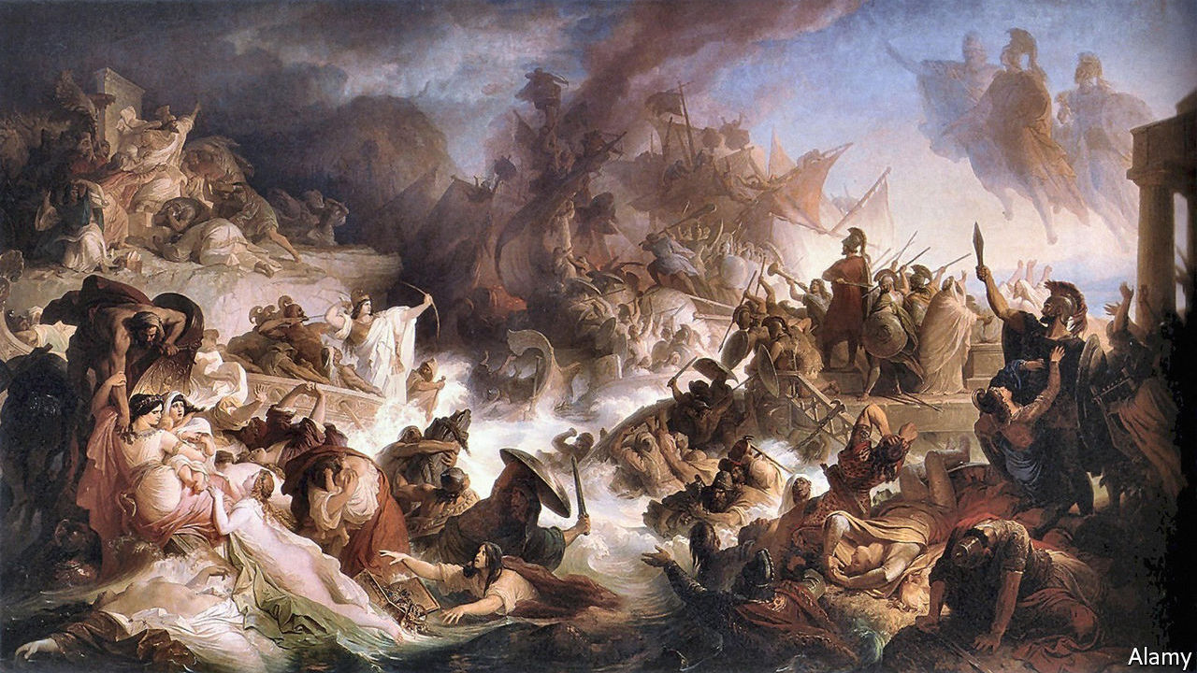

PEOPLE ON SALAMIS hoped that their hilly island would be on the tourist map this year. It is the 2,500th anniversary of one of the greatest naval battles of the ancient world. In the early autumn of 480BC, in the strait between Salamis and the mainland, a few hundred Greek triremes (warships with three banks of oars and bronze battering-rams) defeated a much larger Persian armada.

It was an unexpected triumph. Xerxes, the Persian king, was so confident of victory that he erected a throne from which to enjoy it, on a slope overlooking the sea. To his horror, the agile Greek fleet sank 200 lumbering Persian vessels, and lost only 40 of its own. Xerxes “counted them at break of day—/And when the sun set, where were they?” crowed Lord Byron, an English poet, 2,300 years later. The victory opened the way for Athens, which led the Greek fleet, to become Europe’s first superpower. A Hollywood film in 2014 portrayed the Greek sailors as perfectly sculpted hunks (and annoyed modern Iranians with its cartoonish depiction of the Persians).

Yet still the tourists do not come to Salamis. Covid-19 scuttled plans for a big celebration. Tourist visits to Greece fell by around 75% this summer. Only a few history buffs came to view the battle site. “It’s been a big disappointment,” says Georgios Panagopoulos, the mayor.

There are other reasons why Salamis has never become a tourist destination. It is host to a naval base, so parts of the island are off-limits. It is also close to Perama, a scruffy port surrounded by small ship-repair yards. And there is not much to see, apart from two modern bronze statues of warriors on a low mound, the supposed burial place of sailors killed in the battle. Nearby, noisy hammering comes from a large shed beside a pier. A rusty ship is moored alongside. A 50-year-old shipyard on the island’s Kynousoura peninsula is still in business, despite four government rulings since 2010 declaring the area a protected archaeological zone.

This year the environment ministry fast-tracked a new 15-year licence for the yard, whose owner, say islanders, has powerful connections. Clientelism is hard to crack in Greece, but Mr Panagopoulos, a newish mayor, says “We’ll do our utmost to get this yard shut down.” If he clears it, they may come. Greeks have beaten tougher odds before.

This article was downloaded by calibre from <https://www.economist.com/europe/2020/10/10/why-tourists-shun-salamis-site-of-a-great-sea-battle>

|  |  |  |  |
| --- | --- | --- | --- |
| Previous | Articles | Sections | Next |

|  |  |  |  |
| --- | --- | --- | --- |
| Previous | Articles | Sections | Next |

#### Green like the Grinch

# The French mayor who cancelled the Christmas tree

France’s Green politicians are grabbing attention, not all of it positive

Oct 10th 2020 | BORDEAUX

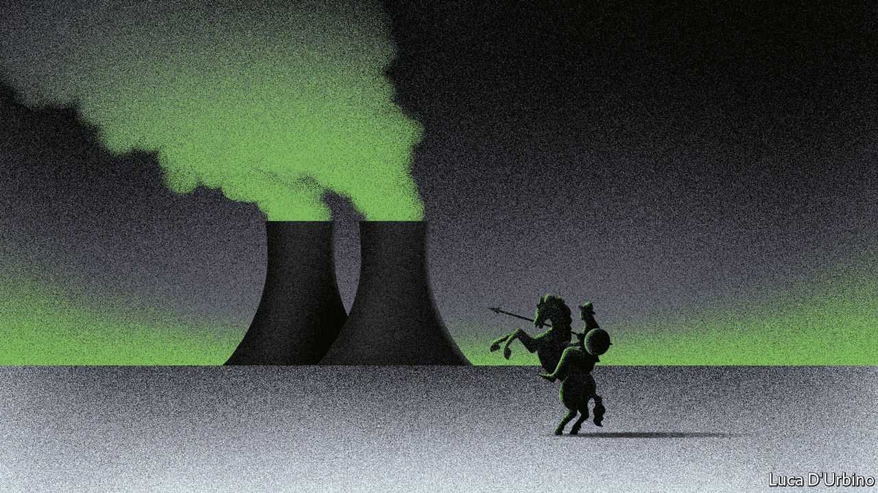

STANDING BEFORE potted plants, Pierre Hurmic, the newly elected Green mayor of Bordeaux, announced last month that the town hall would no longer put up a giant annual Christmas tree. No “dead trees on the town square”, he declared. The opposition cried scandal. The mayor was accused of destroying tradition and family fun. A poll showed that 79% of French people disapproved. Even the prime minister, Jean Castex, was moved to deplore the loss of Bordeaux’s traditional Christmas tree.

“It was absolutely not a provocation,” insists Mr Hurmic, who today professes surprise at the “completely disproportionate” fuss that his comment prompted. “I’m not against Christmas trees,” he says. But transporting a 17-metre tree cut from a forest halfway across the country is unjustifiable. “I prefer living trees,” affirms the mayor, who plans to plant them all over an elegant city that in his view is “too mineral” and needs to breathe.

Mayors are making the Greens heard in France. In 2017 the party did not run its own presidential candidate. In Paris it has just five staff members. Yet at elections in June it won nine of the biggest town halls, most for the first time. The row over the Bordeaux Christmas tree is just one of various recent arguments, revealing both a fierce debate within the party, as well as a growing Green influence on national politics.

Last month Grégory Doucet, the Green mayor of Lyon, denounced the Tour de France as “macho” and “polluting”. The annual cycling race is a national treasure. But Mr Doucet dislikes the team cars that follow riders and all the discarded plastic. In nearby Grenoble, Eric Piolle, its Green mayor, said that he would block the roll-out of 5G networks. The technology, he said, is designed for little more than to let people “watch porn in HD, even in the lift”.

Not all Greens approve of the latest outbursts. Once-internal debates are now being aired in public. The party includes not only décroissance (anti-growth) eco-warriors but also moderates who worry that radicals will undermine any attempt to broaden its appeal. Isabelle Saporta, an activist (and partner of Yannick Jadot, a Green Party leader), has accused the mayors of having “one idiotic idea a day”.

The fact that the Green mayors are stirring national debate also reveals how seriously other parties now take the party. Besides winning big cities, the Greens came third—behind Marine Le Pen’s National Rally and Emmanuel Macron’s La République en Marche—at European elections last year. Even the president, who has embraced a more growth-friendly form of greenery, has begun to lay into the eco-radicals. Last month he accused anti-5G lobbyists of wishing an “Amish model”, and the return of the oil lamp, on France.

Back in Bordeaux, cyclists pedal along riverside bike lanes and an electric tram carries passengers back and forth. In the city centre at least, this once-conservative town—ruled for 73 years by the centre-right, including Alain Juppé, an ex-prime minister—had already embraced greener living. Mr Hurmic now wants to fight new speculative development and stop marketing the city as an investment “magnet” to the detriment of the surrounding area. It is not yet clear how he will square this ambition with a battered local economy that depends heavily on pandemic-hit sectors such as tourism, aerospace and wine.

“My impression is that the Greens weren’t ready for power,” says a Bordeaux tech entrepreneur. Others suggest they are moving at an appropriately organic speed. “He’s in fact a very conservative environmentalist,” says Thomas Cazenave, LREM’s mayoral candidate in Bordeaux. No signature measure has been put in place. Last week the council voted merely for an “impact study” on 5G. “I’m not an Amish, that’s ridiculous,” says Mr Hurmic. By mocking the Greens, Mr Macron is both naming his new rivals, and shaping them. ■

For more coverage of climate change, register for The Climate Issue, our fortnightly [newsletter](https://www.economist.com/theclimateissue/), or visit our [climate-change hub](https://www.economist.com/news/2020/04/24/the-economists-coverage-of-climate-change)

This article was downloaded by calibre from <https://www.economist.com/europe/2020/10/10/the-french-mayor-who-cancelled-the-christmas-tree>

|  |  |  |  |
| --- | --- | --- | --- |
| Previous | Articles | Sections | Next |

|  |  |  |  |
| --- | --- | --- | --- |
| Previous | Articles | Sections | Next |

#### The Hungarian model

# Poland’s ruling party may clobber independent media

Foreign investors could be obliged to sell

Oct 10th 2020 | BERLIN

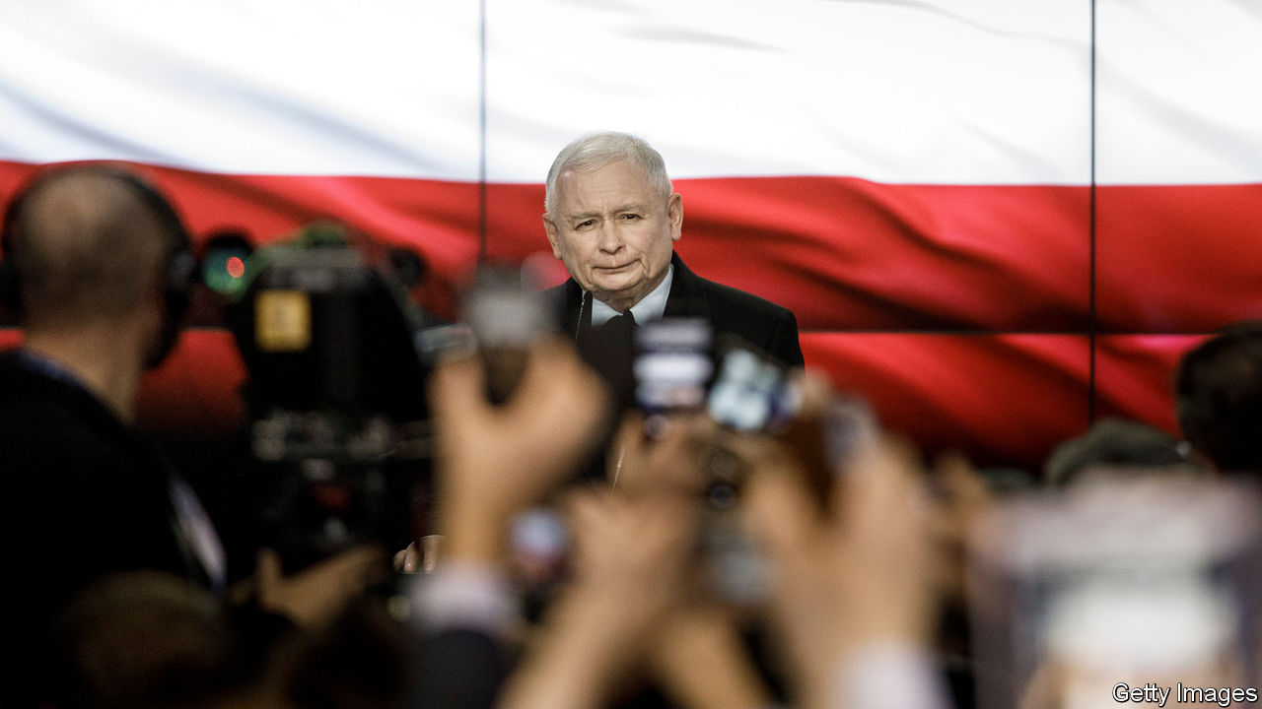

EVER SINCE Poland’s Law and Justice party returned to power in 2015 it has chipped away at the independence of the media. Poland’s annual ranking in the World Press Freedom Index compiled by Reporters without Borders, a non-profit group, has grown worse every year, from 18th in 2015 (ahead of Britain, France and America) to 62nd this year (lower than Niger, Georgia and Armenia). It will slide further if the government carries out its latest plans to “repolonise” the country’s media.

For the past few years leaders of Law and Justice, a populist-nationalist party, have talked about two new laws: one to repolonise and another to “deconcentrate” private media firms. Neither has passed. But after the party lost ground in a general election last October and then won July’s presidential election only narrowly, Jaroslaw Kaczynski, the party boss who has now emerged from the shadows to take up the role of deputy prime minister, seems determined to push them through. In a recent interview Mr Kaczynski said he wanted to limit foreign investors to a stake of no more than 30% in Polish media, while deconcentration would limit the number of outlets that any one media group can own. Repolonisation, Mr Kaczynski said, would “ensure that there are more media outlets that present the world more truthfully”. The opposition fears the opposite is more likely.

Soon after coming to power, Law and Justice tightened the government’s grip on the state television network TVP, the national news agency PAP and Polish Radio. These “national media” now disgorge ruling-party propaganda—and as a result have lost some of their audience, especially city-dwellers and the young. During the recent election campaign TVP openly supported the Law and Justice-backed incumbent, Andrej Duda, and threw in a dollop of anti-Semitic conspiracy theory, too. (It said that if the opposition candidate won, he would cut welfare benefits for Polish families and give the money to Jews.)

Taking its cue from Hungary’s illiberal rulers, Law and Justice is now eyeing private media outfits, such as Fakt, a popular tabloid owned by Ringier Axel Springer, a German-American-Swiss group, and TVN, a television network owned by Discovery, an American firm. Another target is Gazeta Wyborcza, the most popular broadsheet, which is co-owned by Agora, a Polish group, and two American firms. The ruling party is squeezing Gazeta by blocking state-controlled businesses from advertising in it. Private firms that want to do business with the state think twice as well.

Hardly any big media company needs “deconcentrating”, as the market is already fragmented, says Adam Szynol of the University of Wroclaw. One exception is regional dailies: 20 out of 24 of them are owned by the Verlagsgruppe Passau (VGP), a German publishing group. Though most of these papers have a relatively small circulation, they are important for the ruling party because their readers tend to be in rural, very Catholic parts of Poland, its core constituency. As The Economist went to press, VGP was said to be in talks with Orlen, the state-owned petrol retailer, about the sale of Polska Press, its Polish arm.

Treating German and American investors shabbily could backfire. That is why Boguslaw Charbota, editor-in-chief of Rzeczpospolita, a leading daily, says he is not too pessimistic. The government is staunchly pro-American, he argues, and the American ambassador in Warsaw has already signalled that any limits on American investment in Poland will not go down well in Washington.

Others are more alarmed. They fear that the two bills could become law within weeks. They would make it hard or impossible for foreign media investors to do more business in Poland and may even force some sales. And that would actually concentrate Polish media—under the control of the Law and Justice party. ■

This article was downloaded by calibre from <https://www.economist.com/europe/2020/10/10/polands-ruling-party-may-clobber-independent-media>

|  |  |  |  |
| --- | --- | --- | --- |
| Previous | Articles | Sections | Next |

|  |  |  |  |
| --- | --- | --- | --- |
| Previous | Articles | Sections | Next |

#### Europe’s odd man out

# How Sweden hopes to prevent a second wave of covid-19

A lot more tracing is expected

Oct 10th 2020 | STOCKHOLM

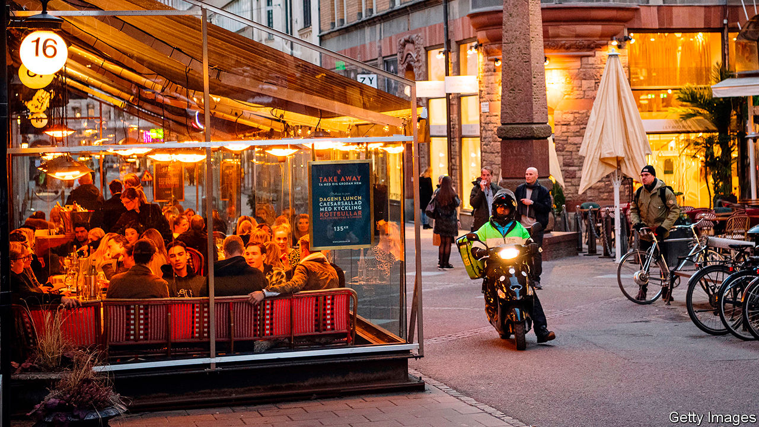

ON A CRISP October evening the tables outside Stockholm’s trendy bars and restaurants sit empty. Inside, most tables are full. As life moves indoors in the coming months, covid-19 cases will inevitably rise, says Johan Carlson, head of Sweden’s public-health agency. Case numbers are already creeping up, though not as steeply as they did in the spring, and more slowly than in much of Europe. In response, Sweden is starting to ramp up contact-tracing and quarantining—but in ways that, once again, set it apart.

When the pandemic rolled into Europe in March, Sweden stood out by not locking down. Life did not carry on entirely as normal: universities and schools for children over 16 switched to online learning (though they have now reopened); gatherings of more than 50 were banned and people were asked to work from home. Those over 70 were urged to self-isolate. But child care and schools for younger pupils stayed open, as did gyms, bars and restaurants (with some restrictions to reduce the mixing of patrons). The goal, as in other countries, was fewer contacts between people and protecting the most vulnerable. But the means were less draconian.

Though social life did not grind to a halt, for most of the spring and summer the footfall at workplaces and on public transport was 20-30% lower than before the pandemic. But in recent weeks offices have been busier, which may be partly why cases are up. Shopping and going out (excluding to parks) also fell by 20-30% in the spring, but have since been back to normal.

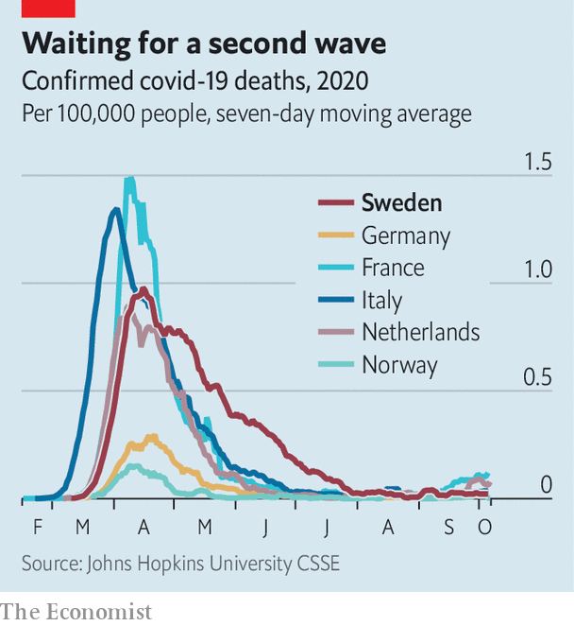

On protecting the elderly, however, Sweden failed. Its covid-19 death rate per person is one of the highest in Europe, and ten times that of Norway and Finland. As in other countries, about half of Sweden’s deaths were in care homes. A public investigation is looking into what went wrong. An early mistake in some municipalities was to ban care workers from wearing masks and gloves, on the grounds that the people they cared for might feel offended.

Beyond care homes, covid-19 has hit ethnic minorities particularly hard. At the cemetery in Sodertalje, a small city near Stockholm that is home to many immigrants, most of the fresh graves hold people who had roots in Syria. Almost all died of covid-19, says Nuri Kino, an activist and journalist. Michel Varli, who runs a restaurant in Sodertalje, calls the first week of April a “catastrophe”. Ambulances were coming and going all day, he says. “Every family around here had someone.”

Covid-19 spread in some immigrant communities unexpectedly fast and early, says Anders Tegnell, the country’s chief epidemiologist. Six of Stockholm’s first ten covid deaths were Swedish Somalis. Official guidance reached immigrant groups too late. Before the ban on large gatherings, funerals with hundreds of guests were the norm—and the source of some early outbreaks. The Sunday service at one of the Syrian Orthodox cathedrals in Sodertalje would draw about 500 people. Households with eight to ten people and three generations under the same roof are common among immigrants. And the elderly in these tight-knit communities have busy social lives. Mr Varli, who has ten siblings, says that before covid his mother would usually see her children and grandchildren every week. She is a lot more cautious now.

By the end of the summer, Sweden’s epidemic subsided without a need for new measures. Covid-19 wards have emptied; the virus is no longer spreading widely. Dr Tegnell says that, based on various studies that test for antibodies, the best guess is that about 20% of Swedes have been infected and so are presumed to be immune, though the rate varies a lot even between parts of Stockholm. This level of immunity is, by itself, not enough to stop the virus. But combined with social-distancing and hygiene measures, it brought Sweden’s first wave to an end.

To prevent a second wave, Sweden is putting new measures into the mix. It recently resumed contact-tracing and quarantining, backed up by an expanded testing capacity. In most of Europe, strict 14-day quarantines are slapped on all contacts of infected people and anyone who travels to some parts of Europe. Sweden’s quarantine, however, is for seven days and only for those who live with an infected person. If a test on day five is negative, the quarantine can end then. Children with no symptoms are exempt from quarantine. All other contacts are simply alerted that they may be infected. They are urged to work from home for a week, to get tested if they have even the slightest symptoms in the next 14 days, and to be extra careful about seeing elderly relatives in that period.

The World Health Organisation bristles at quarantines shorter than 14 days. But the Swedish approach is to have measures that people can live with for at least a year, says Dr Carlson, because there is no vaccine yet. The goal is to stop as much transmission as possible without unduly disrupting people’s lives, especially in ways that harm their mental or physical (not to mention economic) health. Transmission happens most easily within households, and people are most contagious in the first week after they are infected. So Sweden’s quarantine policy could stop the bulk of covid’s spread—as long as people comply.

They probably will. A cash payment is available for quarantined people who cannot work from home, such as taxi drivers. The government pays for antibody tests for anyone who wants one. A positive antibody test exempts you from quarantine and the hassle of getting tested for covid if you have a cold or flu-like sniffle. All these measures look a lot laxer than the other systems across Europe. But whether by doing less Sweden ends up achieving more will become clear only in the next few months. ■

Editor’s note: Some of our covid-19 coverage is free for readers of The Economist Today, our daily [newsletter](https://my.economist.com/user#newsletter). For more stories and our pandemic tracker, see our [hub](https://www.economist.com/news/2020/03/11/the-economists-coverage-of-the-coronavirus)

This article was downloaded by calibre from <https://www.economist.com/europe/2020/10/10/how-sweden-hopes-to-prevent-a-second-wave-of-covid-19>

|  |  |  |  |
| --- | --- | --- | --- |
| Previous | Articles | Sections | Next |

|  |  |  |  |
| --- | --- | --- | --- |
| Previous | Articles | Sections | Next |

#### Charlemagne

# Scrapping vetoes won’t help European foreign policy

The EU should heed the lesson of “The Princess and the Pea”

Oct 10th 2020 |

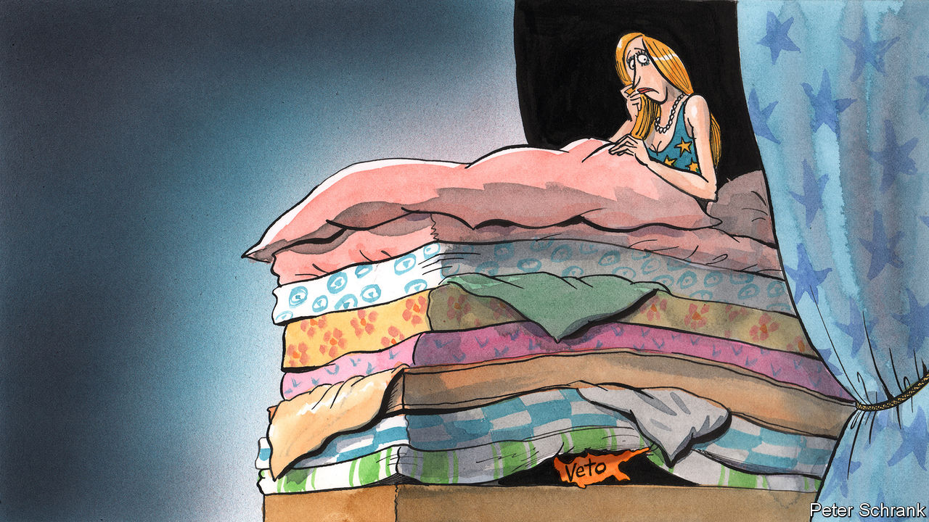

HANS CHRISTIAN ANDERSEN’S story of “The Princess and the Pea” is not on the reading list of many foreign-policy wonks. Perhaps it should be. In the Danish fairy tale, a pea is secretly placed beneath a stack of mattresses on a young lady’s bed. She finds the tiny bump horribly uncomfortable, thus proving herself to be a princess. It is a surprisingly relevant lesson for the EU. The bloc sees itself as a superpower, but when it comes to foreign policy it sometimes behaves like a dainty princess. A single objection from even a pea-sized state is enough to scupper its plans.

So it was when Cyprus, the third-smallest EU country in population and a rounding error in terms of GDP, became a one-country obstacle to sanctions against the Belarusian authorities. Unless the EU agreed to sanctions on Turkey for menacing Cypriot waters, the island would refuse to back similar measures on Belarus. A bloc with designs on being a global actor was held back from flexing its muscle at a country next-door by one of its smallest members. Senior EU wallahs despaired. “Our credibility is at stake,” declared Josep Borrell, the EU’s foreign-policy chief. As in Andersen’s telling, small discomfort led to late-night strife: it was only during an EU leaders’ summit that dragged on past midnight—the most auspicious hour in any fairy tale—that Cyprus backed down.

The Cypriot last stand renewed calls for the EU to switch to qualified majority voting on foreign-policy issues. This would allow countries representing 55% of all member states and two-thirds of the EU’s population to ram through any policy. Mr Borrell is a fan of the idea, as is Ursula von der Leyen, the European Commission’s president. They have a compelling case. How can the EU face up to China or America if countries representing a fraction of its citizens are able to stymie its ability to act? Imagine American foreign policy if, say, Delaware were able to veto the actions of the federal government. In a world without vetoes, the likes of Cyprus would no longer be able to hold others to ransom. Remove the pea, they argue, and Europe can proceed undisturbed.

Scrapping such vetoes would be a big shift. They loom large in the EU’s history. Charles de Gaulle, the former French president, spent the 1960s blocking things he did not like (such as the entry of Britain). A compromise emerged whereby national capitals would not throw their weight around, unless they felt their vital interests were threatened. In a club of half a dozen, allowing each country to scupper a policy made some sense. Now the EU is a cumbersome body of 27 sovereign countries. On most topics, such as the workaday issues of governing the single market, vetoes have been replaced by “qualified majority” voting. About 80% of EU laws are passed this way. But on controversial topics, such as tax, trade deals and foreign policy, unanimity is still required.

Removing these powers, though, would be a mistake. Critics of vetoes fall back on comforting fairy tales. In their telling, with no vetoes a beefier foreign policy is possible. This is naive. Foreign policy is difficult for the EU precisely because countries do not agree on fundamental issues. Whereas France takes an aggressive approach on Turkey, Germany has been doveish. Russia is seen as a potential ally in France, a business opportunity in Germany but a threat in Poland and the Baltic states. Hammering together a cohesive foreign policy on one of these topics, then forcing it through via a majority, is a recipe for rows. The fairy tale is alluring because Brussels is good at procedure. But procedure does not resolve political disputes, points out Nicolai von Ondarza from the German Institute for International and Security Affairs (SWP).

Nor is there a guarantee of a happily-ever-after with qualified majority voting. It can backfire. In 2015 EU countries pushed through a decision to relocate refugees against the wishes of Hungary, the Czech Republic and Slovakia. Their response was simple: they ignored it. EU leaders made a gentlemen’s agreement not to force such measures through in this way again. Consensus is far more comfortable for diplomats, and for good reason. In the kaleidoscopic world of EU politics, any country can find itself in the minority on a particular issue. Overrule a fellow EU member state one week, and you may find your own country overruled the next. In some years as many as 90% of decisions are passed without a single vote against, according to figures from SWP.

## Fairy tale or horror story?

The power of vetoes to make or break the EU is overstated. They tend to delay decisions rather than stop them. Last year Emmanuel Macron, France’s president, halted the accession process to the EU of North Macedonia and Albania. But after a few months of largely procedural fiddling, both countries were allowed to take the next step towards membership. When David Cameron vetoed a fiscal treaty at the height of the euro-zone crisis, some legal gymnastics allowed fellow EU leaders to bypass the British blockade. Even Cyprus’s last stand delayed the EU’s sanctions on Belarus (in any case rather puny) by only a few weeks.

Vetoes have their uses, too. Charles Michel, the European Council president, is right when he argues that unanimity breeds legitimacy, which is vital for the EU’s still fledgling foreign policy. An American state can swallow disagreements in a way that the EU’s sovereign members cannot. It may lead to lowest-common-denominator policies, but this is better than ambitious ones that are ignored. Overriding Cyprus’s wishes would be one thing, but a foreign policy without the backing of, say, France, now the bloc’s sole global hard power, would be preposterous. The veto is the weapon of last resort for small countries, who make up the bulk of EU member states. If Cyprus is steamrollered on Turkey, then Estonia may fear that its interests will be overlooked on Russia. Its occasional use does little to blow the EU off course, while reassuring national capitals that their existential concerns will never be trampled beneath majority rule. Like a pea, a veto causes brief discomfort. But the EU is not a fairy-tale princess. It can cope. ■

This article was downloaded by calibre from <https://www.economist.com/europe/2020/10/10/scrapping-vetoes-wont-help-european-foreign-policy>

|  |  |  |  |
| --- | --- | --- | --- |
| Previous | Articles | Sections | Next |

|  |  |  |
| --- | --- | --- |
| Europe | Sections | International |

Britain

Rishi Sunak: Easy riser

.

Dirty money: Please explain

.

Vaccine programme: Ready, steady, jab

.

Brexit talks: Deadline diplomacy

.

Mortgage market: Fixing it

.

Green energy: Straws in the wind

.

|  |  |  |
| --- | --- | --- |
| Europe | Sections | International |

|  |  |  |  |
| --- | --- | --- | --- |
|  | Articles | Sections | Next |

#### The Treasury

# The rise of Rishi Sunak

The chancellor of the exchequer is more popular than his boss. Winter could change that

Oct 10th 2020 |

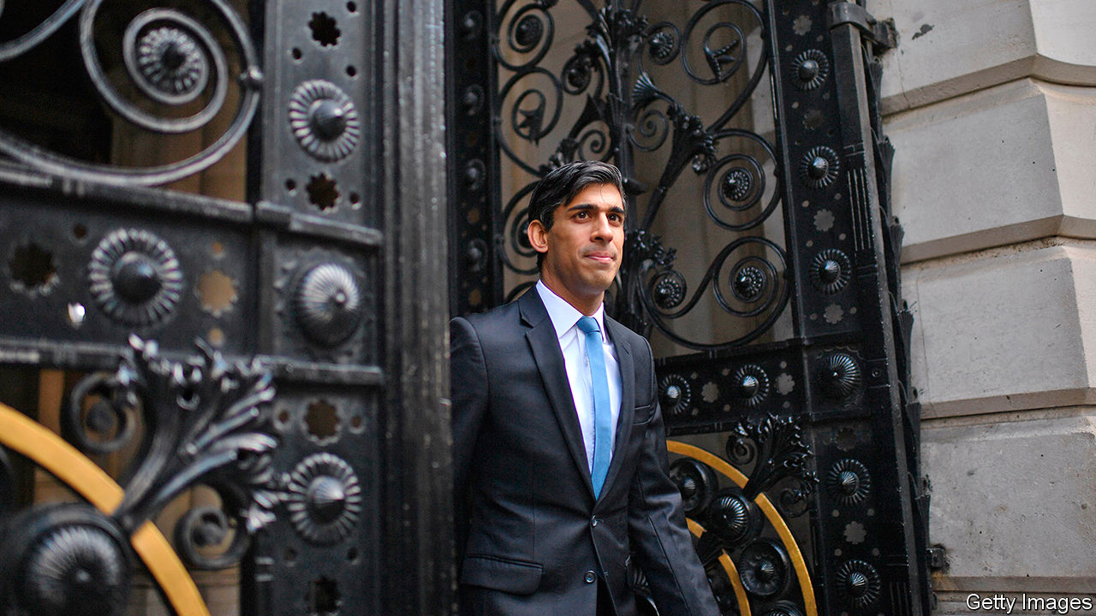

BEFORE HE WAS prime minister Boris Johnson used to enjoy himself at Conservative Party conferences upstaging his duller colleagues, whose jokes fell flat in half-empty halls. Light on substance but full of can-do optimism, his speeches imagined a Britain buzzing with new homes and futuristic energy sources. This year, there was no one to upstage, and no appreciative audience. The prime minister’s address was delivered from a recording studio. The content, though, was familiar: by 2030, he said, Britons would travel in zero-carbon jets and hydrogen-powered trains through a land of plentiful housing, thinner waistlines and racial harmony.

Given Britain’s present difficulties, this talk of sunlit uplands sounded hollow. In a survey by YouGov, a pollster, of how citizens of 22 countries think their government has managed by the pandemic, Britain bumps along at or near the bottom. Mr Johnson’s ratings have suffered in consequence (see chart).

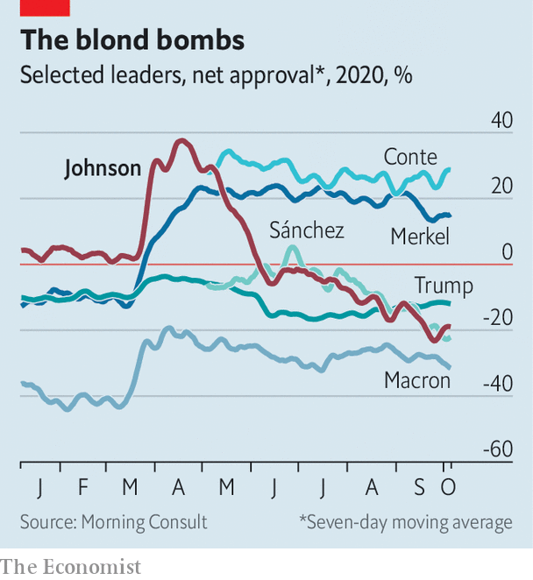

Now Tories are looking to a new king across the water: Rishi Sunak, the chancellor of the exchequer. Not that a leadership challenge is brewing. MPs are grateful to Mr Johnson for the party’s electoral triumph last year. But there are growing doubts about his competence and about recent policy decisions. Many Tories believe that the government has recently erred too far in restricting people’s freedoms, a view that Mr Sunak has championed in cabinet.

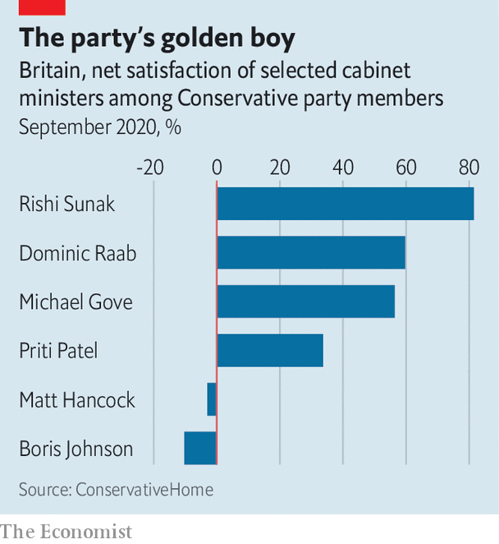

A survey of party members by ConservativeHome, the party’s house website, before the conference, produced a damning result for the prime minister (see chart). Last month Ipsos MORI, a pollster, found that Mr Sunak has the highest satisfaction ratings for a chancellor since Denis Healey in 1978. Unlike his boss, he scores better than Sir Keir Starmer, the Labour leader, on most metrics. “Without him we are cream-crackered,” says a Tory.

Talk of rivalry has been fuelled by Mr Sunak’s attentiveness towards other MPs, who feel unloved by Number 10, and an advertising campaign which has seen his personal signature attached to Treasury policies, in the manner of a television chef’s cookware range. Mr Sunak sought to cool it in his brief conference speech, which hailed Mr Johnson’s “special and rare quality” as a communicator.

His rising stock is a reflection of Mr Johnson’s problems. The prime minister called rumours that he is still unwell after being hospitalised with covid-19 in April “seditious propaganda”. But in interviews he has struggled to recall details of regional lockdown regimes. His main domestic agendas—of levelling up Britain’s poor productivity and improving public services—lack policy content.Disable rich-text

In many ways Mr Sunak is the opposite of Mr Johnson. To those who never liked or have tired of the prime minister’s personal style, that is part of the chancellor’s appeal. Where Mr Johnson is brimming with personality, Mr Sunak is bland. Where the prime minister is chaotic, the chancellor is perfectly organised, well briefed and pays close attention to detail. Where the prime minister is a mess, the chancellor is impeccably groomed.

He rose swiftly, becoming an MP in 2015 and chancellor in February, and has shown no appetite for ideological grandstanding. Many colleagues regard him as a truer Thatcherite than George Osborne or Philip Hammond, Tory predecessors, but he embraced trade union leaders in designing the wage-subsidy programme. He supported Brexit because he believes it will help Britain prosper, but refrains from bombastic Brussels-bashing. A Stanford graduate who has written pamphlets on how the Tories can reach ethnic minorities, he appeals to younger, liberal voters.

But his popularity springs mostly from his largesse. The Treasury will this year spend £192bn ($248bn) on responding to the crisis, including a furlough scheme for workers, business loans and restaurant subsidies. His face adorns adverts for discounted ales at JD Wetherspoon, a pub chain, which benefited from a sales-tax cut, under the banner “Sunak’s Specials”. These schemes used existing tax and payroll systems, so ran more smoothly than the error-prone test-and-trace programme. And the Treasury is the most competent department in government: if Mr Sunak is managing things well, that is partly thanks to the quality of the ministry he inherited.

It is easy to be popular when you are giving people money; harder when you have to take it away. This month Mr Sunak is replacing the furlough scheme with a much less generous wage-subsidy regime, and the prospects for the economy are deteriorating. Tighter restrictions have hit consumer spending, and summer’s recovery seems to be petering out. Unemployment is forecast to hit 8.3% by year-end. As joblessness rises, the chancellor will come under pressure to increase universal credit, the main unemployment benefit.

He may not be inclined to. He used his conference speech to argue that, once Britain is through the worst of the pandemic, it will need to deal with its vast pile of borrowing. If the Tories argue “that we can simply borrow our way out of any hole,” he asked, “what is the point of us?” Since Mr Johnson is keen to maintain a high level of public services, Mr Sunak will either have to fight the prime minister or raise taxes.

“Hard choices are everywhere,” Mr Sunak added. He is beginning to make some. The popularity he has won so easily will soon be tested.■

This article was downloaded by calibre from <https://www.economist.com/britain/2020/10/10/the-rise-of-rishi-sunak>

|  |  |  |  |
| --- | --- | --- | --- |
|  | Articles | Sections | Next |

|  |  |  |  |
| --- | --- | --- | --- |
| Previous | Articles | Sections | Next |

#### Dirty money

# Britain’s new anti-corruption tool is proving useful—in certain cases

Unexplained Wealth Orders force suspects to prove the legitimacy of their assets

Oct 10th 2020 |

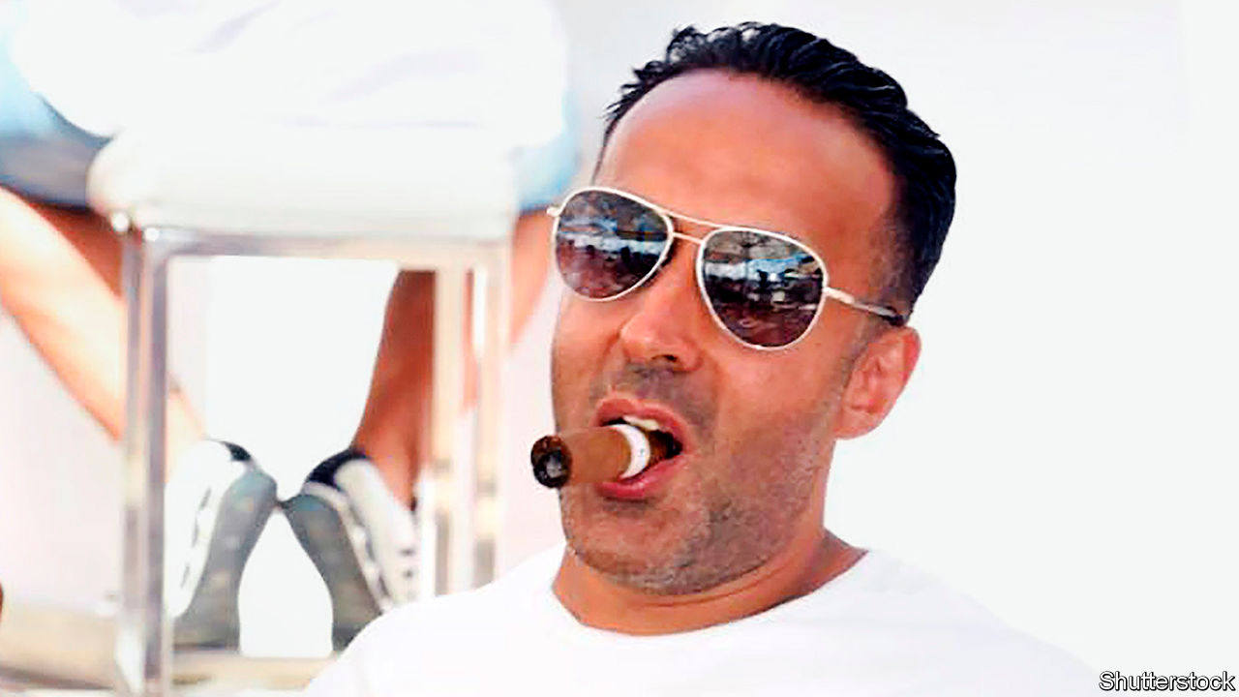

JUDGING BY HIS social-media posts, Mansoor Mahmood Hussain (pictured) was a successful businessman whose shrewd property deals allowed him to enjoy a lavish lifestyle, which included collecting high-performance cars and hobnobbing at VIP parties with the likes of Beyoncé and Simon Cowell. Investigators looking into criminal gangs in the north of England reached a different conclusion: they suspected Leeds-based Mr Hussain of being a major money-launderer who had helped gangsters, including Mohammed Nisar “Meggy” Khan, a convicted murderer, rinse tens of millions of pounds.

Despite intelligence linking Mr Hussain to organised crime, the National Crime Agency (NCA) struggled to gather the exhaustive evidence needed to bring money-laundering charges. So it turned to a newish legal tool called an Unexplained Wealth Order (UWO). This turns the tables on those suspected of buying assets with dirty money, forcing them to open their books and prove their wealth came from legitimate sources. Mr Hussain has agreed to hand over 45 properties worth £10m ($12.9m). He could yet face a criminal investigation.

The NCA says the result is a “significant” step forward for UWOs, which Britain introduced in 2018. Ireland and Australia already had such provisions. It marks the first time a British case involving a UWO has led to assets being recovered. Criminal money-laundering cases are difficult to prosecute; money trails can be horribly tangled, making it hard to connect the loot to the original crime. The UWO process, administered under civil law, involves a lower burden of proof and puts the onus on the suspect to prove that their wealth was not ill-gotten.

When Britain’s crime-busters started wielding UWOs, anti-corruption campaigners hoped that they would be a powerful weapon against a different type of ne’er-do-well: dodgy “politically exposed persons”, or PEPs—such as kleptocrats and their associates from places like Russia, Central Asia and Africa—who plough corrupt foreign capital into swanky British properties. Such swag is largely responsible for the “London laundry” tag bestowed on the capital.

Here, however, the NCA has found the going tougher. Of the three other UWO cases brought so far, two have involved PEPs. The one that drew more attention was against Zamira Hajiyeva, the wife of a banker from Azerbaijan: £22m-worth of assets, including a London mansion, were frozen. Ms Hajiyeva lost an appeal, but the case grinds on. The other case, involving properties owned by the daughter and grandson of Nursultan Nazarbayev, the former president of Kazakhstan, was thrown out in June. The court found that the NCA had not provided sufficient evidence that the use of offshore entities to hold assets suggested financial shenanigans rather than being for legitimate reasons, such as privacy or legal tax mitigation, says Jonah Anderson of White & Case, a law firm.

Cases against PEPs were never going to be easy. They have plenty of money to hire the best lawyers, and many offshore structures are impenetrable. UWOs may prove more useful in domestic-crime cases than those involving international corruption. Gangsters beware.■

This article was downloaded by calibre from <https://www.economist.com/britain/2020/10/10/britains-new-anti-corruption-tool-is-proving-useful-in-certain-cases>

|  |  |  |  |
| --- | --- | --- | --- |
| Previous | Articles | Sections | Next |

|  |  |  |  |
| --- | --- | --- | --- |
| Previous | Articles | Sections | Next |

#### Ready, steady, jab

# Britain prepares to roll out a covid-19 vaccine

Woking Leisure Centre is in for a busy year

Oct 7th 2020 |

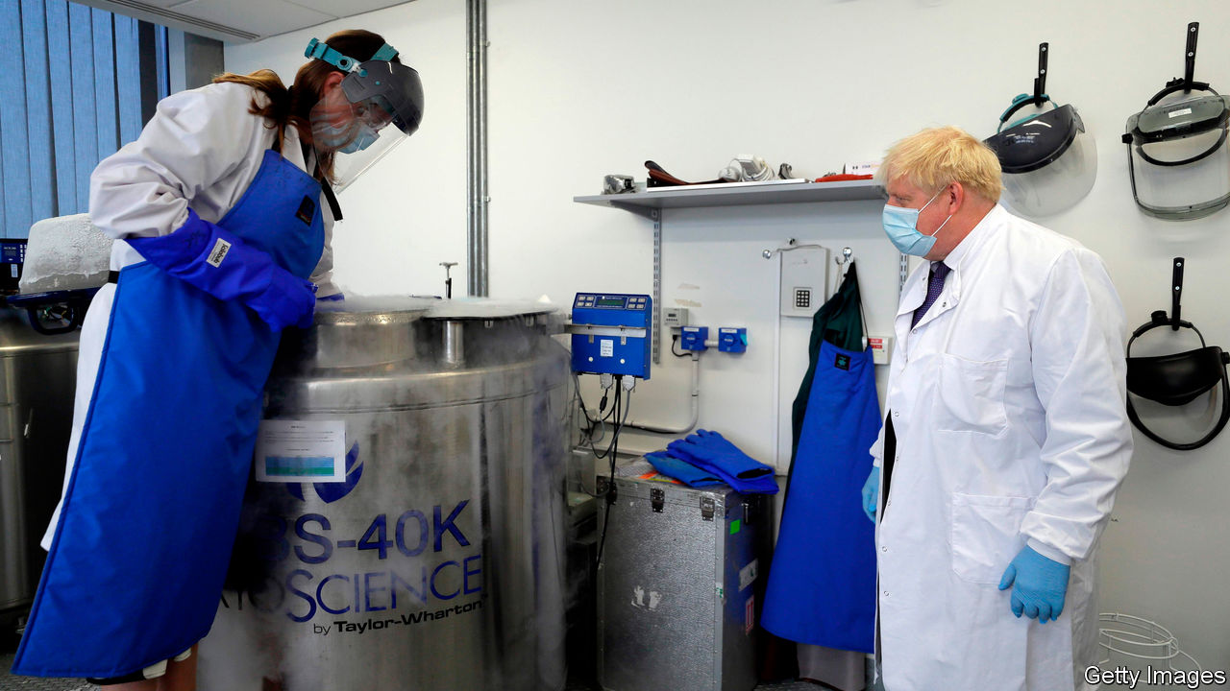

WITH AEROBICS classes, a Costa Coffee and two new swimming-pool slides, Woking Leisure Centre has plenty to attract punters. Soon it may have something more: a mass vaccination centre. According to National Health Service (NHS) plans seen by The Economist, it is one of seven venues so far identified as possible “Nightingale Vaccination Centres” for what will be the country’s biggest-ever vaccination programme. Others include Leeds Town Hall, a university sports centre in Hull and the Olympic Copper Box Arena. The plan is to have some ready to go by the end of the year at the latest.

From its early failure to get on top of the virus to the more recent travails of the test-and-trace system, the British state has struggled to deal with the pandemic. There has been a sharp rise in cases, and the search for a vaccine is increasingly urgent. Yet it is not just a matter of securing a successful vaccine: infrastructure must be in place to inject people as soon as it is ready.

Britain has made deals to buy 400m doses of vaccine, spreading its bets across six different ones under development. Two are out in front: Oxford/AstraZeneca and Pfizer. Expectations are rising that efficacy data could be available within the next month. Then it is up to the regulators. The European Medicines Agency (EMA) started a fast-track review of the Astra vaccine on October 1st and of the Pfizer vaccine on October 6th. Nobody knows how long that will last, but hopes are high for a decision within weeks rather than months.

Brexit could create an extra hurdle: Britain falls within the EMA framework until it leaves the EU at the end of this year. If the British regulator moves ahead of the EMA to allow a vaccine to be used, then from January 1st it would not be possible to use it in Northern Ireland, as it would remain under European legislative control.

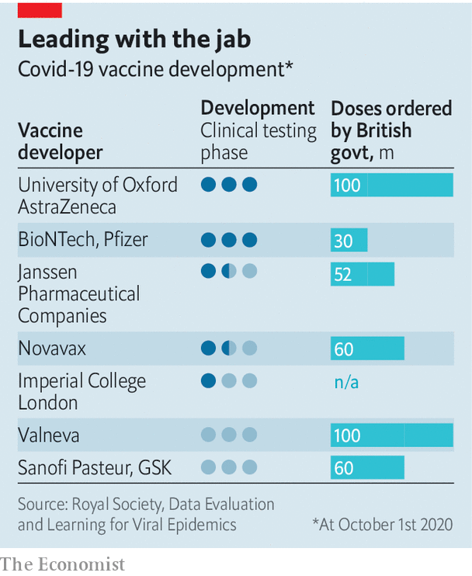

Once the regulators give permission for a vaccine to be used, the race is on to get the stuff into people’s arms. Since Britain lacks domestic manufacturing capacity, it has stockpiled enough vials, stoppers and overseals for around 150m doses. It has also accelerated construction of its own vaccine manufacturing facility: the Vaccines Manufacturing Innovation Centre (VMIC) in Harwell, Oxfordshire. While the VMIC is being built, its equipment is at a nearby site run by Oxford Biomedica, which is believed to have the capacity to supply tens of millions of doses in months.

On October 4th Kate Bingham, the head of the government’s vaccine task-force, said that only 30m people—about half the population—might be vaccinated. The numbers are uncertain because they depend in part on the efficacy of the vaccines that are ready for use soonest. They may, for instance, turn out not to prevent infection but to stop the disease getting serious. And, since the vaccines have been developed so swiftly, some residual risk remains which is absent from well-established programmes. The guidance from the Joint Committee on Vaccination and Immunisation, which advises the government, is therefore to prioritise the elderly in care homes, the over-65s and those with complicating health risks. This may change, depending on the successful vaccines’ characteristics. The NHS hopes to be ready to vaccinate 75-100% of the population.

Matt Hancock, the health secretary, has said that the NHS and the army will share responsibility for delivering the vaccine. Yet a Ministry of Defence source says there has been no official request for the armed forces’ assistance. In reality, the health service is likely to do most of the work. It plans to distribute the vaccine both through the existing methods used for the flu jab and also with a new hub-and-spoke model, which with luck will stop breakdowns from jamming up the entire system. The aim will be to use existing supply chains where possible.

Hubs will supply the vaccine, protective equipment for staff and other supplies. Spokes will take three forms: mass vaccination centres (such as at Woking Leisure Centre), mobile sites (which may set up shop in polling stations) and roving teams (which will go door-to-door visiting care homes and the housebound). Speed will be crucial. Early modelling suggested fixed sites would be able to inject 2,500 people a day; roving teams nine households a day. By the end of the year, the NHS hopes to have hundreds of the latter in each region of the country. Legislation is expected to allow non-medics, perhaps including vets and soldiers, to carry out vaccinations.

The vaccines will probably need to be kept extremely cold. The hub-and-spoke model will make this easier. It will, however, require recipients to travel further. Prioritising access to vaccines will also be tricky, requiring data systems from across the health system to be linked up. The NHS’s history of data management suggests it may struggle to make this work. Some observers worry that the health service is taking on too much responsibility, especially when it has already had difficulties delivering flu vaccines. “As usual [with the NHS], it’s a very top-down, ‘We will deliver this, we’re in charge’ thing,” says a local director of public health.

The covid-19 vaccine will bring unique challenges. It will probably arrive soon and preparations for how to distribute it remain a work in progress. Indeed, the work can be finalised only when the characteristics of the winning vaccine are known. Yet insiders are hopeful that vaccine distribution will avoid the chaos seen in Britain’s test-and-trace system. Large-scale vaccination is, at least, not a new task for the British state. Woking Leisure Centre may help redeem the government’s reputation for competence—or damage it still further.■

This article was downloaded by calibre from <https://www.economist.com/britain/2020/10/07/britain-prepares-to-roll-out-a-covid-19-vaccine>

|  |  |  |  |
| --- | --- | --- | --- |
| Previous | Articles | Sections | Next |

|  |  |  |  |
| --- | --- | --- | --- |
| Previous | Articles | Sections | Next |

#### Brexit talks

# Will Britain's deadline for a trade deal with the EU be met?

The mid-October cut-off could prove soft

Oct 10th 2020 |

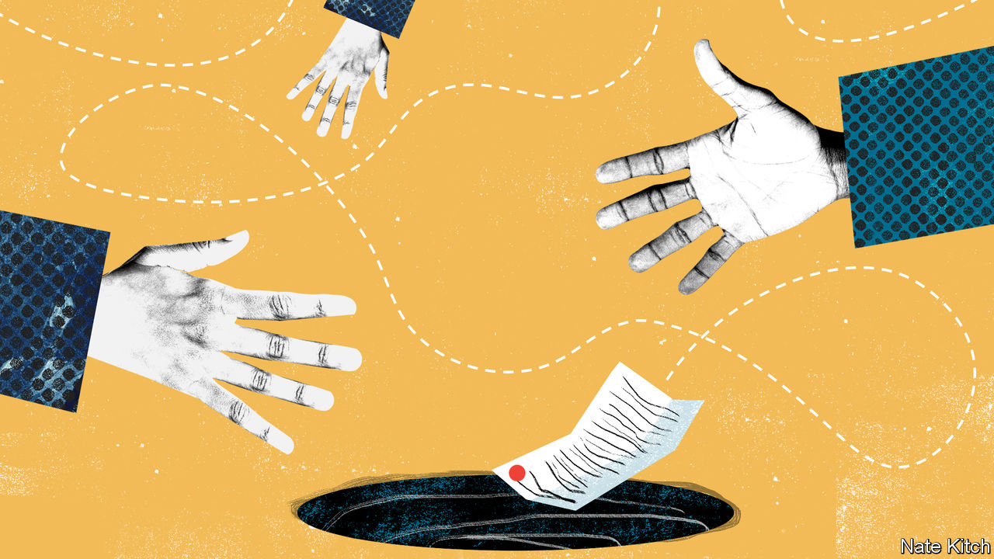

EARLY LAST month Boris Johnson proposed a deadline of October 15th for a free-trade deal with the European Union. If missed, both sides should “accept that and move on”. Yet he and the European Commission’s president, Ursula von der Leyen, decided on October 3rd to intensify trade talks, even though nobody now expects a deal next week. The EU similarly fixed a deadline of September 30th for Britain to scrap clauses in its internal-market bill to override the Northern Ireland provisions in January’s withdrawal treaty. Yet that date has passed and, although the EU has initiated legal action, negotiations continue.

What is going on, and do deadlines not matter? The answer to the first question is that, although both sides see the other as unreasonably intransigent, and the EU is genuinely angry about Britain’s plan to breach international law by rewriting the withdrawal treaty, nobody wants to be responsible for breaking off talks. Moreover, even as big gaps remain over fisheries, state aid and dispute settlement, both prefer a deal to no deal. Hence the curious choreography: keep talking at all costs, and avoid any blame for walking out.

The answer to the second question is that most deadlines are soft. But December 31st, the end of the standstill transition period, is far harder. Working backwards, it leaves very little time for a deal. The documentation runs to hundreds of pages, all needing translation and legal cleansing, and it must be approved by the European Parliament and national governments. As Mujtaba Rahman of the Eurasia consulting group says, this always made the end of October or early November a more serious deadline, after which the risk of no deal hugely increases.

But not inevitable—which is why the talks continue. Recently Britain has even seemed more optimistic than the EU, perhaps to redirect blame for any failure. It should be possible to sort out state aid by putting in place a strictly monitored British regime to police it. And it would be preposterous to allow fisheries, which account for barely 0.1% of GDP, to block a deal. Yet Mr Johnson’s unilateral changes to the withdrawal treaty have undermined trust. His supposed need for a safe fallback if there is no deal is absurd, as the Northern Ireland provisions were included precisely to avoid a hard border in Ireland in such circumstances.

The clauses could yet be removed during the bill’s parliamentary progress. And Mr Johnson may offer last-minute concessions to the EU, as he did last autumn to secure the withdrawal treaty. But his team insists concessions must come from the EU, not Britain. And Mr Johnson repeated this week that Britain could “more than live with” an Australia-type outcome, his euphemism for no trade deal, rather than the Canada-style free-trade deal it seeks. There are certainly people at the heart of his government who are relaxed about the prospect of no deal.

Yet the damage of a no-deal Brexit is clear. Modelling by the London School of Economics for the UK in a Changing Europe, a think-tank, finds that it would reduce GDP in ten years’ time by 8% from what it would otherwise be. But the modelling also says a Canadian free-trade deal would reduce GDP by around 4%. And in either case, short-term disruption would be large. The government admits that there may be queues of up to 7,000 lorries to cross the English channel, requiring a new system of truck permits to enter Kent as well as large parking areas. Other changes, such as the ending of pet passports and European health-insurance cards, will happen with or without a trade deal.

Here lies the psychological risk that may ultimately lead to no deal. Since annoying disruption is bound to happen in any case, it is harder for Mr Johnson to blame the EU if he has just agreed to a deal. But if no deal could plausibly be attributed to the EU’s pigheaded obstinacy, the blame game might just work. And that is why, even as talks continue amid optimistic briefings, no deal remains much more likely than is often appreciated.■

This article was downloaded by calibre from <https://www.economist.com/britain/2020/10/10/will-britains-deadline-for-a-trade-deal-with-the-eu-be-met>

|  |  |  |  |
| --- | --- | --- | --- |
| Previous | Articles | Sections | Next |

|  |  |  |  |
| --- | --- | --- | --- |
| Previous | Articles | Sections | Next |

#### Mortgage reform

# Boris Johnson wants 25-year fixed-rate mortgages

Denmark shows the way

Oct 10th 2020 |

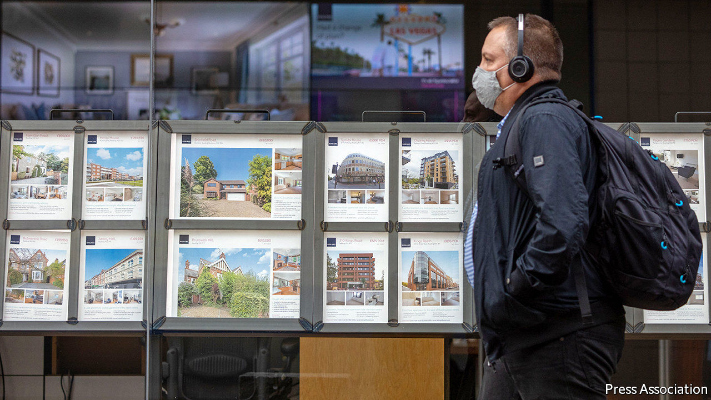

WITH THE average new mortgage costing 2.14% a year, it has never been cheaper to finance a purchase, and the divergence between the costs of buying and renting (see chart) further strengthens the incentive to buy. But regulation makes it impossible for many.

Rules imposed in the aftermath of a financial crisis caused by dodgy lending require banks to check not just whether applicants can afford the offered interest rate but whether they would still be able to if rates were three percentage points higher. That, together with the need for a chunky deposit, raises the bar to home ownership. According to a recent report by the Centre for Policy Studies (CPS), there are currently more than 3.5m “resentful renters” who would be able to afford the monthly mortgage payments but are held back by stringent affordability checks and high deposit requirements. The CPS’s proposed solution is fixed-rate 25-year mortgages with a loan-to-value ratio of 95%. Fixing the rate for the whole term would obviate the need to stress-test borrowers’ ability to pay more.

The government wants to make this happen. Boris Johnson, in his party conference speech on October 6th, argued that doing so “could create 2m more owner-occupiers, the biggest expansion of home ownership since the 1980s”. But how?

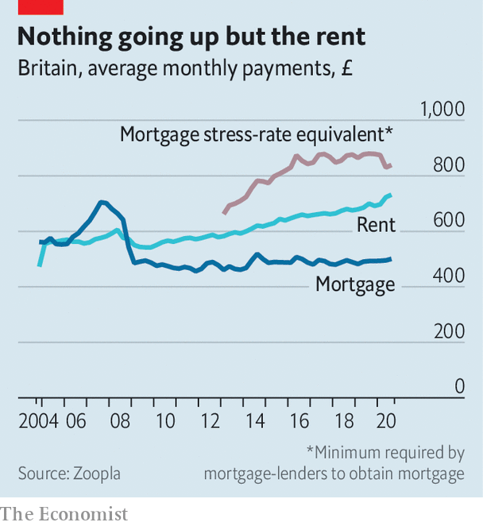

Britain’s mortgage market is dominated by banks and building societies which generally fund themselves with short term borrowings and deposits, and offer fixed rates only for two- or five-year periods to avoid a big mismatch in the duration of assets and liabilities. In Denmark, which has had a system of very long-term fixed-rate lending since the 1850s, the market is served mainly by specialist lenders funded by long-term bonds. No stress-test is needed to avoid a mismatch, so the market determines rates.

A 25-year loan priced at around 4% is an attractive asset in a world in which a 30-year British government bond yields just 0.9%, so the CPS believes that it should be possible to attract insurance companies and pension funds, which have long-term liabilities, into the market. The way mortgages are sold may explain their absence. Brokers, who arrange 70% of mortgages, have an interest in selling clients new products every two or five years rather than one that would last for a quarter of a century. Insurance companies and pension funds are cautious, too. An insurance boss worries that there could be a mis-selling scandal if interest rates were to fall further and new borrowers claimed they had not fully understood the terms and were “trapped on a supposedly penal rate”.

Robert Colvile of the CPS, who helped write the Conservative Party manifesto for the 2019 election, reckons that the government could use its convening power to overcome this hurdle, getting the firms to sit down with the Bank of England and other regulators to make clear that it would welcome such new products. Some Tories want to go further and extend a form of government guarantee to such mortgages, rather as America does through Freddie Mac and Fannie Mae, federally backed mortgage companies. The Treasury, understandably wary of extending a government guarantee to high loan-to-value mortgages, prefers the CPS’s cautious approach.

If it could be made to happen, both long-term lenders and borrowers would benefit. But the government would also need to find a way of getting more houses built if a flood of new money is not just to push prices up even further.■

This article was downloaded by calibre from <https://www.economist.com/britain/2020/10/10/boris-johnson-wants-25-year-fixed-rate-mortgages>

|  |  |  |  |
| --- | --- | --- | --- |
| Previous | Articles | Sections | Next |

|  |  |  |  |
| --- | --- | --- | --- |
| Previous | Articles | Sections | Next |

#### Wind power

# Boris Johnson’s optimistic green-energy plan

Making 40GW of electricity from offshore wind is a stretch

Oct 10th 2020 |

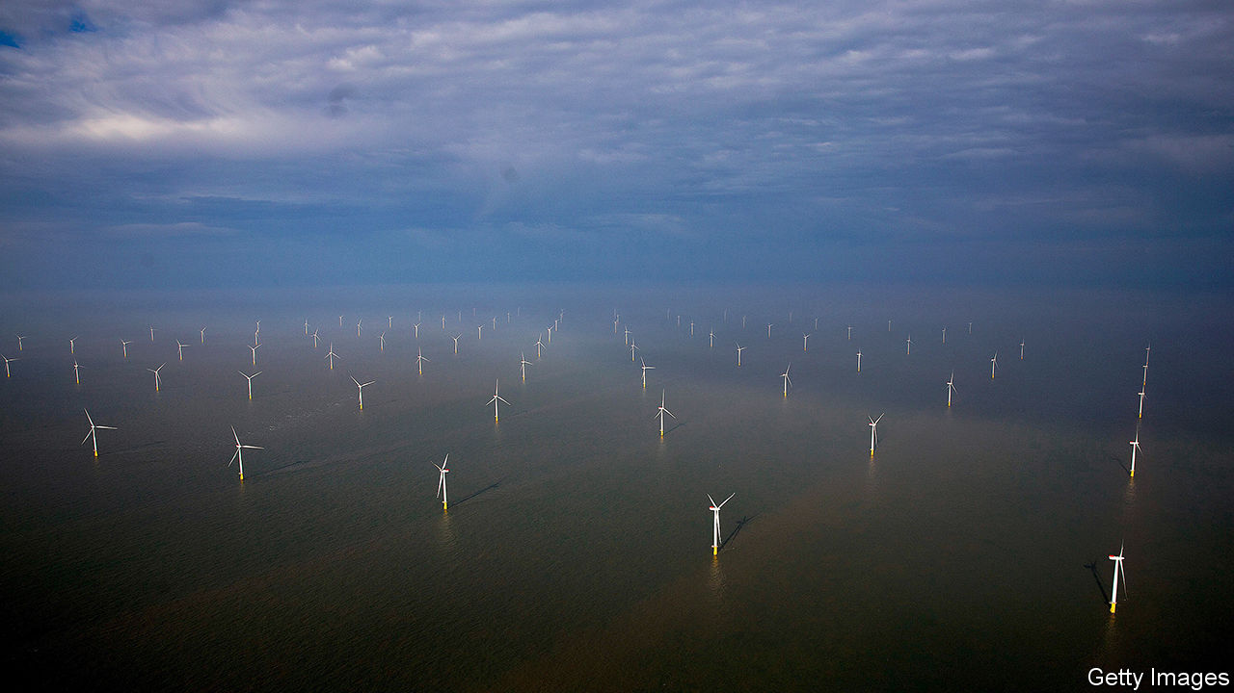

WHEN IT COMES to self-deprecation, Boris Johnson is hard to beat. “I remember how some people used to sneer at wind power 20 years ago and say that it wouldn’t pull the skin off a rice pudding,” he said at the Conservative Party conference on October 6th. By “some people” he meant “me, myself and I, in 2013”. Rebranding himself as a convert, Mr Johnson set out the first step of a ten-point plan for a “green revolution”, the remainder of which is promised later this month.

Step one will involve producing 40GW of electricity from offshore wind by 2030, a 10GW increase on the existing goal. The boost is not new—it was in the manifesto for the 2019 election. In addition to fixed offshore wind turbines, Mr Johnson wants floating turbines that can venture into deeper waters than their fixed brethren and therefore catch gusts farther afield. All this, he says, will make Britain a world leader in green energy.

The country has a long way to go to get there. Roughly one-third of its electricity comes from renewables—the EU average. Though well endowed with wind, its islands are not leaders in making turbines.

Meeting the 40GW target will be a stretch. Earlier this year, a report by Aurora Energy Research, a consultancy, found that it would mean installing 260 new turbines on average every year for five years. There will need to be more money, too. In some ports loading increasingly unwieldy turbines on and off ships is becoming tricky, and new cables and substations will be needed to connect all those turbines to the national grid. Mr Johnson promised £160m ($207m) in public funds to support tens of thousands of new jobs, and upgrade ports and infrastructure to accommodate the additional offshore wind power.

Yet the proposed sums are trifling compared with what the sector needs. The government estimates that every new gigawatt of offshore generation capacity costs £1.5bn to build. With some 10GW installed today, the additional investment required will be on the order of £45bn. Much of that will come from the private sector, and formalising the 40GW target should help build investor confidence. Still, the investment needed is nearly twice the £24bn estimated to have been made during the past decade.

The government says that the boost to the wind-power industry will “support” 60,000 jobs. The careful wording presumably includes the 44,000 jobs that already exist. Britain is not big in turbine manufacture: none of the four companies that accounted for 55% of new orders globally in 2019 is British. Most of the employment is in firms supplying the turbine-making giants with, for instance, cables and foundations. The industry is growing partly thanks to government regulation. The offshore developers have agreed with the government that by 2030 60% of output by value will derive from Britain, up from around 50% today.

But even if Mr Johnson’s announcement does not add up to much, it is at least in keeping with the government’s environmental targets. The Committee on Climate Change, which advises it on green policy, reckons that Britain could be generating more than 75GW of offshore wind by 2050. Realising this potential, it says, is essential for Britain to meet its goal of reducing its greenhouse gas emissions to net-zero by then. And that will take far more huffing and puffing than is required to pull the skin off Boris’s rice pudding. ■

For more coverage of climate change, register for The Climate Issue, our fortnightly [newsletter](https://www.economist.com/theclimateissue/), or visit our [climate-change hub](https://www.economist.com/news/2020/04/24/the-economists-coverage-of-climate-change)

This article was downloaded by calibre from <https://www.economist.com/britain/2020/10/10/boris-johnsons-optimistic-green-energy-plan>

|  |  |  |  |
| --- | --- | --- | --- |
| Previous | Articles | Sections | Next |

|  |  |  |
| --- | --- | --- |
| Britain | Sections | Special report |

International

Funeral culture: Deathly silence

.

|  |  |  |
| --- | --- | --- |
| Britain | Sections | Special report |

|  |  |  |  |
| --- | --- | --- | --- |
|  | Articles | Sections | Next |

#### Terminal verbosity

# Covid-19 is helping wealthy countries talk about death

Amid mass mortality, a taboo is fading

Oct 10th 2020 |

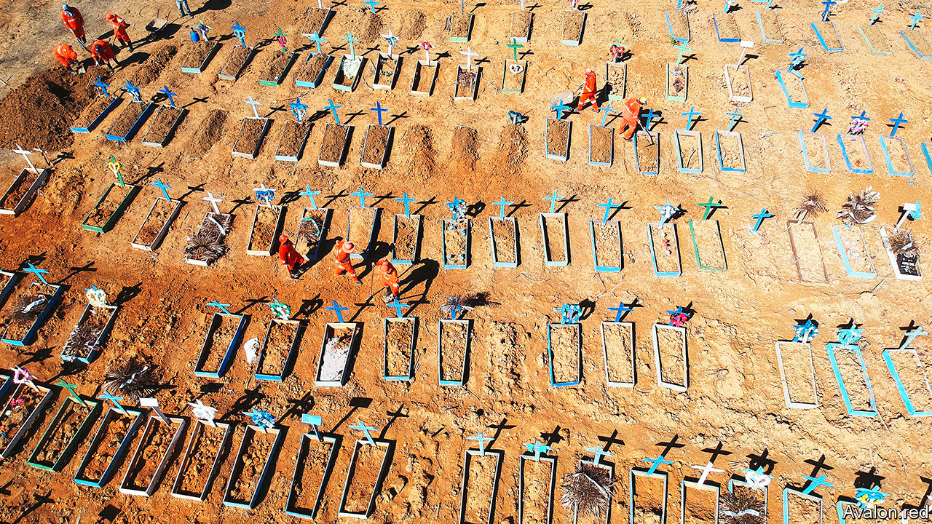

UNTIL THIS year many New Yorkers had never heard of Hart Island, where the city’s unclaimed dead are buried. Then, in the midst of the pandemic, video of contractors digging long trenches there went viral. Around 120 bodies were sent to the tiny islet every week, as burial grounds and crematoriums struggled to keep pace with covid-19. One funeral home in Brooklyn was sued for stacking bodies in an unrefrigerated rental truck. At the peak of the epidemic Sal Farenga, an undertaker in the Bronx, was doing three times as many funerals as usual and turning away 50 grieving families a day. “It was heartbreaking,” Mr Farenga says.

Covid-19 has caused more than a million recorded deaths, most not in developing countries like Brazil (pictured) but in developed ones. That cuts against a long-standing trend. Since the second world war, wealthy states have had few massive episodes of premature fatality. Their cultures have tended to push mortality out of sight, into hospitals and out of polite conversation. Now, the pandemic is nudging people in the rich world to adopt the open and pragmatic approaches to death that are more typical in developing countries, where poverty, poor health care, dangerous roads and armed conflict keep people on familiar terms with the grim reaper.

A new survey by Hospice UK, a charity, found that this year 40% of British who lost a family member to covid-19 wrote down their end-of-life wishes, and a third planned their own funerals. (Overall, less than a fifth of Britons have done either.) More people are opting to die at home: since early June the percentage has been 30-40 points above the five-year average in England and Wales. Reminders of the epidemic—not just news reports but masks and hand-sanitiser bottles—raise the subliminal awareness of death which psychologists term “mortality salience”. “We are surrounded by death whether we like it or not, and it is healthier for us to accept it,” says Tracey Bleakley, head of Hospice UK.

In many ways, rich countries are reverting to old habits. Until the 20th century early death was common in America and Europe. In Victorian Britain families dressed up their departed and posed with them for photographs. An old saw had it that the front room (now the venue of TV dinners) was used for two things: a visit from the queen or laying out a body. But the first world war and the influenza pandemic of 1918-20 left the public exhausted by loss, and an industry emerged to take it off their hands. “I don’t think the public was aware of how [completely] death would be taken away from families and homes,” says Caitlin Doughty, a mortician and advocate for the “death positive” movement, which promotes discussion of it.

In the rich world today, bereavement has been professionalised, medicalised and sanitised. Many youngsters—especially well-off ones—have never seen a corpse. Only 30% of Americans and 25% of Britons die at home. Most pass away in hospitals or nursing homes, where friends and relatives see less of them in their final days. Distance breeds squeamishness. In a recent poll 90% of Germans said most people don’t know how to act around someone who is dying.

The pandemic has helped people to get over such shyness. Susan Barsky Reid launched the Death Café in 2011, organising meetups between strangers over cake and tea (and more recently over Zoom) to discuss everything from estate planning to theories of the afterlife. The number of events has shot up this year. “You don’t get pregnant by talking about sex and you don’t die by talking about death,” she says, but many people think it bad luck. Indeed, it took the pandemic to nudge Ms Barsky Reid herself to broach the topic of end-of-life wishes with her husband.

Such conversations are, literally, morbid. But talking about death can help the old and sick feel less anxious. Frank conversations about end-of-life wishes avert conflict by letting loved ones know whether a patient would want to be taken to hospital or put on a ventilator. Demand for help making a will, advance statement or lasting power of attorney has shot up. Ian Bond, head of will-writing services at Britain’s Law Society, says not just the elderly but medics and young people are calling on his services. “Everyone wants to be remembered for the person they are and not the mess they left behind,” says Mr Bond.

Among medical professionals, the epidemic has accelerated a movement towards helping patients face up to the possibility of death. Ariadne Labs, a research group in Boston, published a conversation guide in April instructing clinicians to tell their patients that not everyone survives the virus, and to ask them about end-of-life decisions. The toolkit lays out the big questions. Whom do you trust to take medical decisions on your behalf? Which abilities are so important to your life that you can’t imagine living without them? It has been downloaded by 9,000 people.

Massachusetts General Hospital, also in Boston, began training doctors in 2017 to have such conversations and document them in patients’ files. In April and May alone the hospital recorded 5,100 conversations, two-thirds as many as the total up to then. “It is mortality salience that allows clinicians, patients and families to get over the emotional barriers,” says Vicki Jackson, head of the hospital’s palliative care and geriatric medicine division.

Even before covid-19, people in the rich world were wondering whether the end of life had to be a clinical experience. In 2017 more people in America died at home than in hospitals for the first time since the early 20th century. The epidemic has reinforced that trend. Many people shun hospitals and care homes for fear of catching the virus or contributing to pressure on health services. Strict rules around visits by loved ones have made patients more reluctant to spend their final days in institutions.

None of this is new in developing countries, where lots of people die at home and cultural taboos on discussing death are often nonexistent. The Acholi people of northern Uganda make little effort to keep death out of sight: village elders meet to discuss support for the family, and the tombstones of ancestors buried on the family homestead are important markers of land ownership. Indeed, one reason counting fatalities from covid-19 is difficult in poor countries is that so many victims die in their own houses. A study of cancer patients in 2015 found almost 60% of deaths in Mexico occurred at home, compared with 12% in South Korea. In some places the issue is access to health care, in others it is simply custom.

For the Tana Torajans in Indonesia the home is deathbed and funeral parlour. Saba Mairi’ recalls losing her grandfather when she was 11. Her family kept his body in a room next to the kitchen, offering him rice and water at mealtimes. Even after the funeral five years later the family did not say goodbye. Following Torajan tradition, they periodically fetch mummified bodies from their tombs, clean them, dress them in new clothes and throw a party. “For us,” says Ms Saba, now 36, “they are still family members and we love them.”

Some traditional practices had already been modernising before the pandemic, though not necessarily in the direction of Western modesty. As incomes have risen in northern Uganda, families have begun using professional funeral services rather than doing the job themselves, sometimes printing T-shirts with the face of the deceased. In Ghana modern families routinely place deceased relatives in deep-freezers for months or years while they save up money for the funeral, a celebratory occasion which can last for days.

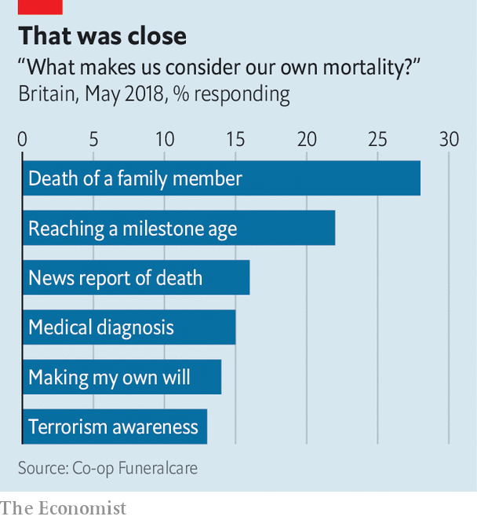

Yet in some parts of the developing world, covid-19 may be sparking a secular turn. In the Middle East places of worship have been spurned as hotspots of contagion. Mourning has moved online, where religious authorities have less reach. Such is the anger at Iran’s ruling clerics for their botched handling of the pandemic that mourners are posting poetry rather than scripture. “Please no religious recitations,” requested one family in the Iranian city of Shiraz. “The nurse became more holy than the imam,” says Hamed Abdel-Samad, an Egyptian-born lecturer in Islamic studies living in Germany.

In the West, ironically, the pandemic is threatening the traditional funeral industry. America’s National Funeral Directors Association (NFDA) says cremation rates have risen, partly because some regulators banned burials for victims of covid-19 in case corpses carry the virus. This furthers a decades-long shift that squeezes the industry’s profitability. In 2015 cremations overtook burials as the most common form of funeral in America. They typically cost around $5,150 with all the extras, compared with $7,640 to go six feet under.

## It’s your funeral

Adding to undertakers’ woes are limits on large gatherings. NFDA members say families are postponing memorials. They have started offering live-streaming options, but those reduce in-person guest lists. That could stick when the virus passes: impious mourners tend to stage simpler ceremonies, and the share of Americans who think it very important to have a religious funeral fell from 50% in 2012 to 35% in 2019.

Lately, those seeking less old-fashioned burial methods have been flocking to a lush forest 45 minutes outside Frankfurt. The woodland, popular with picnicking families, is also a funeral ground where youcan have your ashes buried in biodegradable urns. Alexa Drebes, a local ranger, had to double the number of tours she ran last month. The pandemic, she says, has made people of all ages more conscious of death.

Even for those not talking about it, reminders of the epidemic are everywhere. That has provided a natural experiment for researchers of a psychological notion called Terror Management Theory. This holds that it is the awareness of mortality which sets humans apart from other animals. Researchers find that as the crisis goes on Americans agree more with traditional gender stereotypes such as that men should be brave and that women should be clean, perhaps reflecting a need for certainties in the face of death. (They also think a consciousness of human ephemerality may foster boozing and snacking.)

Yet acknowledging mortality doesn’t have to be depressing. A Bhutanese saying has it that contemplating death five times a day brings happiness. With that in mind, an app called WeCroak sends its users five daily quotations reminding them of their own impermanence. In a pandemic, such an app may seem redundant. But if covid-19 forces people in the rich world to start thinking and talking about death in a more candid, practical way, it will have achieved something that doctors, lawyers, morticians and psychologists have been struggling to do for decades.■

This article was downloaded by calibre from <https://www.economist.com/international/2020/10/10/covid-19-is-helping-wealthy-countries-talk-about-death>

|  |  |  |  |
| --- | --- | --- | --- |
|  | Articles | Sections | Next |

|  |  |  |
| --- | --- | --- |
| International | Sections | Business |

Special report

The world economy: The peril and the promise

.

International trade: Changing places

.

Labour markets: Zoom and gloom

.

Competition: Survival of the fittest

.

Interest rates: The eternal zero

.

Emerging markets: Prognosis uncertain

.

The role of government: The right kind of recovery

.

|  |  |  |
| --- | --- | --- |
| International | Sections | Business |

|  |  |  |  |
| --- | --- | --- | --- |
|  | Articles | Sections | Next |

#### The world economy

# The peril and the promise

The covid-19 pandemic will accelerate change in the world economy. That brings both opportunity and danger, says Henry Curr

Oct 10th 2020 |

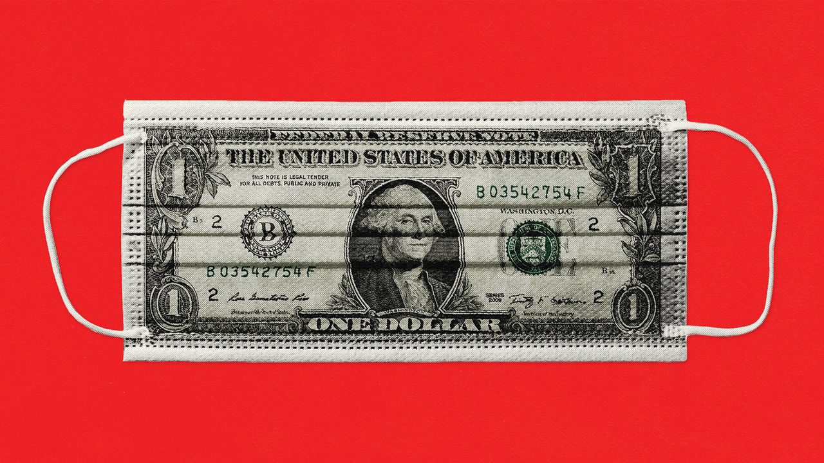

THE THEORY of “black swans” says that unpredictable high impact events play a vastly greater role than most people realise. Long before 2020 scientists feared that a zoonotic respiratory disease might originate in Asia and spread globally. But hardly anybody foresaw the consequences. The story told by a casual inspection of most economic data is this: little happened for decades, and then in 2020 covid-19 upended everything.

Before 2020 the most sophisticated modelling suggested that a pandemic comparable to the Spanish flu of 1918 might kill 71m people worldwide and trim 5% off GDP. The death toll from covid-19 seems far lower, but the hit to GDP has been bigger. According to IMF forecasts in June, due to be updated after this report went to press, by the end of 2020 world output may be about 8% lower than it would have been without the pandemic. Instead of growing by about 3% it will have shrunk by about 5%—the biggest contraction since the second world war. By comparison, in 2009 the “great recession” shrank the world economy by just 0.1%.

The knock-on effects have been seismic. At the employment trough in April, the proportion of American 25- to 54-year-olds in work fell below 70% for the first time in nearly 50 years. In the second quarter one-sixth of young people worldwide lost their jobs. Working hours fell by nearly a quarter for the rest, says the International Labour Organisation. In June the World Bank forecast that low- and middle-income economies will shrink this year for the first time in at least 60 years, and 89m people will be pushed into extreme poverty, a rise of 15%. The effects of shutting schools for months are likely to persist for decades. And lockdowns have damaged mental health: more than 10% of Americans say they have given serious consideration to suicide.

When China locked down Wuhan in January, it was seen as something only an authoritarian, technologically sophisticated government could do. For a while Britain’s scientists did not consider calling for a lockdown because they assumed it was politically infeasible. Yet the readiness of almost all governments to close their economies almost entirely was just one of many surprises. In the rich world covid-19 has led to unprecedented government interventions in labour and capital markets. In Europe’s five largest economies, more than 40m workers were placed on government-funded furlough schemes. America boosted unemployment benefits so much that they exceeded the wages they replaced for more than two-thirds of claimants. The Federal Reserve has in effect backstopped the market for American corporate debt; Germany has offered its firms loan guarantees worth nearly a quarter of GDP.

None of this comes cheap. Public borrowing is soaring. In June the IMF forecast that the overall gross public-debt-to-GDP ratio of advanced economies would rise from 105% in 2019 to 132% by 2021. The rising burden has fostered a new financial activism. Central-bank balance sheets have ballooned as they have created trillions of dollars to soak up government debt, and the European Union is jointly issuing debt at scale for the first time to pay for its recovery fund. Policies of a decade ago, after the financial crisis, were seen as radical at the time but now look paltry by comparison.

At first the response was framed as temporary. “What we’re trying to do is to freeze the economy,” said Peter Hummelgaard, the Danish employment minister, in March. (Denmark can claim to have inspired other furlough schemes.) Experience suggested that rich-world economies could unfreeze quickly after a disaster. After Hurricane Katrina ravaged New Orleans in August 2005, unemployment shot up from around 6% to over 15%, but it fell back below 6% by February 2006. And indeed it looks as if, as well as being the deepest recession on record in many countries, this will be one of the shortest. The recent decline in American unemployment suggests that the worst of the crisis was mercifully brief.

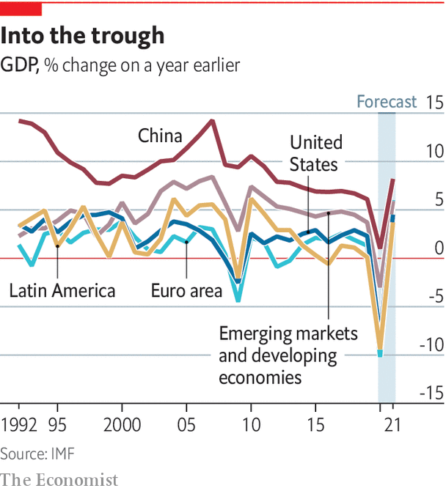

Yet unlike the situation after a hurricane, there is no fleeing to better economic climes. Just as after the financial crisis, this downturn is notable for its breadth as much as its depth. And covid-19 continues to spread. As this report was being written, the seven-day moving average of global infections hit new highs. America and Australia had been through two rounds with the virus; France, Spain and Britain were bracing for a second wave; India was on an upward slope; and nobody knew how pervasive covid-19 was in the poorer world. Though hopes are high for a vaccine in 2021, it is not certain to prove both safe and effective. Economies could yet be trying to operate around the constraints of social distancing for years to come.

## Long-term acceleration

It has indeed become clearer that many changes brought about by covid-19 will be long-lasting. This special report argues that the pandemic will strengthen forces that were already acting on the world economy, accelerating changes in trade, technology, finance and economic policy.

Conditions before the pandemic were forged by the three biggest economic shocks of the 21st century: the integration of China into the world trading system, the financial crisis and the rise of the digital economy. As Chinese workers left rural poverty for factories, cheap goods flowed west and financial assets flowed east, helping to create low inflation, low interest rates and lost rich-world manufacturing jobs. The financial crisis caused a collapse in demand that further depressed interest rates even as globalisation stalled. The rise of technology contributed to a decline in competition, bumper corporate profits and a fall in the share of national income flowing to workers as superstar firms reaped the rewards of network effects and natural monopolies.

The covid-19 pandemic is a fourth big shock. The collapse in demand greatly exceeds that after the financial crisis. Saving may be elevated for years. Low and even negative interest rates are more likely to last. This will prop up asset prices even as economies are weak. Firms are more aware of the risks of supply chains that are both sprawling and fragile; covid-19 will increase the desire to bring them closer to home, and to diversify suppliers. And the pandemic is hastening digitisation. Consumers’ switch from physical retail towards e-commerce has quickened, and they have got used to getting some health-care and education services online.

The share prices of tech giants have soared. Even after a slump in September, the New York Stock Exchange’s “FANG+” index of technology stocks had produced a year-to-date return of about 60%. Companies have adapted to remote work with astonishing speed, stepping up investments in technologies that facilitate remote presence.

The pandemic will mark a turning-point in politics and geopolitics as well as economics. The world will emerge from 2020 into an era of more intense great-power competition. The spread of covid-19 has coincided with, and to an extent exacerbated, escalating tensions between China and America. They have got worse than even the most hawkish observer predicted a few years ago. Trade disputes, with their strange focus on trade deficits and soyabean purchases, are now part of a broader battle. America has lobbied the world to reject Chinese 5G technology, ramped up scrutiny of foreign investors, imposed sanctions to restrict Chinese access to its semiconductor technology and is forcing TikTok, China’s most successful consumer-technology export, to sell itself. Chinese investment in America has collapsed. Both countries are diversifying away from each other in trade. The two economies are too integrated to decouple entirely, but they now combine far-reaching economic ties with pervasive mutual suspicion.

For domestic politics in the rich world, the pandemic represents a challenge to the status quo. Unlike the financial crisis, this is not Wall Street’s fault. But the juxtaposition of a weak economy with high asset prices that result from low interest rates could provoke public anger, especially if it coincides with unemployment concentrated among poorly paid service-sector workers. Low interest rates will make possible substantial prolonged deficit spending. How recessions are fought will change, partly because near-zero interest rates neuter monetary policy, but also because of this year’s experiments with large-scale cash transfers to households. There will be both the appetite and the conditions to facilitate a rewriting of the social contract in ways that many hoped might follow globalisation and the financial crisis. The question will be whether today’s politics is up to the job; or whether it is doomed to channel dissatisfaction with change into another round of backward-looking populism.

What changes are necessary depends on an understanding of just how substantial a structural economic shift the pandemic is likely to bring about. The story begins with trade.■

This article was downloaded by calibre from <https://www.economist.com/special-report/2020/10/10/the-peril-and-the-promise>

|  |  |  |  |
| --- | --- | --- | --- |
|  | Articles | Sections | Next |

|  |  |  |  |
| --- | --- | --- | --- |
| Previous | Articles | Sections | Next |

#### International trade

# Changing places

The pandemic will not end globalisation, but it will reshape it

Oct 10th 2020 |

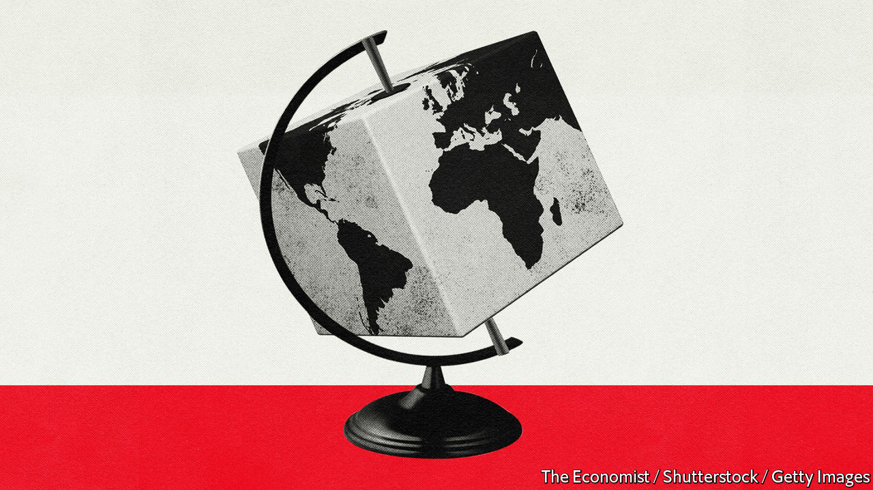

FOR A TIME economic contagion seemed more threatening than the pathological kind. Though the spread of covid-19 was mainly in China, the damage was appearing along supply chains that produce the world’s goods, notably cars and consumer electronics. China is the world’s second-biggest exporter of parts, so as its factories shut down, manufacturers everywhere faced delays. Even before the virus took off in South Korea, Hyundai had halted production because of a shortage of imported parts. The World Economic Forum (whose annual bash in Davos epitomises globalisation) advised companies to bring production closer to customers.

As the pandemic spread, location ceased to matter much. There was no escaping the disease: the world economy saw its deepest, most synchronised collapse on record. Some of the least globalised economic activities—restaurants, cinemas, fitness classes and other services—suffered most. More than goods, people stopped crossing borders; Davos 2021 was postponed. However, the supply-chain panic has left a lasting impression. For business, it is further evidence of the risks of distant disruption. For governments it offers more reasons to turn inward. The result is to accelerate changes to globalisation that were already in train.

Global supply chains were forged in the period from the mid-1980s until the financial crisis 25 years later. Trade surged in volume and changed in nature. It grew nearly twice as fast as global output, as emerging markets in Asia were bedded in to the world economy. After China joined the World Trade Organisation in 2001, its share of world exports of many parts and capital goods grew from under 10% to over 30%. Countries often specialised not in specific goods, but in bits of them. Taiwan, South Korea and Japan made semiconductors for the consumer-electronics industry. China supplied parts to German carmakers. The rise of computing made such complexity manageable. Globalisation brought cheaper goods to the rich world and, thanks to what Ben Bernanke, then Fed chairman, called a “global saving glut”, low interest rates. It also displaced many workers. Perhaps a million Americans lost their jobs to Chinese competition.

The 2010s slammed on the brakes. Trade stagnated as a share of GDP; foreign direct investment fell. As China’s middle class grew, it consumed domestically more of what it produced. Its share of world exports stopped rising in 2015, but its share of world imports continued to grow. As manufacturing became more automated, savings from locating production where workers were cheapest shrank. The rise of social media made consumer fads more volatile, necessitating faster production and shipment to satisfy impatient buyers. “Just in time” delivery of parts worked better with closer suppliers. And disasters highlighted the risk of a specialised economy. The tsunami that hit Japan in 2011 cut Toyota’s production in America by nearly a third because of a shortage of parts, while flooding in Thailand inundated factories producing a quarter of the world’s hard drives. Firms began to see long supply chains as unwieldy and risky. Trade started to concentrate in regional blocks. Globalisation became slowbalisation.

Then Donald Trump was elected in November 2016, and a trade war began between America and China. Companies realised they were exposed to political risk from economic nationalism, as much as from distant disruption. In 2019, as average American tariffs on Chinese imports rose from 12% to 21%, and tariffs in the other direction rose from 17% to 21%, America’s share of Chinese imports and exports fell to its lowest in 27 years, before China’s WTO entry. America circumvented and then sabotaged the WTO, stopping the nomination of judges to its appeal board and thus its ability to adjudicate trade disputes. In Europe Britain voted for Brexit in June 2016. Many European leaders grew frustrated with unfettered markets, wishing to have national champions that could compete with China’s state-backed giants.

The blow struck by covid-19 has made supply chains a “CEO and board level topic,” says Susan Lund of McKinsey, a consultancy. Until this year, she says, many firms did not realise how much their supply chains depended on China. In a survey conducted by McKinsey in May, some 93% of firms reported plans to make supply chains more resilient. The firm finds 180 products for which a single country accounts for over 70% of exports and reckons the production of 16-26% of goods exports could change location in the next five years. Firms are worried not just about trade wars and other shocks, but about their environmental footprint and labour standards. These are easier to monitor closer to home.

Covid-19 has also given politicians a chance to indulge their protectionist instincts. The origin of the virus in Wuhan gave Mr Trump a stick with which to beat China, and another multilateral institution, the World Health Organisation, on which to pour scorn (and, in this case, begin withdrawing from). There has been an upsurge in government intervention to protect jobs and rescue firms; by the end of April the EU had approved more than €2.2trn ($2.6trn) in state aid. Even before the pandemic France and Germany wanted Europe’s state-aid and competition rules loosened in the name of promoting national champions.

## Interdependence days

Politicians have also come to realise how much health-care systems depend on trade. Shortages of personal protective equipment (PPE) spurred many to limit or block exports of these and similar goods. The IMF counts 120 new export restrictions this year. For many medical goods production is highly concentrated: China accounts for 60% or more of exports of antibiotics, sedatives, ibuprofen and paracetamol. Britain has launched “Project Defend”, which will try to reduce reliance on Chinese production of critical products with a mix of reshoring and guarantees that supplies pass through friendly countries.

Unhappily, the political appeal of protectionism grows during slumps. When economies lack demand, governments covet spending that leaks overseas on imports. This is what led to a devastating round of protectionism in the 1930s. Protection also rose after the financial crisis. It does not help that China’s stimulus has tried to keep production going, whereas rich-world governments have supported household incomes. Brad Setser of the Council on Foreign Relations, a think-tank, notes that China’s current-account surplus, which was shrinking, has exploded this year. Its exports have recovered strongly, outward flows of tourists have all but stopped and commodity prices have fallen, making imports cheaper. Were China’s trade surplus in July sustained for a year it would add up to $700bn, surely enough to worsen the trade war with America even if Joe Biden replaces Mr Trump.

Such is the confluence of forces bearing down on global trade—organic slowbalisation, trade wars, suspicion of supply chains—that some draw comparisons between today and the early 20th century. Then, a peak in globalisation collapsed under the weight of the first world war, Spanish flu and then the 1930s depression.

The comparison is too pessimistic. Trade has not done as badly as feared. In April the WTO forecast that goods trade would fall by 13-32% this year; today it seems more likely to be just 10%. The IMF says the decline in trade will be commensurate with the slump in demand from the recession. That is in contrast to the aftermath of the financial crisis, when trade fell by more than its usual relationship with GDP suggested. It also shows that supply chains have not been wholly wrecked. They were crucial for the response to PPE shortages, argues Sébastien Miroudot of the OECD club of mostly rich countries. South Korea, which has been exporting millions of test kits to America and Europe, was uniquely placed to ramp up production using existing supply chains and relationships.

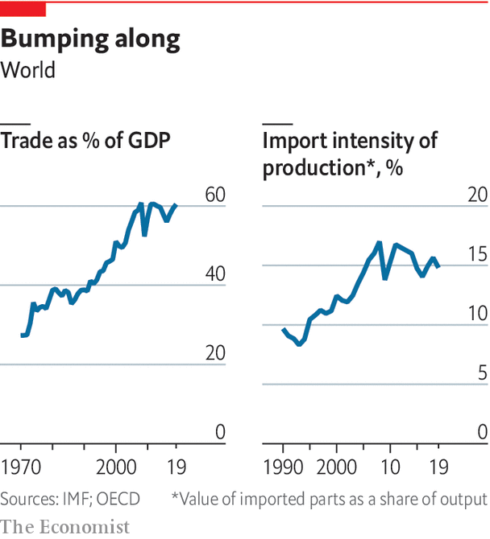

The logic of turning inward in response to the pandemic is shaky. A recent working paper by Barthélémy Bonadio of the University of Michigan and three co-authors studies 64 countries and finds that one-quarter of the drop in GDP this year was transmitted along supply chains, but that reshoring production would not have reduced the damage. Mr Miroudot distinguishes a supply chain’s robustness (the ability to keep working through a crisis), from its resilience (the ability to bounce back from one). The history of supply chains is that they are not robust but they are resilient, because companies are quick to find workarounds. Their robustness could be improved, but not by repatriating production, since disaster can strike at home as well. Had New York been the centre of mask production when covid-19 struck, the result would have been a “real big mess”, argues Shannon O’Neil of the Council on Foreign Relations.

Governments might choose to ignore all this in favour of protection. But most firms are not about to abandon their cross-border investments. A survey by the US-China Business Council shows little change in the number of American firms saying they have moved or plan to move out of China. The survival of the “phase one” trade deal struck in 2019 suggests that even the Trump administration knows there are limits to the desirability of decoupling from China. Rather than a wholesale break, covid-19 is likely to cause an acceleration of forces already in motion. Firms will trade off a bit of efficiency for more robustness, realising that in the long run the robotisation of manufacturing may lead to more local production anyway. Governments will shorten and diversify supply chains for medical equipment. But America and China will trade under a darker cloud of mutual suspicion, balancing commercial and geopolitical interests.

Further ahead the future of globalisation will be determined less by goods than by services. Before covid-19 services trade was not suffering from slowbalisation: it was growing faster than GDP. Exports of services account for around a fifth of all trade, according to the WTO (although what exactly counts as services trade is a matter of some debate). Like trade in goods, trade in services has suffered this year as tourist flows have collapsed. But consumers are unlikely to have suddenly lost their taste for travel, and countries have little long-term incentive to close borders to tourists. It seems likely that tourism will eventually rebound.

Meanwhile, the surge of investment in remote working during 2020 might open the door to more trade in digital services. When work is carried out remotely, it does not matter where it is done. On the more futuristic end, this involves remote presence. Whereas the export of repair services previously required high-skilled engineers to cross borders, virtual- and augmented-reality technologies now allow experts in one country to help lower-skilled workers fix machines in another, says Ms Lund. Richard Baldwin of the Graduate Institute in Geneva points to the potential for remote workers in poor countries to carry out basic office tasks for firms in the rich world. Before the pandemic the WTO was already talking up the potential for more trade in digital services, predicting that if developing countries adopted digital technologies, they could reap the rewards of a higher share of international services trade.

Services trade is hard to liberalise because it often means harmonising regulations. Fields such as education, health care, accounting and finance are littered with barriers to entry and requirements for local credentials. The most successful model for remotely provided services is India’s IT sector, which faces few regulatory hurdles. But disputes over cross-border data flows and the taxation of internet giants augur badly for faster digital integration. Digital trading, just like trade in goods, is increasingly concentrated in regional regulatory blocks. Yet Mr Baldwin argues that the rise of online services trade will bypass tensions between East and West, because it will take place within time zones: South America will supply cheap digital services to North America, Africa to Europe, and South-East Asia to North-East Asia.

The increased digitisation brought on by covid-19 can only help services trade, even as goods trade continues to slowbalise. But the extent of that help depends on how much the pandemic reshapes labour markets, the subject of the next chapter.■

This article was downloaded by calibre from <https://www.economist.com/special-report/2020/10/10/changing-places>

|  |  |  |  |
| --- | --- | --- | --- |
| Previous | Articles | Sections | Next |

|  |  |  |  |
| --- | --- | --- | --- |
| Previous | Articles | Sections | Next |

#### Labour markets

# Zoom and gloom

The transition to remote work is welcome. But it will be painful

Oct 8th 2020 |

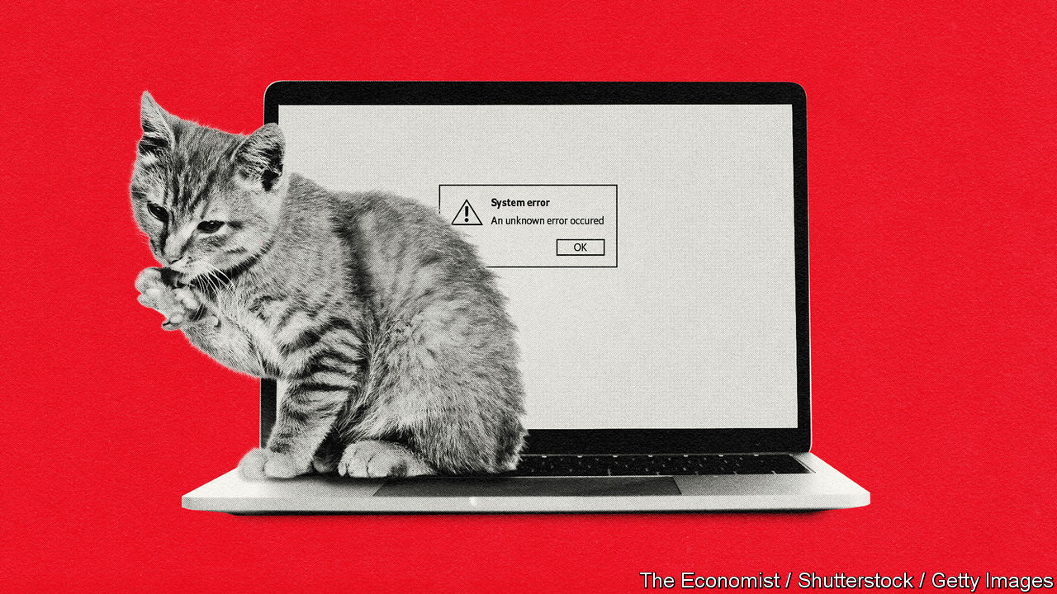

IN 1973 THE Eldfell volcano, long-dormant, erupted on Heimaey, an island off Iceland. The eruption destroyed about 400 homes, a third of the total (Heimaey’s seaport was saved by pumping seawater into the lava). The Icelandic government compensated the unlucky people who lost their homes, many of whom never returned. But when Emi Nakamura and Jon Steinsson of the University of California at Berkeley and Josef Sigurdsson of the Norwegian School of Economics studied how they fared later, they discovered a reversal of fortunes. Among people less than 25 years old at the time of the eruption, those who had moved averaged four more years of schooling and earnings $27,000 greater per year than those from families who had kept their home. Being forced to move had its advantages.

The covid-19 pandemic is a disaster orders of magnitude worse than a volcanic eruption. Yet it too has created an experiment. In a matter of weeks professional workers abandoned their offices en masse in favour of working from home. Meetings were replaced with Zoom calls, and commutes with longer hours at the desk. And just as for the Icelanders, the experiment has turned out to be an improvement for many. Seven out of ten affected Americans say it has gone better or much better than they expected, according to a survey carried out by Jose Maria Barrero of ITAM, Nick Bloom of Stanford University and Steven Davis of the University of Chicago. Mr Bloom reckons that two-thirds of American GDP in May was produced from peoples’ houses, a shift in production techniques unmatched in peacetime.

The idea that disruption can lead to improvement is a voguish one, promoted by such writers as Tim Harford, who advocates “messiness”, and Nassim Nicholas Taleb, who terms things that get better after disruption “antifragile”. The evidence is summarised in a forthcoming paper by Michele Acuto of the University of Melbourne and three co-authors. Cities built to exploit a locational advantage that has disappeared tend to persist unless they are swept away by disaster. When faced with tube strikes in 2014, enough London commuters found new ways of getting to work that the strike is estimated to have saved more commuting time than it cost. Recessions, too, typically bring on Schumpeterian creative destruction: American firms in areas hit most by the financial crisis restructured production towards greater use of technology, leaving a mark on labour markets that persisted even after unemployment had returned to normal levels. But the scale and consequences of this year’s work from home experiment go beyond any previous example.

That firms and workers have suddenly discovered the benefits of remote work seems counterintuitive. The technology allowing it is not new. And it seems to contradict a popular idea about how the world economy functions. In 1997 Frances Cairncross, then of The Economist, wrote “The Death of Distance”, arguing that communication technology was making location ever less relevant to business and personal life. The next two decades seemed to defy her thesis, as economic activity concentrated in successful cities like San Francisco, New York, London, Tokyo and Sydney. The explanation, many thought, lay in the agglomeration effects of bringing together knowledge workers. Productive contacts between people grow exponentially with the numbers gathered in one place. And that is before considering the taste workers may have for the culture and services that cluster in big cities.

Could all this change as the result of one event? Believe surveys of firms and workers and the answer is: partly. The pandemic, they say, has reduced the stigma of working from home. It has spurred firms to invest in the kit needed to make remote collaboration possible. And it has proved that the combination of software and hardware that allows working from home is, for the most part, reliable (if risky; the top prize in the Chess Olympiad, one of the world’s top chess tournaments, had to be shared after two players lost their connections mid-game). According to Mr Bloom and his colleagues, American firms forecast that the proportion of days worked at home will jump from 5% before covid-19 to about 20%, a number that chimes with the average desire of workers. It seems likely that many firms will adopt a model in which large numbers split their working hours between solitary work at home and collaboration in the office.

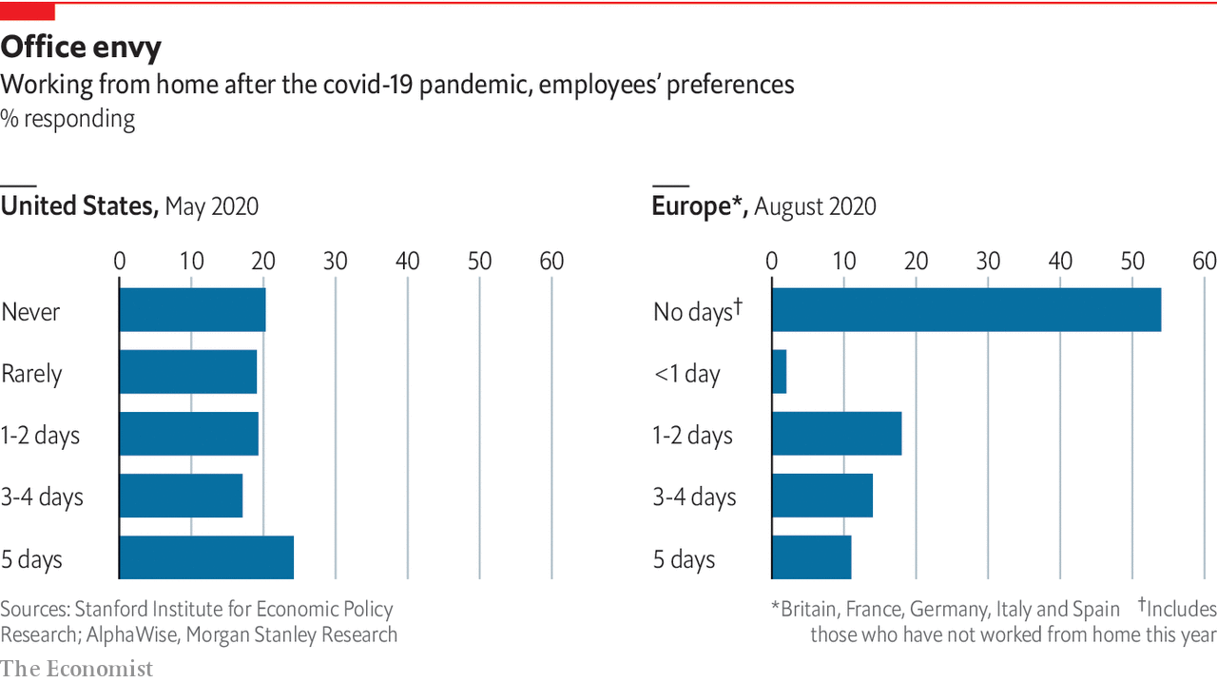

That will hardly kill off superstar cities or end agglomeration effects. Companies need offices to integrate recruits, monitor performance, build relationships and spread knowledge. Many people, especially the young, still want to cluster together and party, as packed concerts in Wuhan demonstrate. And people still need to meet in person. Recent research by Michele Coscia of the IT University of Copenhagen, and Frank Neffke and Ricardo Hausmann of Harvard University, finds that a permanent shutdown of international business travel would shrink global gross product by an astonishing 17% by hindering flows of knowledge across borders. The shift in favour of remote work also looks curiously like an anglosphere phenomenon; workers in mainland Europe have been swifter to return to the office than those in Britain and America.

Nonetheless, the shift will lead to significant structural changes. One is that many jobs lost to covid-19 will not return, because the labour market will adjust to a world with less spending in cities and more in suburbs and online. Based on surveys and share prices, Mr Bloom and his colleagues predict that one-third or more of all job losses during the pandemic will be permanent. That will come as a nasty shock to many who still expect their jobs to return. Only 19% of total American lay-offs since March have been reported as permanent, yet by August overall employment had recovered less than half its losses this year.

A second implication is a period of higher inequality. Recessions are usually worse for the poor and unskilled than for others, but the pandemic has been bad for them even accounting for the severity of the hit to the labour market, according to a working paper by Ippei Shibata of the IMF. Job losses have been heavy among service workers (who are more likely to be young, female and black) whose employment depends on the spending of high-earning professionals. Data from Opportunity Insights, a team of researchers at Harvard University, reveal that by the end of July there were 2% fewer jobs in America paying more than $60,000 a year than in January. But jobs paying under $27,000 were 16% scarcer. Those who feed, transport, clothe and entertain people who are out-and-about account for about a quarter of American employment, note David Autor and Elisabeth Reynolds of MIT. The large number of low-paid service jobs is often lamented, but “having too few low-wage, economically insecure jobs is actually worse than having too many”.

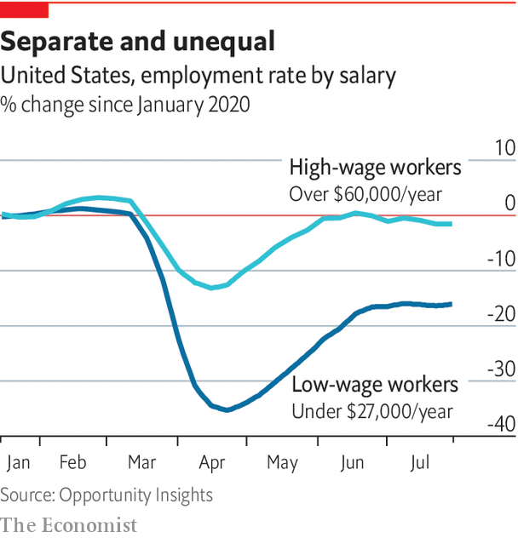

The enormous sums that governments have spent replacing (or more than replacing) lost wages has suppressed the uneven effect of job losses on household incomes. In the early months of the pandemic America’s poverty rate probably fell, according to Jeehoon Han of Zhejiang University, Bruce Meyer of the University of Chicago and James Sullivan of the University of Notre Dame, as Americans received $1,200 cheques and unemployment benefits were boosted by $600 per week. In August consumer spending in low-income zip codes was barely down on its January level, despite the jobs collapse. But Congress has let that support expire. As governments cease replacing household incomes, a veil will be lifted, revealing a more unequal labour market.

This may not last. New service jobs—home delivery, suburban restaurants—will eventually replace those lost in city centres. But such transitions are painful, and it matters who bears the burden of them. Even if you exclude all workers who insist optimistically that they are on temporary lay-off, America’s unemployment rate in August was still about 6.6%, say Jason Furman of the Peterson Institute, a think-tank, and Wilson Powell III of Harvard University. That is roughly equivalent to the unemployment levels in early 2014, long before the labour market could be said to be healthy. Even if unemployment now falls rapidly, as it did after the recession of the early 1980s, it would take well over a year to work off just those job losses.

## Housekeeping points

A third implication of the shift could boost growth and reduce inequality in the long run. It is that a drag on the world economy from housing shortages in and around successful cities will bind less tightly. Such shortages have limited growth by slowing the agglomeration effects on which it relies, as well as acting as barriers to opportunity by making it harder for the poor and young to move to better jobs. They have also widened divides between homeowners, who have enjoyed windfall gains in house prices, and renters. By one estimate American GDP would be 3.7% higher were regulatory constraints on building as loose in New York, San Jose and San Francisco as in the median American city.

But the increase in remote working will spread opportunity across the economy regardless of housing costs. The best case is that the internet ends up beating cities at their own game. In principle, greater numbers of people can gather and interact online than in physical proximity, notes Adam Ozimek, an economist at Upwork, a freelancing website. Moreover, if it becomes possible for employers to hire not just anyone located in a city, but anyone with an internet connection, the pool of possible candidates vastly increases. The resulting better matches between employers and employees should increase growth—perhaps at last unleashing the measured productivity gains that the technological improvements of the 21st century long promised but failed to deliver.

What will it take to realise this optimistic vision? Firms will need to continue experimenting with change rather than getting into a new rut. Some see the future of remote collaboration not in stilted video conferencing but in immersive virtual environments comparable to the computer games on which many people already spend hours of leisure time without suffering from “Zoom fatigue”. Such environments can create a fuller sense of shared experience, spontaneous human interaction and thus relationship building. (Mr Bloom recently spoke at a conference on the future of work hosted on QUBE, a game-like platform complete with a virtual conference hall and spaces in which virtual avatars can mingle.) That might allow more firms to operate completely virtually, rather than in the split-time model that many now expect.

For policymakers, the challenge is to ensure that the structural transitions already under way are not inhibited by a prolonged slump like the one that followed the financial crisis. That means economies must be given enough stimulus to encourage firms to create new jobs to replace those that are now redundant. The pandemic, however, has thrown up a challenge to this: a further reduction of interest rates.■

This article was downloaded by calibre from <https://www.economist.com/special-report/2020/10/08/zoom-and-gloom>

|  |  |  |  |
| --- | --- | --- | --- |
| Previous | Articles | Sections | Next |

|  |  |  |  |
| --- | --- | --- | --- |
| Previous | Articles | Sections | Next |

#### Competition

# Survival of the fittest

Could the pandemic leave markets more concentrated?

Oct 8th 2020 |

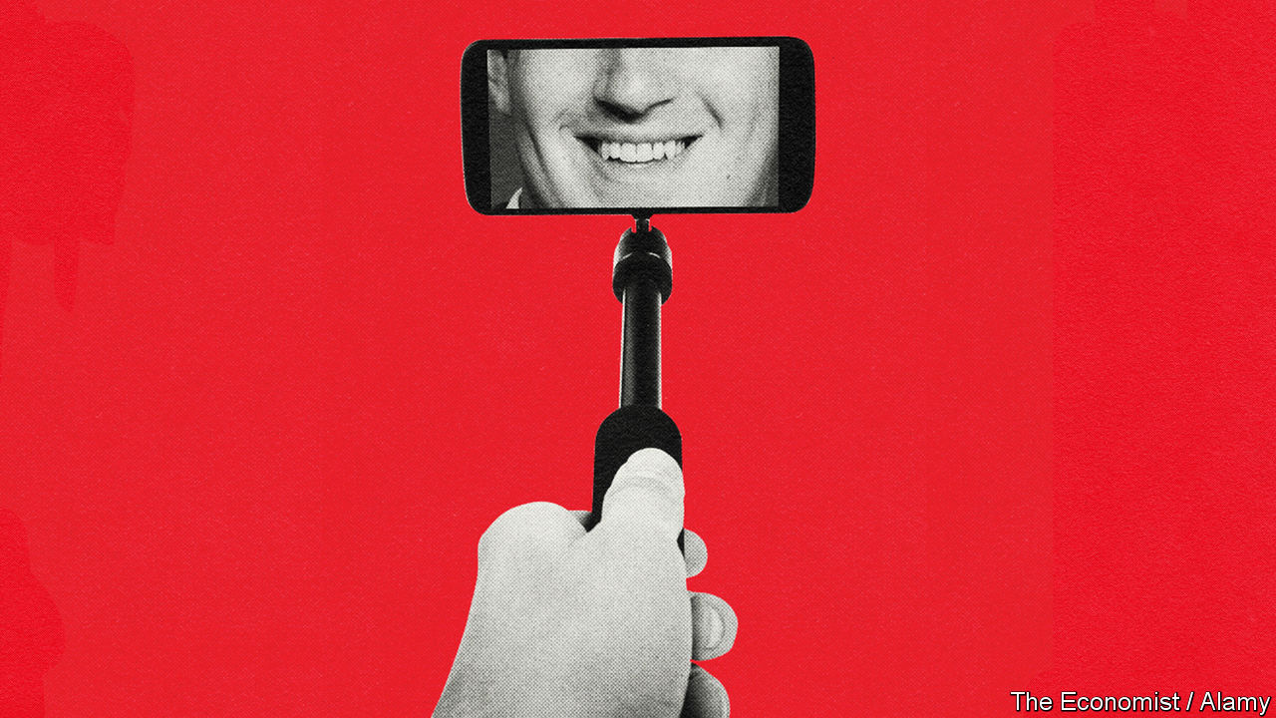

THE GROWTH of remote working is the latest iteration of a decades-long technology shock. It began in the 1990s when personal computers took over offices, continued with the development of the smartphone and social media in the 2000s, and in the 2010s led to cloud computing and artificial intelligence. It has contributed to two features of the world economy: the dominance of “superstar firms” that have amassed valuable know-how, data and intellectual property which is hard to replicate; and an associated decline in the share of GDP accruing to workers in wages (a trend that is most evident in America).

Will covid-19 accelerate these trends? It has been a good year for technology giants, whose shares fuelled a bull run in America’s stockmarkets. In a recent essay, Nancy Rose of MIT argues that covid-19 is shifting the business landscape in a way that portends further market concentration. Greater dependence on technology is not the only mechanism at play. Another is the possibility that the downturn kills off small firms unable to weather the shock, whereas large, listed giants benefit from the liquidity backstops governments have placed behind capital markets.

The data do not yet bear out the bankruptcy concern. In April a quarter of American small businesses shut, but by July only 6% were still closed, according to Goldman Sachs, a bank. It is large companies that have suffered from a surge in bankruptcies, possibly because of their indebtedness. Many small-business failures have been staved off by emergency government support. This year America has distributed 5.2m “paycheck protection programme” loans, worth an average of $101,000 each (for comparison, there are 6m firms with fewer than 500 employees in the whole country). A working paper by Alexander Bartik of the University of Illinois and five co-authors finds that getting such a loan raised a firm’s chances of survival to April 25th by 14-30 percentage points. Even if a wave of small-firm failures follows the end of government support, the businesses most at risk are restaurants, hotels and other service providers not known for market power.

The impact of accelerated technological change is a bigger worry. Christy Johnson of Artemis Connection, a consultancy that is itself remote and advises clients on remote work, says firms vary in their ability to adapt. Bigger firms on average invest a higher share of their sales in IT. A working paper by Ufuk Akcigit of the University of Chicago and Sina Ates of the Federal Reserve argues that it is getting more difficult for firms to ape the practices of those at the frontier of their industries, and that the result is falling business dynamism and less competitive pressure on the winners. John Van Reenen of MIT says that he expects the rising importance of technology to boost winner-takes-all effects in the economy, and to increase the value of large technology investments that small firms find harder to make.

This has not just been a good year for big technology firms. It has been good for technology in general, as it becomes more sophisticated and more crucial to success. And it is a good rule of thumb that the more digitised a market, the more likely it is to become concentrated.

This article was downloaded by calibre from <https://www.economist.com/special-report/2020/10/08/survival-of-the-fittest>

|  |  |  |  |
| --- | --- | --- | --- |
| Previous | Articles | Sections | Next |

|  |  |  |  |
| --- | --- | --- | --- |
| Previous | Articles | Sections | Next |

#### Interest rates

# The eternal zero

The pandemic will leave a legacy of even lower interest rates—and even higher asset prices

Oct 8th 2020 |

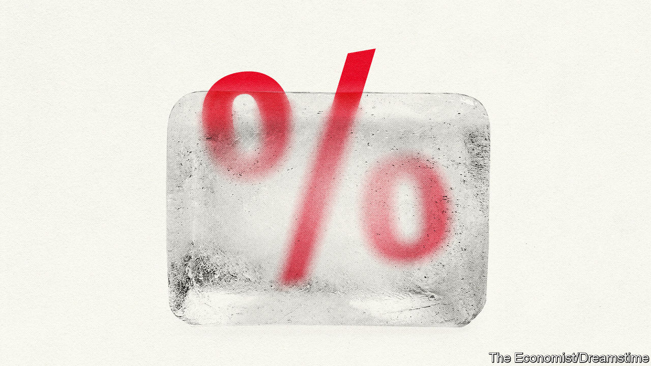

FOR FINANCIAL markets the 2010s were a time when it was hard to tell good news from bad. Even as the world laboured to shake off the financial crisis, the prices of stocks and bonds—not to mention houses—kept climbing. But good news, such as wage growth picking up, could cause markets to wobble. The reason was uncertainty over how far growth would go before central banks, especially the Federal Reserve, raised interest rates. Anything presaging monetary tightening caused bearishness. In the link between economy and markets, monetary policy was a signal dampener.

When covid-19 struck, there was no such ambiguity. Global stockmarkets tanked in March. For a time even American Treasury bonds, the world’s safest asset, fell in price amid a scramble for cash and dysfunctional money markets. But eventually the signal dampener kicked in. The Fed cut interest rates and unleashed a torrent of liquidity to keep dollar markets functioning, preventing a credit crunch, mass bankruptcies and lay-offs. Other central banks followed suit. Since January central banks in America, Britain, Japan and the euro area have created new money worth $3.8trn, much of which has kept yields on long-term government debt close to zero.

Markets were not just calmed: they began a bull run that defied gloomy forecasts. Between the start of April and the end of August, with central banks pinning bond yields down, global stockmarkets rose by 37%, fuelled by rising technology shares. America’s corporate-bond markets saw record issuance in the first half of the year. Many housing markets also defied gravity. In August house prices in Sydney were 10% higher than a year earlier; and Britain’s house prices hit an all-time high, said the Nationwide building society. Tech stocks had a torrid start to September but the market shed only about a month of gains. Asset prices remain high.

The show of force by central banks, and the divergence between high financial markets and the real economy, marks the apotheosis of trends that began in the 2010s. Before covid-19, central banks were already accused of keeping so-called “zombie” firms alive, exacerbating wealth inequality and putting home ownership beyond the reach of young renters, even amid weak economic growth. Since the pandemic hit these side-effects of monetary policy have all, in a short space of time, got worse.

This is not central banks’ fault. They have no choice but to respond to the economic conditions they face. For decades interest rates—both short- and long-term—have been on a downward trend as central banks have fought shocks to the economy. That monetary stimulus has not provoked much inflation in consumer prices demonstrates only that central banks have been reacting to market forces, not distorting them; the global desire to save has grown faster than the desire to invest.

When interest rates are low, the arithmetic of discounting makes future income streams, and hence assets, more valuable. A recent paper by Davide Delle Monache of the Bank of Italy, Ivan Petrella of Warwick University and Fabrizio Venditti of the ECB finds that the decline in the “natural” rate of interest, which balances saving and investment without causing unsustainable recessions or booms, can explain most of the rise in the ratio of prices to dividends in America’s financial markets all the way back to the 1950s.

The pandemic is just the latest shock bearing down on the natural rate of interest. In America, the 30-year interest rate has fallen by almost a percentage point since January. This fits the historical pattern. Recent research by Òscar Jordà of the Federal Reserve Bank of San Francisco, and Sanjay Singh and Alan Taylor, both of the University of California, Davis, studies 19 pandemics since the 14th century and finds that they have suppressed interest rates long afterwards—longer, even, than financial crises. Twenty years after a pandemic, they estimate, interest rates are about 1.5 percentage points lower than they would otherwise be. Covid-19 is not entirely comparable to episodes that include the Black Death and Spanish flu, because it is killing few young workers. But an effect even half as large would still be significant, given how low interest rates were already.

There are several ways in which covid-19 is strengthening structural forces pulling interest rates down. One is by boosting the desire of households and firms to hoard cash. Savings rates have surged as economies locked down and it became hard to spend. Some see the resulting swollen bank balances of consumers as potential fuel for an inflationary boom. But it is more likely that damage to the labour market leads to a prolonged period of “precautionary” saving, as is normal after recessions.

## Pandemic-driven rates

This is not a typical recession. It might have depressed interest rates by drawing attention to the danger of massive disasters, when the world was already becoming more attuned to the risks of climate change. Economists have long suspected that the risk of disasters weighs on interest rates by buoying demand for safe assets. (Decades ago, some were arguing that disaster risk explains the “equity premium puzzle”: the outsized gap between safe interest rates and the returns from shares.) In a recent paper, Julian Kozlowski of the Federal Reserve Bank of St Louis, Laura Veldkamp of Columbia University and Venky Venkateswaran of NYU Stern model the effect of covid-19 on beliefs about risk and estimate that it might depress the natural rate of interest by two-thirds of a percentage point. “Whatever you think will happen over the next year,” they write, “the ultimate costs of this pandemic are much larger than your short-run calculations suggest.”

A third way in which the pandemic may depress the natural rate of interest is by boosting income inequality. Before it, many economists were arguing that, because the rich save a higher proportion of their incomes than the poor, higher rates of income inequality in America and other rich countries had, over a period of decades, contributed to a decline in the natural rate of interest. One estimate by Adrien Auclert of Stanford University and Matthew Rognlie of Northwestern University finds that nearly a fifth of the decline in the natural rate of interest since 1980 is attributable to rising inequality. The pandemic could compound this effect if it leaves labour markets less equal.

Against these forces is an enormous rise in government debt. One explanation for low interest rates and weak growth after the financial crisis was that there was a shortage of safe assets to absorb the world’s savings. But the pandemic has seen a flood of such assets created as governments have issued debt to fund emergency spending. In June the IMF projected that global public debt would rise from a weighted average of 83% of GDP in 2019 to 103% in 2021. Covid-19 has even seen the creation of a new safe asset: the EU plans to issue €750bn ($875bn) of joint debt. In theory, new debt should soak up savings, pushing up the natural rate of interest.

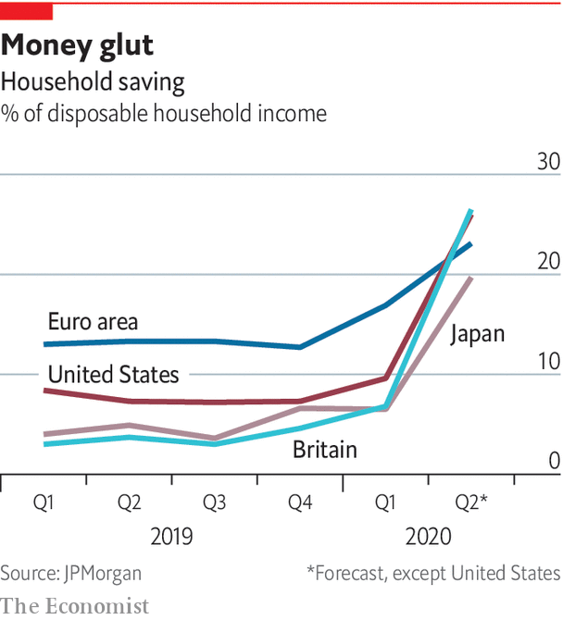

Yet there is little sign of these huge deficits eliminating the shortage of safe assets. That is partly because central banks have bought public debt in a bid to create growth and inflation by keeping long-term interest rates low. Oxford Economics, a consultancy, projects that safe-asset supply will decline in the next five years to just over a quarter of world output, against two-fifths before the financial crisis. The upshot is that the world economy increasingly resembles Japan, where even decades of deficits and net public debts of over 150% have not broken a low-inflation, low-interest-rate equilibrium.

This does not guarantee stagnation. Japan’s economic woes are often overstated because its growth is weighed down by ageing. In the 2010s its GDP per working-age person grew faster than America’s. But Japanification does create a dilemma: whether to increase deficits in an attempt to break the low-inflation, low-rate spell, or to rein in borrowing in the knowledge that the debt-to-GDP ratio cannot rise for ever. Low rates make it easier for politicians to pay for all sorts of demands on the public finances, including more spending on health care and pensions as societies age and on fighting climate change. But they also leave governments dependent on loose monetary policy and vulnerable to rising interest rates, should they ever return. During the pandemic governments and inflation-targeting central banks have been working hand in hand, but the question of what happens if their goals diverge is an open one.

Low interest rates also mean that high asset prices are all but guaranteed. This will reinforce complaints about wealth inequality and intergenerational unfairness—complaints that carry more bite given the unequal distribution of job losses this year. Homeowners, mostly drawn from the professional classes, will benefit as they can take advantage of cheaper mortgages. So will homebuyers. One reason why housing markets are holding up is that the downturn has not hit the typical house-hunter. Those without wealth or access to finance will feel understandably aggrieved.

Most significantly, central banks will be deprived of their traditional tool for fighting recessions: cutting short-term interest rates. The recovery from covid-19, and from future recessions, will instead hinge on the willingness of governments to provide an adequate fiscal response. Even central-bank bond-buying is of declining importance, because long-term rates are close to zero. The most that monetary policy can do is to stop long-term rates rising. The Fed’s recent promise to allow inflation to overshoot its 2% target during the recovery will take effect only if fiscal stimulus brings about more inflationary conditions.

If there is an overarching impact of low interest rates, it is fragility. The public indebtedness they allow might cause problems when circumstances change. It becomes harder to fight recessions. Investors find it harder to hedge risk, because with yields near zero, bond prices cannot rise much further, however bad the news. And high asset prices, especially when accompanied by income inequality, threaten the social contract. It is against this background that economic policy needs a fundamental rethink.■

This article was downloaded by calibre from <https://www.economist.com/special-report/2020/10/08/the-eternal-zero>

|  |  |  |  |
| --- | --- | --- | --- |
| Previous | Articles | Sections | Next |

|  |  |  |  |
| --- | --- | --- | --- |
| Previous | Articles | Sections | Next |

#### Emerging markets

# Prognosis uncertain

Covid-19 has not brought on an emerging-market crisis—but it could

Oct 8th 2020 |

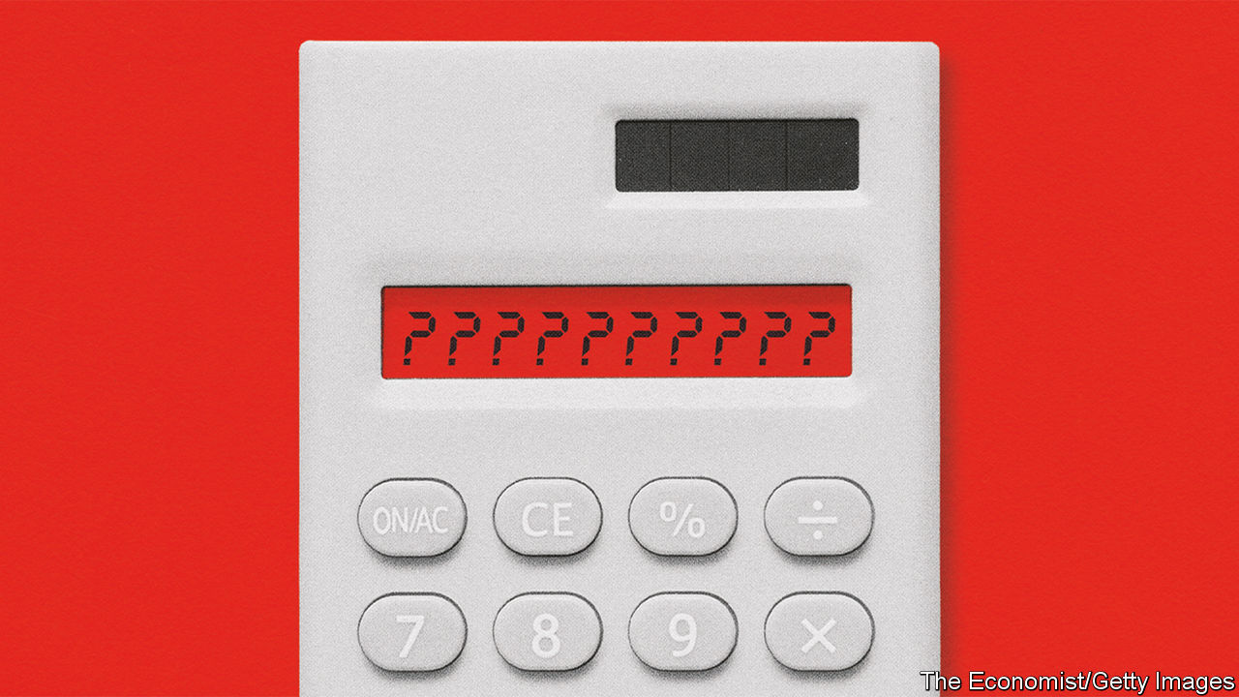

POORER countries depend on trade more than rich ones, especially on exports of tourism and commodities. They have fewer professional jobs that can be done from home, making social distancing costlier. Because their governments and companies often borrow in dollars, they suffer in times of economic stress, when their currencies usually fall against the greenback. That creates inflation, making it harder to cut interest rates to support their economies. And their governments have less capacity to borrow for emergency health-care spending or to bail out workers and firms. The pandemic seemed certain to send them into financial turmoil.

Yet it has proved easier to contain the financial crisis than the disease. The virus has run rampant in some middle-income countries such as Brazil, India and South Africa, colliding with poverty and patchy health care. Emerging markets’ GDP will probably shrink this year by the largest amount on record; in the second quarter India’s output was, astonishingly, nearly a quarter lower than in 2019. But they have mostly kept access to capital markets, raising $124bn during the first half of 2020, according to the IMF. Their currencies and foreign-exchange reserves have been under less pressure than during the financial crisis, the “taper tantrum” of 2013 or the sell-off in 2018. The IMF has lent $89bn to countries in financial distress—a lot, but only a fraction of its $1trn firepower that, in the spring, some warned might run out.

Much of the credit for such resilience goes to the Fed, which ameliorated a global crunch in dollar markets in the spring. It did so in part by providing dollars directly to some emerging markets: Brazil, Mexico, Singapore and South Korea were given currency swap lines, and most central banks were allowed temporarily to exchange American Treasuries for cash. As with many of the Fed’s interventions, the mere presence of a lifeline may have shored up confidence, rendering its exercise unnecessary. The Treasuries programme has hardly been used.

The easing of dollar strains has created space for stimulus. Emerging markets have deployed fiscal programmes worth around 3% of GDP, about a third as large as rich countries. Brazil has been dispersing a 600 reais ($110) monthly handout to nearly a third of its population. But most striking has been the use of unconventional monetary policy, inspired by rich-world central banks. Thirteen have undertaken some sort of bond-buying programme. This is a little strange; it has happened in countries such as Turkey, Mexico and South Africa which still have room to cut interest rates. But a report by the Bank for International Settlements suggests that bond purchases have eased financial conditions and supported emerging-market currencies rather than undermining confidence.

Yet it is too early to be sanguine. Many economists continue to fear a wave of sovereign- and corporate-bond defaults and possible funding crises in some big emerging markets. Their experiments with unconventional policy could yet turn sour. Or the virus could continue to wreak havoc. “History shows that it is not unusual that countries can keep borrowing even when default risk is high,” warn Jeremy Bulow, Carmen Reinhart, Kenneth Rogoff and Christoph Trebesch in a recent article. And the IMF says that the poorest countries face losing a decade’s worth of progress fighting poverty without more help.

This article was downloaded by calibre from <https://www.economist.com/special-report/2020/10/08/prognosis-uncertain>

|  |  |  |  |
| --- | --- | --- | --- |
| Previous | Articles | Sections | Next |

|  |  |  |  |
| --- | --- | --- | --- |
| Previous | Articles | Sections | Next |

#### The role of government

# The right kind of recovery

How the pandemic should change the role of the state

Oct 8th 2020 |

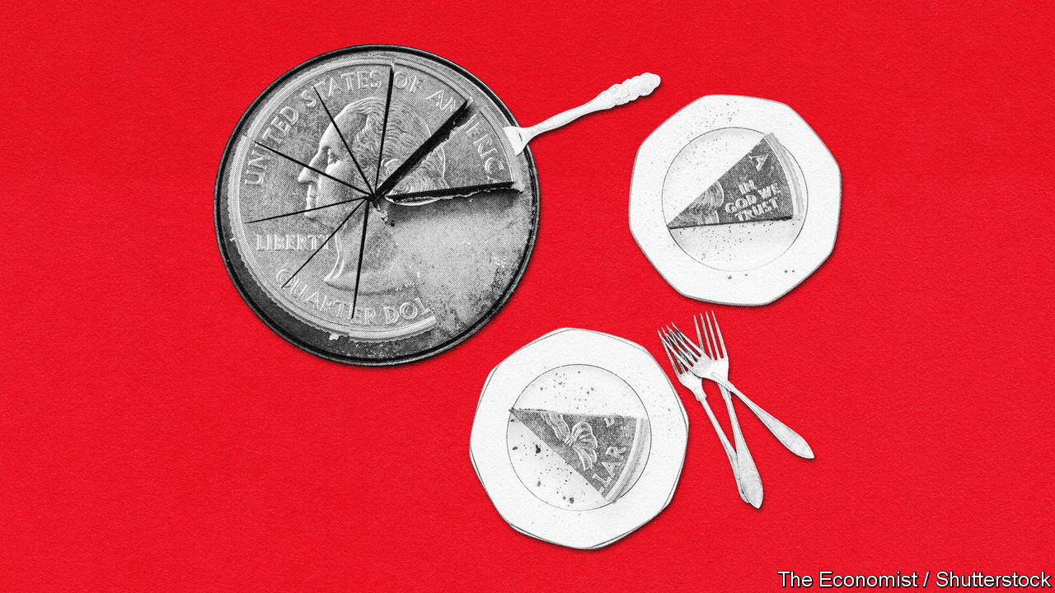

EVERY FEW decades in the 20th century the relationship between the state and the individual was reforged in the fire of crisis. Liberal reformers in Britain won the election of 1906 amid a loss of confidence in conservatism. In America the 1930s depression was followed by the New Deal. The second world war preceded the trente glorieuses, never-had-it-so-good Keynesianism, the expansion of welfare states and government-guaranteed full employment. In the 1980s Ronald Reagan and Margaret Thatcher banished stagflation and statism with a philosophy of individualism and economic discipline that gave birth to third-way politics.

Before covid-19 the big economic shocks of the 21st century—the rise of China, technological advances and the financial crisis—had not led to any such change. Many voters felt they had lost control to nameless forces. The gains from growth were insufficiently spread, and most governments did not think about how to ease the blows faced by people and places on the losing side of change. That the financial crisis led to incremental not fundamental reform might have been defensible, had it not been followed by too rapid a tightening of fiscal and monetary policies.

The result was a wave of angry politics. In many countries older voters are nostalgic for an economy that, whatever governments do, is never coming back. Young people are frustrated by declining social mobility and high asset prices, and fear the effects of climate change. Though there is fierce debate about how much they have changed over time, almost everyone laments inequalities of income, wealth or opportunity. And there is rising concern for the precarious position of service-sector workers in rich-world labour markets, exposed by covid-19.

This report has argued that the virus will hasten changes in the economy. That presents a risk: that governments will again fail to respond adequately to the depth of the transformation. If inequality rises, asset prices boom, urban service-sector jobs shrink, technology firms grow more dominant and governments turn to austerity too fast, politics will become more toxic, further polarising between the right’s unhinged economic nationalism and the left’s naive millennial socialism. The pandemic has created conditions ripe for misguided interventionism that tries to prevent change rather than adapt to it. Massive government loans to firms, central banks offering blank cheques for fiscal stimulus and government backstops for jobs look like a recipe for stasis. Bailing out every failing firm and protecting jobs indefinitely can only make societies poorer in the long term. The same goes for mistaken retreats to protection and the promotion of national champions.

Rather than trying to restore yesterday’s economy, governments must adapt to change, ensure it does not expose people to outsized losses, and seek to share the fruits more widely.

Goods trade is crucial to living standards today but, thanks to automation, it will keep declining in importance. A future of digital services trade promises more gains, but politicians must lift the regulatory obstacles in its way. This will be hard. It means exposing more white-collar workers, often protected by strict licensing, to the kind of competition that blue-collar workers have faced for decades, solving cross-border spats about digital tax and ensuring that rules on the cross-border flow of data, which are proliferating, do not act as barriers to trade. The gains could be substantial. A global digital labour market, spurred by firms’ investments in technology, might unleash a new wave of innovation. Governments could themselves take advantage: health care and education are two sectors ripe for disruption by cross-border providers.

Voters will not support more disruption without more risk-sharing. Governments should be more willing to act as insurer-of-last-resort for household incomes, as they have this year. Emergency support for households has borne out the libertarian mantra that governments are better at moving money around than at running things. Income support has been quicker, more transparent and less vulnerable to capture than other forms of fiscal stimulus. Governments should be readier to shield workers’ incomes from events beyond their control. Lockdowns fall into this category, but so do recessions and technological disruption. Automating payments to households during downturns would prevent suffering and guarantee that economies get the stimulus they need when interest rates are stuck near zero. Structural change also counts: those laid off should be supported with grants and retraining subsidies. It is right to worry about encouraging joblessness, but the solution does not have to be a stingy safety net. Better to raise taxes to finance an adequate welfare state than to lay poverty traps and distort incentives with poorly designed eligibility tests.

The final aim of spreading the benefits of growth is the hardest to achieve. The late 2010s demonstrated the wonders of tight labour markets. Between 2014 and 2019 real median American household incomes grew faster than in the much-vaunted late 1990s. Governments should seek to create another jobs boom, avoiding a premature turn to the fiscal austerity and tight monetary policy seen after the financial crisis. But there is no escaping that, in the long term, income distribution is shaped more by structural factors than by the economic cycle. The premium the labour market places on technological skills is an indictment of modern education. Not everyone can spend their days writing machine-learning algorithms, but workers and firms could do better in implementing existing technology (it should not have been a surprise that working from home has been such a success). Governments must fight to make the digital economy more competitive. That means promoting common data standards and portability and loosening intellectual-property rules. That superstar firms thrive online makes it even more important to tear down barriers to entry.

The prospects might seem grim, given many countries’ recent dysfunctional politics. But 2020 could be the start of an era in which populism wobbles while economic policymaking escapes from a rut. Plenty of orthodoxies have been upended. But with the right response, some old ones—such as the merits of free-market capitalism—might yet be restored.■

This article was downloaded by calibre from <https://www.economist.com/special-report/2020/10/08/the-right-kind-of-recovery>

|  |  |  |  |
| --- | --- | --- | --- |
| Previous | Articles | Sections | Next |

|  |  |  |
| --- | --- | --- |
| Special report | Sections | Finance & economics |

Business

The global shipping industry: It’s an ill wind that blows no one any good

.

Canada’s oil industry: Crude crutch

.

Cinemas: Curtains

.

Regulating big tech: Ex-antics

.

Bartleby: Free the workers

.

Japanese telecoms: Dialling down

.

Schumpeter: Battle for the iron throne

.

|  |  |  |
| --- | --- | --- |
| Special report | Sections | Finance & economics |

|  |  |  |  |
| --- | --- | --- | --- |
|  | Articles | Sections | Next |

#### Not so choppy

# How covid-19 put wind in shipping companies’ sails

Despite a slowdown in global trade, the maritime industry is having a banner year

Oct 10th 2020 |



SICKNESS AND shipping have a long shared history. The word quarantine is derived from the 14th-century Venetian practice of isolating ships at anchor for 40 days if plague was suspected on board. The latest ailment is a global pandemic that has killed at least 1m people and put the world economy, and global commerce, full steam reverse. This might have been expected to becalm an industry which carries 90% of traded goods—11.9bn tonnes last year, or 1.6 tonnes for every human—and where profits have often been elusive. The last time trade volume declined, in the aftermath of the financial crisis of 2007-09, maritime shipping suffered. Clarksons, a shipbroker, expects volumes to fall by 4.4% in 2020.

Still, Neptune seems to have smiled on shipping companies. Oil tankers and dry-bulk vessels that transport iron ore, coal and grain will turn a profit in 2020. Operators of ships ferrying containers, packed with consumer goods or components, are set fair for a banner year. Shipping is a business where, in the words of Martin Stopford of Clarksons, firms “make a living and occasionally make a killing”. This year, it appears, belongs to the second category. What is going on?

One answer is that the carnage wrought by the coronavirus has not been as bad as anticipated. The World Trade Organisation initially expected trade volume to shrink by as much as 30% in 2020. Drewry, a consultancy, had reckoned worldwide port visits by ships in the second quarter might decline by 16%. In fact they fell by 8%.

The industry has been able to take advantage of the swifter-than-expected recovery thanks to big underlying changes in its structure over the past decade, towards greater concentration. Container shipping, like tankers and dry bulk, seems finally to have learned a lesson from the debilitating overcapacity created as companies battled for market share.

In the decade before the financial crisis demand grew by around 10% a year. The order book swelled to the equivalent of 60% of the entire fleet when Lehman Brothers collapsed in 2008. An armada of new ships, which take at least two years from order to launch, arrived just as growth slowed. In the 2010s the fleet expanded by 100% while demand grew by just 50%, points out Peter Sand of BIMCO, a shipowners’ association.

The excess capacity ruined returns for years afterwards. McKinsey, a consultancy, reckons that between 2012 and 2016 container-shipping destroyed $84bn of shareholder value. Over the past five years, notes David Kerstens of Jefferies, an investment bank, the industry in aggregate has done a bit better, just about breaking even.

Now, though, efforts to cut costs and win market power are finally paying off. After years of consolidation the top seven firms now claim three-quarters of the global fleet, up from 55% in 2016, according to Jefferies. On top of that, 2017 saw the birth of three global alliances that now control 85% of capacity across the Pacific and almost all capacity between Asia and Europe.

Increased co-ordination has allowed the companies to respond to slowing trade. “Blank sailings”, industry jargon for cancelled voyages, came thick and fast. In May a record-breaking 12% of the global container fleet was idled, according to one estimate. Even as capacity has been reinstated—the share of the fleet that is idle has fallen to around 3%—freight rates have rocketed to cope with an unexpectedly vigorous recovery. Now, says Lars Jensen of SeaIntelligence, a consultancy, the container industry is on course for record profits of $12bn-15bn this year. Maersk, the world’s biggest container-shipping firm with 17% of the market, expects profits of $6bn-7bn, up from a pre-pandemic estimate of $5.5bn.

Rates have shot up most dramatically on trans-Pacific routes (see map). Spot prices for sending a container from China to America’s West Coast have risen by 127% since last year, to record highs. The port of Long Beach in California reported its busiest August ever; Los Angeles saw business that month up by 12% year on year.

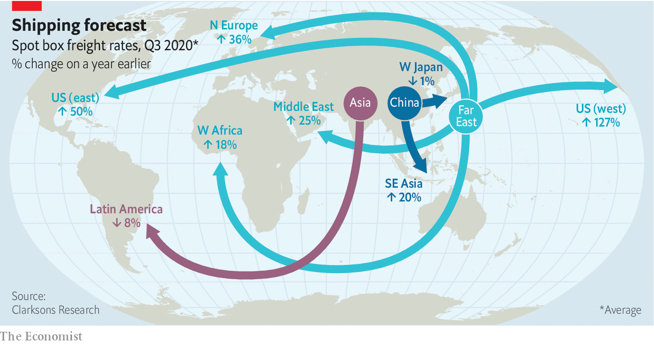

Can firms continue to manage capacity and resist the urge to order ships? Possibly, thinks Mr Kerstens. Maersk and Hapag-Lloyd, another big firm, have eschewed chasing volume and market share in favour of profitability. Maersk is investing heavily in integration with more lucrative links in the chain, such as lorries and warehouses.

The thin order book (see chart)—now equal to just 7% of the fleet—is not entirely down to newfound sobriety. Stricter environmental rules play a part, says Mark Jackson of the Baltic Exchange, a data provider. The International Maritime Organisation, the UN’s shipping agency, wants to halve the industry’s carbon emissions by 2050, relative to 2008. As long as the pathway to meet the target remains sketchy, and the requisite technology nascent, companies are reluctant to order vessels with a lifespan of 25 years or more.

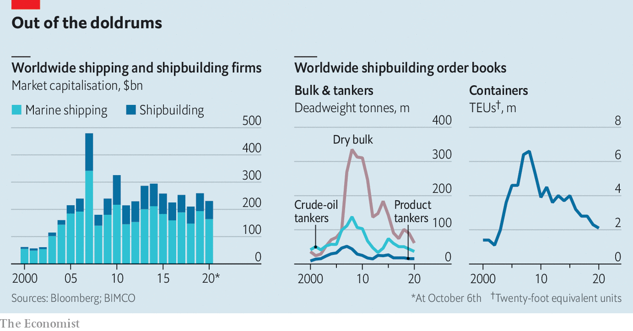

Shifting trade patterns are another factor. Supply chains are being reconfigured by the pandemic and the Sino-American economic war. As manufacturing shifts from China to other parts of Asia—Cambodia has rapidly replaced it as the predominant source of America’s Christmas-tree lights, for example—smaller ships will be required. These can ferry goods directly from minor Asian ports to Europe or, because vast existing vessels plying the route between China and Europe have plenty of life left, to trans-ship smaller loads to Asian mega-hubs for onward dispatch. All that means building ever-mightier ships offer diminishing returns to scale. Today’s leviathans—such as the Hong Kong, owned by OOCL, a firm based in the Chinese territory—can carry well over twice as many containers as the largest ships in 2005.

Tankers and dry-bulk carriers face rougher conditions. Both segments are far more fragmented than container shipping, and so unable to cut capacity as easily. The biggest specialist tanker operator, Teekay of Canada, wholly owns around 60 vessels totalling nearly 7m deadweight tonnes out of a global fleet of 623m in 2019. The average number of ships per firm is around 5.5.

Even so, tanker-owners were “having a party in the first half of the year”, says Mr Sand of BIMCO, thanks to sinking oil prices. Average annual earnings over the past decade were above break-even only half the time for the largest crude-oil tankers. But the collapse of an agreement between the Organisation of the Petroleum Exporting Countries and Russia sent oil prices tumbling just as covid-19 sapped demand for crude. Traders with nowhere to stash unwanted oil turned to tankers. At one point this spring more than a tenth of the world’s fleet was chartered as storage. Rates for the largest craft soared from $6,500 a day to $240,000, ten times the break-even level. Rates have now slipped below break-even but that bonanza will tide tanker-owners over to an annual profit.

## Bulking up

Dry-bulk vessels, by contrast, had a terrible start to the year. But they have since been helped by China’s swift recovery. The country accounts for 40% of the global dry-bulk trade, mostly because it imports 70% of the world’s iron ore (see [Schumpeter](https://www.economist.com/node/21792668)). Stimulus measures have led to record production and iron-ore imports hit all-time highs in the first seven months of the year. That has offset lower activity in the rest of the world, says Bimco. All sizes of ships are now making money.

One risk for commercially minded companies is that big rivals with different motivations might undermine capacity cuts. Governments in China, South Korea and Taiwan regard their state-controlled shipping giants, four of which are in the world’s top ten, not so much as profit motors but as a way to preserve their place in the global trading system. Hyundai Merchant Marine, the ninth-largest firm, is the only big shipper not to trim capacity. There are hints that China’s government does not approve of the high prices to shift Chinese-made goods. It has reportedly asked its carriers to reinstate capacity to America. COSCO and OOCL, which are state-controlled, will refrain from raising rates.

It is a similar story with ports. Maersk’s port division, APM, has clear financial imperatives. But Hyundai and Evergreen Marine, a Taiwanese company, probably regard their ports as a cost to bear for the sake of their shipping businesses. China Merchants and COSCO, which also runs big ports, are owned by a state keen to use trade to spread Chinese influence around the globe. Dubai’s DP World, which delisted in February, and PSA, a Singaporean operator, are both commercially driven but ultimately in state hands, too. Hong Kong’s Hutchison, one of the world’s biggest port operators, saw profits dip by 15% in the first half of the year. Often the interests of shareholders do not completely align with the role of enabling trade, says Eleanor Hadland of Drewry.

Another doubt is whether governments will allow their shipbuilders to fall into desuetude. China, Japan and South Korea now control 90% of global shipbuilding. They have incentives to keep shipyards in business, even if some could soon be out of work; reopening mothballed yards is a long and expensive process.

Keeping the world’s goods flowing is, then, a complex business—just ask the seamen trapped on board for months as lockdowns and travel restrictions have prevented regular changeovers. But their employers are moving into the nascent global economic recovery with wind in their sails. That is good news for world trade. ■

Editor’s note: Some of our covid-19 coverage is free for readers of The Economist Today, our daily [newsletter](https://my.economist.com/user#newsletter). For more stories and our pandemic tracker, see our [hub](https://www.economist.com/news/2020/03/11/the-economists-coverage-of-the-coronavirus)

This article was downloaded by calibre from <https://www.economist.com/business/2020/10/10/how-covid-19-put-wind-in-shipping-companies-sails>

|  |  |  |  |
| --- | --- | --- | --- |
|  | Articles | Sections | Next |

|  |  |  |  |
| --- | --- | --- | --- |
| Previous | Articles | Sections | Next |

#### Crude crutch

# Canadian oilmen drill the government for aid

Finding oil looks like a doddle in comparison

Oct 10th 2020 |

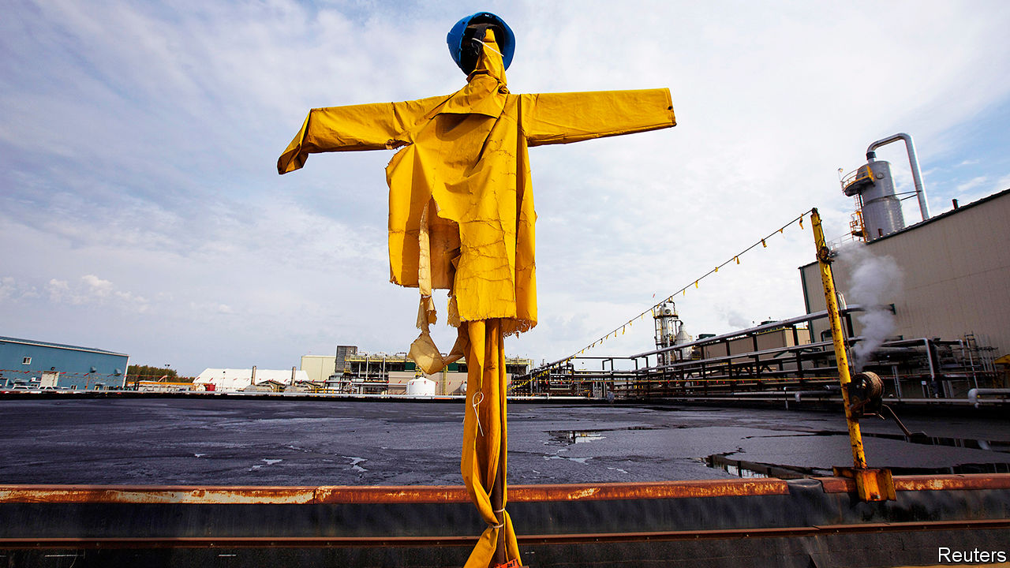

IN FRIGID WATERS 350km east of Newfoundland, the West White Rose project is designed to produce up to 75,000 barrels of oil a day. Whether it actually pumps a drop is a separate question. In September Husky Energy, its main backer, said it would review the investment and urged Canada’s government to take a direct stake. The province has since set new incentives for exploration and the federal government has announced C$320m ($240m) to support its energy sector. Yet Husky says West White Rose’s future remains in doubt.

This year’s implosion of oil prices has led companies to reconsider investments from Newfoundland to Nigeria. As capital has become scarce, some governments have taken action—for better or worse. Norway set new climate targets but also passed tax relief to encourage new drilling. In Canada, where an index of energy companies has shed more than half its value this year, the downturn has amplified long-standing questions about how the government can help—or whether it should.

Canada pumps more oil than anyone bar America, Saudi Arabia and Russia. But covid-19 caps a bumpy decade. American shale has offered fast, easy (if not always profitable) growth compared with Canada’s offshore projects or its mucky oil sands, where building mines and processing thick bitumen is both costly and carbon-intensive. Inadequate pipelines from Alberta, the industry hub, added further strain. Equinor of Norway, ConocoPhillips, an American major, and Royal Dutch Shell, an Anglo-Dutch one, sold their oil sands in 2016 and 2017. In February Teck Resources, based in Vancouver, scrapped plans for a large new project. The company cited capital constraints, opposition from indigenous groups and uncertain regulation.

Justin Trudeau, Canada’s prime minister since 2015, has coupled green ambition with a desire to avert the industry’s collapse. In his first term he passed a carbon tax. But he also backed the government’s purchase of the Trans Mountain pipeline from Kinder Morgan, an American firm, to bring oil from Alberta to the Pacific.

As the pandemic has battered Canadian oil firms, Mr Trudeau has tried to prop companies up without quite bailing them out. Measures include C$1.7bn to clean up abandoned wells and a national scheme to help all industries pay wages, more than C$1bn of which went to oil, gas, mining and quarrying firms. The C$320m earmarked for Newfoundland and Labrador aims to help oil producers reduce their emissions and invest in research and facilities.

Paul Barnes of the Canadian Association of Petroleum Producers, a trade group, welcomes the assistance for Newfoundland and Labrador. Whether it helps projects advance is another matter, he says.

Equinor is among those to delay plans for Canadian offshore drilling. In September Jason Kenney, Alberta’s premier from the opposition Conservative Party, blasted Mr Trudeau, a Liberal, for failing to offer more help. Mr Kenney maintains that Canada’s oil sector can thrive if only Mr Trudeau would let it (and, in a feat of rhetorical finesse, has argued the world will continue to depend on oil, not “unicorn farts”). In March Alberta took a C$1.5bn stake in TC Energy’s Keystone XL pipeline, to funnel crude from Alberta to refineries along America’s Gulf Coast, and backstopped the project with a $6bn loan guarantee.

Even generous aid would not spur rapid growth. Suncor, a giant Canadian producer, announced 2,000 lay-offs this month. Investors have little appetite for big projects. The sector won’t vanish; existing oil-sands endeavours can have operating costs as low as C$7 a barrel, says Mark Oberstoetter of Wood Mackenzie, a research firm. Beside fast-depleting American shale, oil sands’ steady output may look attractive, says Benny Wong of Morgan Stanley, a bank. Waterous Energy Fund, a private-equity firm that has bought more than half of the Canadian reserves sold in the past three years, has a simple strategy, says its boss, Adam Waterous: “Hold production flat and maximise sustainable free cashflow.” With or without government handouts. ■

This article was downloaded by calibre from <https://www.economist.com/business/2020/10/10/canadian-oilmen-drill-the-government-for-aid>

|  |  |  |  |
| --- | --- | --- | --- |
| Previous | Articles | Sections | Next |

|  |  |  |  |
| --- | --- | --- | --- |
| Previous | Articles | Sections | Next |

#### Curtains

# As audiences gingerly return, cinemas face a new problem

If Hollywood keeps postponing big releases, many theatre chains will struggle to survive

Oct 6th 2020 |



IT IS TURNING out to be a long intermission. Cinemas across the West closed in March and, despite attempts to reopen in the summer, the box office has not recovered. From October 9th Cineworld, the world’s second-largest chain, will temporarily shut its 536 Regal theatres in America and its 127 British outlets. AMC, the biggest, will cut the opening hours at some Odeon cinemas in Britain.

Early in the pandemic the problem was audiences. In March Disney’s “Onward” flopped as people refused to breathe recirculated air with a crowd of strangers. Business got harder when governments ordered theatres to shut, or imposed profit-crushing closures of refreshment counters and caps on capacity.

As countries have eased restrictions and audiences prepared to return, cinemas are finding little to show them. In China, where covid-19 seems under control, studios have resumed pumping out hits. But Hollywood will not risk premiering costly blockbusters while many markets, including New York and California, remain closed, and cinema-goers wary. Most big titles have been postponed (see chart). The last straw for Cineworld was the decision on October 2nd by MGM and Universal Pictures to delay “No Time to Die”, James Bond’s latest caper, from November until April 2021. No big release is planned until Christmas Day, when Warner Bros’ “Wonder Woman 1984” will ride to the rescue.

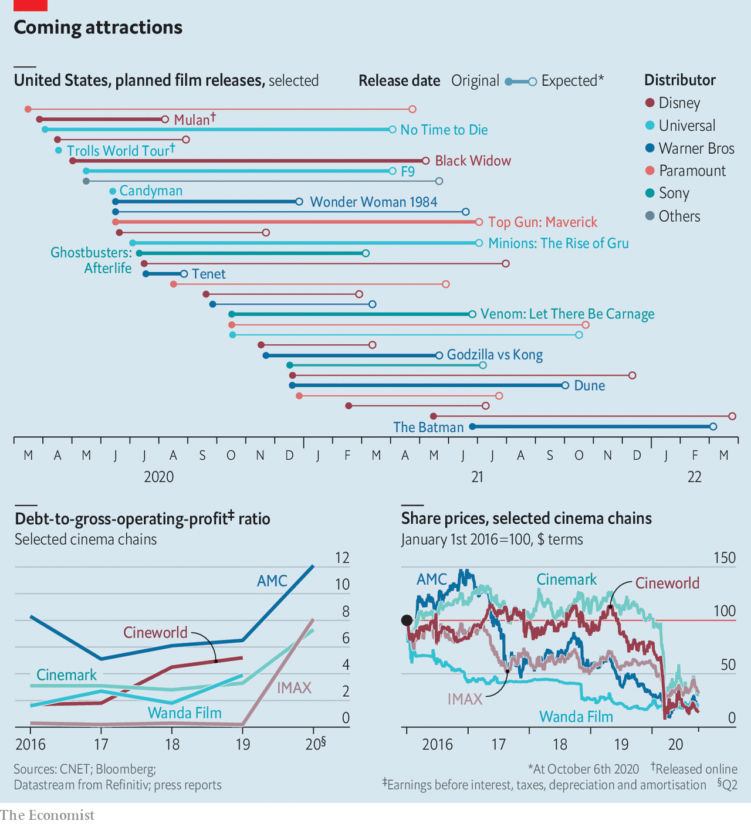

She may be too late. Attendance was declining before covid-19. To distinguish a night at the movies from a night with Netflix, cinemas built snazzy multiplexes with waiters ferrying burgers to viewers lolling in reclining seats. This helped rack up debt: AMC’s $10bn-worth was more than six times last year’s gross operating profit. Cineworld’s ratio was almost as high.

Nine months without revenues from big releases would be disastrous. America’s National Association of Theatre Owners predicts that seven out of ten small or medium-sized cinema companies will go bust without a bail-out, which it has urged Congress to grant. Both AMC and Cineworld are likely to default or file for bankruptcy, believes Moody’s, a ratings agency;AMC could run out of cash by January. Share prices of Western operators have slumped this year, and are now worth a fifth as much as five years ago. (Chinese ones have done better.)

Cinema bosses have urged studios to keep the films coming. Eric Wold of B. Riley, an investment bank, says Hollywood may need to “take a hit to feed the industry” and keep it from “completely falling apart”. Warner Bros took one by releasing “Tenet” in the summer; with takings of just $45m at the American box office, the sci-fi thriller may not break even. And studios cannot afford charity. Disney recently laid off 28,000 workers from its covid-hit theme parks.

One day the blockbusters will return. Even then, cinemas will have to defer investments, raise prices and close branches to shore up their balance-sheets—just as viewers have more reasons than ever to stay home. The average American household subscribes to four streaming services, reckons Deloitte, a consultancy. Film studios are bargaining down how long films are shown exclusively in theatres; AMC recently let Universal put future releases online after just three weekends in cinemas, in return for a share of the takings. Even if covid-19 doesn’t smash it entirely, the big screen is likely to get a lot smaller.■

Editor’s note: Some of our covid-19 coverage is free for readers of The Economist Today, our daily [newsletter](https://my.economist.com/user#newsletter). For more stories and our pandemic tracker, see our [hub](https://www.economist.com/news/2020/03/11/the-economists-coverage-of-the-coronavirus)

This article was downloaded by calibre from <https://www.economist.com/business/2020/10/06/as-audiences-gingerly-return-cinemas-face-a-new-problem>

|  |  |  |  |
| --- | --- | --- | --- |
| Previous | Articles | Sections | Next |

|  |  |  |  |
| --- | --- | --- | --- |
| Previous | Articles | Sections | Next |

#### Ex-antics

# Google, antitrust and how best to regulate big tech

Antitrust cases over past behaviour have proved mostly ineffectual. So regulators are turning their attention to forward-looking rules

Oct 7th 2020 | SAN FRANCISCO

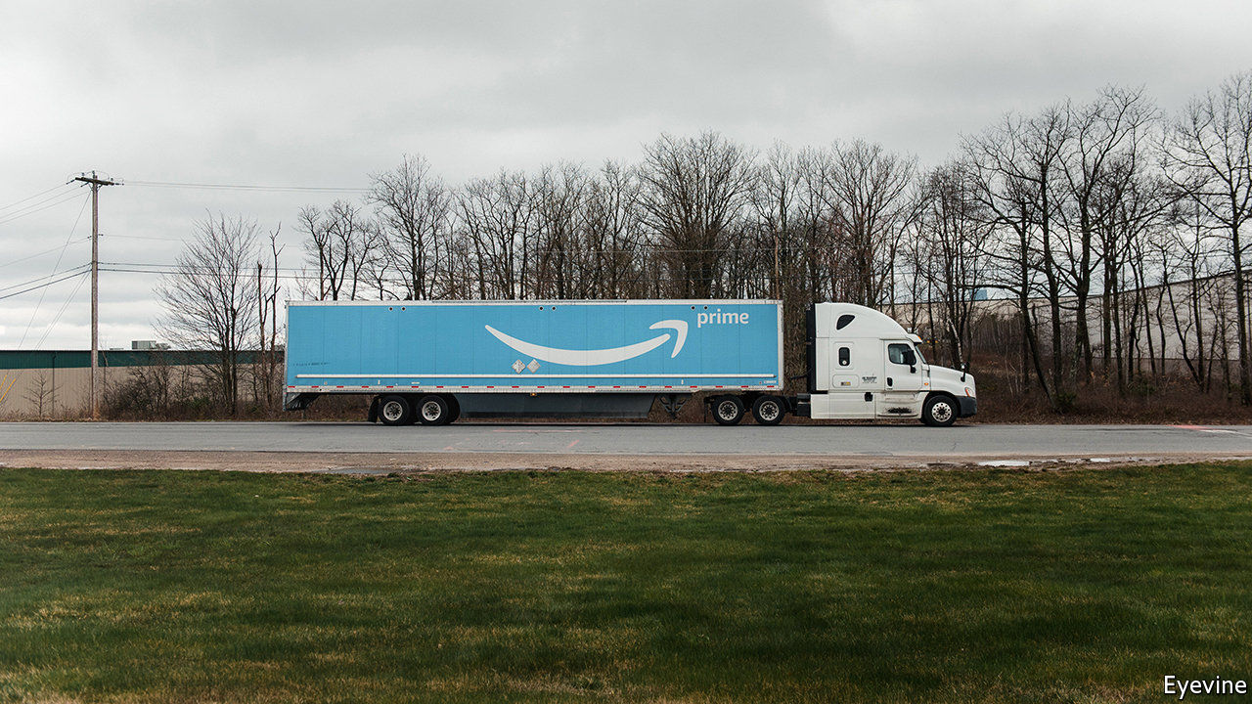

ANY DAY now America’s Department of Justice (DoJ) will file a lawsuit against Google, accusing it of abusing its monopoly in online search. It will be the first big antitrust case in technology since the DoJ went after Microsoft in 1998. Expect William Barr, the attorney-general, to flaunt this as proof that the Trump administration is uncowed by big tech.

Political posturing notwithstanding, the lawsuit will be no Google-slayer. Few states are likely to join the case. The firm’s broader advertising business will probably not be targeted. If the Microsoft trial is a guide, the ordeal will drag on for years and be distracting for Google. But it is likely to end in a forgettable settlement—even under a President Joe Biden.

Potentially more consequential tech regulation is on the boil elsewhere, however. Many policymakers see antitrust suits filed after the fact (“ex post”) unfit for purpose in fast-moving tech markets. They are pushing for “ex ante” rules that would, as in other industries, constrain online platforms upfront. On October 6th a Congressional committee published a 449-page report on how America should update its competition law. Days earlier a laundry list of rules to be included in the EU’s Digital Services Act, an ambitious regulatory package expected in early December, was leaked. Will these efforts be more successful than old-school competition remedies?

Start with the report, the result of a 16-month probe by the House of Representatives, led by David Cicilline, a Democrat. Despite America’s polarised politics, much of the diagnosis enjoys bipartisan support. The report “accurately portrays how Apple, Amazon, Google and Facebook have used their monopoly power to act as gatekeepers to the marketplace”, wrote Ken Buck, echoing many fellow House Republicans.

Predictably, the two parties disagree on what to do about it. Democrats want big tech firms to separate their main line of business from other activities. For example, Amazon could no longer sell wares under its brands on its marketplace, where it allegedly gives itself preferential treatment, including better placement in search results. Republicans reject such measures as too interventionist and propose to tweak existing antitrust laws.

Amazon disputed the report’s findings. “The presumption that success can only be the result of anticompetitive behavior is simply wrong,” it said. Apple, Facebook and Alphabet, Google’s parent company, issued statements to similar effect. Still, for anything meaningful to pass in Congress, next month Democrats must win not just the presidency but also, more fancifully, a big Senate majority that would allow them to push through bold legislation even if some party moderates are not on board.

Having already tried, without much success, to change the tech giants’ behaviour with antitrust probes and fines, the EU is betting on ex ante. Its big idea is to prohibit the big gatekeepers from engaging in “unfair practices”. The leaked paper lists 30 such practices, ranging from platforms favouring their own services to their refusal to work with competing ones.

If all the EU suggestions were enacted, gatekeepers would end up in a legal straitjacket. The proposals could weaken “network effects”—forces in online markets that let big firms get bigger. For instance, dominant messaging apps such as Facebook’s WhatsApp may be forced to accept messages from smaller ones. Platforms may be compelled to share data with rivals, removing a barrier to entry for newcomers.

As ever, the devil is in the details—with which the European Commission, the EU’s executive arm, is now grappling. What exactly counts as a gatekeeper? The number of users and revenue matter. But what about data assets, which are harder to measure? What data should platforms share? Interoperability between messaging apps would be welcome in some ways—as mobile providers must accept calls from rival networks. But it may harm competition between encryption methods, which interoperable apps would need to harmonise. Being too prescriptive could keep big platforms from innovating.

Eurocrats find themselves in what Mark Shmulik of Bernstein, a research firm, calls “a regulator’s dilemma”: coming up with robust rules that avoid unintended consequences. The commission’s answer is for its own experts, and perhaps a new agency, to decide on a case-by-case basis what activities are anticompetitive. Firms would have to prove they are not.

Coming up with effective rules will take time—possibly no less time than antitrust cases. But it would be a historical anomaly if tech were not to be robustly regulated, as other systemically important industries such as banking and food were before it. The public seems ready: 72% of American adults say that social-media firms have too much political power, according to a Pew poll. So are smaller tech firms, which are pursuing their own, ex post efforts. Epic, which makes “Fortnite”, a hit video game, has sued Apple on antitrust grounds. Oracle’s crusade against Google over alleged copyright infringement, which the Supreme Court agreed to hear on October 7th, has an antitrust tinge. The techlash may be subsiding. The tech-slog has begun.■

This article was downloaded by calibre from <https://www.economist.com/business/2020/10/07/google-antitrust-and-how-best-to-regulate-big-tech>

|  |  |  |  |
| --- | --- | --- | --- |
| Previous | Articles | Sections | Next |

|  |  |  |  |
| --- | --- | --- | --- |
| Previous | Articles | Sections | Next |

#### Bartleby

# What happens when companies devolve power

Free the workers

Oct 10th 2020 |

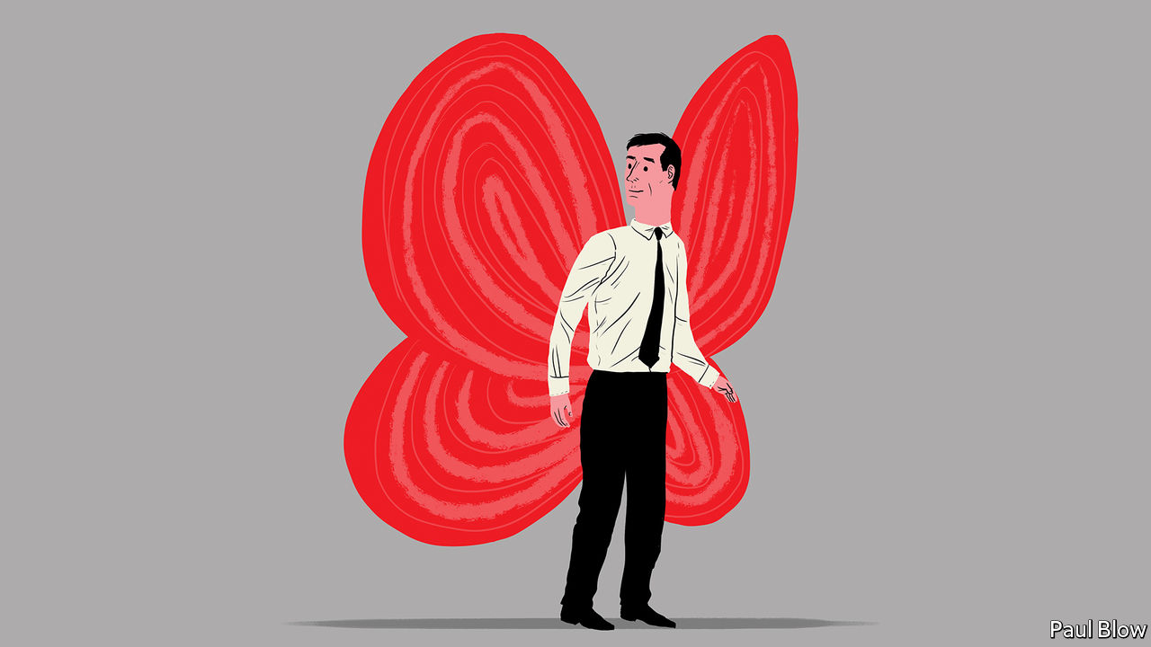

MANY COMMENTATORS paint a bleak picture of the future of work. Automation will spread from manufacturing to services, eliminating well-paid white-collar jobs. The workforce will be divided into a narrow technocratic elite and a mass of low-skilled, insecure jobs in the “precariat”.

But it does not need to be this way, according to Gary Hamel and Michele Zanini, two management consultants whose new book, “Humanocracy”, is as optimistic as its title is off-putting. They envisage a world in which low-skilled jobs can be enhanced—if only employees are given the chance to use their initiative and change the way they operate. “What makes a job low skilled is not the nature of the work it entails, or the credentials required, but whether or not the people performing the task have the opportunity to grow their capabilities and tackle novel problems,” they write.

This can only be achieved if managers relax their centralising tendencies and devolve power to individual business units. Few big companies—Toyota and Netflix being notable exceptions—have followed this path. The authors finger the dead hand of bureaucracy.

Since 1983 the number of managers and administrators in the American workforce has more than doubled, while employment in other occupations has gone up by only 44%. One study of executives published in the Harvard Business Review found that the average respondent worked in an organisation with six management layers; in large organisations, it tended to be eight or more. Employees in the survey spent an average 27% of their time on bureaucratic chores, such as writing reports or documenting compliance.

The result of all this paperwork, say the authors, is a corporate organisation that promotes conformity and dulls enterprise: “it wedges people into narrow roles, stymies personal growth and treats human beings as mere resources.” They envisage a different model.

All employees should be encouraged to think like businesspeople, be organised into small teams with their own profit-and-loss accounts (and appropriate incentives), and be allowed to experiment. Units within decentralised companies should be able to negotiate the price of services and products provided by the rest of the group.

The book is full of practical examples. Buurtzorg, a Dutch provider of home health services, is split into more than 1,200 self-organising teams. Each team is responsible for tasks such as finding clients and recruiting workers, rather than putting such duties in the hands of regional managers. That allows an organisation with 15,000 employees to have a central staff of just over 100 people.

Another highly decentralised group is Nucor, an American steel company. Essentially it is a confederation of 75 divisions which carry out their own research and development, sales and marketing. Bonuses are paid to teams, not individuals. The result is that teams take the initiative. One rejected outside bids for replacing a furnace shell and designed it themselves, saving 90% of the cost. Morning Star, America’s largest and most profitable tomato processor, has no managers and no job titles; 500 “colleagues” work in teams spanning 20 business units. Each staff member contracts with the rest of the team to provide the services they require.

The beauty of this approach, the authors argue, is that employees are more satisfied and motivated. This can lead to reduced staff turnover—and, potentially, to higher profits. In 2018, 20.5m Americans worked as managers or supervisors, with another 6.4m working in administrative support. Collectively, they took home more than $3.2trn in compensation, or nearly a third of the national wage bill. Cut this bill in half while also halving compliance costs, and American companies would save around $2.2trn a year, the authors estimate.

Such a cull would be bad news for some managers, of course. It could also be disruptive in the short term. But Messrs Hamel and Zanini may be onto something. Too many people feel dissatisfied with their jobs. A Gallup survey of American employees in 2019 found that less than a quarter said they were expected to be innovative in their job; only one in five felt their opinions mattered at work. Unleash their creativity, and productivity will improve, job satisfaction will increase and workers in supposedly “low-skilled” jobs will be free to demonstrate their abilities. If so, the future of work needn’t be gloomy after all.

This article was downloaded by calibre from <https://www.economist.com/business/2020/10/10/what-happens-when-companies-devolve-power>

|  |  |  |  |
| --- | --- | --- | --- |
| Previous | Articles | Sections | Next |

|  |  |  |  |
| --- | --- | --- | --- |
| Previous | Articles | Sections | Next |

#### Dialling down

# Japan’s cosy telecoms firms are being told to lower prices

Rate cuts to bring prices for customers more in line with other developed markets will hurt margins

Oct 10th 2020 | TOKYO



WHEN SUGA YOSHIHIDE emerged as the likeliest to succeed Abe Shinzo as Japan’s prime minister, telecoms bosses in Tokyo let out a collective groan. As Mr Abe’s chief cabinet secretary, Mr Suga urged operators to cut prices by as much as 40%. “They are using our public airwaves, an asset of the people,” he said in 2018. “They should not be generating excessive profit.” Since replacing Mr Abe last month, Mr Suga has made competition in mobile services a signature issue. The share prices of Japan’s three big carriers—NTT DoCoMo, SoftBank Corp and KDDI—fell by 10-15% between late August and late September.

Mr Suga’s calls were also the soundtrack to a pair of blockbuster announcements. On September 29th Nippon Telegraph and Telephone (NTT) said it was taking NTT DoCoMo, its listed mobile subsidiary, private. The tender offer, of $40bn for the 34% of shares it does not already own, is Japan’s biggest ever. The next day Rakuten, a Japanese e-commerce giant with ambitions to shake up mobile telephony, launched its much-awaited 5G network. An entry-level plan costs ¥2,980 ($28) a month, about half as much as comparable offers from rivals.

The government reckons that data-heavy users in Japan pay more than in other developed countries. For users of plans with 5GB of data, prices in Tokyo are three times higher than in Paris (see chart). Operators counter that users get what they pay for. Japanese networks consistently rate among the world’s best. The three big providers top the global rankings for 4G availability compiled by Opensignal, an analytics firm. Consumers have choice: SoftBank Corp and KDDI have their own budget brands, and myriad “mobile virtual network operators”, which piggyback on existing infrastructure, have cropped up in recent years, offering cheaper services.

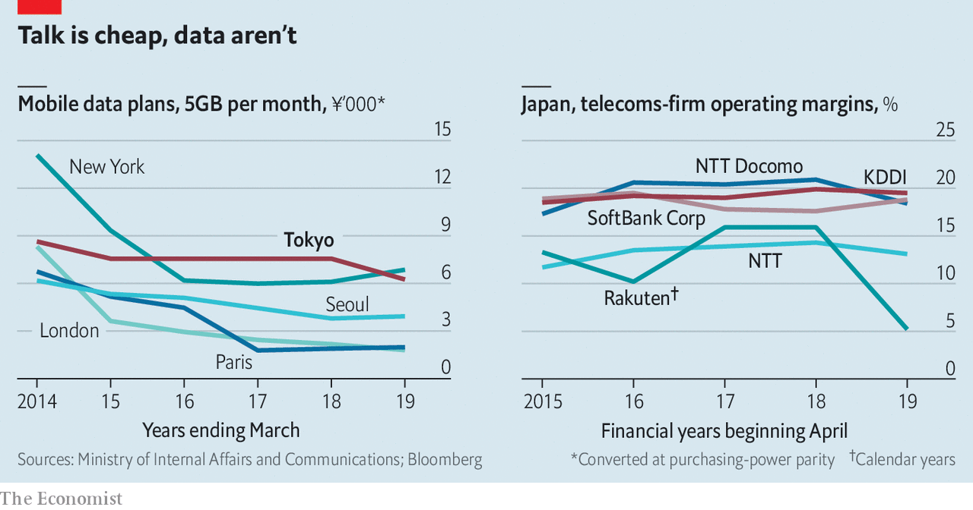

Yet the promise of bringing prices down offers the new prime minister a quick political win. “Most people have phones and most people think they are expensive,” says Yokota Hideaki of MM Research Institute, a consultancy. Such efforts have been under way for years. Back in 2015 Mr Abe argued that phone bills were a drag on household budgets. Legislation enacted last year capped subsidies on handsets and cracked down on contracts that made it difficult to switch providers. DoCoMo announced a round of price cuts that brought it closer to SoftBank’s and KDDI’s levels.

The main tool for spurring competition was supposed to be Rakuten’s entry in the market, which Mr Suga encouraged under Mr Abe. The tech firm at last launched its cloud-based 4G network in April and its 5G service last month. That may put downward pressure on prices eventually. But Rakuten’s network coverage remains too patchy and its market share too small to spook the incumbents right away.

A bigger jolt may come from the spectre, raised by Mr Suga, of higher fees for mobile-spectrum use. (Japan awards its spectrum to operators based on merit, a nebulous concept, rather than auction.) NTT’s buy-out of DoCoMo, which was at least six months in the making, may make it easier to placate the prime minister. When he announced the deal, the company’s chief executive, Sawada Jun, said it would leave DoCoMo in “a more solid financial position so it will have capacity to carry out further price cuts”. SoftBank and KDDI have since said they, too, will consider cuts.

After being spun off from NTT in 1992, DoCoMo became a pioneer of mobile internet, launching i-mode, which allowed users to read email and browse the web, eight years before the iPhone was released. Yet the firm has slipped recently. Although DoCoMo has the largest market share of the three large carriers, with 37% to KDDI’s 28% and SoftBank’s 22%, its profits have fallen and a hacking scandal undermined an attempt to expand into fintech. NTT hopes that bringing it in-house will help speed up decision-making and unlock cost savings that will mollify minority shareholders angry about rate cuts.

The reductions, when they come, are unlikely to be anywhere near the 40% Mr Suga once sought. “There will be pressure on pricing, but there won’t be massive step change in the industry,” reckons Kirk Boodry of Redex Holdings, an advisory firm. Cuts could be targeted at heavy data-users or low-earners. The reduced sales will only accelerate the mobile operators’ shift from providing connectivity towards other revenue streams, such as offering fintech products for consumers or cloud services for businesses, says Mr Boodry. Operators will focus on attracting customers to pricier 5G plans. With a cap on handset subsidies, competition will shift to network quality, argues Tsuruo Mitsunobu of Citigroup, a bank. That, he says, “is exactly what the government wants to see”. ■

This article was downloaded by calibre from <https://www.economist.com/business/2020/10/10/japans-cosy-telecoms-firms-are-being-told-to-lower-prices>

|  |  |  |  |
| --- | --- | --- | --- |
| Previous | Articles | Sections | Next |

|  |  |  |  |
| --- | --- | --- | --- |
| Previous | Articles | Sections | Next |

#### Schumpeter

# Why Rio Tinto and China are at loggerheads

The future of iron-ore mining is at stake

Oct 10th 2020 |

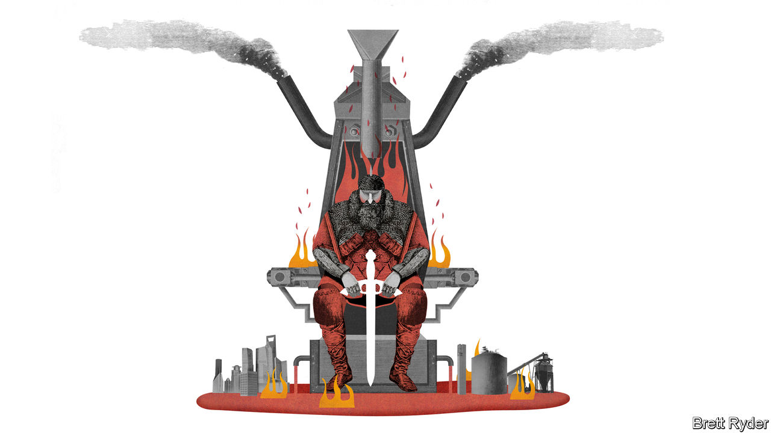

CHINA DOES not like to feel jealous of Japan. But in the case of iron ore it has plenty to envy. Back in the 1960s, when Japan was building up its steel industry, the world’s supply of the stuff was so fragmented that Japan could play off producers in Australia and Brazil against each other. China, now the world’s biggest steelmaker, does not have that luxury. Though it imports 70% of the world’s iron ore, most of this comes from three companies that in the intervening six decades have become titans. They are Rio Tinto and BHP, two Anglo-Australian firms, and Vale, a Brazilian one. They have brought about consolidation in the industry. They benefit from high barriers to entry. None is keen to undercut the other two. That puts them in a far stronger position vis à vis Chinese customers than their predecessors were with the Japanese.

China wants to change that. It is in the odd position of having world-leading technology companies but barely a toehold in one of the most basic industries of all, iron-mining, at a time when prices above $100 a tonne are throttling its steel mills. It has long hoped to alter the balance of power by backing the development of a vast iron-ore deposit in Guinea called Simandou, in which Rio Tinto has a joint venture with Chinalco, China’s state-owned aluminium producer (and Rio’s biggest shareholder). For years, Rio has subtly thwarted China’s ambitions by keeping the west African project on the back burner. But since last year a China-backed consortium in Guinea has upped the ante by pledging to push ahead with its own $14bn project to develop Simandou’s two northern blocks. Rio and Chinalco control the southern ones.

That creates a conundrum: should Rio double down on Simandou, sell out, or somehow continue to play a waiting game without offending either its Chinese customers or the Guinean government? It will fall to whoever replaces Jean-Sébastien Jacques, the outgoing boss of Rio whose departure was announced last month in the wake of the disastrous destruction of a 46,000-year-old Aboriginal site in Western Australia, to grapple with it.

Simandou, a forested mountain in inland Guinea, comes with 2bn tonnes of some of the world’s highest-grade iron ore—and a ton of trouble. In the decade since Rio forged its joint venture with a unit of Chinalco, the pair have been stripped of half of their concession, Rio tried and failed in 2016-18 to sell its share of the project to Chinalco, and the legal quagmire surrounding the whole Simandou saga has been so deep that Paul Gait of Azvalor, a fund-management firm, likens it to a John Grisham corporate thriller.

Adding to the drama, SMB-Winning, Guinea’s biggest bauxite exporter, which counts Shandong Weiqiao, a Chinese aluminium producer, as an investor, in June won Guinean government approval to develop the northern part of Simandou. It is also to build a 650km (400-mile) railway from the mine and a deepwater port. It clearly hopes that Rio and Chinalco will share the burden. This coincides with a geopolitical spat between China and Australia that has put Rio in an uncomfortable position. Though it still has power in the iron-ore market, its tune is changing. It now says that if Simandou is going ahead anyway, it may as well join in. But that is oversimplifying what should be a very careful calculation.

Start with the economics. Rio once estimated that the cost of developing Simandou, including building the railway and port, could be more than $20bn. That could now be partially split with SMB-Winning. However, if that were the case, Rio would lack full control of its freight costs, a critical factor in the iron-ore business. Erik Hedborg of CRU, a commodity consultancy, says that bringing both northern and southern blocks into production would add about 150m tonnes a year to the 2bn-tonne seaborne iron-ore market, which could push prices down by up to $10 a tonne. That would hurt Rio. If, however, only the smaller northern block were developed, the price impact would be far shallower.

As it is, many analysts expect prices to fall with or without Simandou. They have been artificially inflated in the past two years as a result of disaster-related outages in Brazil. China’s demand for iron ore is also considered close to peaking, especially given the mounting pile of scrap steel the country can recycle. The world hardly needs a new gusher of supply.

Then there are the environmental and social complexities. The deposit sits among rainforests rich in tropical species. The railway would traverse unforgiving hills and valleys, could require the relocation of local communities, and will raise the prospect of heightened scrutiny from investors already alarmed by Rio’s governance failures during the Aboriginal-site debacle. Not to mention the risks of dicey politics, corruption probes and social unrest that have hitherto plagued Simandou.

But what if SMB-Winning decides to forge ahead regardless? Rio has no easy options. Throwing all its weight behind the consortium would be reckless, especially if it would clobber prices that are already likely to fall. There are far safer ways to allocate capital. They include further iron-ore development in the Pilbara in Western Australia, which is so cheap and well served by infrastructure that Paul Gray of Wood Mackenzie, a consultancy, says producers could make money even if iron-ore prices fall as low as $40 a tonne. It could also try to develop copper, lithium, nickel and other minerals vital for clean-energy infrastructure, for instance.

## Nerves of steel needed

Alternatively, it could try to sell its stake in the southern block. But after failing to do so to Chinalco, it is not clear who else would be a willing buyer. The best way for it to preserve its interests may be to sit tight on the southern block, advising everyone else how to make progress, but avoiding sinking lots of capital into producing its own ore. Whether the other firms want to proceed will be up to them. For all Rio’s ups and downs at Simandou, the policy of strategic inaction has worked so far. Whoever becomes Rio’s next boss would be unwise to abandon it. ■

This article was downloaded by calibre from <https://www.economist.com/business/2020/10/10/why-rio-tinto-and-china-are-at-loggerheads>

|  |  |  |  |
| --- | --- | --- | --- |
| Previous | Articles | Sections | Next |

|  |  |  |
| --- | --- | --- |
| Business | Sections | Science & ... |

Finance & economics

The future of finance: The digital surge

.

Labour markets in Europe: Pain relief

.

America’s presidential election: Braced for impact

.

International trade: Working to rule

.

Buttonwood: Feel the burn

.

Free exchange: Beggars banquet

.

|  |  |  |
| --- | --- | --- |
| Business | Sections | Science & ... |

|  |  |  |  |
| --- | --- | --- | --- |
|  | Articles | Sections | Next |

#### The digital surge

# How the digital surge will reshape finance

Thanks to covid-19, more people than ever are banking and making payments online

Oct 8th 2020 |

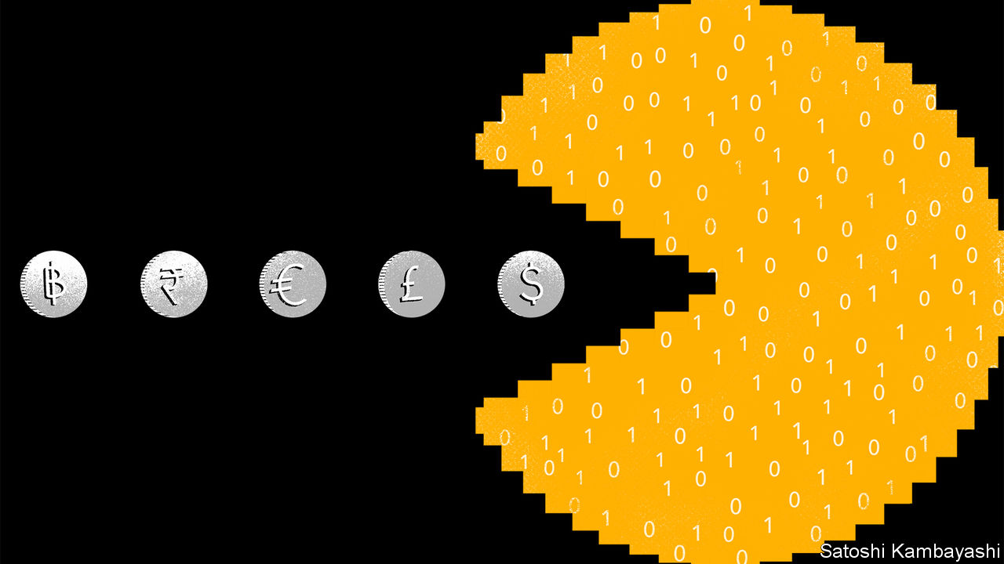

Editor’s note: Some of our covid-19 coverage is free for readers of The Economist Today, our daily [newsletter](https://my.economist.com/user#newsletter). For more stories and our pandemic tracker, see our [hub](https://www.economist.com/news/2020/03/11/the-economists-coverage-of-the-coronavirus)

IN 2012 DAVID VÉLEZ tried to open a bank account in Brazil. “It was like going to prison,” he says. He was ordered to leave his belongings in a locker before walking through bulletproof doors. After waiting an hour, he faced a barrage of questions from a hostile manager. It took five months for him to be offered a bare-bones account costing him hundreds of dollars a year and a credit card charging an annualised interest rate of 400%. The next year, in the hope of eroding Brazil’s crusty banking oligopoly, he founded Nubank, a digital lender. By early 2020 the bank was valued at $10bn.

Then the pandemic came—and business really took off. This year alone the number of accounts at Nubank has risen by 50%, taking the total to 30m. In June it partnered with WhatsApp, which has 120m users in Brazil, to offer payments through the messaging service. In September it bought Easynvest, a digital broker, and launched operations in Colombia. In November Brazil will implement Open Banking, a reform that will give fintechs access to data held by banks, fund managers and insurers. All this, says Mr Vélez, is just the beginning of the digital revolution: “it is only the first second of the first half of the game.”

Just as a digital surge brought on by the pandemic is speeding up a transformation in retail and e-commerce, finance too is being reshaped. The shift from physical to digital payments this year has been dramatic. Pundits canvassed by The Economist reckon that the share of cashless transactions worldwide has risen to levels they had expected it to reach in two to five years’ time. In America mobile-banking traffic rose by 85% and online-banking registrations by 200% in the month of April.

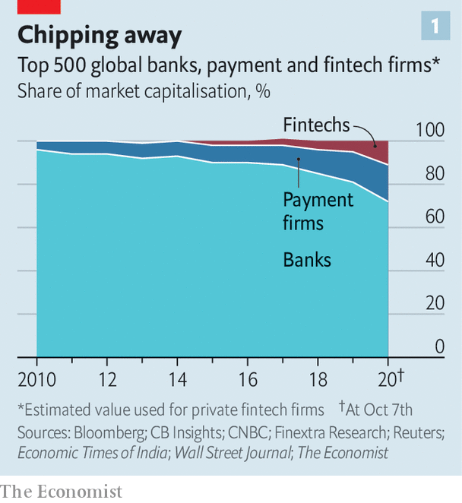

Some firms will cash in on the digital rush, while others will be left behind. Capital markets think a new era is dawning: conventional banks now account for only 72% of the total market value of the global banking and payments industry, down from 81% at the start of the year and 96% a decade ago (see chart 1). Fintech firms such as Ant Group and PayPal make up 11%: their market value has almost doubled this year to nearly $900bn. Conventional non-bank payments firms such as Visa are booming, too, and make up the other 17% of the industry total.

Digitisation may spell the end of the dinosaurs in some industries, such as entertainment or retail. But in finance they seem likely to live on. Banks are well entrenched, albeit to different degrees in different places. Regulators, the gods of their ecosystem, are unwilling to let them die off. So the new and old will coexist, with the precise features of the hybrid system varying from place to place.

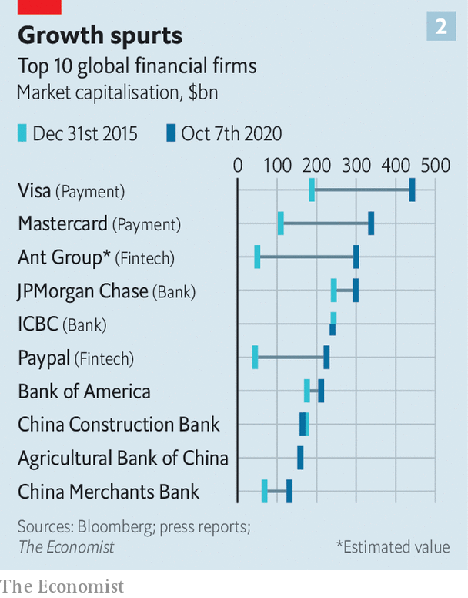

The acceleration in digitisation is most visible in payments. Although the crisis has led to an increase in physical cash held by the public, its pace of circulation has fallen, suggesting people are hoarding rather than spending banknotes. Card payments, by contrast, have kept growing. That is partly thanks to the boom in online shopping, which has itself leapt forward by several years. But it also reflects the efforts of brick-and-mortar shops to reach customers online. In the spring Stripe, a firm that powers payments, helped the centuries-old farmers’ market in Paris set up virtual checkouts in place of physical ones, says John Collison, its president. Food-order volumes processed by Marqeta, a payments firm that works with many of America’s restaurant-delivery firms, tripled between March and mid-April.

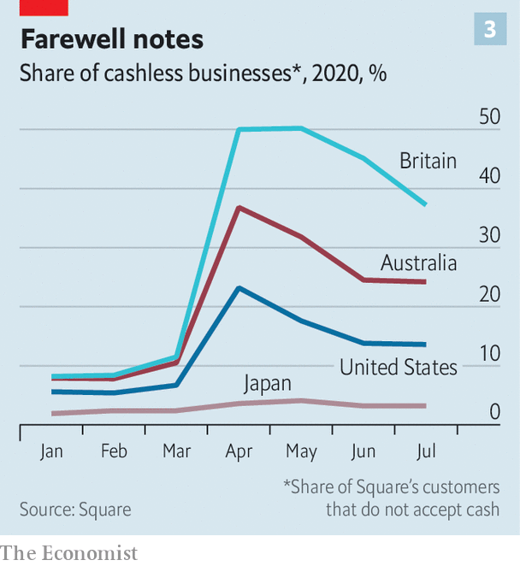

Shops have reopened, but people are sticking to plastic. Governments in 31 countries have helped by raising limits on contactless payments (and card firms are lobbying for even higher ceilings). Those at Visa and Mastercard, two card networks that account for 94% of transactions processed outside of China, surged by over 40% in the first quarter of 2020, compared with the same period in 2019. Square, which helps small businesses accept credit-card payments, saw its share of fully cashless clients in America jump from 5% in February to 23% in April; it has since stabilised at 14%. In Britain the share now stands at 37% (see chart 3).

## All change

The shift goes beyond cards. Hiroki Takeuchi of GoCardless, which helps companies collect payments from bank accounts, says many membership businesses like gyms took the opportunity of shutdowns to upgrade from cash registers to direct debits. Consumers are using peer-to-peer (P2P) services to send money to relatives or buy fitness classes online. Payments processed in America by Venmo, a P2P firm, grew by 50% year-on-year in the second quarter.

Outside the West, mobile wallets, with which you can pay after loading money on to your phone, were becoming commonplace even before the pandemic. The virus has given them a leg up. A third of Singapore’s 18,000 street hawkers let consumers pay by scanning a QR code in July, a boost of over 50% in just two months. Many governments in Africa declared these wallets essential services and banned transfer fees. Amounts held in M-PESA, a mobile-money service ubiquitous in Kenya, rose by a fifth in the month of May alone.

Digitisation is also racing ahead in other areas of finance. As millions of households received stimulus cheques and furlough payments, many took to betting on stocks from their sofas using zero-fee e-brokers. Keith Denerstein of TD Ameritrade, one such broker, says customers worldwide have opened 50% more accounts in 2020 than in its best full year. Meanwhile insurers that relied on agents to sell policies have learnt to do without. Sachin Shah, who runs the Asian unit of Manulife, says 97% of its products can now be bought online.

Banking—the core of retail finance—has not been immune to change. Western lenders report surging connections to their apps and digital sales. Adoption is even faster in emerging markets, reflecting a lower starting point. José Antonio Álvarez, chief executive of Santander, a Spanish banking group that spans three continents, says the use of its digital channels rose by 20% in Europe, 30% in South America and 50% in Mexico in the first half of the year, compared with the first half of 2019.

Digital finance, already a force for inclusion, has brought yet more people into the banking system in recent months. In April DBS, Singapore’s biggest lender, opened 40,000 accounts for migrants in a weekend so that they could send money home digitally. Brazil’s government, which has extended aid to 60m people, is increasingly using the mobile route to reach citizens in the Amazon. Joshua Oigara, the boss of KCB, Kenya’s largest bank, says the number of customers using its app has doubled since covid-19 struck. These moved 35bn shillings ($329m) from their mobile wallets to bank accounts in June—six times more than in January.

These changes in behaviour seem likely to stick. Many customers were unfamiliar with the technology before the pandemic—and surveys suggest they like it. In April nearly a fifth of American adults used digital payments for the first time, reckons Forrester, a research firm. Since February Nubank has gained 30,000 users over the age of 60 every month. In a global survey Bain, a consultancy, found that 95% of consumers plan to use digital banking post-pandemic. And banks, which had already been planning to shrink their physical footprint, are closing branches more quickly than they had envisaged. Brazilian lenders have shut down 1,500 this year, 7% of the total stock. Those in Europe are planning to slash 2,500 branches. Banks will strive to keep the everyday business online, with branches that stay open often being revamped to provide “high-value” services such as advice, says Allison Beer of JPMorgan Chase, America’s biggest lender.

## The law of the bundle

In the middle of the digital rush, a new business model is emerging—and new entrants are being drawn in. Banks, e-commerce sites, fintechs, social networks, taxi apps and telecoms firms are all vying to become “platforms”—marketplaces through which users can buy a range of financial products made in-house or by third parties. “Everybody is trying to become the home page,” says Tara Reeves of Omers Ventures, the venture-capital arm of Canada’s municipal-pension fund. Grab, a ride-hailing app in Singapore that has grown into the country’s most popular mobile wallet, has over 60 tie-ups with banks, insurers and other financial firms. Reuben Lai, who runs its finance arm, says it wants “to be a one-stop platform” that fulfils South-East Asians’ financial needs.

Investors reckon that “embedded finance”—the integration of credit, insurance and investment into non-financial apps or websites—could in time become as valuable as payment services are today. Both banks and fintechs are therefore racing to integrate the services they offer. In September Yandex, Russia’s leading web-search and ride-hailing app, said it would buy the country’s largest digital bank. A week later Sberbank, Russia’s top lender, dropped “bank” from its name in order to rebrand itself as a tech firm dabbling in food delivery and telemedicine. Peter Ndegwa, who runs Safaricom, a Kenyan telecoms firm and M-PESA’s main owner, wants the service to become a “lifestyle brand” offering overdrafts, loans, wealth management and insurance.

The main attraction of the new model is money. As rising competition and, in the rich world, low and falling interest rates reduce lending margins, banks need to diversify. Tech-based challengers, for their part, want to increase the stickiness of their apps so they can sell more of their core products, or take a cut of the financial wares they distribute for others. As physical branches become irrelevant, finance is exposed to the same network economics that have upended other sectors. Huw van Steenis of UBS, a bank, thinks the pandemic is accelerating a “winner-takes-most” dynamic, where popular platforms attract exponentially more traffic.

Much of the gains could come from the ability to merge and exploit data long siloed within different financial services. Armed with a full picture of users’ behaviour, firms hope to use algorithms that spit out tips on, say, how to save for a dream house. That will make the platforms even stickier and allow them, in turn, to recommend yet more products. Backbase, a fintech that designs digital-banking software for incumbents, is also working on such wizardry. “The more people share their daily lives with you, the more you can give them these additional benefits,” says Jouk Pleiter, its boss.

## Many zeros, and many ones

Though it has obliterated incumbents in other industries, Big Tech has contented itself with skirting around the margins of finance. Apple has launched a credit card with Goldman Sachs, and a payment tool. Facebook’s payments efforts have made little headway. The number of American e-commerce sites that use Amazon’s checkout button is rising only slowly, says Lisa Ellis of MoffettNathanson, a research firm. Google has teamed up with banks to offer current and saving accounts; in India, where its payment app is dominant, it doles out instant loans to shoppers. But Diana Layfield, a payments executive at Google, is adamant that it does not want to become “a grand unifying platform”. (That may be because it is eyeing a juicier market. The financial industry, at first slow to move data to the cloud, is becoming keener to do so. That will most benefit: Alibaba, Ant’s former parent group; Amazon; Google; and Microsoft.)

Where does all this leave banks? Many fintechs, with their shinier apps and better risk analytics, certainly have an edge over them. But these firms are not trying to usurp lenders. This is because banking is made of two parts, says Miklós Dietz of McKinsey, a consultancy. “Core banking”—heavily regulated, capital-intensive activities such as running a balance-sheet—makes $3trn in revenue worldwide, and returns on equity (ROE) of 5-6%. By contrast, freer-wheeling lines of business, such as payments or product distribution, yield $2.5trn in sales but ROEs of 20%. Fintechs are after the tasty bits. But for this, they need banks to stay alive.

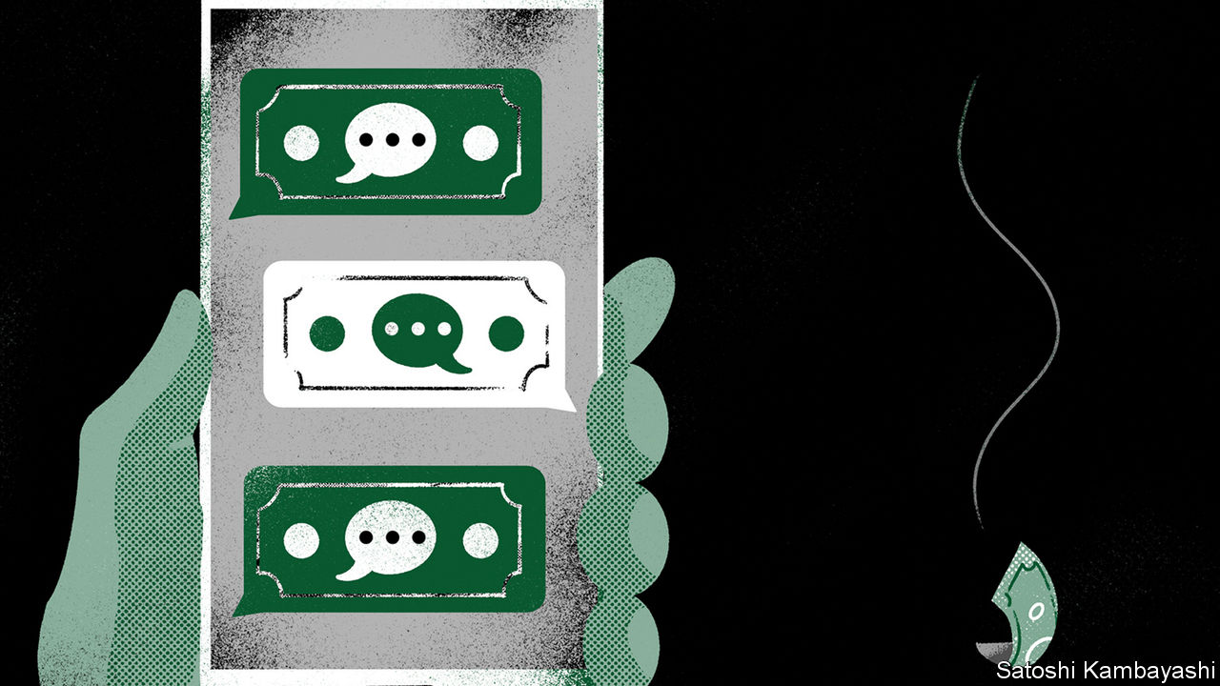

To see how coexistence might work, look to China. The duopoly of Tencent and Ant use powerful algorithms to price and distribute a fast-growing portion of the loans made to consumers and small firms in the country (see Briefing). Yet the products they sell are held on banks’ balance-sheets. Despite the hefty cut they take—gobbling up a big chunk of the lenders’ profit—banks still accept the deal, because they crave access.

But coexistence will take varied forms across the world. Some banks may be better suited to the new world of tech than others, itself a function of the state of banks today. Dirk Vater of Bain sees a strong link between a bank’s digital performance and how badly it was hit by the financial crisis of 2007-09. European banks, burdened by dud loans and low interest rates, spent the 2010s cutting costs rather than investing in transformation. Their apps can do little. By contrast the Commonwealth Bank of Australia, based in a country unscathed by the financial crisis, has built an app that has won plaudits for offering Netflix-like personalised service. It notifies users when bills are due and advises them on their tax returns. Piyush Gupta, DBS’s boss, says it spent the past few months plugging “last-mile” gaps so that complex products, such as mortgages, can be sold online.

## Cheques and balances

Regulation will also determine how much tech firms can prise away from the banks. China long let them roam free (though it has recently clawed back some of that liberty to protect the banks). At the other extreme, America has shielded banks and credit-card firms the most, by being slow to build fast-payment pipes and making it hard to gain digital-banking licences. It has left it to the market to decide when data should be shared, and at what price. Europe and many emerging markets are somewhere in the middle. These have tried to instil competition by allowing data to flow. Some version of Open Banking will soon be in force in 51 countries, ranging from Malaysia to Mexico.

Bring these initial conditions together, and you start to see why certain financial systems are where they are today, and where they might end up. America is at stage zero. Customers are locked into sticky credit-card schemes funded by extortionate levies on merchants. Tech firms must rely on creaky financial plumbing run by well-protected incumbent banks.

At the next stage, banks would still run the infrastructure, but payments and other non-core tasks would be open to new entrants. European fintechs, for example, can initiate transfers but they still move money between bank accounts. In Sweden they originate 60% of consumer loans.

At stage two, payments would routinely cut out the incumbents—like, for instance, the flows between Africa’s mobile wallets, which do not transit through banks. But most other financial services would still involve them. Stage three is the realm of “super-apps” like Grab and Gojek in South-East Asia, which started as ride-hailing services, or Mercado Pago, the financial arm of MercadoLibre, Latin America’s largest e-commerce site. These want to become financial supermarkets that offer a range of products mostly manufactured by others. The most advanced incarnations of these are the super-apps in China.

For as long as regulators are determined to keep banks alive, stage four, where non-banks dominate both the production and distribution of financial services, will probably never come to be. With so many countries so far off the frontier, though, this hardly rules out dramatic change over the years ahead. ■

This article was downloaded by calibre from <https://www.economist.com/finance-and-economics/2020/10/08/how-the-digital-surge-will-reshape-finance>

|  |  |  |  |
| --- | --- | --- | --- |
|  | Articles | Sections | Next |

|  |  |  |  |
| --- | --- | --- | --- |
| Previous | Articles | Sections | Next |

#### Pain relief

# Are Europe’s furlough schemes winding down?

Nearly 9% of workers are still on the schemes, down from 20% in April

Oct 8th 2020 |

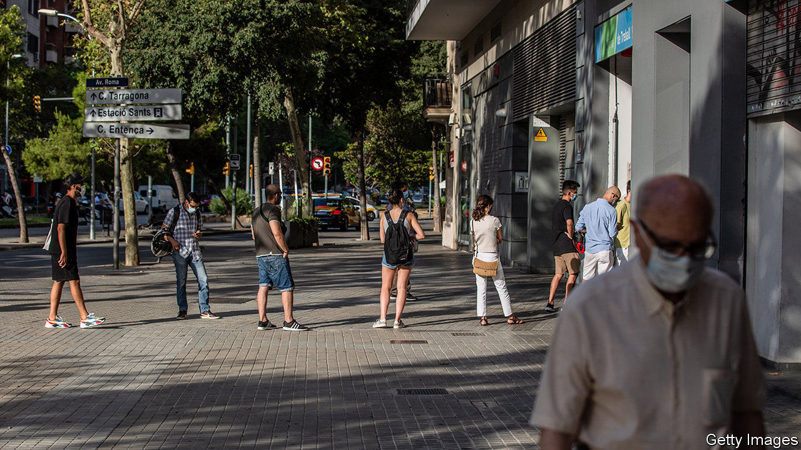

SO IMPRESSIVE IS Germany’s trading prowess that when the coronavirus pandemic struck, it even found something new to export: its short-time working scheme, or Kurzarbeit. Most OECD countries deployed such programmes this year, as they sought to avert mass unemployment and support workers’ incomes during lockdowns. Those that had never had them, such as Britain, imported the idea wholesale. Others, such as Spain, drastically expanded access to existing programmes. America, however, went in another direction, preferring to increase the generosity of unemployment benefits.

In April more than 26m workers in Britain, France, Germany and Spain were on furlough schemes, equivalent to a fifth of the workforce (see chart). While America’s unemployment rate swelled from just over 3% in February to 14.7% in April, in Europe it barely budged.

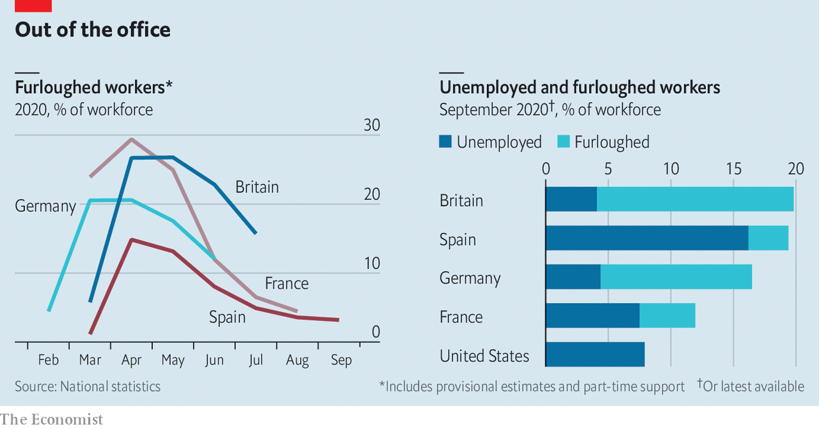

A few months on, how has the picture changed? In the big four countries nearly 11m workers were still on job-retention schemes in the summer, or 9% of the workforce. The numbers have fallen dramatically in France and Spain. By contrast, 15% of British workers were still furloughed in July, according to official data, a fifth of whom worked in the hospitality industry. A survey of employers suggests the share of furloughed workers fell to 11% in August.

The furlough schemes were intended to freeze the labour market in place, covering the cost of workers so that bosses facing a temporary cash crunch during shutdowns did not have to sack them, and allowing for seamless recovery once economies reopened. Most people coming off the schemes indeed seem to have resumed work. Unemployment rates have edged up only a little as the number on short-time working schemes has fallen. Workforce participation has so far fallen very slightly, suggesting few were discouraged enough to leave the labour market altogether.

Despite these successes, though, about 11m workers are still waiting to resume their normal working hours. The longer they are furloughed, the more likely it is that normality is not restored. Yet they have little incentive to find other work. In June economists at Allianz, an insurer, reckoned that up to 9m furloughed jobs in industries such as tourism and hospitality in Europe may be eventually culled.

This suggests that the true unemployment rate in Europe is probably higher than official figures suggest. As an upper bound, if you were to assume that all of those still on furlough schemes are in fact out of a job, unemployment rates in the big four would rise to 12-20%. America’s rate, in contrast, has gone in the opposite direction, falling from its peak in April to just below 8% in September. ■

Editor’s note: Some of our covid-19 coverage is free for readers of The Economist Today, our daily [newsletter](https://my.economist.com/user#newsletter). For more stories and our pandemic tracker, see our [hub](https://www.economist.com/news/2020/03/11/the-economists-coverage-of-the-coronavirus)

This article was downloaded by calibre from <https://www.economist.com/finance-and-economics/2020/10/08/are-europes-furlough-schemes-winding-down>

|  |  |  |  |
| --- | --- | --- | --- |
| Previous | Articles | Sections | Next |

|  |  |  |  |
| --- | --- | --- | --- |
| Previous | Articles | Sections | Next |

#### Braced for impact

# How investors are hedging against possible election chaos in America

They were once betting on a contested outcome. That has changed

Oct 10th 2020 | NEW YORK

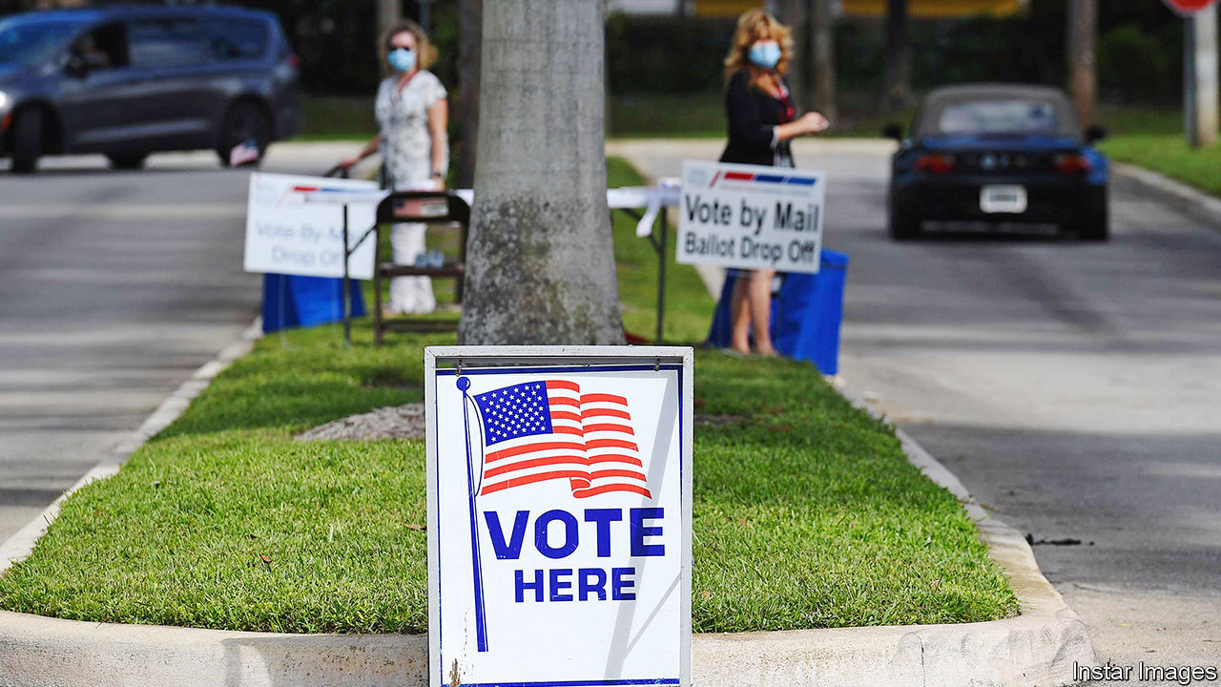

ELECTION YEARS are not often the best times for stockmarket investors. Over the past 90 years shares included in the S&P 500, an index of America’s biggest firms, have returned an average of about 8.5% a year. The twelve months leading up to each of the 22 presidential elections in that time have been leaner affairs, returning just 6%. Investors tend not to care whether the victorious candidate is Democratic or Republican, but they do like familiarity—returns are a shade higher in years when incumbents are returned to office. The democratic cycle, for all its virtues, tends to bring with it a dose of uncertainty—first about who will win and then about what that victor will do. And uncertainty tends to make financiers nervous.

These jitters are most easily observed in VIX futures, derivatives that measure the level of volatility in stocks. Because periods of very high volatility are correlated with plunging share prices, VIX futures are often traded by investors as an insurance policy against losses in the S&P 500. Because there is usually more potential for volatility over longer time horizons, longer-dated VIX futures tend to be more expensive. They also tend to be dearer around uncertain events that are likely to prompt volatility, such as elections or even important central-bank meetings.

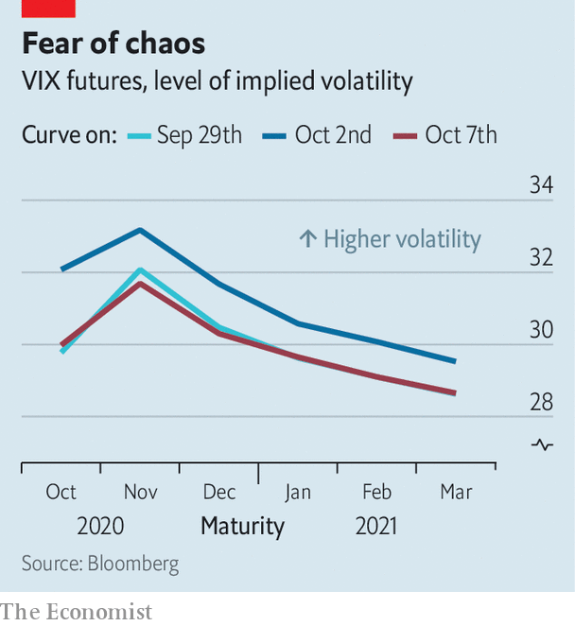

Investors appear to be especially keen on downside protection around this election. In September Cameron Crise, a strategist at Bloomberg, wrote that VIX futures markets have “never had an event risk command this sort of premium”. Even more unusually, VIX futures prices are elevated not just around the date of the election, but for the months between the vote on November 3rd and the inauguration on January 21st (see chart).

There are plenty of reasons for investors to worry about post-election chaos: the coronavirus pandemic means an enormous number of voters will opt to avoid crowded polling stations this year and send their ballots in by post instead. These votes can take longer to count, raising the prospect of a period without a clear winner. Even once a victor is declared, a slew of lawsuits may follow. The uncertainty is exacerbated by President Donald Trump’s suggestion that postal ballots may be fraudulent, and his reluctance to say that he will accept the election result.

The nearest guide to market reaction in such a situation would be to look at the contest between Al Gore and George Bush in 2000, which was too close to call on election day and involved recounts and lawsuits. Markets dropped by 1.6% the day after the election as it became clear there was no decisive winner. The S&P 500 sank by more than 8% by the end of the year—though at least some of that probably reflects the beginnings of the dotcom bust.

A happier scenario for investors—and citizens more broadly—would see a clear victor emerging on election day. And it may be that investors have begun to think this has become more likely than they did mere days ago. Though the news that Mr Trump had been diagnosed with covid-19 sent VIX futures higher on October 2nd, by the 7th futures maturing in November, December and January had dropped below the level they had reached after the first presidential debate on September 29th. That might be thanks to a flurry of polls putting Joe Biden, Mr Trump’s Democratic challenger, even further ahead. As the campaign moves into the home straight, investors are betting on less, rather than more, chaos. ■

This article was downloaded by calibre from <https://www.economist.com/finance-and-economics/2020/10/10/how-investors-are-hedging-against-possible-election-chaos-in-america>

|  |  |  |  |
| --- | --- | --- | --- |
| Previous | Articles | Sections | Next |

|  |  |  |  |
| --- | --- | --- | --- |
| Previous | Articles | Sections | Next |

#### Working to rule

# How trade is being used to enforce labour standards

Both America and the EU are toughening up

Oct 10th 2020 | WASHINGTON, DC

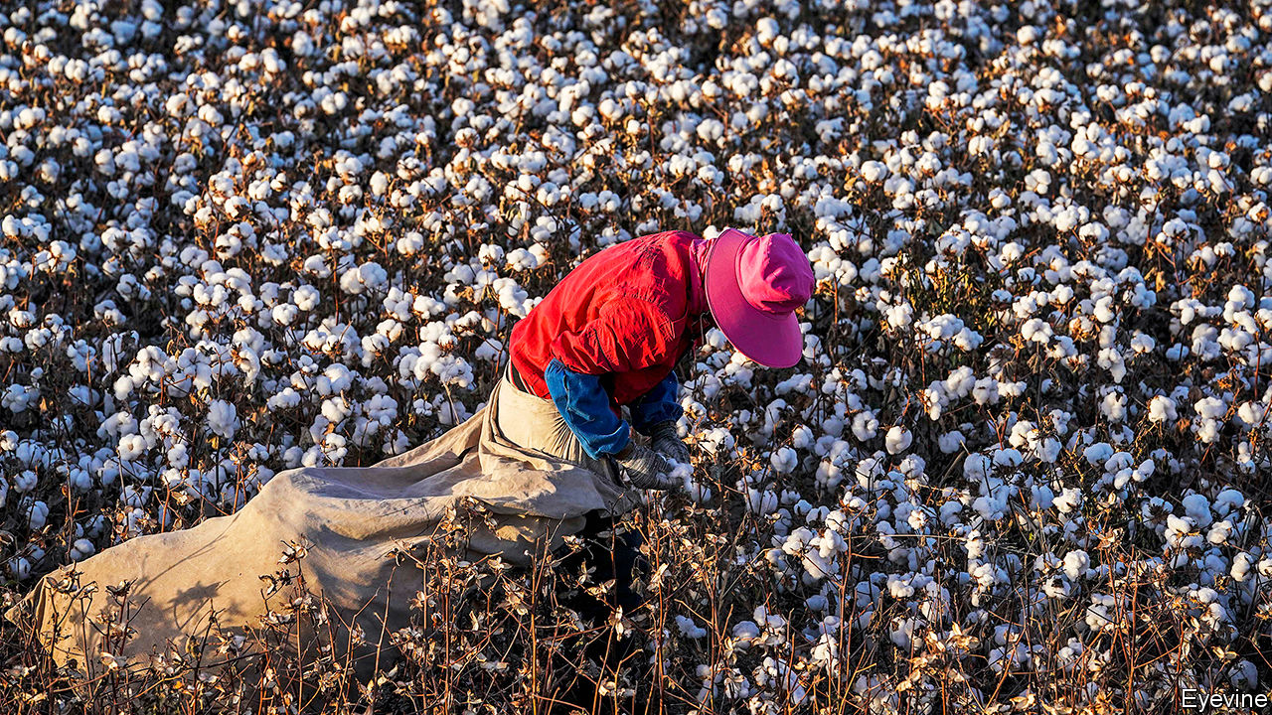

EVEN ARDENT free traders have their limits. Most would agree, for example, on the odiousness of imports made with slave labour. They could also sniff at stuff made by children, or workers unable to join a union of their choice. And yet, as one person’s labour protections are another’s protectionism, baking such standards into the global trading rules has proven impossible. Increasingly, though, America and the European Union (EU) are toughening up on their own.

This year America has added new rules to the books, and tightened enforcement of existing ones. It has applied 12 “withhold release orders” (WROs) mostly on products from China on the grounds that they had been made with forced labour in Xinjiang. These allow customs agents to seize suspicious shipments; in order to secure their entry into the country, companies must prove that the goods have not been made with forced labour.

The USMCA, America’s deal with Canada and Mexico, which was implemented on July 1st, also builds in opportunities for enforcement. All signatories must enact bans on imports made with forced labour—Canada introduced its version in March. The deal also sets out a swathe of labour reforms for Mexico to implement. And a new “rapid-response mechanism” allows for independent experts to assess whether factory workers have been denied the right to organise—and if they have, for targeted trade restrictions to be used.

The EU has mostly worked to enforce already existing rules. At a hearing on October 8th it accused South Korea of breaking the labour rules agreed in their bilateral trade deal. In August it raised tariffs on imports from Cambodia, in response to human- and labour-rights violations. And more action seems likely. It has appointed a chief enforcement officer, who will make lodging such complaints easier. At his confirmation hearing on October 2nd Valdis Dombrovskis, the EU’s new trade commissioner, said that he would be willing to explore “conditioning tariffs on certain sustainability outcomes” in future deals.

Past experience suggests that there are limits to how far such measures will spread, and how effective they can be. Poorer countries tend to be reluctant to sign up to them, complaining that they are an affront to their sovereignty, and a ruse to neutralise their comparative advantage. Companies despise them too, for undermining the certainty trade deals are supposed to generate. Moreover, if rich countries write the rules too broadly, their own labour practices might come under scrutiny. American negotiators have long been wary of that happening—which is why the USMCA’s rapid-response mechanism requires complaints against America to be made domestically first.

Overly harsh action also risks unwarranted supply-chain disruption. Earlier this year American customs agents mulled a WRO on all cotton imported from Xinjiang, which could have affected billions of dollars’ worth of imports. But the opacity of supply chains means that such a measure would probably have ended up banning some fairly produced stuff, too. The idea is reportedly undergoing legal analysis.

Still, the activist trend is here to stay. On September 22nd America’s House of Representatives passed a bill that would force customs authorities to apply the broader WRO (though it is unlikely to get Senate approval). Joe Biden, America’s Democratic nominee for president, has pledged both to enforce labour standards and to require provisions in future trade deals. The EU is planning to oblige companies to be transparent about their supply chains.

What of the charge that all this reflects an onslaught of protectionism? It is difficult to see how the actions so far could bring jobs back to America or Europe, where wages are much higher than in the countries their measures typically target. And although there may be scope for enforcement tools to be applied too broadly, there are certainly legitimate reasons to suspect that imports from Xinjiang are made with forced labour.

Within the USMCA, the process of coaxing evidence from workers afraid of retaliation is hard enough that a wave of frivolous cases seems unlikely. Although the AFL-CIO, an American union of unions, was hoping to file a case against a Mexican producer by the end of September, it did not, partly because the pandemic made gathering evidence harder. “We want to bring a strong case to start off with,” says Eric Gottwald of the AFL-CIO. Some rules, and their limits, are still to be tested.■

This article was downloaded by calibre from <https://www.economist.com/finance-and-economics/2020/10/10/how-trade-is-being-used-to-enforce-labour-standards>

|  |  |  |  |
| --- | --- | --- | --- |
| Previous | Articles | Sections | Next |

|  |  |  |  |
| --- | --- | --- | --- |
| Previous | Articles | Sections | Next |

#### Buttonwood

# What takeovers of fund managers tell you about markets

Trian, an activist hedge fund, has taken stakes in two asset managers. It has mergers on its mind

Oct 8th 2020 |

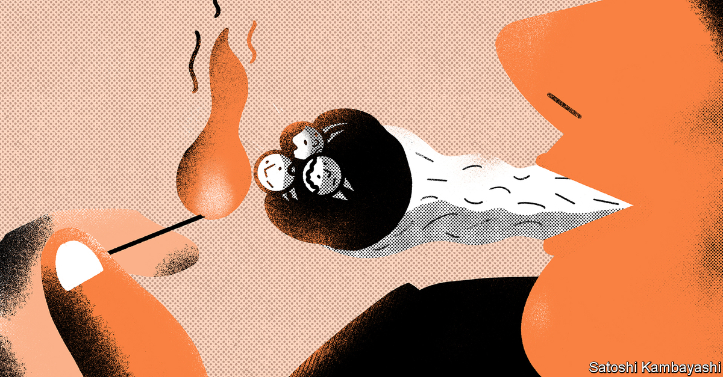

MARTIN AMIS, a novelist, was once asked why he preferred roll-ups to ready-made cigarettes. “It’s simply the best burn available,” he replied. In finance, a roll-up is a strategy of buying lots of small companies in the same industry and combining them into a big one. A big firm can cut costs by reaping economies of scale—in marketing or IT, say, or in negotiations with suppliers. The markets are attracted to the glow. They often assign big companies a higher valuation than small ones.

Could a roll-up work in fund management? The question is often asked, only to be dismissed: you would have to be unusually daring (or smoking roll-ups of the jazz variety) to consider taking on such a challenge. So a few eyebrows were raised when it emerged last week that Trian, a hedge fund led by Nelson Peltz, a veteran agitator for corporate change, had taken stakes of almost 10% in two asset managers, Invesco and Janus Henderson. Asset management is undergoing significant change, noted Trian in its regulatory filings. Firms with scale and a breadth of products are better placed to succeed. So Trian has in mind “certain strategic combinations” to generate value from its newly acquired stakes.

Both Invesco and Janus Henderson are the product of recent industry mergers. Were Trian to act as broker to a merger between them, the result would look awfully like a roll-up. If so, it is a bold gambit. But it is one that is telling about the state of the industry, and the markets more broadly. The pressures in fund management come from two familiar sources. The first is lower expected returns. Long-term interest rates in both nominal and real terms have been declining steadily for four decades. They took a decisive fall after the global financial crisis of 2007-09. The pandemic has postponed any prospect of a revival. The value of many assets has risen in lock-step with the fall in real interest rates. Share prices in America have rarely been higher relative to company earnings. Since fund-management companies charge a fixed fee on the stock of the assets they manage, a stockmarket boom is a boon to current revenues. But higher valuations today mean lower expected returns tomorrow. And that translates into a gloomier outlook for asset managers in general.

The second factor is the growth of low-cost index investing. An index fund holds shares in proportion to its constituents’ market capitalisation. Trading costs are negligible. The fund buys shares when they qualify for the index and sells those that drop out. The market for large-capitalisation stocks is liquid enough to absorb any sales or purchases without moving prices whenever index funds need to match inflows or redemptions. There are powerful economies of scale in index investing, which is why just three firms—BlackRock, Vanguard and State Street—have come to dominate it. The marginal cost of running a bigger fund is trivial: it simply requires a bit more computing power. There are no expensive portfolio managers. So management fees are low—just a few basis points.

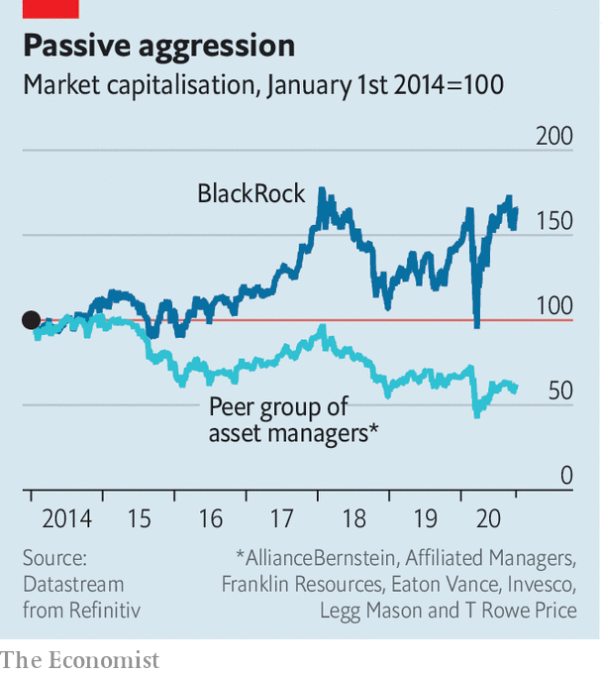

You can see the effect in the diverging path of share prices (see chart). Conditions seem ripe for an industry roll-up. Scale seems to be an advantage; there are plenty of target firms to buy; and the prices of many firms have become more attractive. “A lot of midsized players are now priced for ripping out costs,” as one industry bigwig rather brutally puts it.

As anyone who has fiddled with a tobacco pouch and papers can attest, the results of a roll-up are not always great. For a start, there are the problems that bedevil any biggish merger: clashes of business culture; incompatible IT systems; mutinous staff; and so on. It is far from easy to find savings in asset management, where the biggest cost is people. And the industry’s main problem is growth. For the past half decade, the flow of new business has gone to index funds, much of it to the Big Three. Active managers have suffered outflows. Their business is steadily shrinking. Drawn-out mergers often make the outflows even worse. New clients may stay away while a tie-up is pending. And bigness is not itself a very distinctive capability. The index giants are already working that particular corner.

Yet for all the pitfalls, there is something almost inevitable about a fund-management roll-up. The scale economies of index investing create excess capacity. Mergers are a way to reduce it. Like the tobacco version, industry roll-ups are messy. You can be easily burned. But if you need a fix, you’ll try it—if only because there are no alternatives around.

This article was downloaded by calibre from <https://www.economist.com/finance-and-economics/2020/10/08/what-takeovers-of-fund-managers-tell-you-about-markets>

|  |  |  |  |
| --- | --- | --- | --- |
| Previous | Articles | Sections | Next |

|  |  |  |  |
| --- | --- | --- | --- |
| Previous | Articles | Sections | Next |

#### Free exchange

# Why trade imbalances are a worry during a global downturn

Monetary policy begins to look more like a zero-sum game

Oct 10th 2020 |

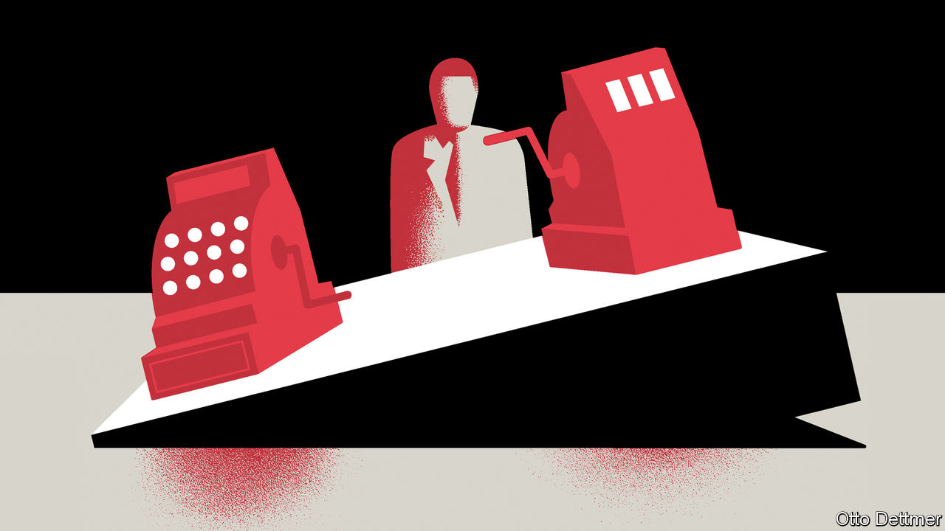

LIKE OTHER crises before it, covid-19 seems destined to accentuate troublesome features of the world economy. Take global imbalances. Though these were briefly suppressed when the pandemic first struck, they have now rebounded. America recorded its largest trade deficit in 14 years in August, despite having gone from being a big importer of oil to a net exporter in that time. Its goods deficit is neatly matched by a resurgent surplus in China. Temporary factors, such as a surge in China’s exports of personal-protective equipment, are partly to blame. But there is reason to worry that these fault lines will persist, adding a dangerous element to an already fraught global policy environment.

Global imbalances reached a modern peak just before the onset of the financial crisis of 2007-09, when the absolute sum of countries’ current-account surpluses and deficits amounted to over 5% of world GDP. Current-account gaps were pushed wider in part by what economists called the “global saving glut”, the result of soaring oil prices, and precautionary saving by emerging-economy governments prepared for sudden reversals in global risk appetites. Gaps eased in the decade after the crisis as oil prices fell and China edged towards rebalancing its economy. Yet on the eve of the pandemic, imbalances still remained at about 3% of global GDP, roughly one-and-a-half times the level common in the early 1990s. And yawning trade gaps have since opened up in some places. America’s current-account deficit, which stood at 2% of GDP at the end of 2019, had leapt to 3.5% of GDP six months later. China’s current-account balance went from a surplus of 1.1% of GDP in late 2019 to a deficit in the first quarter of 2020, before flipping back to a surplus of 3.1% of GDP in the second.

Current-account gaps are not inherently bad. A developing economy in need of investment, for instance, might consume more than it produces for a time as it builds up its productive capacity—and the wherewithal to repay accumulated foreign obligations in future. But in some cases they can be a source of crisis, if they reflect a build-up of financial vulnerabilities. And, most pertinently for the global economy today, in times of depressed demand they are particularly problematic. Economies run current-account surpluses when they produce more than they consume. When there is plenty of global demand to go around, this is at most a minor inconvenience for deficit economies, which enjoy more consumption than their domestic productive capacity alone would allow. When demand is scarce, however, surplus countries siphon off spending power from trading partners when they have precious little to spare.

In a paper published in 2015, Ricardo Caballero of the Massachusetts Institute of Technology, Pierre-Olivier Gourinchas of the University of California, Berkeley, and Emmanuel Farhi, then also of Berkeley, described this effect. The authors frame their argument in terms of the demand for safe assets. Globally, every surplus must be matched by a deficit, and saving in one place must be met by borrowing elsewhere. Surplus countries save by buying foreign government bonds. When global interest rates are well above zero, these purchases simply push interest rates down, inducing deficit countries to borrow and spend more. When interest rates drop to zero, however, this channel stops working, as rates cannot fall much further. Instead, the offsetting rise in borrowing in deficit countries must come through squeezed incomes—a recession.

Since the financial crisis, interest rates across the rich world have been near zero, with a few brief exceptions. And parts of the emerging world have edged closer to the low-rate quagmire this year. In these circumstances, fiscal expansion—which increases the global stock of government bonds—is an effective way to boost growth, both within the stimulating country and beyond. America’s large current-account deficit partly reflects strong consumption, supported by stimulus, of goods produced at home and abroad. But decisions about monetary easing become more fraught. Part of the boost, especially at low rates, comes from currency depreciation, which helps exporters grab a larger share of trading partners’ spending. In the 1930s, countries on the losing end of such demand grabs put up tariff barriers, leading to escalating protectionism and the breakdown of global trade.

## There goes the neighbourhood

Today, bold fiscal stimulus could spare the world this fate. But governments are already less free-spending than they were in the spring. On October 6th President Donald Trump ended talks on a new round of stimulus. The day before, Rishi Sunak, Britain’s chancellor of the exchequer, spoke of the need to get public finances under control. If fiscal stimulus is scaled back, that leaves monetary easing looking increasingly zero-sum. A doveish tweak to the Federal Reserve’s strategy in August contributed to a decline in the dollar against the euro, exacerbating a deflation problem in Europe. For its part, America is putting some surplus countries in the cross-hairs. On October 2nd it opened an investigation into currency manipulation by Vietnam. Rapid growth in the foreign-exchange reserves of a number of surplus Asian economies suggests that governments are intervening to depress their currencies, reckons Brad Setser of the Council on Foreign Relations, a think-tank. American scrutiny of China might also intensify if imbalances stay wide. Though the dollar has fallen against the yuan by around 5% since May, some evidence suggests that China has acted on the sly to slow the pace of its currency’s appreciation.

The trade spats of recent years were in many ways a delayed reaction to earlier economic grudges, inflamed by persistent imbalances. Had the global expansion continued, they might have fizzled out. Instead, the world finds itself bound once more by the harsh realities of depression economics. If they are not defused by enlightened self-interest and co-operation, imbalances could easily become the basis for debilitating economic conflict. ■

This article was downloaded by calibre from <https://www.economist.com/finance-and-economics/2020/10/10/why-trade-imbalances-are-a-worry-during-a-global-downturn>

|  |  |  |  |
| --- | --- | --- | --- |
| Previous | Articles | Sections | Next |

|  |  |  |
| --- | --- | --- |
| Finance & economics | Sections | Books & arts |

Science & technology

The 2020 Nobel science prizes: They walked in looking like dynamite

.

Living with El Niño: One man’s bane is another’s bounty

.

New materials: Joint approach

.

Conservation: How to prepare poached eggs

.

|  |  |  |
| --- | --- | --- |
| Finance & economics | Sections | Books & arts |

|  |  |  |  |
| --- | --- | --- | --- |
|  | Articles | Sections | Next |

#### Scientific awards

# Who won this year’s Nobel science prizes?

The laureates proved black holes are real, created a new form of gene editing and identified the hepatitis C virus

Oct 8th 2020 |

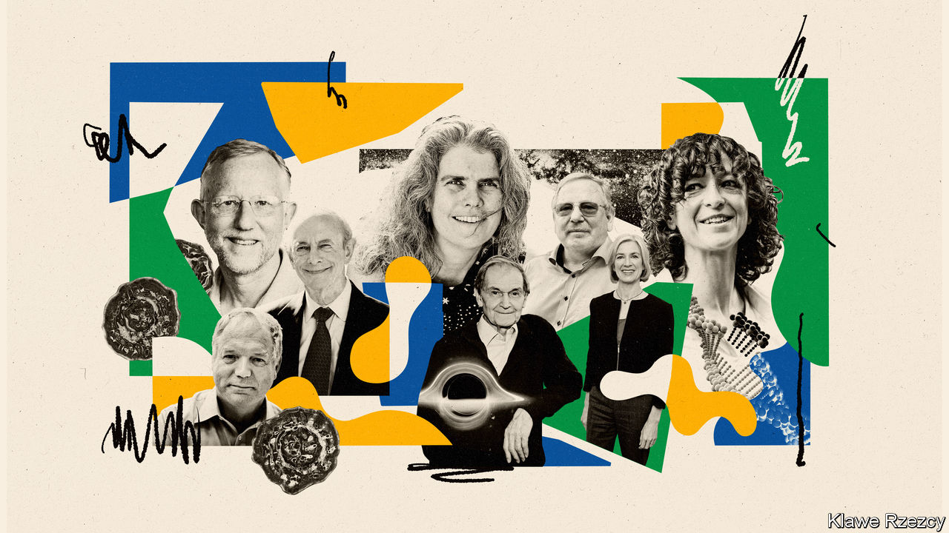

OCTOBER’S FIRST week is a nervous time for scientists with serious accomplishments under their belts—for this is when the phone might ring from Stockholm. Those who give out the Nobel science prizes (the Karolinska Institute for the physiology or medicine award, and Sweden’s Royal Academy of Science for the awards in physics and chemistry) are known neither for offering the winners more than an hour or two’s notice of the public announcement of their success, nor for respecting time zones. New laureates in North America receive the news in the dead of night. That, though, is normally reckoned a small price to pay for what is still seen as science’s most prestigious honour.

Britain being in a more convenient time zone from the Swedish point of view, Sir Roger Penrose, of Oxford University, was not actually asleep when his own phone rang. But he was, he says, in the shower. He was one of three winners of the physics prize, the others being Andrea Ghez and Reinhard Genzel, of the University of California’s Los Angeles and Berkeley campuses respectively. Their prize was for the theoretical explanation and subsequent discovery of some of the strangest objects in the universe: black holes.

Black holes are, famously, so dense that nothing, not even light, can escape their immense gravitational pull. A black hole’s centre is thought to be a point of infinite density, called a singularity, where the known laws of physics break down. Though the possibility that they existed was hypothesised a century ago, as a consequence of Einstein’s general theory of relativity (which is actually a theory of how gravity shapes the structure and contents of the universe), early work suggested that they could form only from the collapse of perfectly symmetrical stars or gas clouds. That is hardly realistic, and Einstein himself doubted that they actually existed.

They therefore remained a theoretical curiosity until 1965, when an as-yet-unknighted Dr Penrose worked out the specifics of how real matter could collapse in a way that would form one. He showed, using a mathematical concept which he called a trapped surface, that even asymmetric, clumpy stars and dust clouds could become black holes. This work provided the tools needed by observational astronomers to go out hunting for them.

By definition, it is impossible to see a black hole directly. Instead, physicists glean insights into them by studying the effect of their gravity on the motion of their stellar neighbours. Dr Ghez and Dr Genzel used this idea to gather evidence that Sagittarius A*—a bright source of radio waves at the centre of the Milky Way, Earth’s home galaxy—is actually a supermassive black hole around which all the stars in the galaxy, the Sun included, orbit.

Dr Ghez and her team employed the Keck Observatory telescope, in Hawaii, with its ten-metre-wide primary mirror, to make their observations. Dr Genzel’s group used a series of eight-metre-wide telescopes high in the mountains of the Atacama desert, in Chile, for theirs. These instruments were all sensitive enough to peer through the clouds of dust that otherwise obscure the heart of the Milky Way.

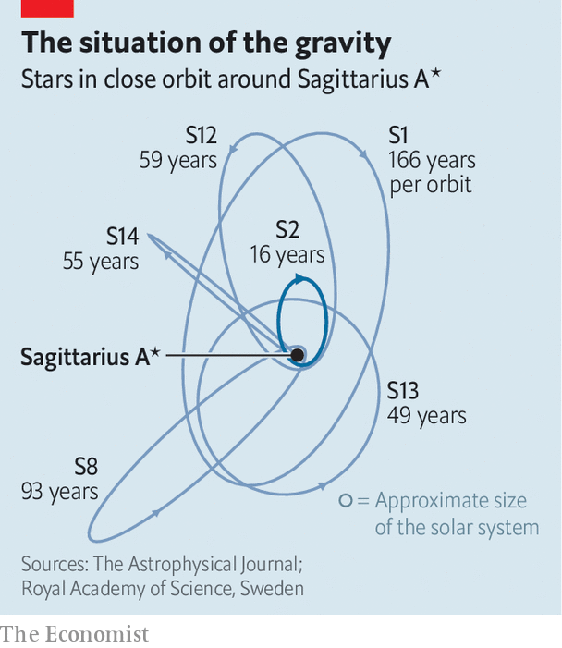

Over three decades both sets of researchers, working independently, tracked around 30 of the brightest stars at the galactic centre (see chart). A star called S2, for example, takes 16 years to complete an orbit of Sagittarius A*, and, at its closest approach, comes within 17 light-hours of it. These measurements have permitted astronomers to piece together a picture of Sagittarius A* as a black hole of around 4m solar masses, packed into a region of space that is about the size of the solar system.

April 2019 saw the release of the first-ever image of a black hole (Sagittarius A*’s local equivalent at the centre of a galaxy called M87, 53m light-years from Earth). This was taken, in radio frequencies, using the Event Horizon Telescope, a collaboration that links eight existing radio telescopes all around Earth and thus permits far higher resolution than any single instrument could manage. As technology improves, the Event Horizon Telescope could also one day provide a more detailed image of the region around Sagittarius A*.

## Chase to the cut

As is often the way, the chemistry prize went for a discovery that might equally well have been handed out for medicine—CRISPR-Cas9 gene editing. The winners were Emmanuelle Charpentier of the Max Planck unit for the science of pathogens, in Berlin, and Jennifer Doudna of the University of California, Berkeley.

CRISPR-Cas9 is derived from a bacterial defence mechanism that snips small sequences of DNA from viral interlopers and copies them into a bacterium’s own genome, thus creating a scrapbook by which to recognise such aggressors, should they come again. The laureates’ prize is not, though, for the mere discovery of a novel bacterial immune system. It is for the adaptation of that discovery into the most important gene-editing tool yet invented—one that is already helping to design disease-resistant crops and new therapies for cancer, and which may, perhaps, end hereditary disease in human beings.

If an organism’s collective DNA can be thought of as the book of its life, CRISPR-Cas9 allows for any specific sequence of words within that book to be identified, selected, removed and replaced. This is done by creating a molecule called a guide RNA, which matches a target DNA sequence, and pairing it with an enzyme, Cas9, that is capable of snipping the DNA helix at this point. Then, if so desired, a new piece of DNA can be inserted.

The laureates’ path to Stockholm began at a café in Puerto Rico in 2011. That was when Dr Charpentier, who had discovered intriguing and unexplained RNA fragments in a bacterium, engineered a meeting with Dr Doudna, an expert in the DNA-snipping capability of Cas proteins. Since this collaboration bore fruit in 2012, progress has been rapid. By February 2013 Feng Zhang of the Broad Institute in Cambridge, Massachusetts and George Church of Harvard Medical School had independently demonstrated the technique’s effectiveness in mouse and human genomes, paving the way for the treatment of human diseases. Clinical trials are now under way to test its power against sickle-cell anaemia and certain cancers, with animal experiments showing promising results in the treatment of muscular dystrophy.

There has also been controversy. In 2018 He Jiankui of the Southern University of Science and Technology, in Shenzhen, China, announced the birth of twin girls whose embryos he had edited with the help of CRISPR-Cas9. Dr He’s stated goal was to induce immunity to HIV, by disabling the gene for a protein which that virus uses to gain admission to cells. This was too much for the authorities. Even ignoring the issues of consent involved when a procedure is carried out on an embryo, making genetic edits so early in life means that they will be incorporated into germ cells, and thus passed down the generations. That raises serious ethical questions, and what Dr He did was declared illegal by the Chinese government. Dr He is now in prison.

Nor is germ-line editing the only controversy surrounding CRISPR-Cas9. A further complication concerns who gets the patents that will monetise it. The University of California and the Broad have been involved for years in a legal battle over the matter. By giving the prize to Dr Doudna and Dr Charpentier the Royal Academy of Science may have put its thumb on the scales. In picking them it has also, for the first time, awarded a Nobel science prize to an all-female group. Dr Charpentier, via a phone link to the room where the announcement was made, said “I hope this provides a positive message to young girls. Women in science can also be awarded prizes. But more importantly, women in science can also have an impact.”

Regardless of which category it truly fits into, the creation of CRISPR-Cas9 was a high-end piece of technowizardy. The actual prize for medicine, however, went for a piece of old-fashioned medical detective work—the identification of hepatitis C, a virus that causes life-threatening liver infections and is passed on by exposure to contaminated blood. Though other widespread diseases, such as malaria and HIV/AIDS, gain more attention, the World Health Organisation (WHO) reckons that around 70m people are infected with hep C and that it kills 400,000 people a year. Hep C has also, in the past, turned the business of blood transfusion into a lottery, since there was no way to tell whether a particular batch of blood harboured it. That this is no longer the case is, in no small measure, thanks to the work of this year’s laureates—Harvey Alter, Michael Houghton and Charles Rice.

## Blood simple

Dr Alter’s work came first. In the 1960s he was a colleague of Baruch Blumberg, who discovered the hepatitis B virus (for which he won a Nobel prize in 1976). Hepatitis viruses are labelled, in order of discovery, by letters of the alphabet. “A”, a waterborne pathogen, causes an acute infection that passes after a few weeks and induces subsequent immunity. The effects of “B” and “C”, though, are chronic and may result eventually in cirrhosis and cancer. Blumberg’s discovery led him to a vaccine for hep B, and also meant that blood intended for transfusion could be screened. But it became apparent that such screened blood still sometimes caused hepatitis, albeit at lower rates. Since hep A was also being screened for by this time, that suggested a third virus awaited discovery.

In 1978 Dr Alter, then working at America’s National Institutes of Health, proved this was true by injecting into chimpanzees blood from recipients of transfusions screened for the known viruses who had nevertheless developed hepatitis. These animals sometimes then went on to develop the illness. It took until 1989 to clone the new virus. That was done by Dr Houghton, who was then working at Chiron, a Californian biotechnology firm subsequently bought by Novartis, a Swiss pharmaceutical giant.

Dr Houghton amplified viral genetic material drawn randomly from chimpanzees infected with the as-yet-unidentified virus and tested this against antibodies from infected humans. Antibodies are proteins crafted by the immune system to stick specifically to parts of particular pathogens. By looking at which chimpanzee-derived material the antibodies in question attached themselves to, Dr Houghton was able to isolate the virus and identify it as a type of flavivirus, a group that also includes yellow fever and dengue. He also thus provided a way of screening blood intended for transfusion.

Dr Rice, working at Washington University, in St Louis, Missouri, eliminated lingering uncertainties about whether the flavivirus Dr Houghton had identified was the sole cause of hep C. Attempts to use cloned, purified versions of it to infect chimpanzees had not worked, leading to doubts about whether it was acting alone. Dr Rice identified part of the viral genome which looked crucial to the process of infection, but was highly mutable. He suspected that this mutability was hindering successful infection in the laboratory, and was able to eliminate it by genetic engineering. The stabilised virus was, indeed, infectious to chimps.

The consequence of all this is that blood for transfusion can now be screened routinely for hep C, and drugs to treat it have now been developed. Unfortunately, this has not stopped the march of the illness. Those in rich countries have benefited. Deaths in Britain, for example, fell by 16% between 2015 and 2017. But the wider picture is grim. Some countries, such as Egypt, have recently done well. Others, less so.

One reason is that, besides transfusion, hep C is spread by drug users sharing needles. It can also be spread sexually. This stigmatises it in the eyes of some. And unlike HIV/AIDS, which spreads in similar ways but quickly developed a political lobby to find a treatment once it was discovered, no one spoke up at the beginning for those suffering from the effects of hep C.

That is starting to change. In 2016 the WHO published a strategy for the elimination of all forms of hepatitis. The tools are there to do this. Whether the will to use them also exists remains to be seen.■

This article was downloaded by calibre from <https://www.economist.com/science-and-technology/2020/10/08/who-won-this-years-nobel-science-prizes>

|  |  |  |  |
| --- | --- | --- | --- |
|  | Articles | Sections | Next |

|  |  |  |  |
| --- | --- | --- | --- |
| Previous | Articles | Sections | Next |

#### South American agriculture

# Farmers of old relied on El Niño

Modern ones simply put up with it

Oct 10th 2020 |

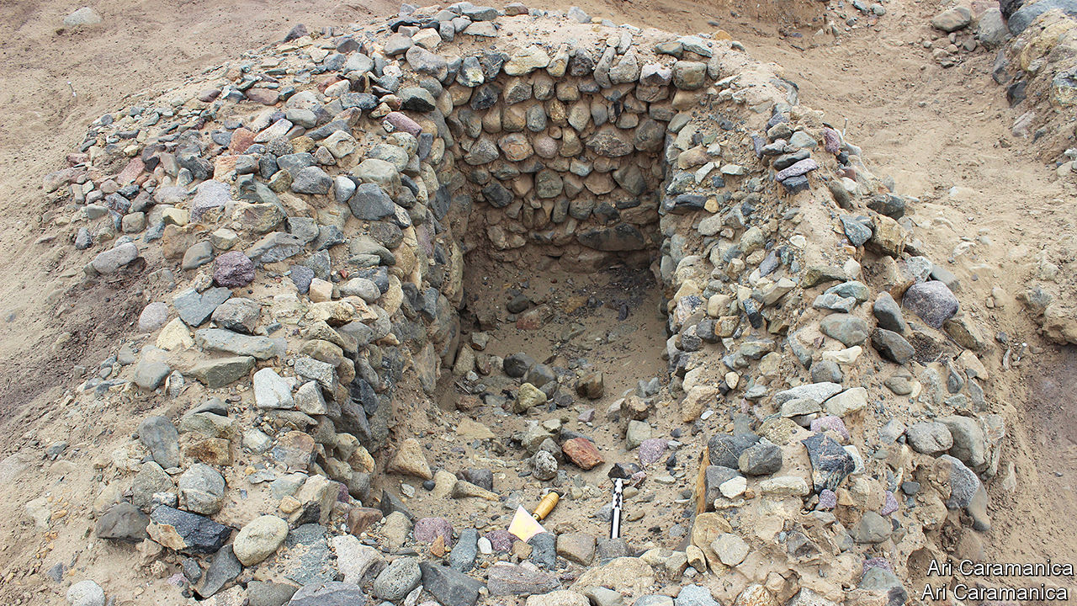

EVERY FOUR or five years, vast quantities of warm water build up along the west coast of South America. This phenomenon, El Niño, creates storms that cause devastating floods. The result is costly. In 2017, for instance, El Niño shut down northern Peru’s sugar-cane business.

Modern farmers view El Niño stoically. They use money saved in good years to rebuild in bad ones. But history suggests it need not be like that. In a paper published recently in the Proceedings of the National Academy of Sciences, Ari Caramanica, an archaeologist at University of the Pacific, in Lima, shows how it used to be done. And the answer seems to be, “better”.

Dr Caramanica and her colleagues have been studying the Pampa de Mocan, a coastal desert plain in northern Peru. Pampa de Mocan is not ideal for farming. Its soil contains little organic matter and the annual rainfall in non-Niño years is usually less than two centimetres. Today’s farmers therefore depend on canals to carry water from local rivers to their fields.

It had been assumed that ancient farmers had a similar arrangement—and so they did. But Dr Caramanica also found eight canals that could carry water far beyond the range of modern farms. Since the climate was similar to the present day’s when these canals were dug, and the river no higher, she hypothesises that they were intended to guide the floodwaters arriving during Niño years. Around a quarter of the ancient agricultural infrastructure of this area seems to have been built solely for managing Niño-generated floodwaters.

Evidence from pollen supports this theory, revealing that Pampa de Mocan produced lots of crops in some years, while remaining nearly barren in others. The team also uncovered two cisterns in the area serviced by the extended canals. These, presumably, were used to store surplus floodwater. They excavated one (pictured) and found it had a capacity of 300-400 litres.

These findings suggest that, rather than resisting El Niño, early farmers in Pampa de Mocan were ready to make use of it when it arrived. Precisely how they managed their fields in Niño years remains to be discovered. But it seems likely that farmers only sowed seeds in flood fields in preparation for the deluges to come in years when they had first noticed coastal waters warming. Given that these farms remained productive until just before the conquistadors arrived—a period of nearly 2,000 years—modern farmers might do well to learn from them. ■

This article was downloaded by calibre from <https://www.economist.com/science-and-technology/2020/10/10/farmers-of-old-relied-on-el-nino>

|  |  |  |  |
| --- | --- | --- | --- |
| Previous | Articles | Sections | Next |

|  |  |  |  |
| --- | --- | --- | --- |
| Previous | Articles | Sections | Next |

#### New materials

# A novel polymer should make 3D printing more effective

A joint approach

Oct 10th 2020 |

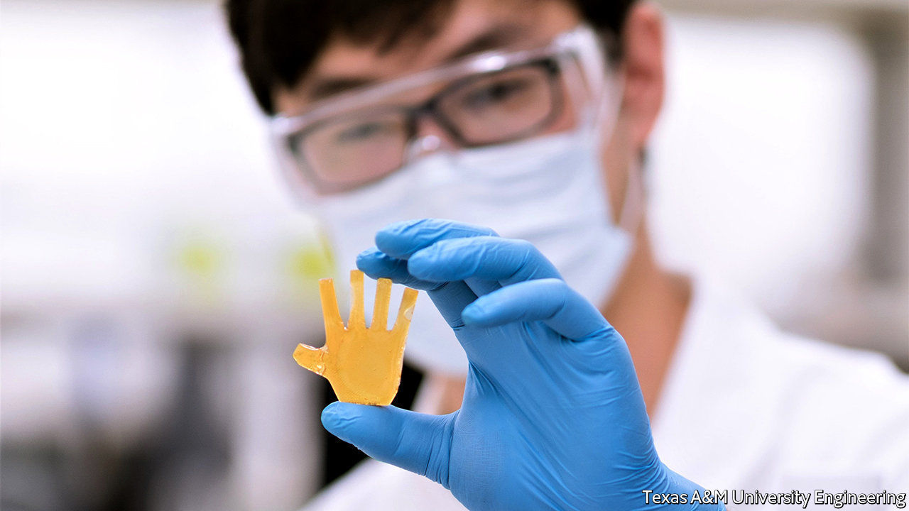

MATERIALS SCIENTISTS have long sought to emulate biology’s trick of joining materials that have wildly different properties into seamless functional units with no weak points, in the way that bones, connective tissue and skin are joined into limbs. Conventional manufacturing techniques, in which components of different composition are first created, and only then fitted together, make such emulation hard. However, three-dimensional (3D) printing, which permits materials to be blended as they are applied to a growing structure, offers a way to do this in principle. And a group of researchers at America’s Army Research Laboratory and Texas A&M University, in College Station, now think they have turned principle into practice.

The materials they are interested in are called interbonding polymer networks, and those they have lighted on in particular share the same underlying chemistry. A simple polymer is a molecular chain, the links of which are called monomers. Interbonding polymer networks involve a second set of monomers that form chemical links with the first. Crucially, these second monomers are symmetrical molecules, so both ends can make such links. This means they can bind polymer chains together by forming cross-links at numerous places between chains, to create a structure resembling a net. The physical properties of this net will depend on the density of cross-links. And that density is under the control of the chemists doing the mixing.

According to Svetlana Sukhishvili, who leads the Texas A&M side of the project, the pair of monomers the team has chosen can be used thus to make materials with stiffnesses ranging from the consistency of soft rubber to the sort of hard plastic used for car bumpers and aircraft canopies. Crucially, the pre-polymerisation mixtures of these monomers have the same viscosity regardless of the final mechanical properties of the polymer networks they result in. This means that, if printed together, they blend easily with one another when they come into contact rather than suffering what is known as weak interlayer adhesion—a bane of standard 3D printing that can cause objects so printed to split apart when stressed. The results are strong enough to act as load-bearing members.

Obtaining the desired variety of properties in an object is simply, therefore, a question of loading a set of printing nozzles with different pre-polymerisation mixtures and swapping them around as needed. Doing so can create, for example, a wheel with a hard-wearing outer surface and a shock-absorbing interior, or a rotor blade that is flexible but has a rigid supporting spine for strength. Interbonding polymer networks could also make better surgical prosthetics.

On top of this, if components made of the new material get damaged, any small cracks will seal up spontaneously, even without heating. Cracks propagate through the stuff by pulling the cross-links apart. Once the crack-causing force has gone, these links reform spontaneously. At room temperature, according to Frank Gardea, Dr Sukhishvili’s opposite number at the Army Research Laboratory, fractures disappear and the material heals itself within 12 hours. Dr Gardea says that with stiffer versions of the material, heat may need to be applied for full healing, and they are looking at ways of doing this. Continuous self-repair could greatly extend the life of components which otherwise succumb to normal wear and tear.

The new materials also have “shape memory”. If they are deformed, heat will cause them to revert to their original configuration. Conversely, an object in its original preferred shape can be reprogrammed to adopt a new one by heating, deforming and cooling it.

One early application of the new materials will be to make components for American army robots. As a prototype of this approach the researchers have built a miniature hand, the fingers of which employ the material’s shape-memory effects to move without motors. Dr Gardea suggests that another application might be to create shape-changing drones which could, like birds, alter their wing conformations in flight to switch between efficient cruising, high-speed sprints and extreme manoeuvrability. Dr Sukhishvili, meanwhile, is looking into programming the new materials to respond to light. By adding photosensitive molecular units to the polymer networks it might, she thinks, be possible to change their properties, including stiffness and shape, merely by illuminating them appropriately. That would, as it were, give a whole new meaning to the idea of photo manipulation. ■

This article was downloaded by calibre from <https://www.economist.com/science-and-technology/2020/10/10/a-novel-polymer-should-make-3d-printing-more-effective>

|  |  |  |  |
| --- | --- | --- | --- |
| Previous | Articles | Sections | Next |

|  |  |  |  |
| --- | --- | --- | --- |
| Previous | Articles | Sections | Next |

#### Conservation

# A new device may help stop the robbery of turtles’ nests

How to prepare poached eggs

Oct 10th 2020 |

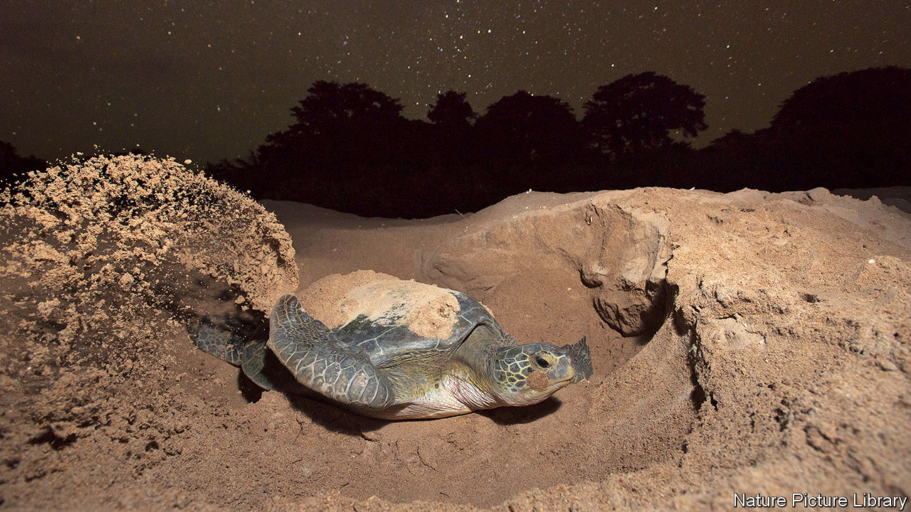

TURTLES HAVE A problem. They are delicious. And so are their eggs. That has led to heavy hunting in the past. These days, though, the seven species of marine turtle are protected in most countries. If turtle soup is legally on the menu its source will be a freshwater species such as the North American snapping turtle. But that does not stop the eggs of marine turtles being poached. Which they are, frequently.

Such poaching is often ignored by local bobbies. But even if the authorities do wish to clamp down on it, arresting the small-fry who dig the eggs up on beaches where turtles nest will not deal with the problem. That requires finding the trade’s organisers. And this can be hard.

To assist the process Kim Williams-Guillén of Paso Pacifico, an American conservation charity, and Helen Pheasey of the University of Kent, in Britain, have come up with a nifty gadget. It is a global-positioning-system transmitter enclosed in a plastic shell made by 3D printing. The result looks like a turtle’s egg and weighs about the same. Dug up and carried away by poachers, it can lead the police to those poachers’ bases of operation.

As they report this week in Current Biology, Dr Williams-Guillén and Dr Pheasey have now tested their invention in Costa Rica, a place where turtle-egg poaching is rife. They set the printer to mimic the eggs of two species, the green and the olive ridley, which frequent that country’s coastlines, and placed a decoy egg into each of 101 turtle nests on four beaches where poaching is a problem. The decoys were rigged to remain dormant until their shells were exposed to the air. At that moment—presumed to signal the arrival of poachers—the “egg” in question starts broadcasting its location once an hour.

In all, 25 of the decoys were poached. They told different stories. Some travelled just a few kilometres, with one ending up at a bar 2km away from the nest it was taken from, where its signal abruptly ended. Others went quite a distance. One, for example, was carried 137km inland, to a supermarket loading bay, before transmitting its final signal from a residential property nearby.

The most curious tale, though, was told by a decoy that ended up in Cariari, a town 43km from the beach where it had been deployed. To their surprise, the researchers were sent photographs of this particular device by members of a local turtle-monitoring project. This group had been contacted by the egg’s purchaser, who was happy to volunteer where he had bought it—indicating either that he did not understand that the trade was illegal, or that he didn’t care.

To make sure that they, themselves, were not harming what they were intending to protect, the researchers monitored all of the decoy-laden nests which had survived the attentions of poachers and compared these nests’ outputs of hatchlings with those of 44 other surviving nests that had no decoy in them. Both sorts of nest had the same hatching rates, suggesting that adding a decoy did not affect the development of the eggs it was hidden among.

Given the success of their project, Dr Williams-Guillén and Dr Pheasey propose that the idea should be used more widely for turtles. They also suggest that similar decoys might help protect the eggs of other endangered reptiles—and birds—that are collected and traded illegally.■

This article was downloaded by calibre from <https://www.economist.com/science-and-technology/2020/10/10/a-new-device-may-help-stop-the-robbery-of-turtles-nests>

|  |  |  |  |
| --- | --- | --- | --- |
| Previous | Articles | Sections | Next |

|  |  |  |
| --- | --- | --- |
| Science & ... | Sections | Economic & ... |

Books & arts

Money and morals: The way of the world

.

The history of science: Sleeping giants

.

Classical music: Phoning it in

.

Pets and poetry: Dead cat bounce

.

Theaster Gates: Feats of clay

.

|  |  |  |
| --- | --- | --- |
| Science & ... | Sections | Economic & ... |

|  |  |  |  |
| --- | --- | --- | --- |
|  | Articles | Sections | Next |

#### The way of the world

# Two books examine the global role of corruption

It is a slippery problem, for both authorities and authors

Oct 10th 2020 |

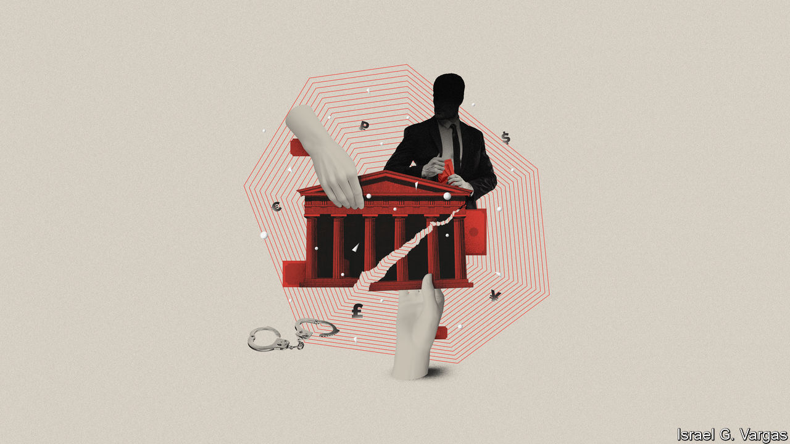

Kleptopia: How Dirty Money is Conquering the World. By Tom Burgis. Harper; 464 pages; $28.99. William Collins; £20.

On Corruption in America. By Sarah Chayes. Knopf; 432 pages; $28.95. Published in Britain as "Everybody Knows"; C. Hurst & Co; £20.

A FEW YEARS ago Francis Fukuyama, a political scientist, described corruption as “the defining issue of the 21st century”. Whereas the 20th century saw ideological battles between democratic, fascist and communist regimes, he argued, the chief divide among today’s governments is whether they primarily serve the interests of their people (as in Denmark or Canada) or of their leaders (as in Zimbabwe or Russia). The worst are “kleptocracies”, states whose very purpose is to enable elites to plunder resources, in which bribes, favours and violence are the methods of rule.

In an era when prime ministers and presidents from Malaysia to Ukraine amass billions in cash, and Western banks that handle the money turn a blind eye to its provenance, Mr Fukuyama’s thesis commands widespread assent. Yet the lineaments of corruption can be hard to define, not least because corrupt people tend to be good at constructing excuses for themselves. After all, isn’t government supposed to encourage commerce? Shouldn’t politicians and businessmen talk? Corruption on a grand scale is fantastically complicated and tough to write about, not least (in Britain especially) because of libel law. Two new books take up the challenge.

“Kleptopia” does the job brilliantly. Tom Burgis of the Financial Times spins his tale of global corruption from the ground up. He begins with a hero straight out of a John le Carré novel. Nigel Wilkins is an ageing, introverted economist with an obstreperous streak. He takes a job as a compliance officer at the London office of BSI, a Swiss bank, just as the global financial crisis strikes. He soon suspects that BSI is laundering money for a long list of the international high and mighty, and surreptitiously copies reams of documents which he tries to bring to the attention of the Financial Services Authority. It ignores him.

Mr Burgis also follows the story of ENRC, a metal and minerals outfit that listed in London in 2007. Partly owned by the government of Kazakhstan, the firm was founded by three Central Asians who bought ex-Soviet factories at discount prices, quickly becoming billionaires. The listing brings an injection of cash from Western investors; they also expand into Africa, taking in more money in Zambia and Congo. A parallel storyline concerns Mukhtar Ablyazov, a former Kazakh minister and banking tycoon turned opposition leader. In this telling, after Mr Ablyazov falls out with the regime, he, his family and his staff face lawsuits, surveillance, false arrest and torture. In 2009 he fled from Kazakhstan, where he has been convicted in absentia of murder and accused of fraud and embezzlement, all of which he denies. (He also left Britain after a judge ordered him jailed for concealing assets; he has just been granted political asylum in France.)

“Kleptopia” is wonderfully if grimly entertaining, replete with tales of Zimbabwean thugs, late Soviet gangsters and KGB officers-turned-entrepreneurs, as well as a Romeo-and-Juliet romance between the children of rival oligarchs. Mr Burgis’s depiction of the interlocking worlds of post-Soviet business and politics captures the way corruption binds together economic and political power. He meticulously demonstrates how, once overseas money enters Britain (attracted by the protections of its legal system), the associated power struggles and skulduggery follow.

When Western governments and media try to take on Kazakh wrongdoing, they are misled by what Mr Burgis terms a “presumption of regularity”. European courts treat international arrest warrants from Kazakhstan as if they emanated from a genuine national legal system, rather than the ruling clique. Worst of all, money-hungry Western banks, lawyers, public-relations firms and security consultants exacerbate the sleaze, developing a sort of international kleptocracy-service system. As the web widens, readers unfamiliar with Kazakh or Russian politics will start to come across names they may recognise, such as Felix Sater and Donald Trump.

Sarah Chayes, too, is intrigued by wide webs of corruption. Her interest in the issue began in the 2000s, when she worked for an NGO in Afghanistan. As she wrote in her excellent previous book, “Thieves of State” (published in 2015), she soon realised that resentment of government corruption was the main factor driving Afghans towards the Taliban—and that American intervention was making corruption worse.

## The hydra rears its heads

Her new book ranges more widely—too widely. She begins with the decision by America’s Supreme Court in 2016 that voided the influence-peddling conviction of Bob McDonnell, a former governor of Virginia. He and his wife had accepted lavish gifts from a vitamin-supplement manufacturer, and asked the state health authority to consider recommending its products. But because no explicit bribe was offered in exchange for an official act, the court ruled unanimously that a guilty verdict could criminalise the normal conduct of democratic politics. Prosecutors say this standard has made it almost impossible to convict American politicians of corruption.

Ms Chayes tries to set this event in historical context, but she overdoes it. She starts by looking at the vexed origins of money itself, going on to tackle fractional reserve banking, credit bubbles, graft in the Gilded Age and the labour movement. But, lacking a framework to distinguish legitimate links between commerce and the state from the crooked kind, the book soon drifts into lazy condemnations of capitalism. To describe the global mechanism of corruption, Ms Chayes uses the metaphor of the hydra—an image that has been common in polemics against international finance since the 19th century. Some passages have the tinge of conspiracy theories.

In a way, her book illustrates the risk identified by the Supreme Court: to the oversensitive, every handshake can seem suspect. Yet Mr Burgis, too, ends his analysis with a description of a web of money-laundering, legal harassment, propaganda and violence that enmeshes the world. America and Britain, he thinks, are ever-more like Ukraine, Russia and Kazakhstan: “Like a parasite altering a cell it invades, so kleptocratic power transforms its host.” ■

This article was downloaded by calibre from <https://www.economist.com/books-and-arts/2020/10/10/two-books-examine-the-global-role-of-corruption>

|  |  |  |  |
| --- | --- | --- | --- |
|  | Articles | Sections | Next |

|  |  |  |  |
| --- | --- | --- | --- |
| Previous | Articles | Sections | Next |

#### Sleeping giants

# The intellectual flare of the so-called dark ages

In “The Light Ages”, Seb Falk lays out the wonders of medieval science

Oct 8th 2020 |

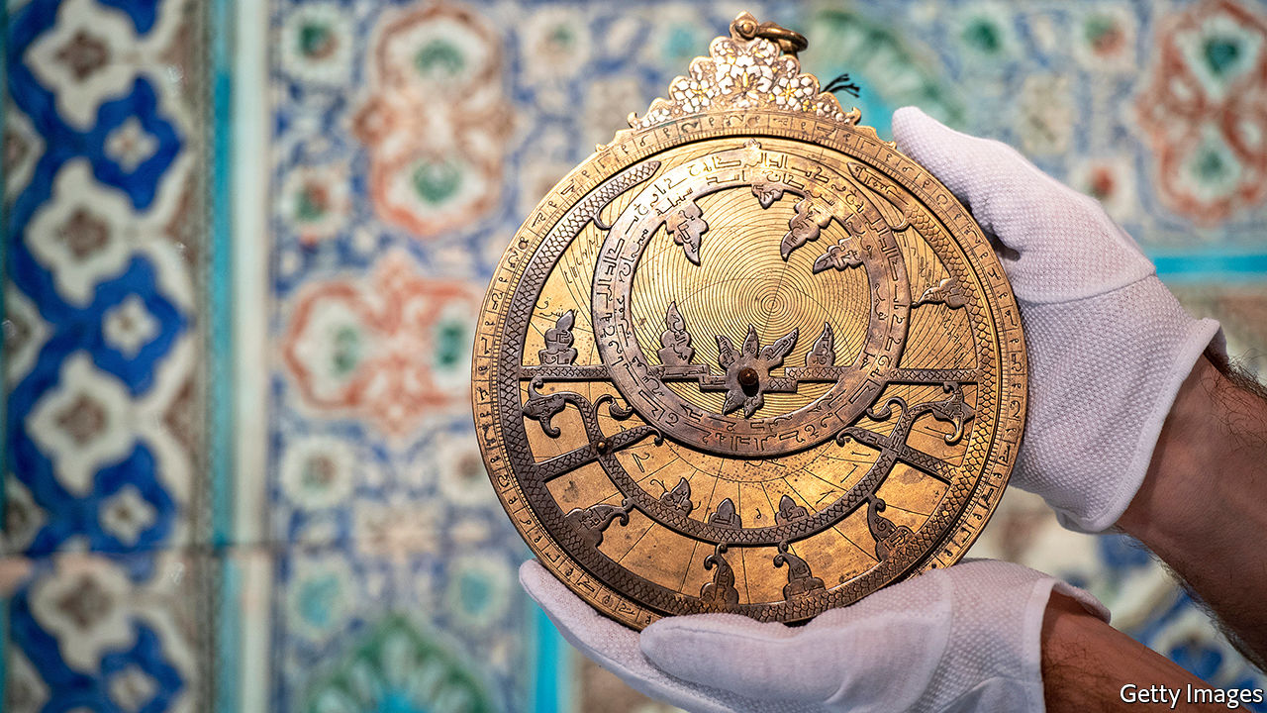

The Light Ages. By Seb Falk. W.W. Norton; 320 pages; $30. Allen Lane; £20.

IN THE 11TH century, nearly 500 years before Leonardo da Vinci drew a similar flying machine, a young monk called Eilmer strapped wings to his hands and feet and jumped off a tower at Malmesbury Abbey in England. After he had glided more than 200 metres a gust of wind caught him, and he crashed, breaking both legs.

Eilmer’s exploit seems to capture much about the Middle Ages, as Seb Falk, a historian, presents them in “The Light Ages”. They fizzed with scientific curiosity and experimentation, much of it in religious institutions. There were a lot of dead ends, but there was progress too. And they don’t deserve to be tainted as “the Dark Ages”.

A deeply rooted intellectual prejudice holds that nothing much happened in the 1,000-odd years between the fall of the western Roman Empire and the rediscovery, in the 15th century, of the texts of the ancient world. Mr Falk sets out to discredit it. Those texts were well-known in the Middle Ages, when they were brought together in European libraries with the musings of the finest contemporary minds (many from far beyond Europe’s borders), translated into Latin, copied, debated and sometimes improved upon. A shift did begin in the 15th century, but it was more quantitative than qualitative—an acceleration, largely due to the invention of the printing press, rather than a watershed.

Mr Falk acknowledges that medieval science was not the same as the modern kind. Astronomy was the most important discipline, but astrology was respectable too, and it shaded into magic. Monks and nuns toiled in scriptoria to understand “a living cosmos endowed by God”, not “a coldly mechanistic natural world”. But were the methods really so different? Confronted with the unknown, human beings generate a chaotic mass of hypotheses that gradually gets whittled down through observation and experiment. That describes medieval science as much as today’s.

And medieval scientists had a virtue that their modern counterparts can seem to have lost: humility. That is the reason Mr Falk chooses an obscure 14th-century monk-scientist, John Westwyk, as his guide. He cites Westwyk’s description of the astrolabe, an instrument that assisted in many useful tasks, such as telling the time and finding north, based on calculations of the positions of celestial bodies. The astrolabe sometimes seems to have more personality than the monk, probably because of the paucity of biographical information available. Still, Westwyk plays a valuable role in Mr Falk’s story.

To become an astronomer, he had to learn mind-boggling quantities of information, often in the form of numerical tables for which the astrolabe provided a handy, but less accurate, shorthand. Reading about what Westwyk knew can be hard-going, because people are not used to thinking that way any more; computers do it for them. The reward is an understanding of the daily feats of memory that he and his contemporaries performed. It was because their knowledge was derived from first principles, Mr Falk shows, that they regarded the night sky with such wonder.

The mechanical clock, spectacles, advances in navigation, a grasp of tides and currents—these were among the achievements of the Middle Ages. They produced a theory of impetus that influenced Galileo Galilei in the 17th century. By then Nicolaus Copernicus had overturned everything medieval astronomers held dear, by placing the sun at the centre of the universe; but he couldn’t have done so without their patiently elaborated geometry. Fittingly, a metaphor Isaac Newton used in 1675—“If I have seen further it is by standing on the shoulders of giants”—was coined in a 12th-century cathedral school. ■

This article was downloaded by calibre from <https://www.economist.com/books-and-arts/2020/10/08/the-intellectual-flare-of-the-so-called-dark-ages>

|  |  |  |  |
| --- | --- | --- | --- |
| Previous | Articles | Sections | Next |

|  |  |  |  |
| --- | --- | --- | --- |
| Previous | Articles | Sections | Next |

#### Phoning it in

# How to produce an opera in lockdown

“Eight Songs from Isolation” shows how the form can adapt to the pandemic

Oct 10th 2020 |

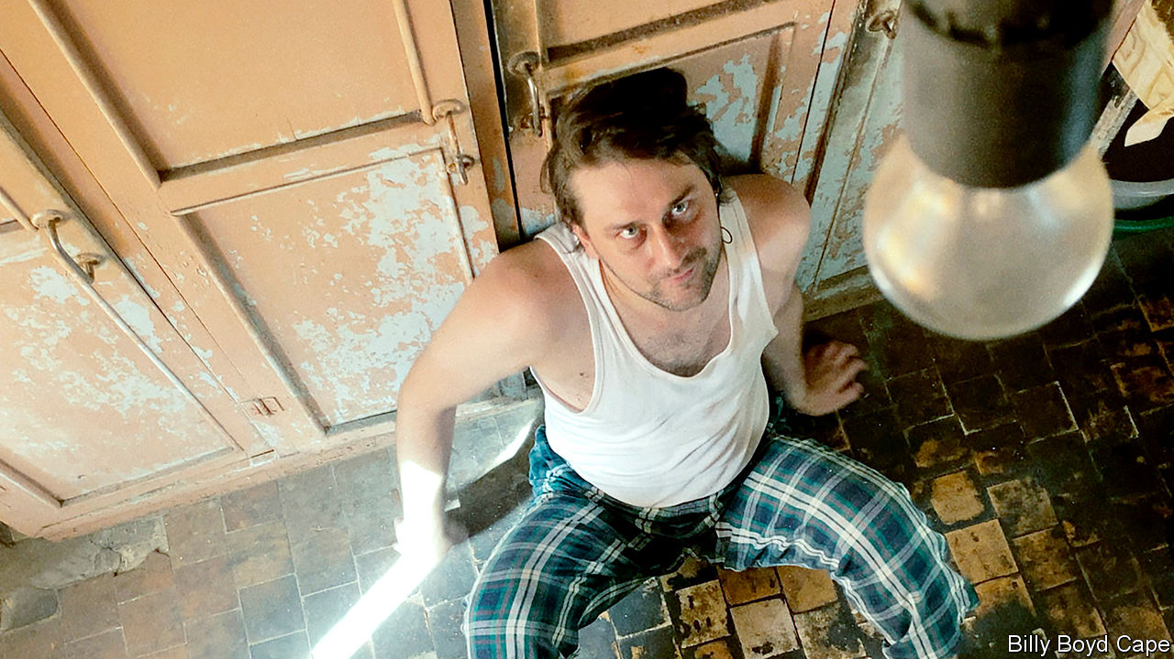

IN THE VOID left by restrictions on theatres, opera has pursued a shadow life elsewhere. The English National Opera has managed a zany drive-in version of “La bohème” in a car-park in north London, but most companies have resorted to streaming old shows, with the odd effort on Zoom. “Eight Songs from Isolation”, a 45-minute work created by eight composers, takes a new approach: forget the stage, commission for today’s medium, and put the drama where it counts—in the music.

The idea of a “socially distant” opera occurred to Oliver Zeffman, a British conductor, when it became clear that two fundamental elements of concerts—interaction between artists, and between them and their audiences—might be out of reach. He commissioned eight composers around the world, from established names such as Nico Muhly, an American, to Freya Waley-Cohen, a rising talent based in Britain, to write songs responding to the concept of isolation. Using iPhones, the singers filmed themselves performing the results in or around their homes, guided by Billy Boyd Cape, the director, and accompanied remotely by musicians from the Academy of St Martin in the Fields in London.

Together they show how digital opera can maintain some of the enchantment that makes the onstage kind so powerful. The traditional linear plot is abandoned in favour of eight miniatures. By turns subdued, playful and deranged, the songs run the gamut of bridled lives under lockdown.

Some of the libretti are drawn from poems; others take inspiration from reality. The Russian composer Ilya Demutsky unexpectedly adapts the rant delivered by a hostage-taker during a recent bank heist in Moscow. The use of a sheng (a reed instrument) and the Chinese lute make Du Yun’s piece the least conventional. The lyrics reflect on a city’s burst of blooms: “re-awakening/the spring begins to trill outside the window”. The line becomes more poignant when you learn that it comes from a newspaper report written by the libretto’s co-author, Yang Nan, who was locked down in Wuhan earlier this year.

Now available on Apple Music, “Eight Songs from Isolation” proves that remote collaborations can succeed if classical musicians abandon conventions that belong to the proscenium. In the 18th century Mozart saw the potential in song and orchestration to dramatise life’s more absurd predicaments. Today, with almost all auditoriums closed, that is harder. Mr Zeffman’s decision to shed the theatrics of the stage to focus on stories and music forfeits some of opera’s glamour. But it brings a serious musical response to these times onto listeners’ screens and into their homes. ■

This article was downloaded by calibre from <https://www.economist.com/books-and-arts/2020/10/10/how-to-produce-an-opera-in-lockdown>

|  |  |  |  |
| --- | --- | --- | --- |
| Previous | Articles | Sections | Next |

|  |  |  |  |
| --- | --- | --- | --- |
| Previous | Articles | Sections | Next |

#### Dead cat bounce

# For he will consider Jeoffry, the poet’s cat

His 18th-century life “is imaginary”, says Oliver Soden. But that is “no reason for it not to be true”

Oct 10th 2020 |



Jeoffry: The Poet’s Cat. By Oliver Soden. History Press; 208 pages; £16.99.

THE HERO of our story was born in a whorehouse during an earthquake in March 1750. He entered the world mewling and mewing and was carried upstairs in a silk stocking by a harlot straight out of Hogarth. His father was a ginger tom, his mother an importuned tabby. He was christened Squit by his first mistress, but would go down in history as Jeoffry.

Most biographers have just the one life to marshal; Oliver Soden has nine. His subject was a purring muse to the 18th-century poet Christopher Smart. Mr Soden’s delightful, insinuating book curls around your thoughts and tickles you with its whiskers.

It is not the first life of a pet. “The history of Pompey the Little” offered a lap-dog’s perspective on the world in 1751, when Jeoffry was still a kitten. Mr Soden acknowledges a debt to Virginia Woolf’s “Flush”, a biography of Elizabeth Barrett Browning’s spaniel—a tough act to follow, and in one respect “Jeoffry” falls short. The author imagines the escapades a cat might have had; Woolf played on every sense to conjure up a dog set on an adventure.

This much is known: that between 1759 and 1763 Jeoffry shared Smart’s cell in a lunatic asylum, and that Smart devoted 74 of the surviving 1,700 lines of his religious poem “Jubilate Agno”—“whimsical in its ecstasy, and ecstatic in its whimsy”—to his cat. The sequence beginning “For I will consider my Cat Jeoffry…” is among the most anthologised poems in English; Benjamin Britten set it to music. Jeoffry’s life, writes Mr Soden, “is imaginary. But that seems to me no reason for it not to be true.”

The result is as much a history of literary and theatrical London as a feline biography. Jeoffry catches mice in Drury Lane, scratches holes in pig-skin prophylactics in a Bow Street bordello, leaps into the lap of the 16-year-old Fanny Burney and bats at her loose lace fichu. He pauses on the Strand to lick Samuel Johnson’s proud, panther-like Hodge on the forehead. He offers a cat’s-eye-view of David Garrick’s stroking gloves, George Frideric Handel’s swollen legs, George II’s glittering buckles and straining gold garters. A cat dares to look at a king—and what he sees is mostly stomach. Prowling Smart’s desk, Jeoffry spills the poet’s pounce pot of powdered cuttlefish bone.

Mr Soden jokes that if “Jubilate Agno” is a magnificat (a song of praise to God), the Jeoffry verses are a magnifi-cat. His own magnifi-cat recreation, bound in cloth-covers and sporting a Gainsborough kitty, would make a fine stocking filler—silk, buckled or gartered.

This article was downloaded by calibre from <https://www.economist.com/books-and-arts/2020/10/10/for-he-will-consider-jeoffry-the-poets-cat>

|  |  |  |  |
| --- | --- | --- | --- |
| Previous | Articles | Sections | Next |

|  |  |  |  |
| --- | --- | --- | --- |
| Previous | Articles | Sections | Next |

#### A visionary American artist

# Theaster Gates turns discarded objects into art

He has never had a major solo show in America—until now

Oct 10th 2020 |

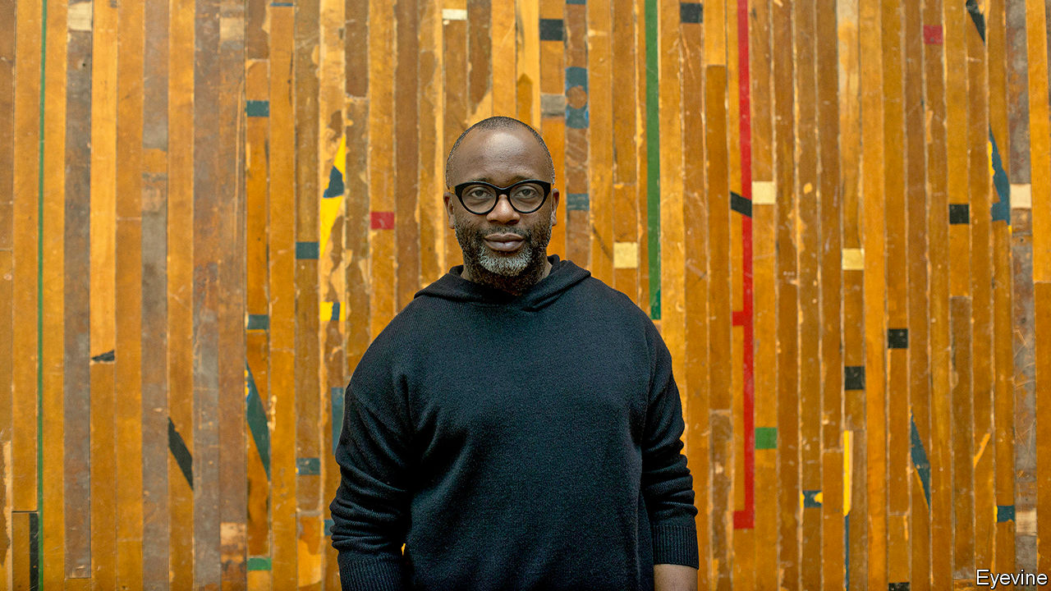

IN 2012 THEASTER GATES shipped a cargo of construction materials from a dilapidated house on the South Side of Chicago to the German city of Kassel. He had been invited to exhibit at Documenta, a city-wide art show held there every five years. In Kassel Mr Gates had come upon Huguenot House, a run-down hotel built by migrants and named after the French Protestants who fled abroad in the 17th and 18th centuries. Once people had sought refuge in the building’s cellar, but it had been abandoned since the second world war. He was fascinated by parallels between the Huguenots who made a new home in Germany and the African-Americans who travelled north to Chicago during the great migration of the mid-20th century. He asked to take over the whole building.

Mr Gates and his team exposed torn wallpaper and stripped away plaster. They filled one of the disused rooms with staircases to nowhere, made wall hangings out of mattress ticking and a shoeshine stand from old floorboards. (Those stands feature a lot in Mr Gates’s installations: at openings he often asks his well-heeled collectors to polish visitors’ shoes.) The project, entitled “12 Ballads for Huguenot House”, became one of Documenta’s biggest draws, with Mr Gates’s music ensemble, Black Monks of Mississippi, playing ballads that blended Zen chanting with slave spirituals. “You know we had Kassel rocking,” he remembers. “It became an extremely electric place.”

The artist’s postbox began to fill up with invitations from other European curators, intrigued by the way he trawled through African-American history to create conceptual artworks about memory and music. These led to solo exhibitions in Switzerland, Sweden, Austria, France and Britain. But not in America, where he featured only in group shows.

“I think that [in] the US we can be quite provincial,” Mr Gates comments. But there may have been another reason. In his home country, where he studied urban planning, he is best known for something else. In 2006 he moved to the South Side and bought a former sweetshop, aided by a loan from his mother and a subprime mortgage. Ever since, he has been scooping up condemned buildings and transforming them into vibrant culture centres, with libraries, studios and space for meetings, exhibitions and performance—in a part of Chicago that is 93% African-American and notoriously short of such places.

He coaxed the University of Chicago to spend $2m on an arts hub in the neighbourhood. He persuaded Rahm Emanuel, then the mayor, to sell him the Stony Island State Savings Bank, boarded up but owned by the city, for a dollar—plus a promise that Mr Gates would raise the money to turn it into an arts venue. In 2013 he cut 100 marble slabs from the building, inscribed them with the words “In Art We Trust”, and sold them for $5,000 each at Art Basel as if they were bonds.

These days Mr Gates owns or manages more than a dozen buildings in Chicago. “Every morning I check on fences, make sure the grass is mowed,” he says. “If it’s rained I check there are no major leaks. I’m a landlord.”

## Through the roof

That is Mr Gates the social entrepreneur. But America is about to learn more about Mr Gates the artist, thanks to a major new show that opens at Gagosian in New York on October 10th. As his centres in Chicago closed when covid-19 took hold in the spring, Mr Gates retreated to his studio. He spent a month cleaning assiduously, “to help me cope with the anxiety”. Then came the killing of George Floyd and the nationwide protests against racial injustice. His advice to white Americans who want to help improve race relations is eminently practical: “If you really want to help, get some black friends, marry a black man. The number of white people I know who don’t have one real black friend, it’s scary. It blows my mind that we live such racially distanced lives.”

Lockdown helped him hone his ideas for the Gagosian show. Called “Black Vessel”, it is a tribute to family life (an only son, Mr Gates has eight older sisters), maternal love and manual labour. His father was a roofer, and this exhibition, based on clay and roofing materials, will be his “origin story”, he explains. “It’s about homage to my dad,” but also about the transfer of “a skill and a way of making from one generation to another”. The elder Gates did not want his son to be a roofer; that is why he sent him to college. “The show says a lot about the potential within blackness, the potential within labour, the potential between—in this case—a father and a son to transfer and do better.”

Some of the work harks back to the years he spent making pottery in America and Japan. In 2007, at a series of dinners in Chicago, he memorably served up soul food on plates that he crafted, supposedly in honour of a Japanese potter named Shoji Yamaguchi, who turned out not to exist. His new pots will fill one room at the gallery.

A second will display his “roofing” sculptures: slabs of rubberised roofing from some of Mr Gates’s building projects, coated with tar and painted in industrial colours (tile red, terracotta and blueish-green). These recall the work of Robert Rauschenberg or Alberto Burri, an innovative Italian painter and sculptor who took up working with plastic, blowtorches and sacking after he was released from a POW camp in Texas. Prices for Mr Gates’s ceramics will start at $200,000, and for the roofing sculptures at $500,000—far above his previous auction prices, but a sign of his growing following and of soaring demand for African-American artists.

But the showstopper, and the real “Black Vessel”, will be the large main gallery, which Mr Gates is lining entirely with special bricks from a factory in South Carolina. Whenever the plant switches from, say, making red bricks to blue ones, the offcuts produced during the transition are thrown away. Some of these were saved for him, and fired black. They are symbols of Mr Gates’s artistic and civic interests: the salvage and repurposing of discarded black artefacts. It will transform Gagosian into “an empty black sanctuary”, which, in a difficult year, “feels really, really good”. ■

“Theaster Gates: Black Vessel” will be at Gagosian, 555 West 24th St, New York, from October 10th

This article was downloaded by calibre from <https://www.economist.com/books-and-arts/2020/10/10/theaster-gates-turns-discarded-objects-into-art>

|  |  |  |  |
| --- | --- | --- | --- |
| Previous | Articles | Sections | Next |

|  |  |  |
| --- | --- | --- |
| Books & arts | Sections | Graphic detail |

Economic & financial indicators

Economic data, commodities and markets

.

|  |  |  |
| --- | --- | --- |
| Books & arts | Sections | Graphic detail |

|  |  |  |  |
| --- | --- | --- | --- |
|  | Articles | Sections | Next |

# Economic data, commodities and markets

Oct 10th 2020 |

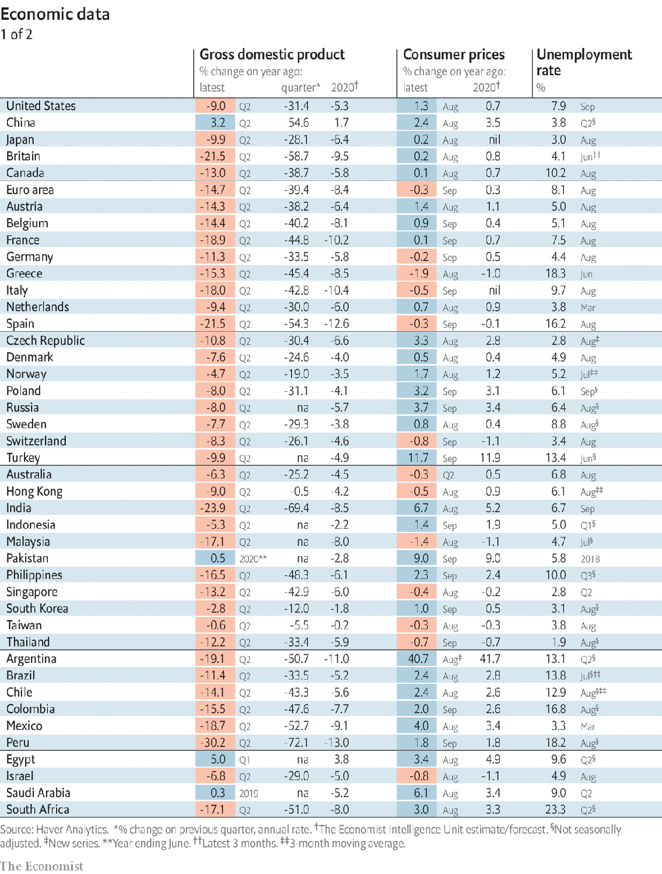

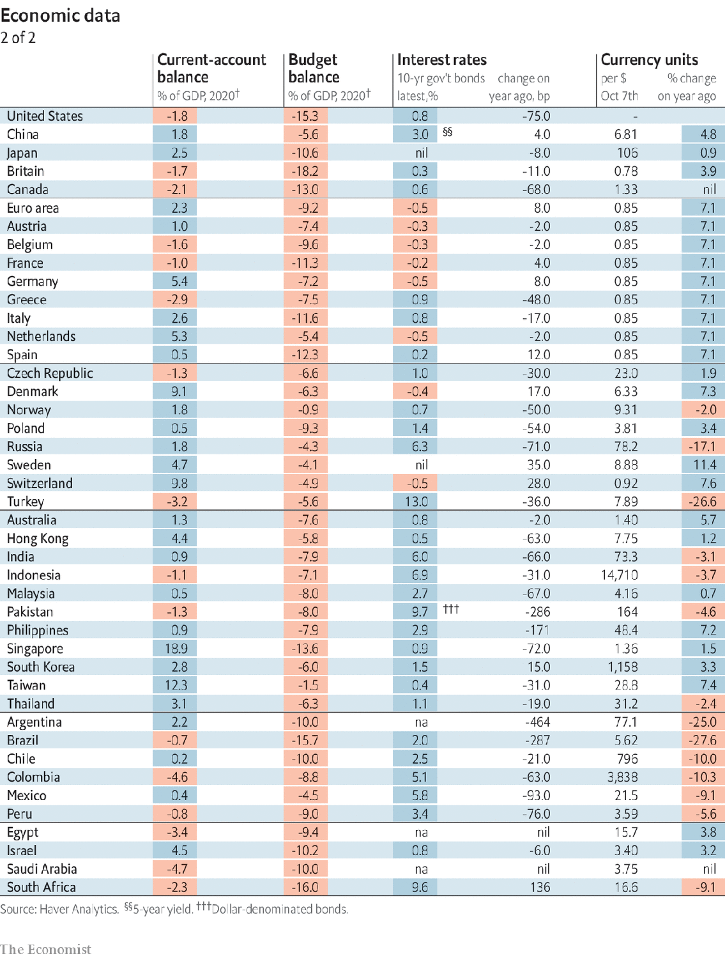

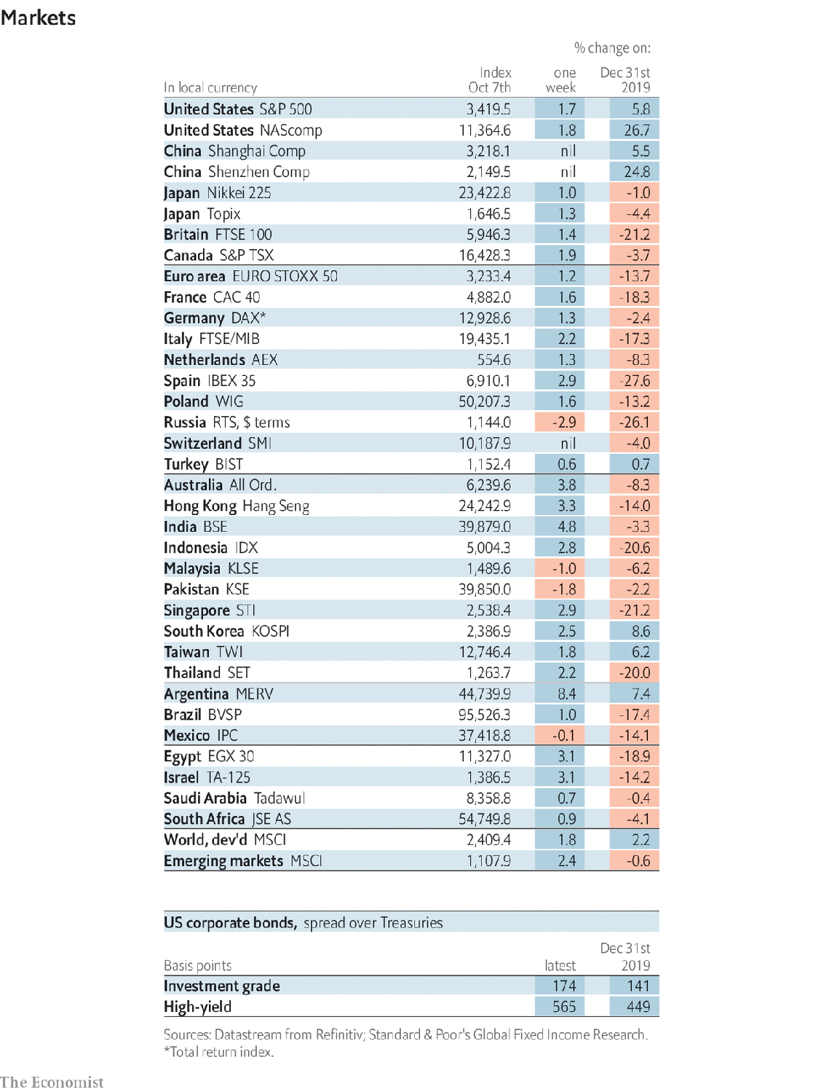

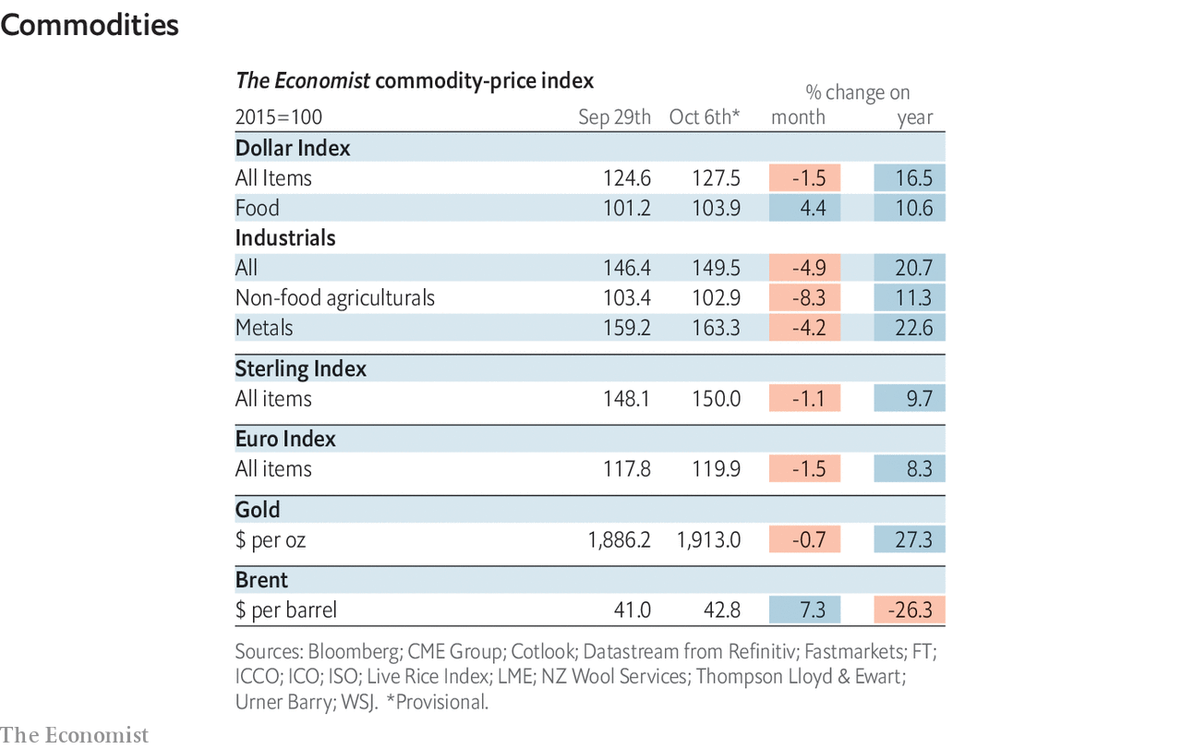

This article was downloaded by calibre from <https://www.economist.com/economic-and-financial-indicators/2020/10/10/economic-data-commodities-and-markets>

|  |  |  |  |
| --- | --- | --- | --- |
|  | Articles | Sections | Next |

|  |  |  |
| --- | --- | --- |
| Economic & ... | Sections | Obituary |

Graphic detail

|  |  |  |
| --- | --- | --- |
| Economic & ... | Sections | Obituary |

|  |  |  |
| --- | --- | --- |
| Graphic detail | Sections |  |

Obituary

Swami Agnivesh: Of human bondage

.

|  |  |  |
| --- | --- | --- |
| Graphic detail | Sections |  |

|  |  |  |  |
| --- | --- | --- | --- |
|  | Articles | Sections | Next |

#### Of human bondage

# Swami Agnivesh died on September 11th

The liberator of India’s bonded labourers was 80

Oct 10th 2020 |

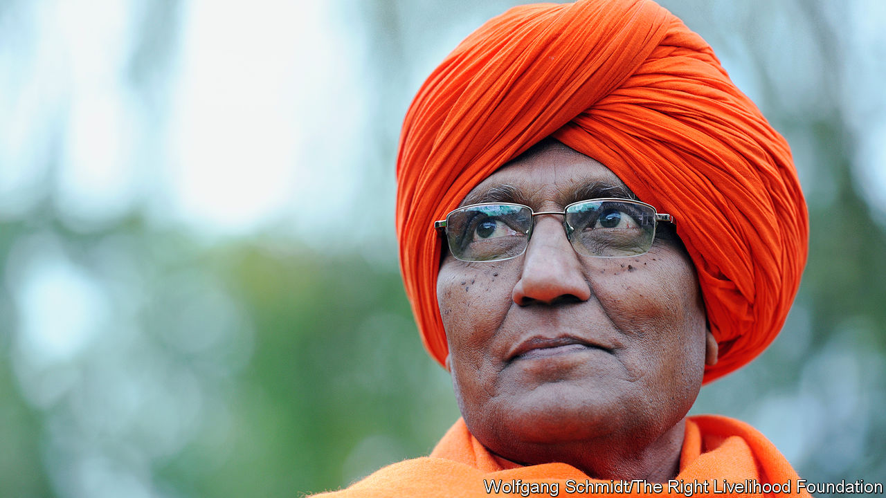

THE HINDU life-stage of sanyasa, or renunciation, is traditionally the last. The elderly lay aside their material possessions and take up a spiritual existence, perhaps in some remote ashram in the forest or the hills. Vepa Shyam Rao, as he was then, was only 30 when he took the title of Swami, or monk, put on saffron robes and travelled to Haryana, in northern India. His mission was still not quite in focus, but his philosophy was. He had gladly renounced his life as a lawyer and lecturer in management studies in Kolkata, reducing what he owned to his robes and a bagful of books. His career and his things he could lightly put aside. But the world and its problems, no.

His life from that moment was focused on some of the hardest parts of that world. The stone quarries outside Delhi, for example, where men, women and children were paid five rupees a day to dig out, shift and break great blocks of stone, as though they were beasts of burden. The unventilated, deafening carpet workshops where labourers were sometimes chained to the looms and locked in at night. Silk factories where hands already white with blisters plunged repeatedly into scalding water to reel the fibres from the cocoons, and tanneries where arms were burned with toxic chemicals. Outside his penetrating gaze, but mentioned in whispers, were the punishments for working slowly: a blow on the head from a brick, a beating while tied to a neem tree, or simply non-payment of the pitiful few coins that were supposed to have been earned.

Almost all this labour, he discovered in Haryana—which was a hotbed of it—was indentured servitude. The workers were landless Dalits or their children, forced to borrow to pay for medicines or dowries from a local, higher-caste moneylender. The average loan was around 2,000 rupees, or $27, but at interest rates of 40% or more it could seldom be paid back. Payment was made in the form of labour from which workers could not escape, and the debt was passed down the generations.

Many of these enslaved workers were therefore children, some as young as four or five. By his own estimates, of perhaps 60m bonded workers, 15m were under 14. Once he was on the watch for them he saw them everywhere: bending all day over tobacco baskets to hand-roll beedis, gathering broken cups outside teashops, picking rags. Their small, soft hands were thought ideal for delicate jobs such as knotting threads, dozens to each square centimetre, in carpet-making. But their bodies were deformed by it, and their lives shortened. There were laws against this, as against bonded labour in general. They were rarely enforced, because servitude was accepted as part of the natural order.

He did not accept it. In 1981 he set up the Bonded Labour Liberation Front, raising money to buy the freedom of as many workers as possible and to teach the rest what their rights were. Almost recklessly, because his bright robes advertised him everywhere, he and his helpers slipped into the wretched shanty-villages to encourage the labourers to organise. Eventually unions were created for stone-cutters, builders and brick-kiln workers; meanwhile, he battled employers in the courts. Those workers he managed to rescue—around 178,000 in all, roughly 26,000 of them children—were trained for new jobs or sent, for the first time, to school.

Much of this, especially the shouts of “Revolution!” after some of his worker meetings, seemed more political than priestly. But he did not see a distinction. He had decided early, under the influence of the Arya Samaj movement and the works of Gandhi and Marx, that his dharma or spiritual duty was to go among the poor, serving them. He called this “Vedic socialism”; and though completely guided by the Vedas, the most sacred texts of Hinduism, it had to involve political action. When followers treated him as a monk, bending to touch his feet in respect, he would tell them to stop; he might recite a verse from an Upanishad one moment, but the next he would be quoting, by paragraph number, an article of national law. In the late 1970s he actually became a politician in Haryana, and briefly education minister. But he fell out with the government when police fired on protesting bonded workers, and after that he was a one-man political party.

As such, he cast his interests wide. He took up the cause of tribal peoples without land rights and of farmers who could not get fair prices. He campaigned for better treatment of Dalits overall and pushed for laws empowering women, leading marches across India to protest against sati and female foeticide. In the villages, where he explained that God had created the Sun and Moon for men and women alike, he was feted as a celebrity, garlanded with marigolds and led round on elephants. The attention embarrassed him, but the publicity was good: the same reasoning that led him to appear in 2011 on the reality-TV show “Bigg Boss”, where he hoped he could bring peace to the other contestants in the house.

In that role of peacemaker, he also trekked in 2011 into the forests of Chhattisgarh to oversee the handover by Maoist rebels of five abducted policemen. (In general, he thought the Maoists had been driven to violence by injustice, and urged the Indian government to talk to them.) He called often for dialogue with Muslims, too. This sort of thing got him regularly beaten up as anti-Hindu, a suggestion with which he had no patience. Certainly he rejected barbarisms such as sati, or the superstitious worship of stone idols. But the true enemies of Hinduism were elsewhere, in the Hindutva movement championed by the prime minister, Narendra Modi: fundamentalists who had perverted the sacred, inclusive power of Hinduism for partisan and nationalist ends. He saw nothing but calamity in the growth of that ideology in India.

His work with bonded labourers also caused him disappointment. Relatively speaking, he had rescued few, and the practice went boldly on. He might have taken heart, though, from the number who came to his funeral, shyly recounting to reporters the horror of their work before, and their hopes now. They, in particular, were glad he had not made his sanyasa in some remote mountain or forest but with them, in the weariness and pain and dust. ■

This article was downloaded by calibre from <https://www.economist.com/obituary/2020/10/10/swami-agnivesh-died-on-september-11th>

|  |  |  |  |
| --- | --- | --- | --- |
|  | Articles | Sections | Next |